Supplemental Information

Vitrification confers the low post-implantation development capability of mice embryos through alterations of DNA damage and epigenetic modifications

Yurong Chena, Haibo Zhua, Fucheng Guo, Luyao Wang, Wenli Zhang, Ruizhi Liu, Xiaoling Zhang, Xiangpeng Dai

SUPPLEMENTAL SECTION INVENTORY

Figure S1 relates to manuscript Figure 2.
Figure S2 relates to manuscript Figure 2.
Figure S3 relates to manuscript Figure 2.
Figure S4 relates to manuscript Figure 5.
Figure S5 relates to manuscript Figure 5.
Figure S6 relates to manuscript Figure 6.
Figure S7 relates to manuscript Figure 8.
Figure S8 relates to manuscript Figure 9.

Supplemental Figure 1. Effects of vitrification on mitochondrial membrane potential, mPTP and mtDNA copy number (related to Figure 2).
(A) Representative images of JC-1 monomer and aggregate in blastocysts.
(B) The fluorescence intensity ratio of JC-1 aggregates to monomers in blastocysts (n = 9 for Con, n = 14 for Vit). ***p < 0.001.
(C) Representative images of mPTP in blastocysts.
(D) The fluorescence intensity of Calcein AM + CoCl₂ in blastocysts (n = 15 for Con, n = 16 for Vit). Scale bar, 50 μm. Con represents control sample; Vit represents vitrified sample.
(E) The Nd1/18s rRNA ratio used as an estimate for the relative mtDNA copy number in blastocysts.

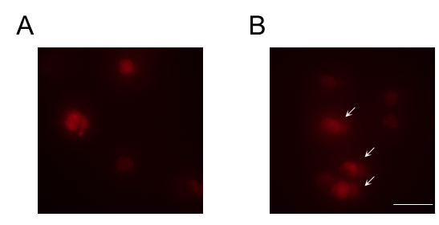
Supplemental Figure 2. Comet assay images of blastocysts (related to Figure 2).
(A) Images of Comet assay of control blastocysts. Scale bar, 200 μm.
(B) Images of Comet assay of blastocysts derived from the vitrified 8-cell embryos. The white arrows indicated the DNA-tail. Scale bar, 200 μm.

Supplemental Figure 3. Effects of vitrification on BAX and BCL2 protein level in blastocysts (related to Figure 2).
(A) Immunoblot (IB) analyses of whole-cell lysate (WCL)from control and vitrified blastocysts. (B) The quantitative results of (A). * P<0.05. Con represents control sample; Vit represents vitrified sample.
Supplemental Figure 4. Effects of vitrification on histone methylation (related to Figure 5). (A) Representative images of blastocysts stained for H3K9me3.
(B) The fluorescence intensity of H3K9m3 (n = 20 for Con, n = 21 for Vit).
(C) The fluorescence intensity of H3K9m3 in ICM and TE (n = 6 for Con, n = 6 for Vit). Con represents control sample; Vit represents vitrified sample.

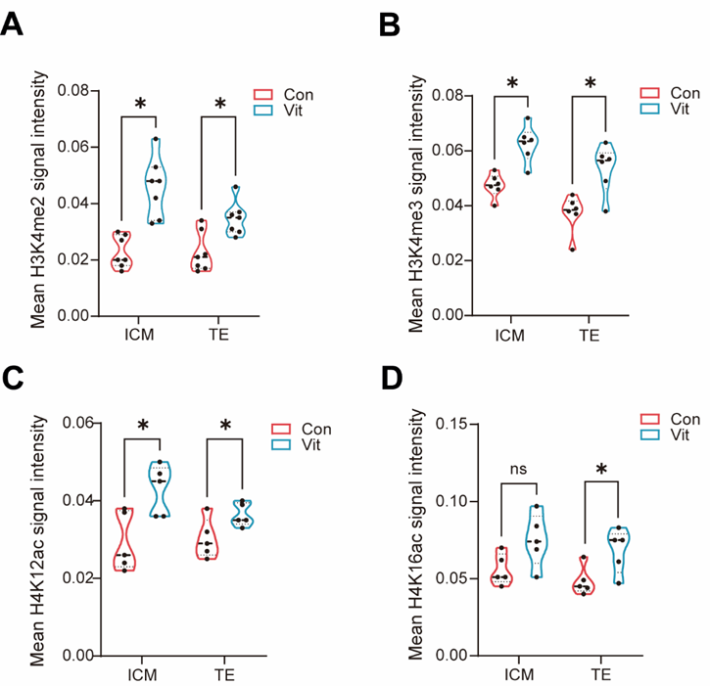
Supplemental Figure 5. Effects of vitrification on histone methylation (related to Figure 5). (A) The fluorescence intensity of H3K4m2 in ICM and TE (n = 7 for Con, n = 7 for Vit).
(B) The fluorescence intensity of H3K4m3 in ICM and TE (n = 6 for Con, n = 6 for Vit).
(C) The fluorescence intensity of H4K12ac in ICM and TE (n = 5 for Con, n = 5 for Vit).
(D) The fluorescence intensity of H4K16ac in ICM and TE (n = 5 for Con, n = 5 for Vit). Con represents control sample; Vit represents vitrified sample.

Supplemental Figure 6. Effects of vitrification on RNA N6-methyladenosine (related to Figure 6).
(A) The fluorescence intensity of m6A in ICM and TE (n = 11 for Con, n = 11 for Vit).
(B) Relative abundance of genes related to m6A modification. *p < 0.05. Con represents control sample; Vit represents vitrified sample.

Supplemental Figure 7. GSEA of differentially expressed genes between control and vitrified group placentas (related to Figure 8).

Supplemental Figure 8. GSEA of differentially expressed genes between control and vitrified group brains (related to Figure 9).

