Figure S1. Variables involved in all the models tested and their intercorrelation.

The Epigenetic Maternal Neglect scores (EMNs) significantly and positively correlated with a) the intensity of adverse events and all subtypes of childhood maltreatment and b) psychopathological internalizing and externalizing dimensions. By contrast, EMNs significantly and negatively correlated with c) cognitive status; and d) emotional availability measures (maternal and child behavior). Finally, emotional availability (mother and child) did not correlate with cognitive status or psychopathology (Internalizing and Externalizing symptoms).
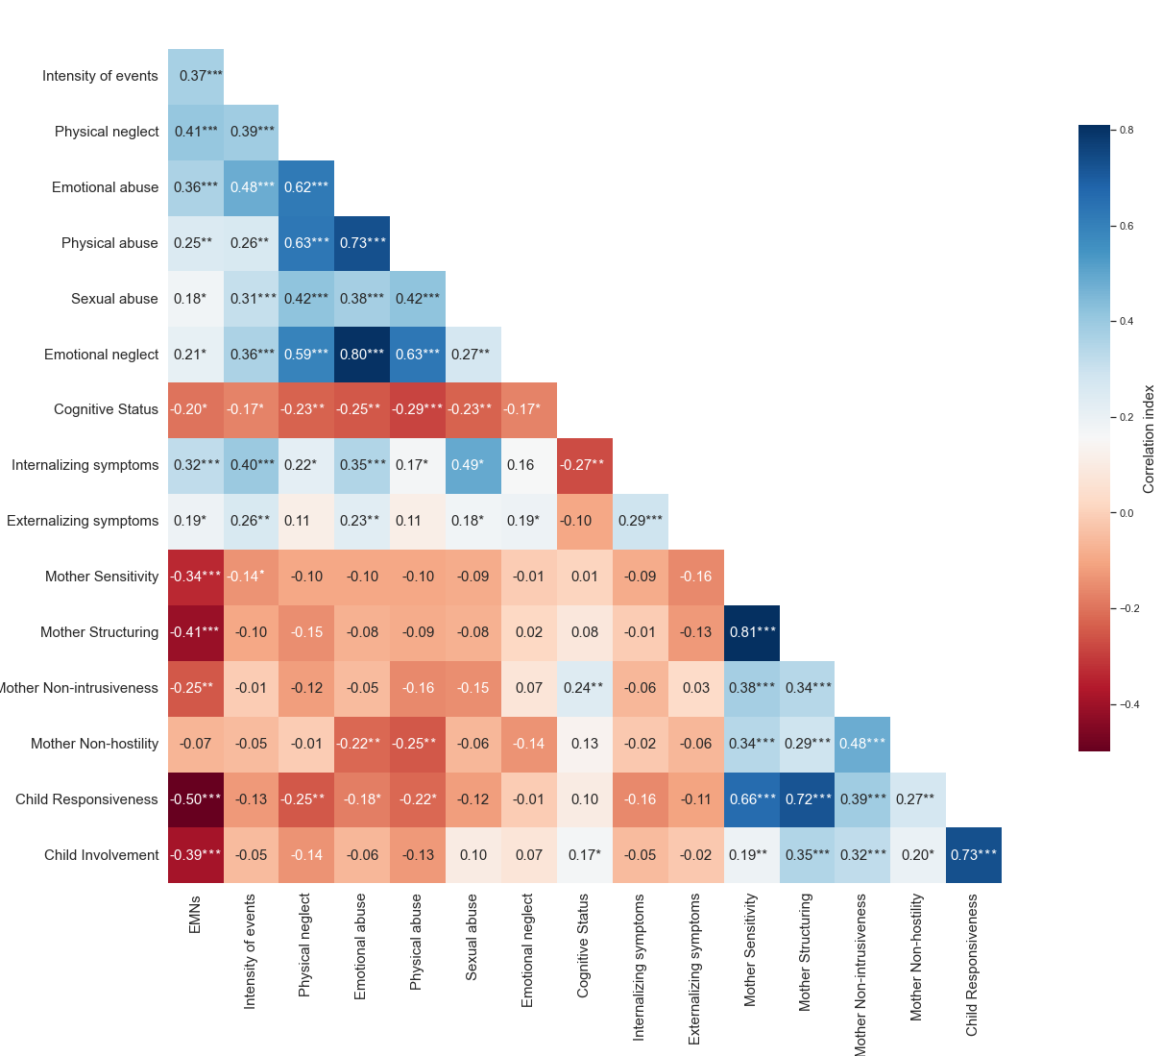
Figure S1. Pearson matrix of correlations among the variables included in the SEM initial model (*p<.05: **p<.01; ***p<.001)

