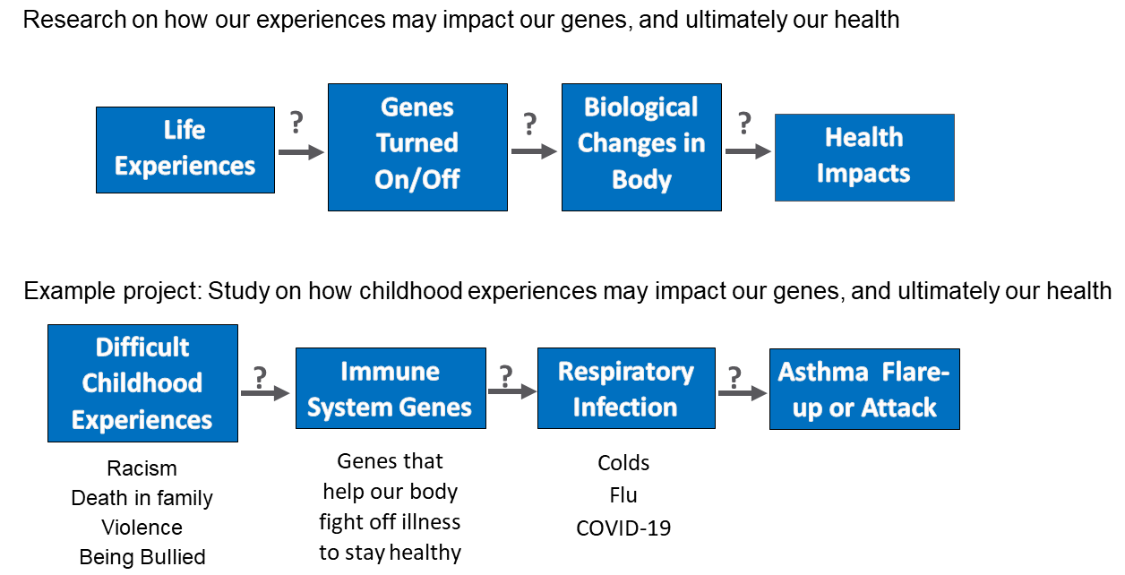

Supplemental Figure 1. Educational illustration provided to focus group participants about social epigenomic research with the SEA study used as an example.

