Supplementary Information
Table S1. Metabolic and reproductive characteristics of study population who completed both visits and for whom DNA methylation was measured. Continuous variables reported as mean ± standard deviation.

 | Visit 1 (n=16) |  | Visit 2 (n=16) |  | V1 vs. V2 (p, paired T test) | Control v T2D at Visit 1 (p, two-sample t-test)
 | Control  (n=7) | T2D  (n=9) | Control  (n=7) | T2D  (n= 9)
Age (years) | 40.6± 12.5 | 49.7 ± 7.5 | 40.6 ± 12.5 | 49.9 ± 7.5 | 0.16 | 0.12
BMI (kg/m²) | 30.3 ± 4.0 | 34.4 ± 6.7 | 29.4 ± 3.0 | 33.6 ± 6.2 | 0.02 | 0.15
Fat Mass (kg) | 27.7 ± 11.2 | 38.1 ± 15.6 | 24.8 ± 6.4 | 36.9 ± 15.2 | 0.15 | 0.15
Fat-free Mass (kg) | 75.1 ± 19.3 | 77.5 ± 16.0 | 66.4 ± 7.2 | 76.4 ± 14.0 | 0.27 | 0.79
Adiponectin (mcg/ml) | 6.9± 2.2 | 4.3 ± 1.6 | 6.3 ± 3.1 | 4.8 ± 1.4 | 0.94 | 0.03
Leptin (ng/ml) | 5.0 ± 2.7 | 5.7 ± 2.8 | 4.5 ± 3.0 | 4.8 ± 2.0 | 0.18 | 0.66
HbA1c (%) | 5.2 ± 0.2 | 7.6 ± 1.1 | 5.2 ± 0.3 | 7.3 ± 1.0 | 0.42 | <.001
Fructosamine (umol/L) | 237.3 ± 27.4 | 309.7 ± 85.5 | 280.6 ± 65.3 | 285.3 ± 39.2 | 0.80 | 0.04
FSH (mIU/mL) | 4.1 ± 2.6 | 10.3 ± 5.6 | 4.4± 2.1 | 9.6 ± 5.0 | 0.47 | 0.01
LH (mIU/mL) | 2.8± 1.4 | 5.7 ± 2.3 | 3.2 ± 1.6 | 5.7 ± 2.4 | 0.03 | 0.01
Total Testosterone (ng/dL) | 369.4± 165.4 | 330.2 ± 79.4 | 371.7 ± 126.9 | 336.4 ± 87.9 | 0.79 | 0.58
Semen Volume (ml) | 3.5 ± 1.8 | 2.9 ± 1.5 | 3.1± 1.5 | 3.3 ± 1.8 | 0.96 | 0.49
Semen Concentration (million/ml) | 55.5 ± 24.3 | 55.3 ± 31.1 | 52.8 ± 30.7 | 73.8 ± 34.5 | 0.29 | 0.99
Total Sperm Number (million) | 183.9 ± 83.0 | 144.4 ± 101.5 | 171.2 ± 134.0 | 266.7 ± 211.5 | 0.14 | 0.41
Motility (%) | 51.1 ± 18.2 | 47.4 ± 24.2 | 41.1 ± 31.9 | 52.8 ± 25.7 | 0.81 | 0.74
Progressive Motility (%) | 20.4 ± 8.9 | 17.7 ± 12.0 | 14.0 ± 12.1 | 20.6 ± 11.7 | 0.73 | 0.62
Total Motile Sperm Number (mil/ejaculate) | 102.8 ± 55.8 | 82.1 ± 82.6 | 102.5 ± 119.3 | 139.7 ± 132.0 | 0.21 | 0.56
Somatic cells / 100 sperm | 0.36 ± 0.30 | 0.53 ± 0.44 | 0.55 ± 0.58 | 0.28 ± 0.59 | 0.96 | 0.36
% Purity | 99.6 ± 0.30 | 99.5 ± 0.44 | 99.5 ± 0.58 | 99.7 ± 0.59 | 0.96 | 0.36

Table S2*. Data table including mean methylation values for individual probes at visit 1 and visit 2 including beta and M, p (moderated t test, paired by subject), FDR, log₂ fold change (visit 2/visit 1), and annotations.
Table S3*. Data table including mean methylation values for individual probes for control vs. T2D participants, including beta and M, p (moderated t-test), FDR, log₂ fold change (T2D/control), and annotations.

*Please note that these files (Table S2, S3) are submitted under the supporting data file designation. If this is not successful we will be happy to provide the files via an alternative approach.

Figure S1. Consort diagram of the study population. T2D (Type 2 Diabetes), HC (Healthy Control), PD (Prediabetes).
Recruitment and Screening
N= 43 men recruited, informed consent obtained
Visit 1 (baseline)
- N= 40 (16 control , 6 PD, 18 T2D)
- Anthropometrics, laboratory analysis
- Sperm analysis
Exclusions, N=17
- Lost to follow up/withdrawn (N=7: 4 control, 3 T2D)
- Unable to provide semen at V2 (N=3: 2 T2D, 1 PD)
- Low motility (<10%) (N=7: 5 control, 1 T2D, 1 PD)
Visit 2 (3 months after visit 1)
- N= 23 (8 control, 4 PD, 11 T2D)
- Anthropometrics, laboratory analysis
- Sperm analysis
- DNA methylation in 7 control, 9 T2D
Exclusions, N=3
- HIV positive (T2D)
- Hypogonadism (T2D)
- Abnormal prolactin (control)

Figure S2. Density plot of A. beta values (range 0-1) and B. M values, colored by group.

- B.

Figure S3. Principal component analysis of sperm DNA methylation samples obtained at visit 1 (red) and visit 2 (green). Circle indicates control, while triangle indicates T2D.
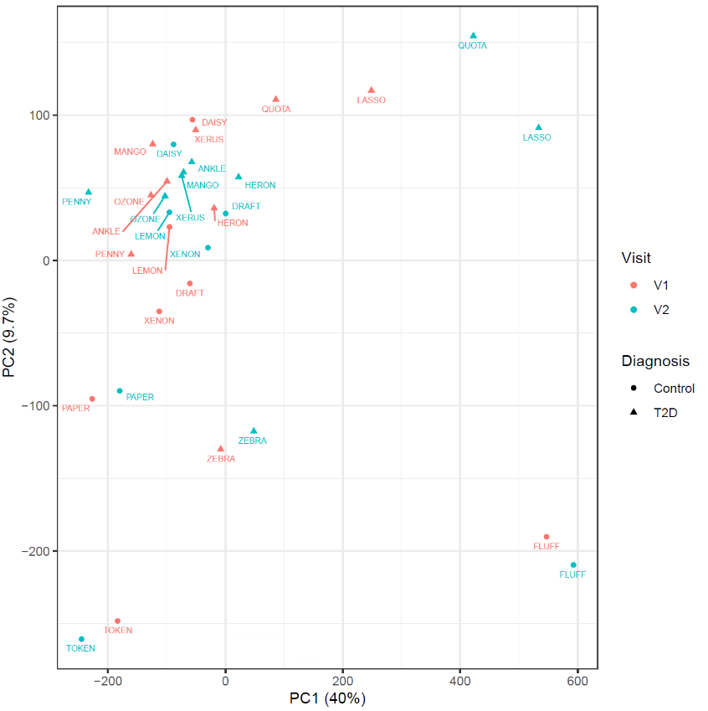

Figure S4. A. Q-Q plot for comparison of visit 1 vs. visit 2 sperm DNA methylation (left). Histograms of significance for paired comparison of sperm DNA methylation samples from visit 1 vs. visit 2, for P values (middle) and false discovery rates (right). B. Q-Q plot for comparison of men with T2D as compared with normoglycemia (left). Histograms of significance for comparison of sperm DNA methylation samples from men with T2D as compared with normoglycemia, for P values (middle) and false discovery rates (right).
- Paired comparisons (Visit 2 vs. Visit 1)

- Group comparison (T2D vs. control)

Figure S5. Top ranking pathways enriched in the comparison of genes adjacent to differentially methylated probes for control vs. T2D sperm. A. Molecular function ontology. B. Cellular component ontology. C. Biologic process ontology.
A.
B.

C.

Figure S6. Probe-specific differences in methylation at the ADAMTS16 locus in sperm from controls (n=7) and type 2 diabetes (n=9). 9 of 78 loci annotated to the ADAMTS16 locus had increased methylation in type 2 diabetes group relative to controls. *denotes FDR<0.05. X axis indicates genomic localization while Y axis indicates β value (range 0, indicating fully demethylated, to 1, indicating fully methylated).

Figure S7. Manhattan plot of differentially methylated loci in men with type 2 diabetes vs. controls. The X axis represents the chromosomal location of CpG probes, while the Y axis shows the –log10 of p values (Limma t-test). The horizontal threshold line indicates the significance level corresponding to FDR<0.05 (4.4 x 10⁻⁵).
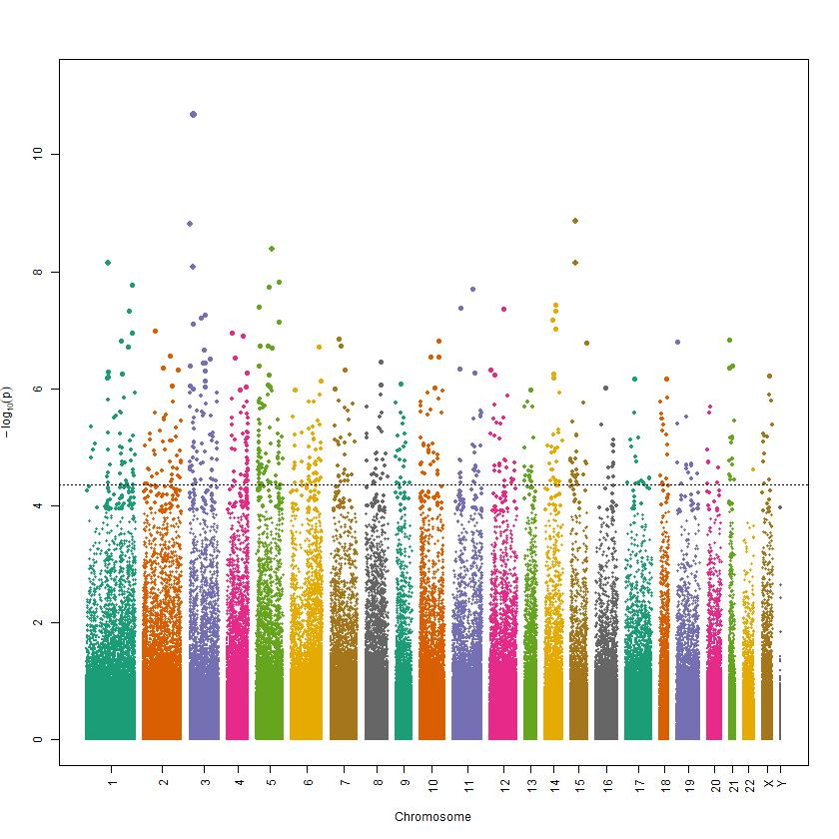

Figure S8. Heat map showing association between age and DNA methylation (M value, Z-scored log2) for top 25 probes. Rows are labeled by gene annotations for probe, while columns are ordered in pairs for each individual (V1, then V2 for each individual).

