Epigenetic editing and epi-drugs combination strategy to simultaneously target KDM4 as a novel anti-cancer approach
Federica Sarno ^{1,2}, Jim J. Jacob¹, Roos E. Eilers¹, Angela Nebbioso ^{2,4} Lucia Altucci ^{2,3,4}, Marianne G. Rots¹

Human (GRCh38/hg38)
# | Sequences | Target | Chr. | strand | start | end | TSS | CpG island
SgRNA(1)-KDM4A | AGTGGGCCGGTCCGGTAGAT | KDM4A | 1 | - | 43649855 | 43649874 | -288 | OUT
SgRNA(2)-KDM4A | CTCTAGCTGGATCGCGAAGC | KDM4A | 1 | - | 43649942 | 43649961 | -201 | OUT
SgRNA(3)-KDM4A | GAGTTTCGGCCTTCGCCTGC | KDM4A | 1 | + | 43650159 | 43650178 | +16 | IN
SgRNA(4)-KDM4A | GCGGCCGAGCTTCACTCGCCA | KDM4A | 1 | + | 43650493 | 43650513 | +351 | IN
SgRNA(5)-KDM4A | GATCGGCCAGTGGCGACAGC | KDM4A | 1 | + | 43650193 | 43650212 | +51 | IN
SgRNA(6)-KDM4A | ACATGCCGATCACTCACCGC | KDM4A | 1 | - | 43650351 | 43650370 | +208 | IN
SgRNA(1)-KDM4B | GCGGTTGGGGCGTTAACCGCC | KDM4B | 19 | + | 4969395 | 4969415 | +279 | IN
SgRNA(2)-KDM4B | GCGCTCGCGGGGGGGCTTATA | KDM4B | 19 | - | 4969086 | 4969106 | -30 | IN
SgRNA(3)-KDM4B | GAGGGACCCTAACTATTCCGA | KDM4B | 19 | + | 4968369 | 4968389 | -747 | OUT
SgRNA(4)-KDM4B | CGCCCGACGACCGCACAGAG | KDM4B | 19 | - | 4968745 | 4968764 | -371 | IN
SgRNA(5)-KDM4B | CGACATTAAGGGGTGCCGGC | KDM4B | 19 | - | 5131266 | 5131285 | +104 | OUT
SgRNA(1)-KDM4C | GAGGCCGCCATAGGTGCGCGT | KDM4C | 9 | + | 6757635 | 6757655 | -348 | IN
SgRNA(2)-KDM4C | GCGGGTACCGAACCTCGGTAA | KDM4C | 9 | - | 6758435 | 6758455 | +452 | IN
SgRNA(3)-KDM4C | GAGAAACGAGTTCAAGCGCG | KDM4C | 9 | + | 6756848 | 6756867 | -1135 | OUT
SgRNA(4)-KDM4C | CCGCCGTCTACACCGCATCA | KDM4C | 9 | - | 6758780 | 6758799 | +978 | IN
Supplementary Table 1. sgRNAs specific for KDM4A, KDM4B and KDM4C: sequences and chromosome position.
SgRNA_  KDM4A | MIT  Specificity score (for KDM4A) | CFD  Specificity score (for KDM4A) | Off target gene | Mismatches | Chromosome position |  | Distance from TSS | MIT  Off-score | CFD  Off-score
SgRNA_2 | 98 | 99 | RP11-334A14.8-SLC1A7 | 3 | chr1:53124489-53124511 | intergenic | 18.107 | 0.02 | 0.047
SgRNA_3 | 93 | 96 | Clostridiales-1-RP11-1094H24.4 | 3 | chr17:50046685-50046707 | intergenic | 9,389 | 0.11 | 0.00
SgRNA_4 | 96 | 97 | EGF-ELOVL6 | 3 | chr4:110032467-110032489 | intergenic | 166,018 | 1.01 | 0.41
SgRNA_4 | 96 | 97 | PACRG-RP1-257A15.1 | 3 | chr6:162896290-162896312 | intergenic | 168,278 | 0.08 | 0.17
SgRNA_4 | 96 | 97 | PLCB1-PLCB1-IT1 | 3 | chr20:8205360-8205382 | intergenic | 73,082 | 0.31 | 0.018
SgRNA_5 | 88 | 95 | AC021224.1-GAREM | 2 | chr18:32422907-32422929 | intergenic | 47,944 | 0.75 | 0.18
SgRNA_5 | 88 | 95 | RP11-18B16.2-AL157702.1 | 2 | chr9:113690185-113690207 | intergenic | 39,449 | 0.74 | 0.079
SgRNA_5 | 88 | 95 | RN7SL308P-ZNF704 | 3 | chr8:80785624-80785646 | intergenic | 89,078 | 0.31 | 0.02
SgRNA_5 | 88 | 95 | XX-FYM637E10_5.1-PPP2R2D | 2 | chr10:131859323-131859345 | intergenic | 16,319 | 0.27 | 0.00
SgRNA_5 | 88 | 95 | PTCHD2-RP1-69M21.2-DISP3 | 3 | chr1:11563783-11563805 | intergenic | 84,621 | 1.7 | 0.18
SgRNA_5 | 88 | 95 | LINC00959 | 3 | chr10:130110736-130110758 | Exon | 50 | 0.3 | 0.014
SgRNA_6 | 94 | 99 | GADD45B-RNU6-993P | 3 | chr19:2494038-2494060 | intergenic | 17,904 | 0.49 | 0.009
Supplementary Table 2. sgRNAs specific for KDM4A off-targets and chromosome position.

Target gene | Sequences | Forward/Reverse
KDM4A | GAACCTGTGCGCGATTCCTG | FW
KDM4A | CCTAGCACTGGGATTCAGAGTT | RW
KDM4B | TGACATCAGGCCCTCTTTGT | FW
KDM4B | TACCAGGACTTAGGCTCCCC | RW
KDM4C | GGAAGACCACGTTTGCATGG | FW
KDM4C | GCCTCCTGGGTTATCTTGTCA | RW
GAPDH | CCACATCGCTCAGACACCAT | FW
GAPDH | GCGCCCAATACGACCAAAT | RW
Supplementary Table 3. List of primer sequences

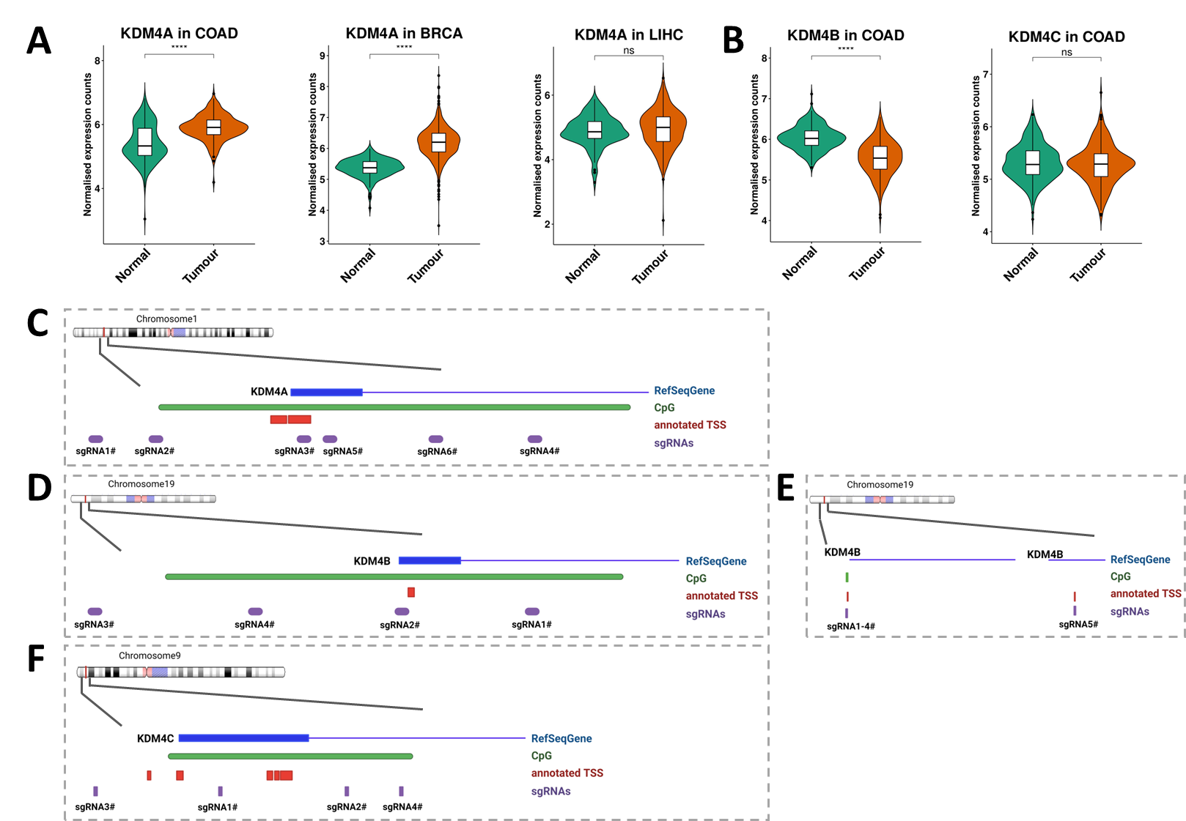
Supplementary Figure 1. (A) KDM4A gene expression online database in colon adenocarcinoma (COAD), breast invasive carcinoma (BRCA) and liver hepatocellular carcinoma (LIHC) compared to normal samples; (B) KDM4B and KDM4C gene expression online database in colon adenocarcinoma (COAD) compared to normal samples; (C-F) KDM4-A/B/C sgRNAs targeting KDM4A or KDM4B or KDM4C promoter regions. Close to the annotated TSS (in red) and the CpG islands (in green), six sgRNAs were designed for (C) KDM4A, five for (D-E) KDM4B ((D) four close the TSS1 (left) and (E) one on TSS2 (right)) and (F) four for KDM4C. In blue is showed the promoter gene and gene body.
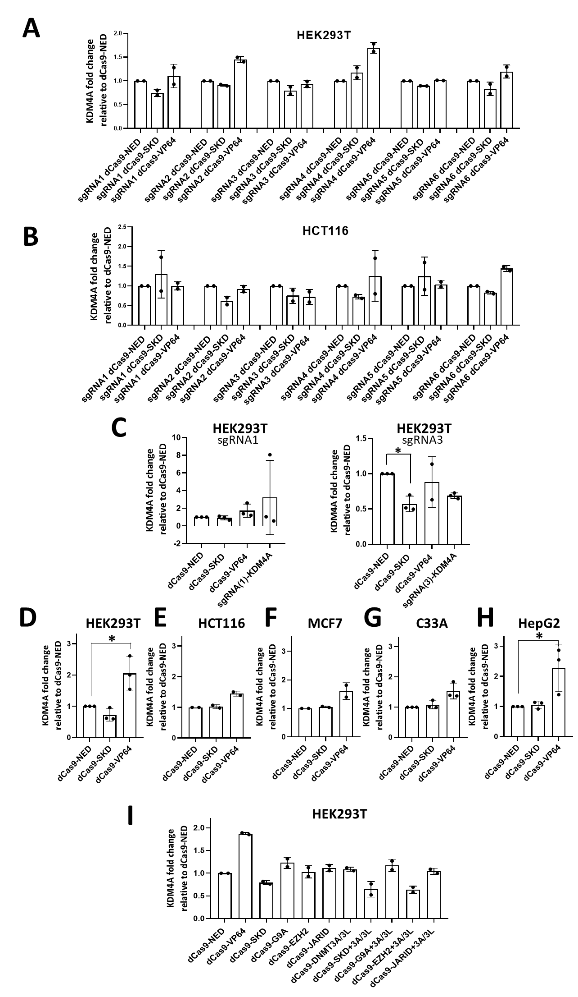
Supplementary Figure 2. Validation of KDM4A gene expression modulation by epi-editing in (A) HEK293T and (B) HCT116 using single sgRNA; (C) KDM4A gene expression in (left) sgRNA(1)-KDM4A and (right) sgRNA(3)-KDM4A HEK293T stable cells after 48 h of dCas9-NED, dCas9-SKD, and dCas9-VP64 transient transfected. KDM4A gene expression modulation using mix of sgRNA-KDM4A in (D) HEK293T, (E) HCT116, (F) MCF7, (G) C33A and (H) HepG2 cells for dCas9-SKD and dCas9-VP64 compared to dCas9 without an effector domain (NED); (I) KDM4A gene expression modulation in HEK293T cells, 48 h after transfection, using sgRNA-KDM4A and dCas9-G9A (H3K9me1/me2 writer), or dCas9-EZH2 (H3K27me3 writer), or dCas9-JARID (H3K4me3/me2 eraser), or dCas9-DNMT3A/3L (writer of DNA methylation) alone or in combination.
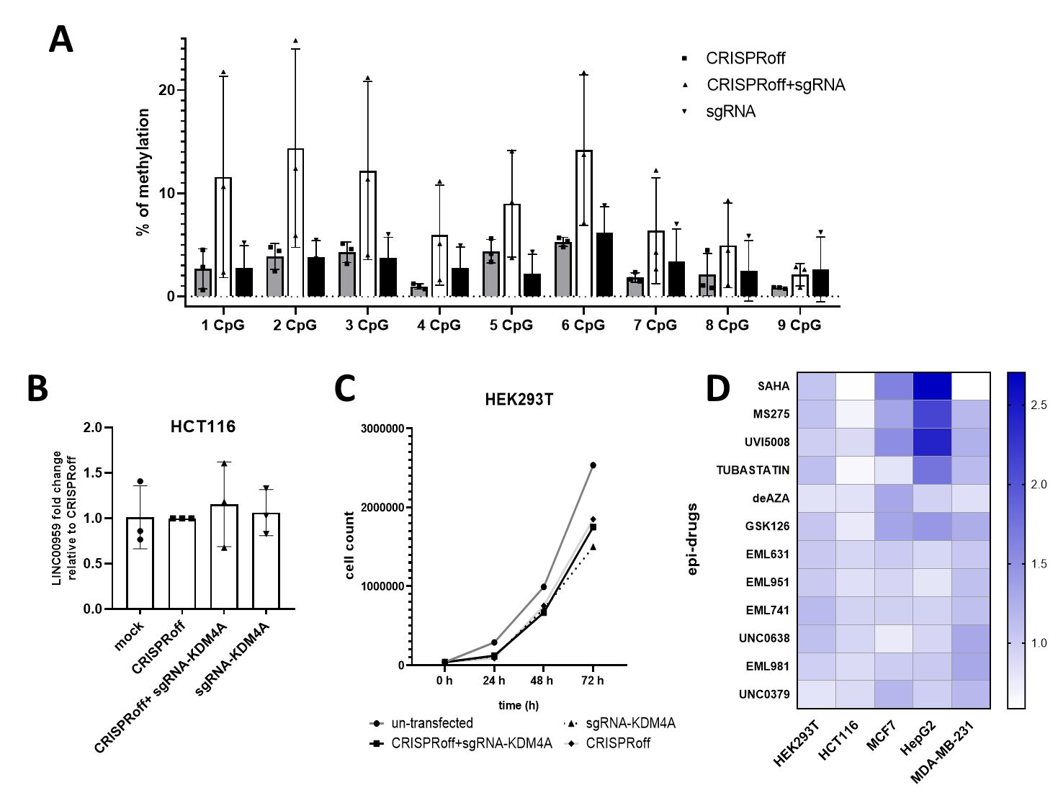
Supplementary Figure 3. (A) DNA methylation profile of analysed KDM4A promoter region (chr1:43,649,905–43,650,085), in HCT116 cells 3 days post-transfection; (B) LINC00959 gene expression modulation using CRISPRoff+sgRNA-KDM4A. CRISPRoff and sgRNA-KDM4A transfected alone, and mock transfected cells (cells transfected with empty MLM3636) were used as controls; (C) Proliferation assay in HEK293T cells upon epi-editing downregulating KDM4A. The dark grey line (symbol: circle) shows the un-transfected cells, the black line (symbol: square) shows the cells transfected with CRISPRoff and sgRNA-KDM4A, in the dashed line (symbol: triangle) the cell transfected only with sgRNA-KDM4A, in light grey (symbol: rhombus) the cells only with CRISPRoff; (D) KDM4A expression in HEK293T, HCT116, MCF7, HepG2, and MD-MB-231 cells after treatment with 12 epi-drugs: HDACs inhibitors (SAHA, MS275, UVI5008, and TUBASTATIN); DNMTs inhibitor (deAZA); EZH2 inhibitor (GSK126); Spindlin-1 inhibitor (EML631); MRG15 inhibitor (EML951); G9a inhibitors (EML741, and UNC0638); CARM-1 inhibitor (EML981); SETD8 (UNC0379) (data represent the mean of two independent experiments).

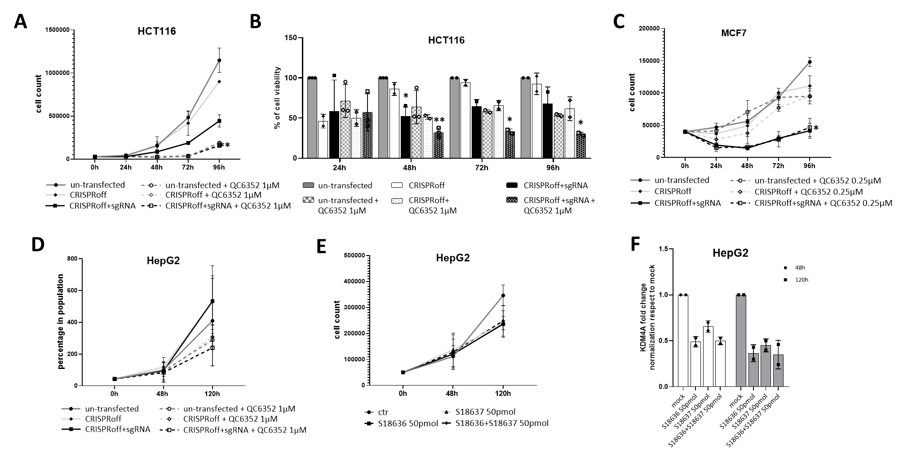
Supplementary Figure 4. Proliferation assay in (A) HCT116, (C) MCF7 and (D) HepG2 cells with/without sgRNA-KDM4A (sgRNA) and CRISPRoff treated with QC6352 at (A,D) 1µM, and (C) 0.25µM or DMSO; (B) MTS assay in HCT116 with/without sgRNA-KDM4A and CRISPRoff treated with QC6352 at 1µM or DMSO. The dark grey lines and bars show the un-transfected cells (symbol: circle), in light grey the cells only with CRISPRoff (symbol: rhombus), in black the cells transfected with CRISPRoff+ sgRNA-KDM4A (symbol: square). The solid lines and bars represent the cells only transfected with epi-editing, and the dashed lines and bars, the cells treated with QC6352 24h after transfection; (E) Proliferation assay in HepG2 transfected with KDM4A or siRNA S18636 target exons 15-16 (black line, symbol square), or siRNA S18637 target exons 19 (light grey line, symbol triangle) or both (black dashed line, symbol circle); (F) KDM4A gene expression in HepG2 transfected with or siRNA S18636 or siRNA S18637 or both for 48 h (white) and 120 h (grey).

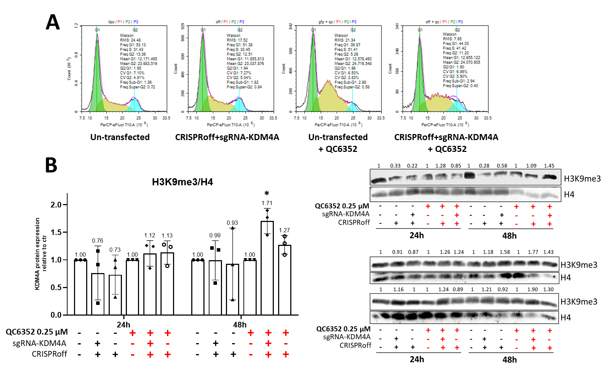
Supplementary Figure 5. (A) HCT116 cell cycle with/without CRISPRoff+sgRNA-KDM4A treated with QC6352 at 1µM or DMSO; (B) Western blot H3K9me3 and H4 in HCT116 with/without CRISPRoff+sgRNA-KDM4A treated with QC6352 at 0.25µM for 24h and 48h or DMSO. On the left, the graph showed the average of blots quantization, obtained with ImageJ.

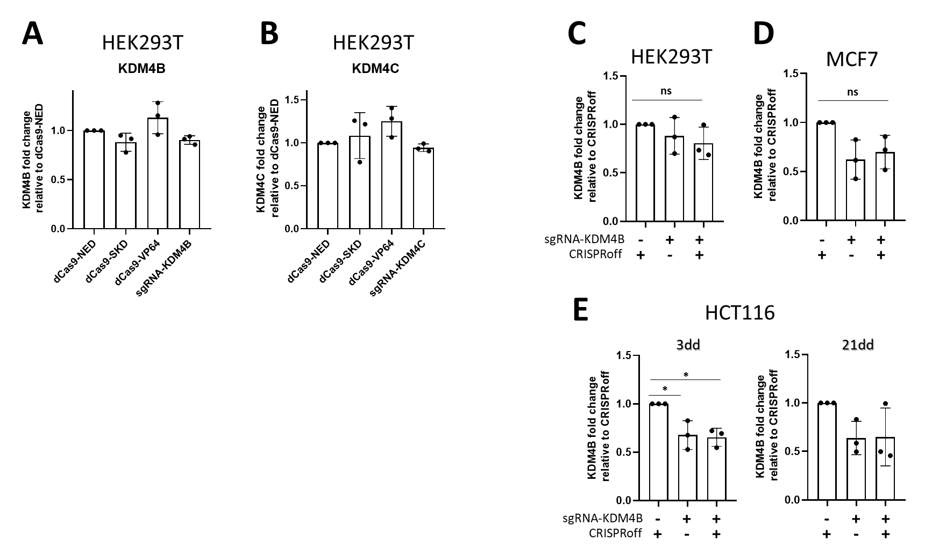
Supplementary Figure 6. (A) KDM4B and (B) KDM4C gene expression modulation by epi-editing in HEK293T 48h after transfection; (C-D) KDM4B gene expression reduction by epi-editing in (C) HEK293T and (D) MCF7 3 days after CRISPRoff + sgRNA-KDM4B transfection; (E) KDM4B gene evaluation in HCT116 after 3 and 21 days after CRISPRoff+sgRNA-KDM4B transfection.

