FigureS1
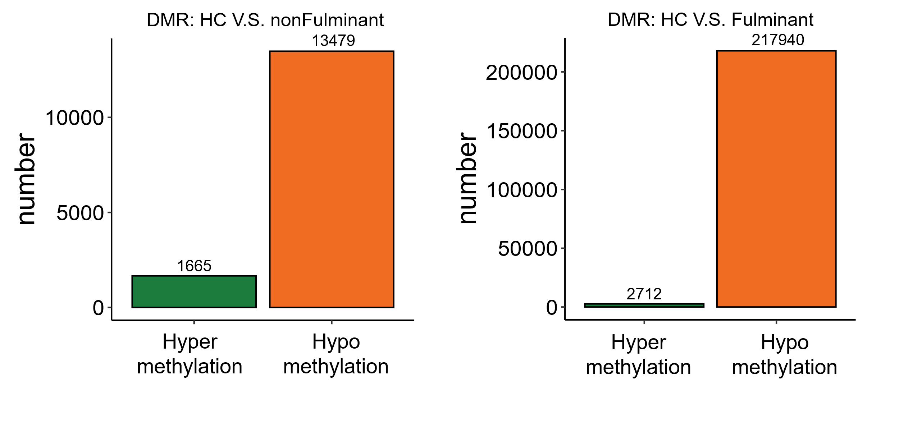Methylation status of DMRs (Healthy control : nonFulminant : Fulminant = 20:14:10).

FigureS2
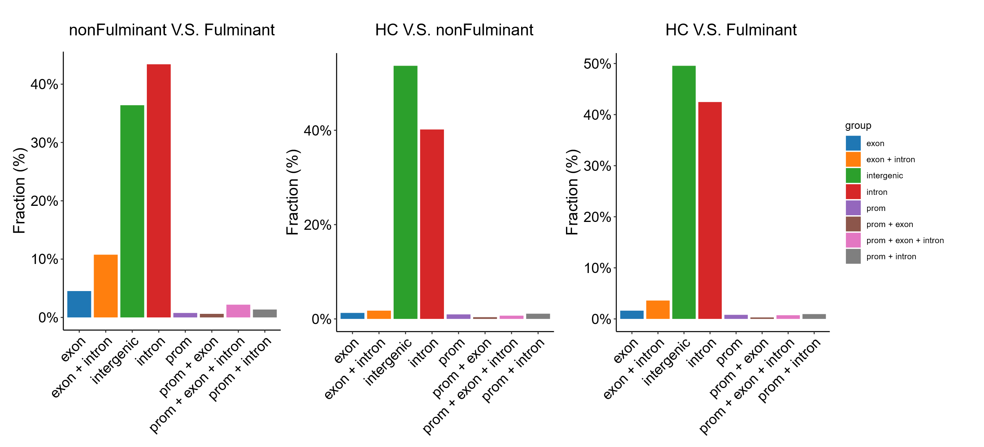
The distribution of DMR on chromosomes (Healthy control : nonFulminant : Fulminant = 20:14:10).

FigureS3
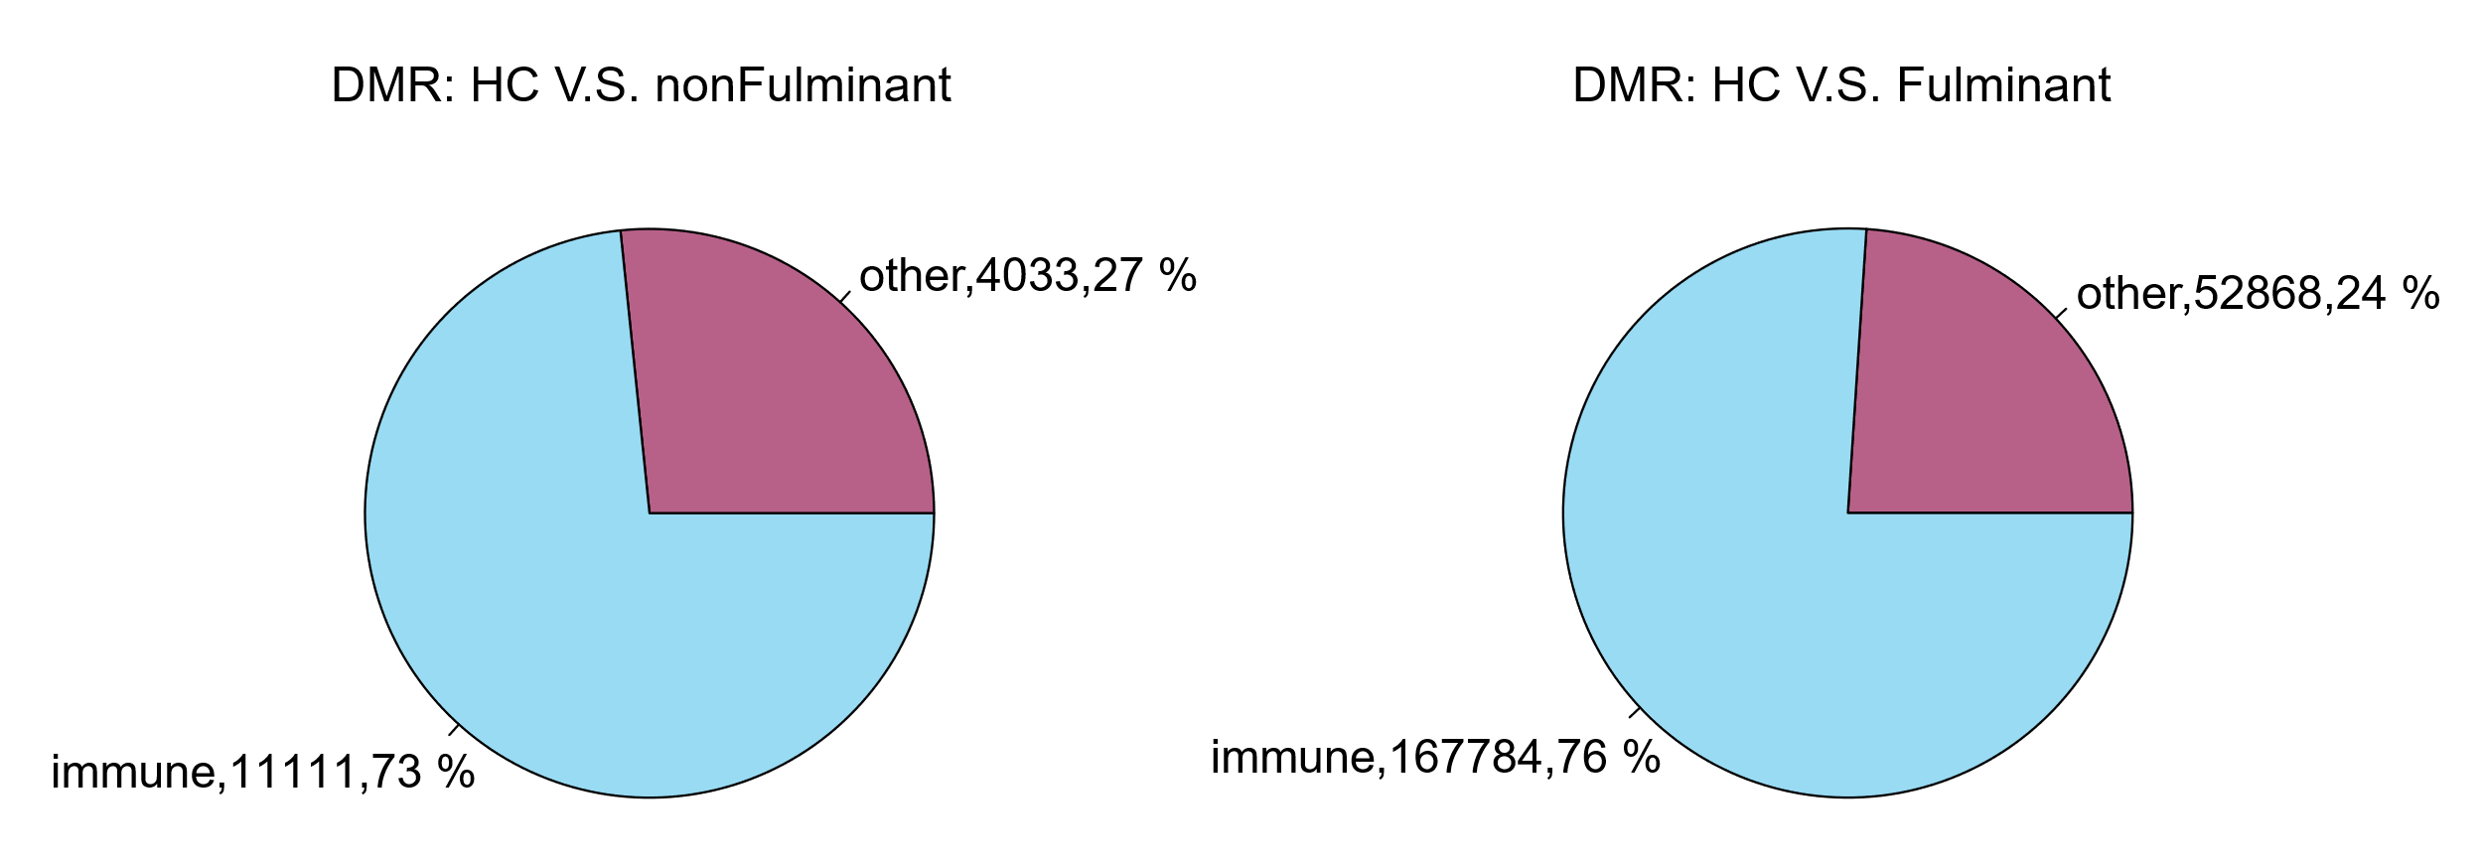
The function proportion of DMR (Healthy control : nonFulminant : Fulminant = 20:14:10).

FigureS4
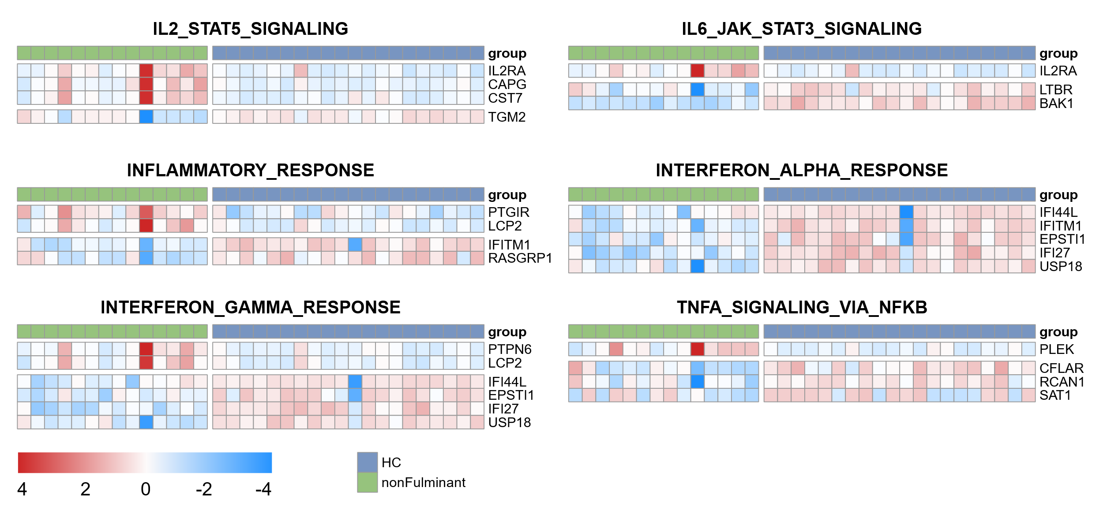
Methylation status of promoter regions of genes associated with various immune pathways (in the heat map, red indicates high methylation, blue indicates low methylation, Healthy control : nonFulminant = 20:14).

FigureS5
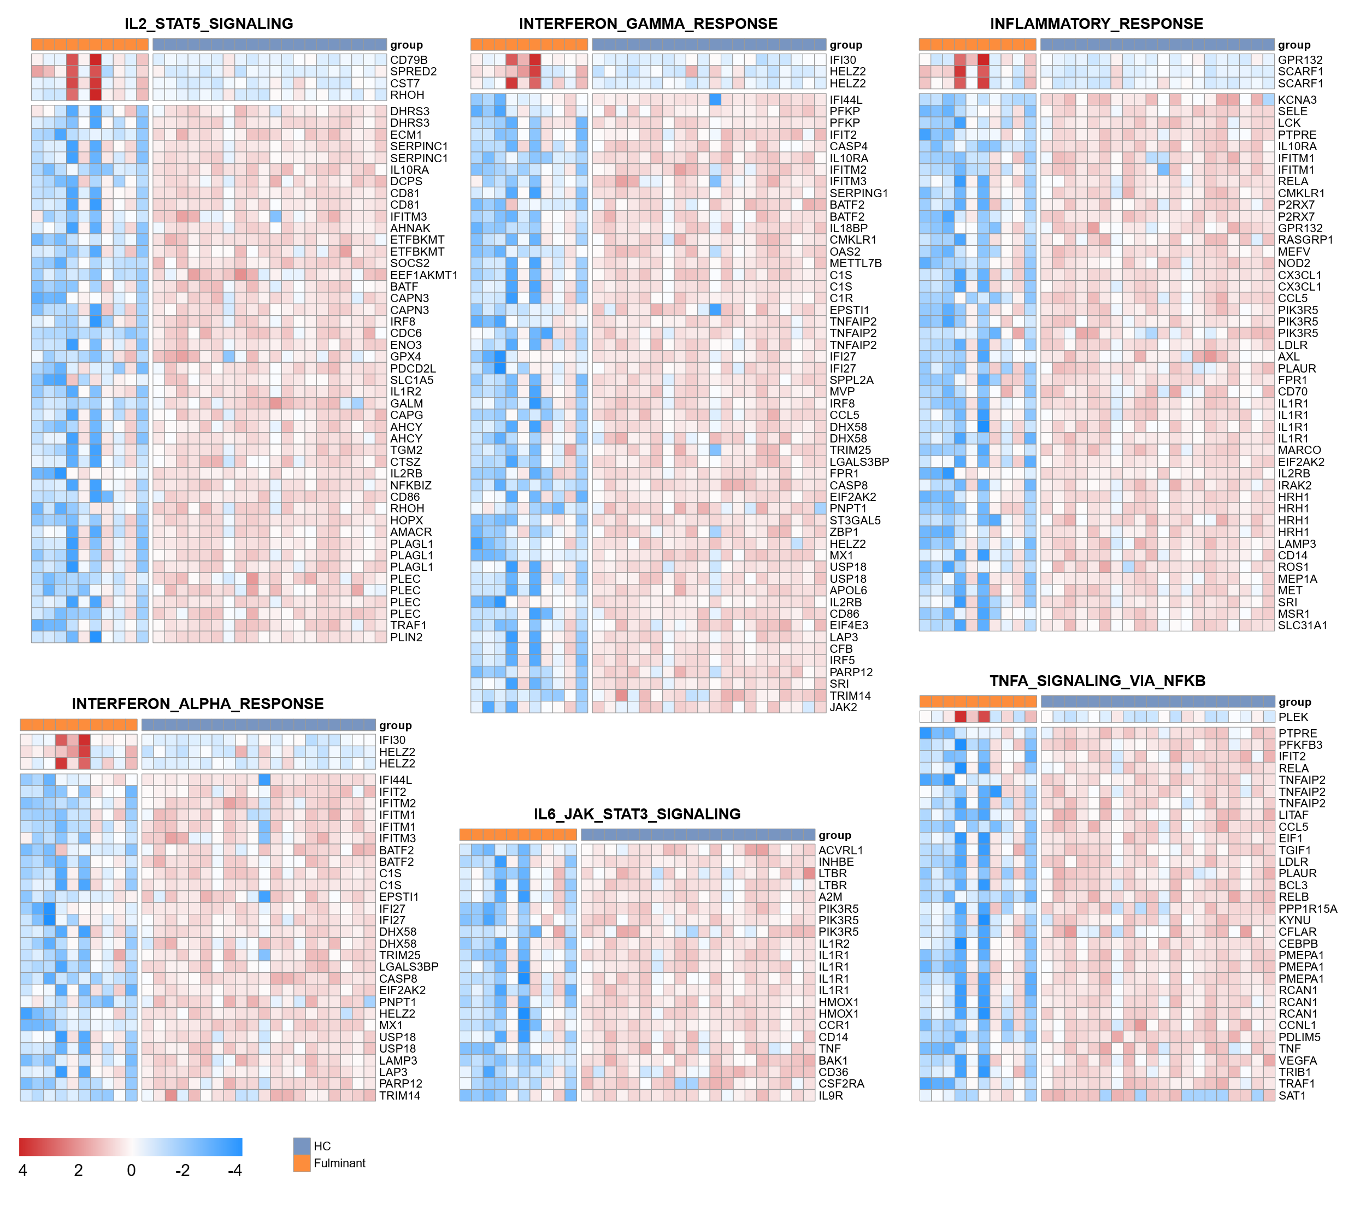
Methylation status of promoter regions of genes associated with various immune pathways (in the heat map, red indicates high methylation, blue indicates low methylation, Healthy control : Fulminant = 20:10).

FigureS6
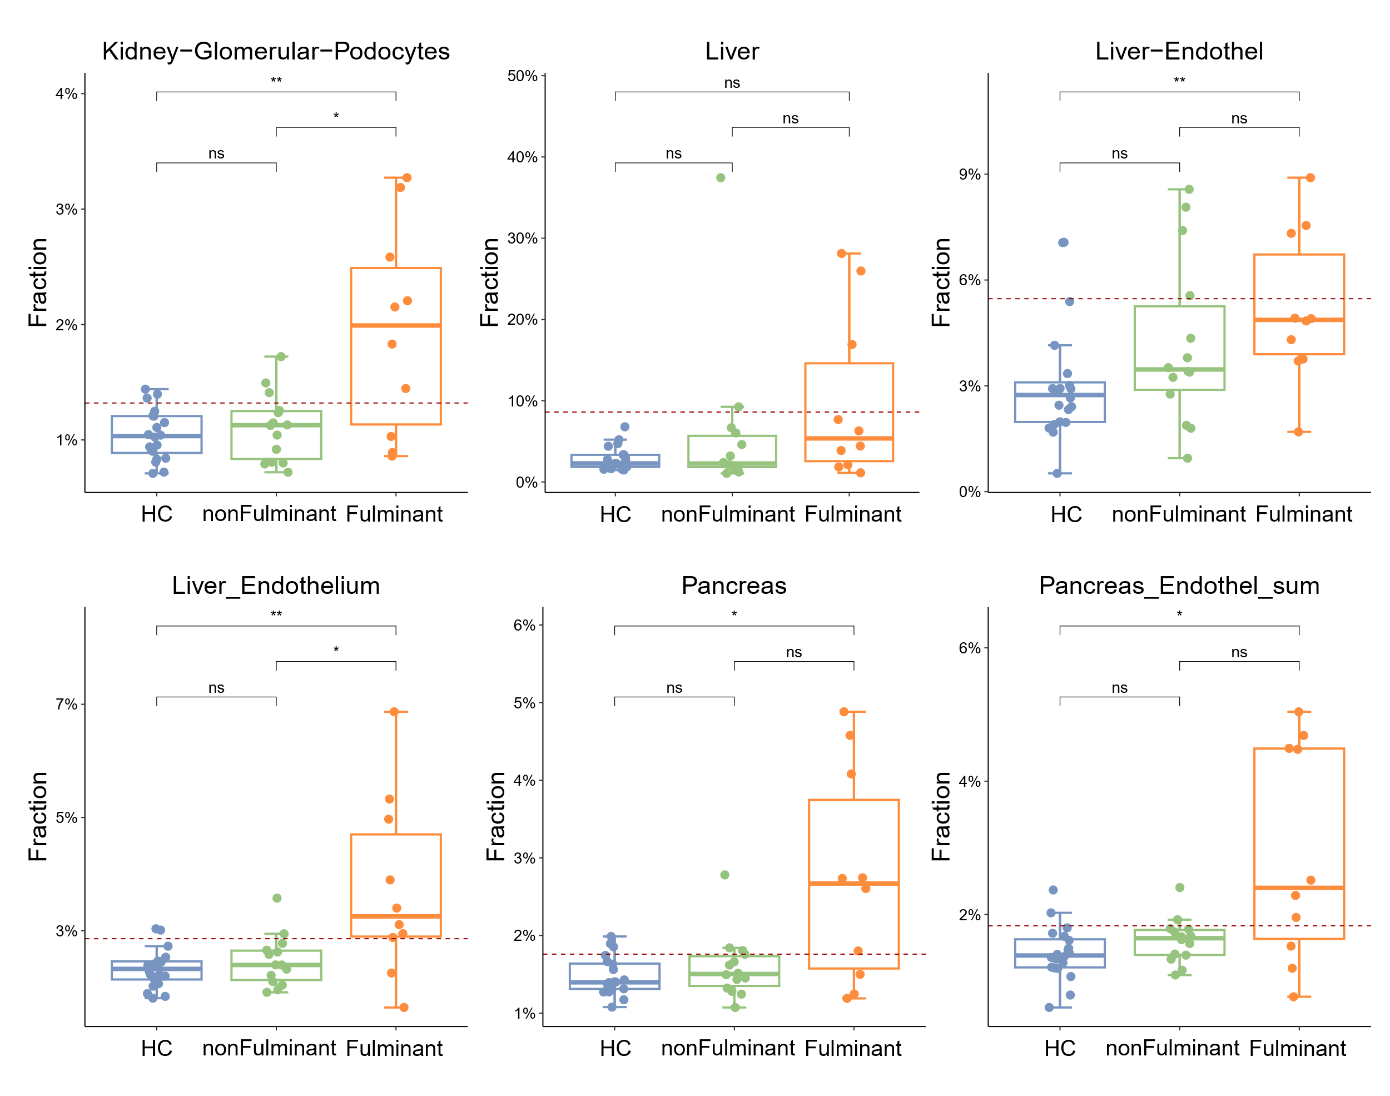
Analysis of cfDNA released from other organs or cells in healthy controls and patients with fulminant and nonfulminant myocarditis (Healthy control : nonFulminant : Fulminant = 20:14:10).

FigureS7
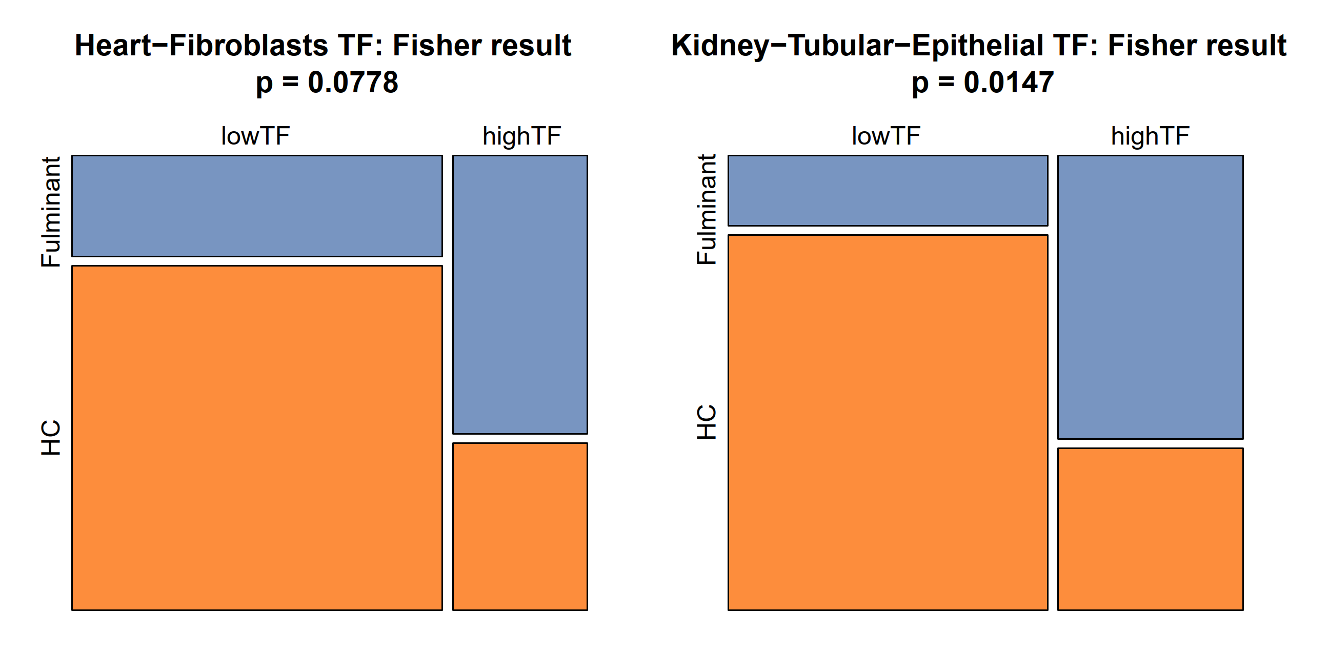
Fisher test results for cfDNA released from cardiac fibroblasts and renal tubular epithelial cells in healthy controls and patients with fulminant myocarditis (Healthy control : Fulminant = 20:10).

FigureS8
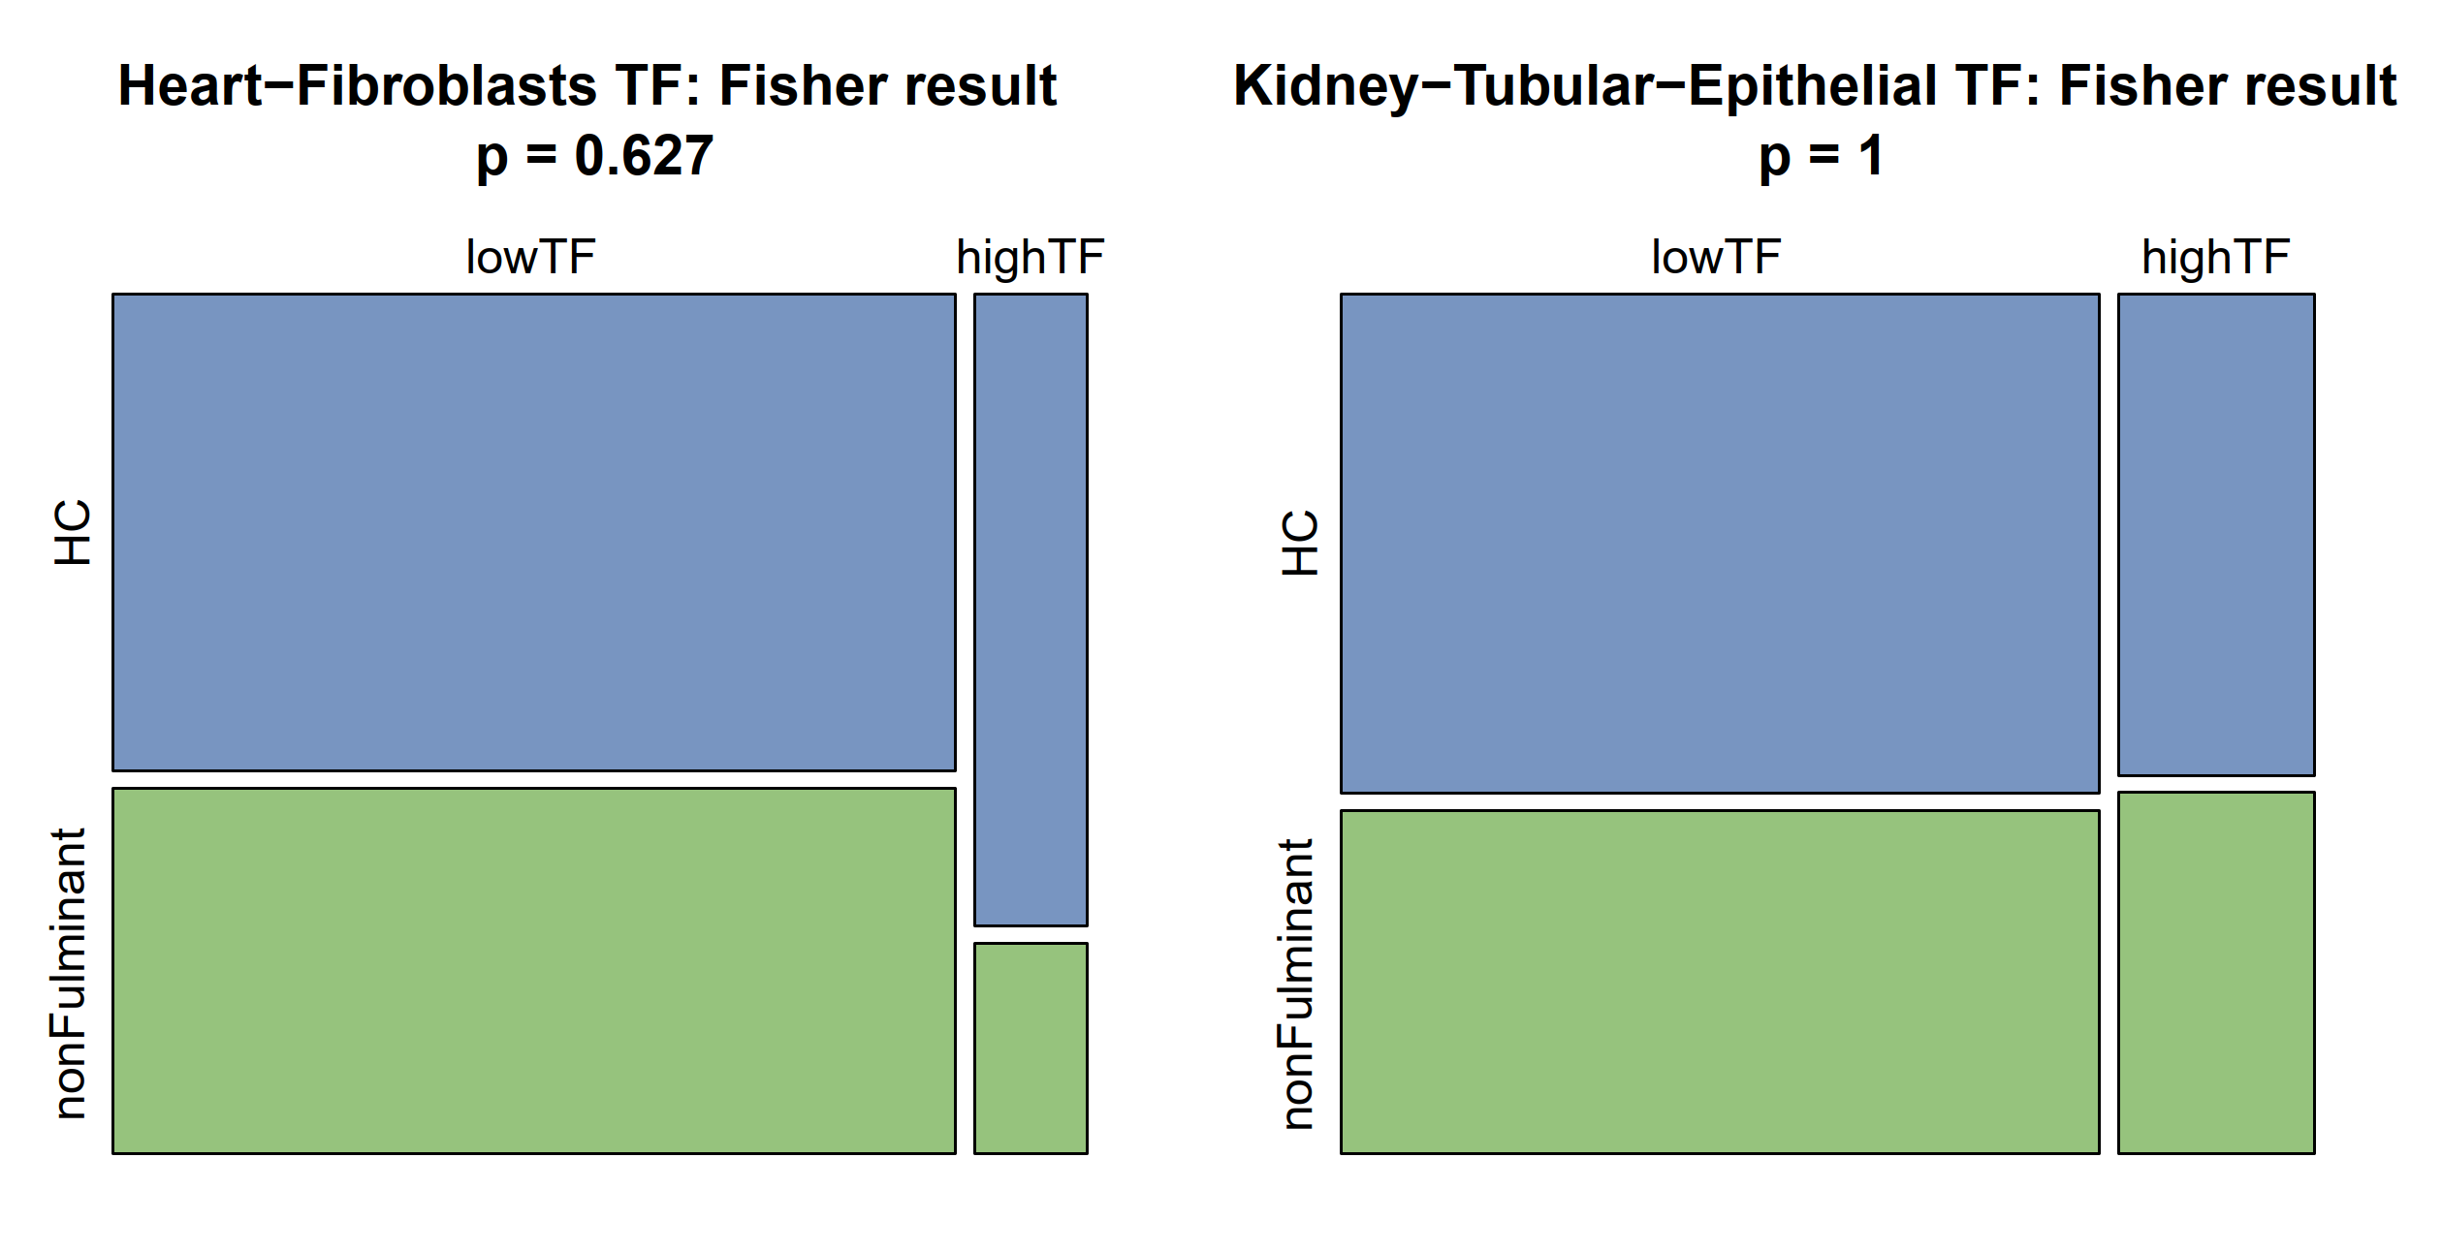
Fisher test results for cfDNA released from cardiac fibroblasts and renal tubular epithelial cells in healthy controls and patients with nonfulminant myocarditis (Healthy control : nonFulminant = 20:14).

FigureS9
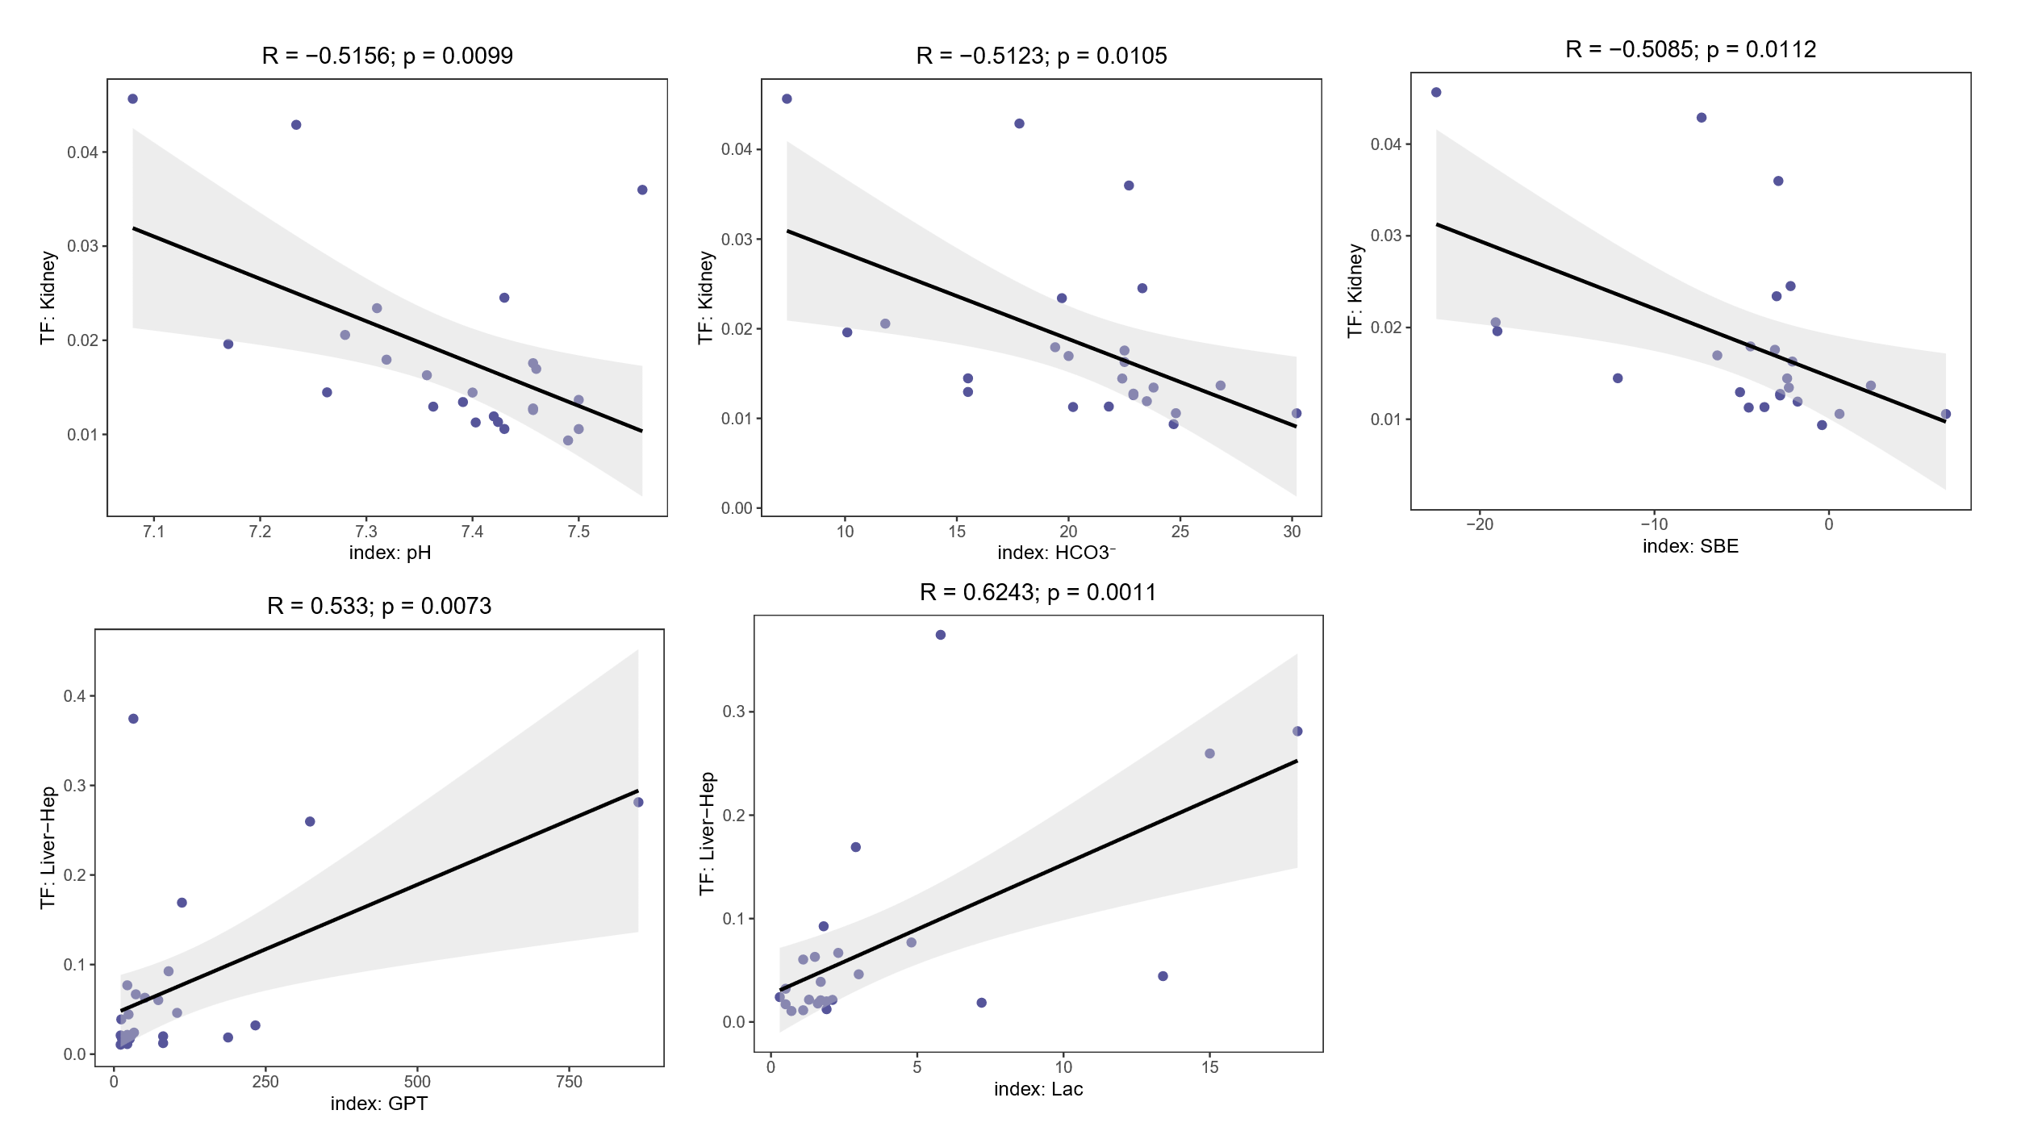
Correlation between cfDNA released from renal and hepatic cells and clinical indicators (nonFulminant : Fulminant =13:10).

FigureS10
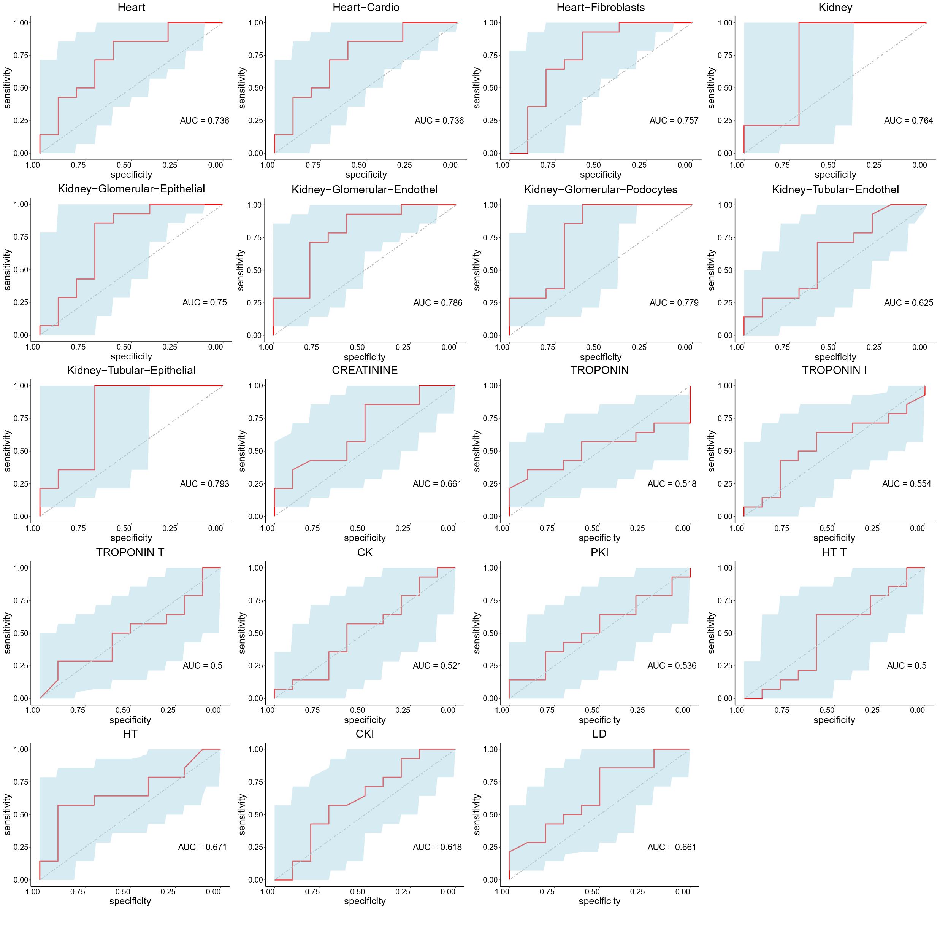
ROC for distinguishing between fulminant (n=10) and non-fulminant myocarditis (n=13) patients using cfDNA released from cardiac, renal, and their cellular origins and traditional clinical indicators.

FigureS11
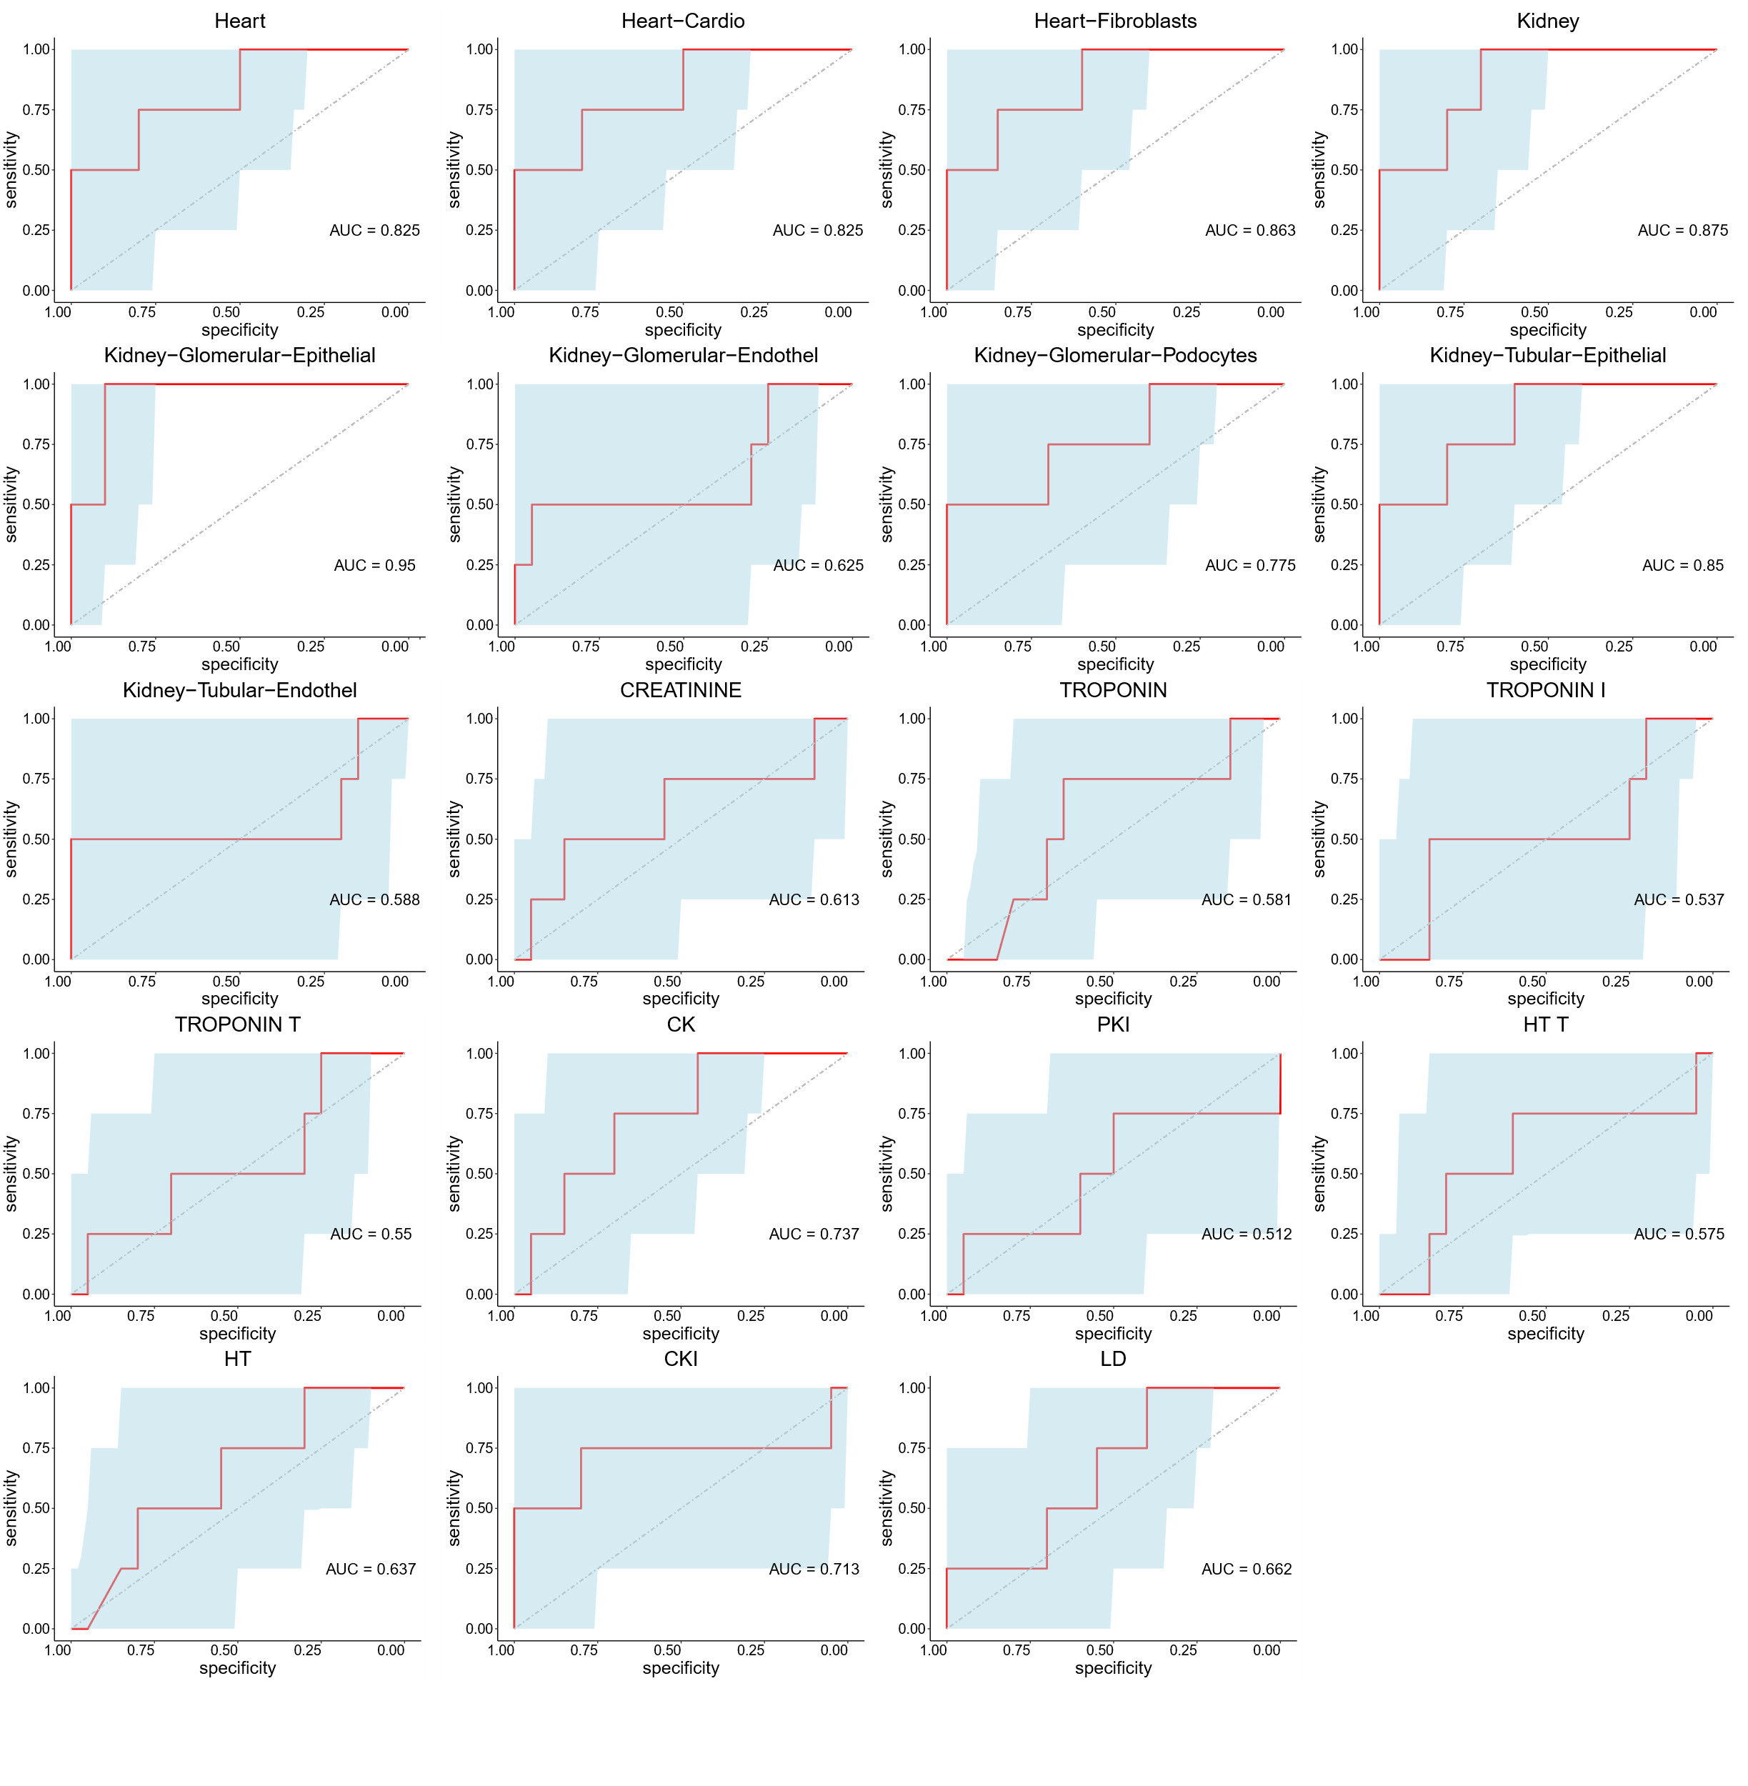
ROC for distinguishing clinical outcomes of survival (n=19) or death (n=4) using cfDNA released from cardiac, renal, and their cellular origins and traditional clinical indicators.

FigureS12
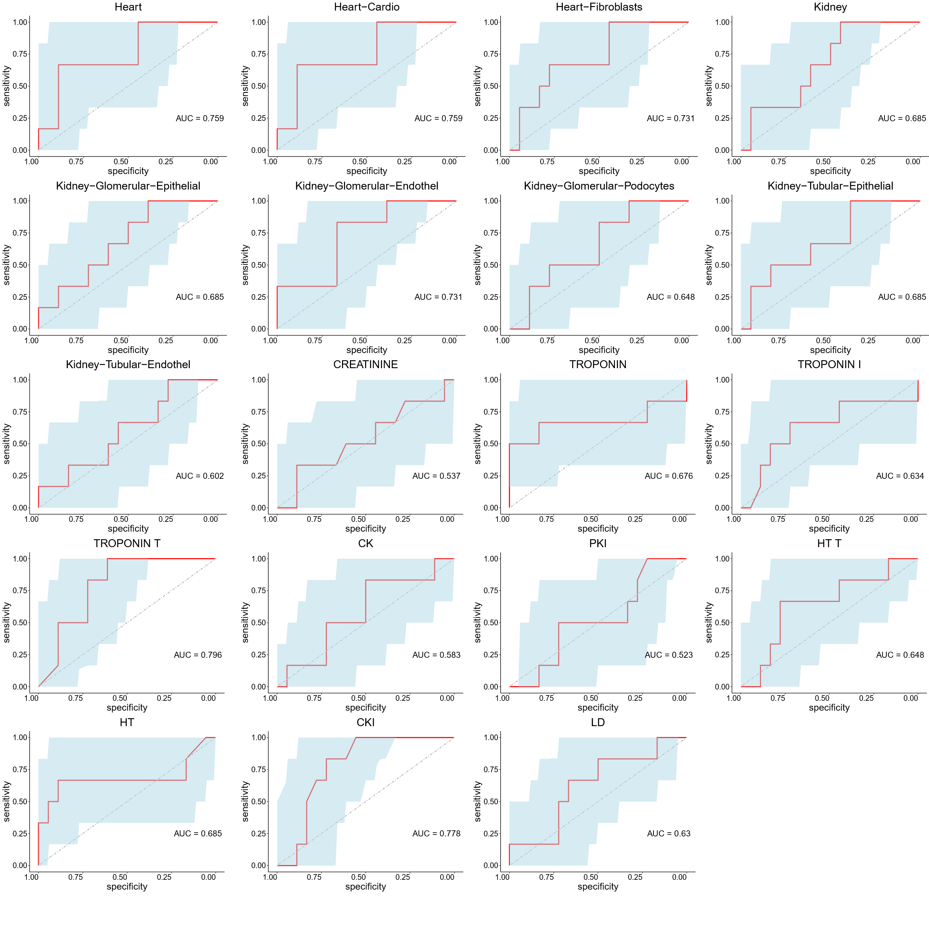
ROC for distinguishing ICU support required (n=17) from ICU support not required (n=6) using cfDNA released from cardiac, renal, and their cellular origins and traditional clinical indicators.

FigureS13
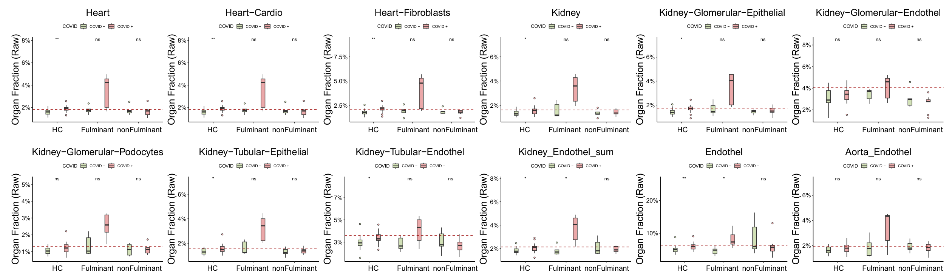
Analysis of cfDNA released from different organs and cells in the healthy control group, fulminant myocarditis group and clinically suspected myocarditis group from the perspective of COVID-19 positivity (healthy control COVID positive : COVID negative = 10:10, fulminant myocarditis COVID positive : COVID negative = 5:5, clinically suspected myocarditis COVID positive : COVID negative = 9:5). P values were calculated by two-sided Wilcoxon rank sum test. * P <0.05; ** P < 0.01

