In our enrolled cohort, there was no statistically significant difference in the prevalence of diabetes between the fulminant and nonfulminant myocarditis groups. However, patient age (p = 0.013) and treatment status at the time of sampling (p = 0.024) differed significantly between groups (Table 1).

To address this issue, we performed the following analysis: using nearest-neighbor matching, we conducted a propensity score–matched (PSM) analysis based on age and treatment status. A total of 10 matched samples (5 from each group) were selected for exploratory comparison.

1. As shown in Figure PSM-1, after matching, there was no statistically significant difference in age between the fulminant myocarditis and nonfulminant myocarditis groups (p = 0.21).
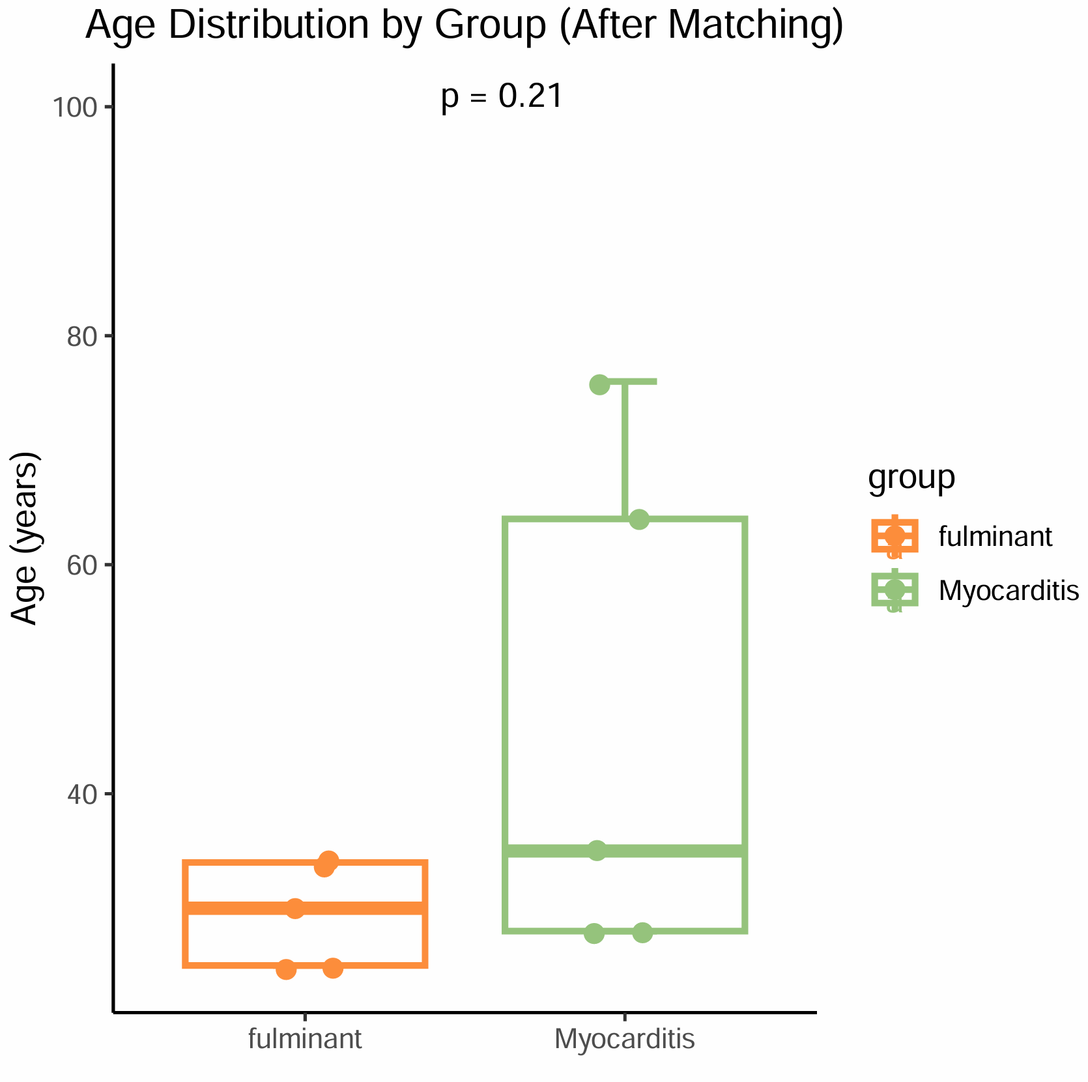
Figure PSM-1

2. Among these matched patients, the total cfDNA levels remained significantly different between groups, with fulminant myocarditis patients exhibiting significantly higher cfDNA release compared to those with nonfulminant myocarditis (Figure PSM-2), corresponding to Figure 2A in the main text.
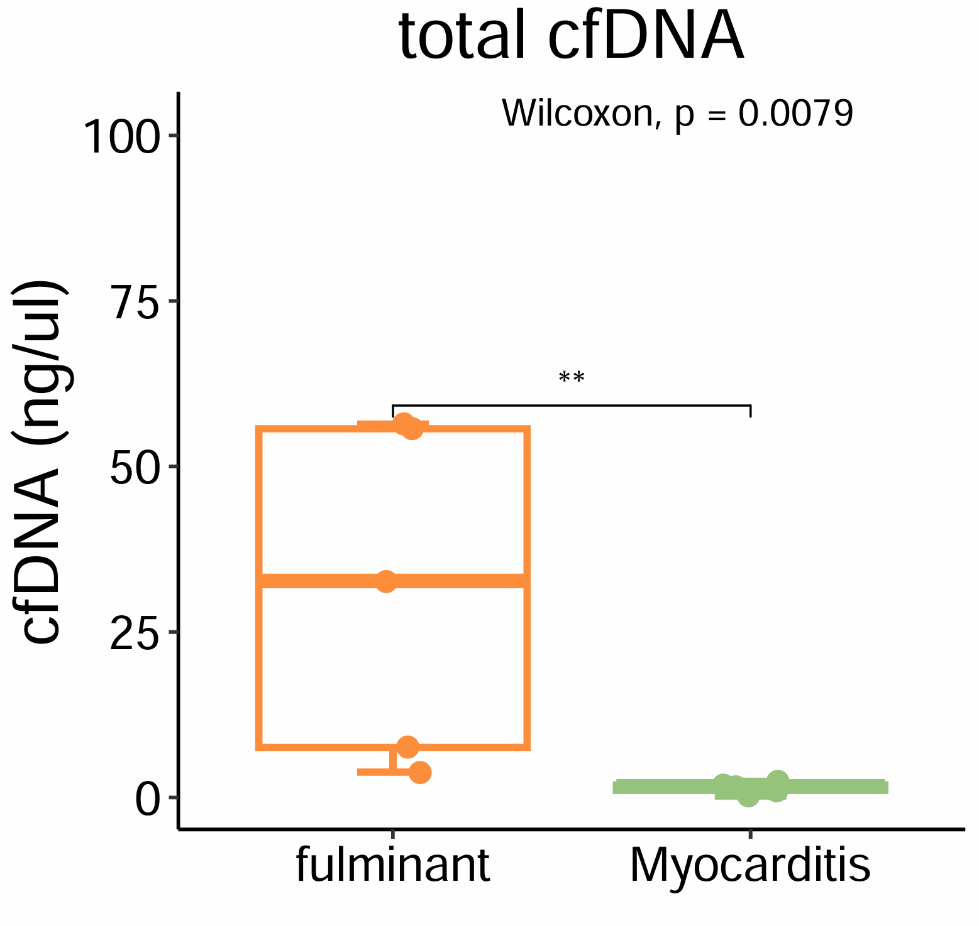
Figure PSM-2

3. Among these patients, cfDNA release from cardiac sources (cardiomyocytes and cardiac fibroblasts) and renal sources (glomerular epithelial and tubular epithelial cells) was higher in fulminant myocarditis patients compared to those with nonfulminant myocarditis. However, due to the limited sample size (5 patients per group), these differences did not reach statistical significance (Figure PSM-3), corresponding to Figure 2B in the main text.
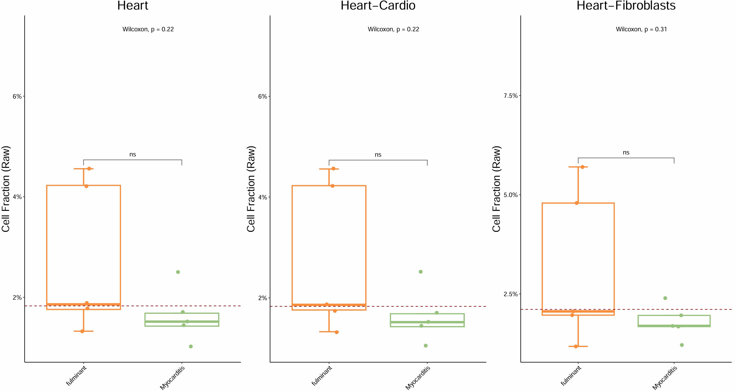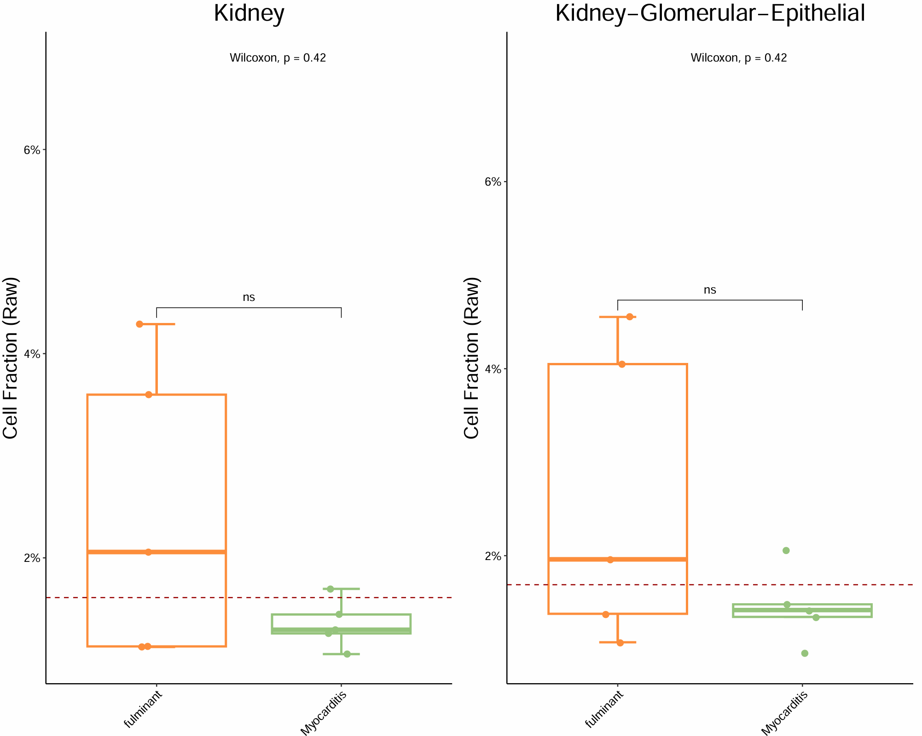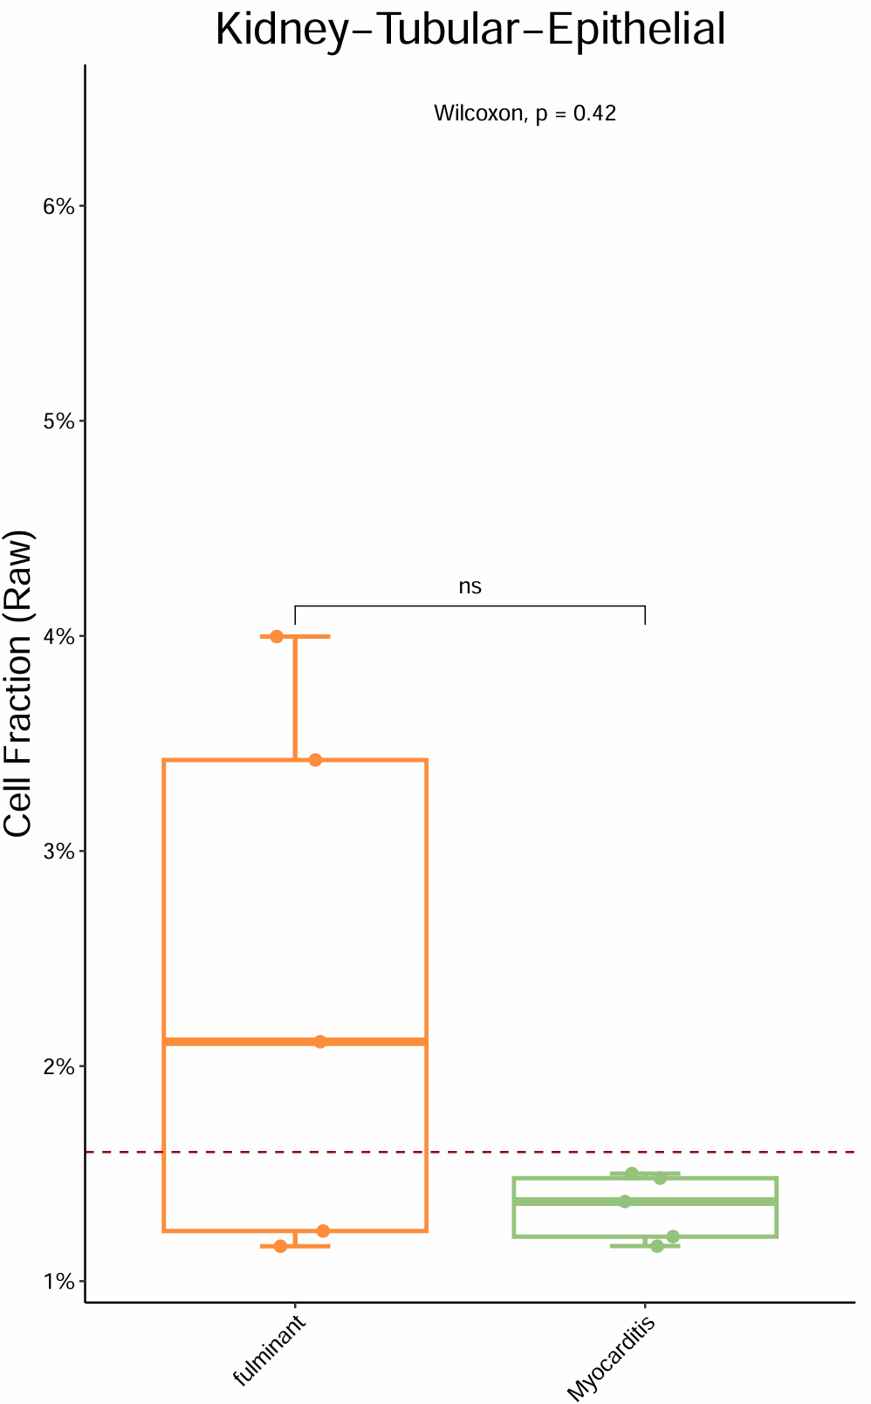
Figure PSM-3

4. Among these patients, cfDNA release from cardiac (cardiomyocytes and cardiac fibroblasts) and renal (glomerular and tubular epithelial cells) sources demonstrated the ability to differentiate between fulminant and nonfulminant clinical presentations (Figure PSM-4), was associated with in-hospital mortality (Figure PSM-5), and correlated with ICU admission status (Figure PSM-6), corresponding to Figure 3 and Figures S4–S6 in the main text.
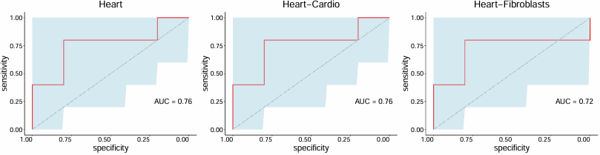
Figure PSM-4 ROC: Fluminant VS Myocarditis

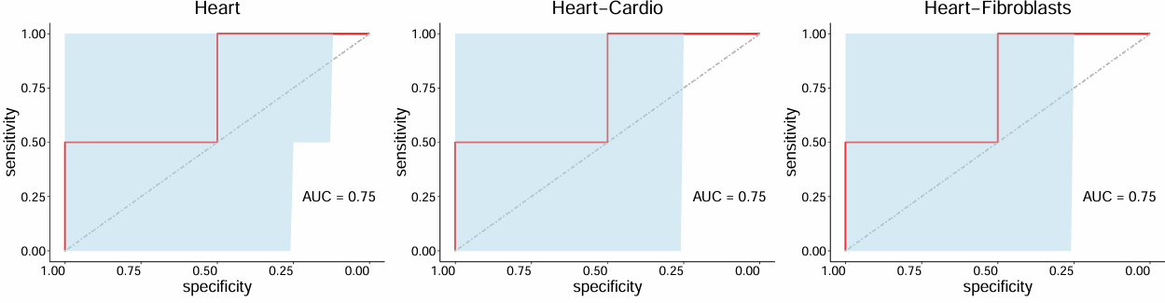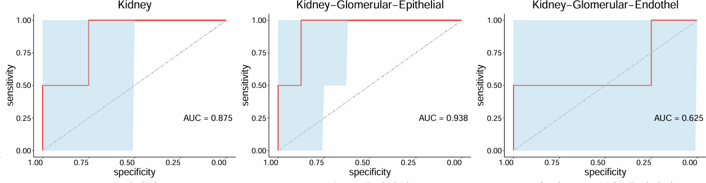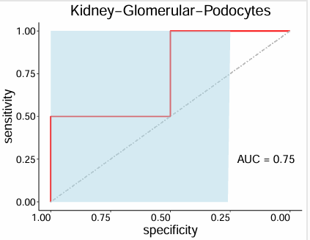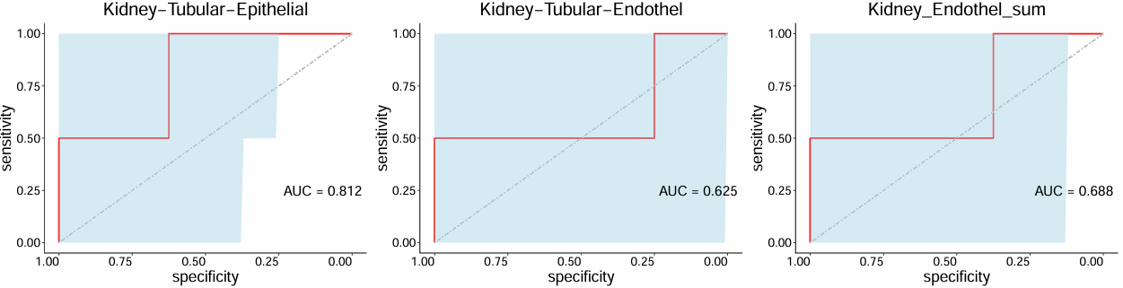
Figure PSM-5 ROC: Alive VS Death

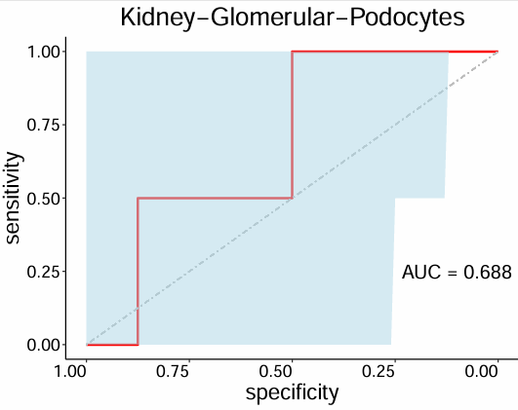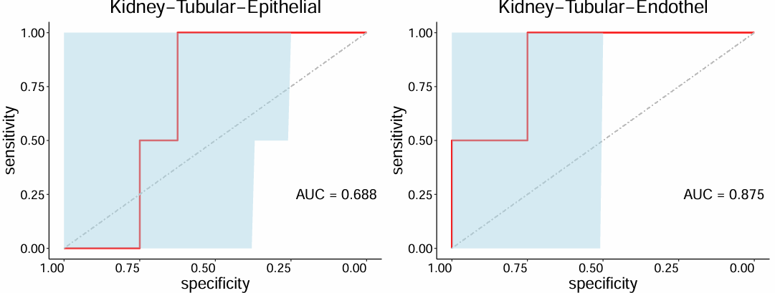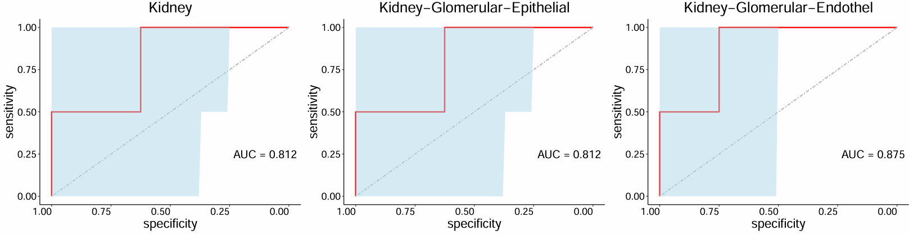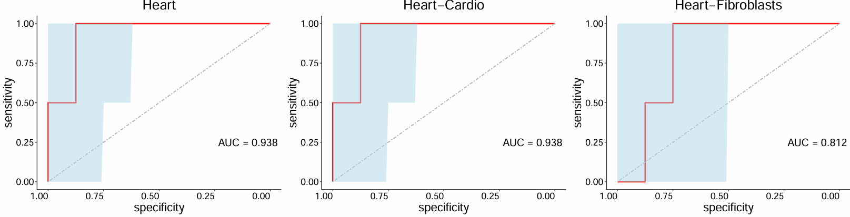
Figure PSM-6 ROC: ICU VS non ICU

In summary, after accounting for the effects of patient age and treatment status, we still observed more pronounced cardiac and renal injury in patients with fulminant myocarditis. Furthermore, cfDNA derived from cardiac and renal sources showed potential utility in stratifying patients by disease severity and clinical outcomes.

