Supplemental Information

Methods
DAA treatment
Regimens: SOF 400 mg/VEL 100 mg daily (n = 16/36.3%); SOF 400 mg/LED 90 mg daily (n = 8/18.18); ELB 50 mg/GRA 100 mg, daily (n = 10/22.7%); or OMB 12.5 mg/PAR 75 mg/RIT 50 mg daily (n = 3/6.8%), SOF 400 mg/VEL 100 mg daily plus ribavirin calculated by weight (n = 4/9.0%) and GLE 50mg/PRIB 20mg (n=3/6.8%) administered for either 12 or 16 weeks, depending on each patient's individual clinical conditions.
PRF and DAA temporality
Time gap between end of DAA treatment and the beginning of the PR-PFD treatment was a minimal of 12 months.
Exclusion criteria
Patients with the following clinical conditions were excluded: coexisting serious medical condition or advanced liver disease (including decompensated cirrhosis, Acute-on-Chronic Liver Failure, and hepatic carcinoma); evidence of impaired lung, heart, or kidney function; pregnancy and lactation; allergy or hypersensitivity to PR-PFD; coexisting liver pathology: ALD, MASLD, hemochromatosis, Wilson's disease, α-1-antitrypsin deficiency, amyloidosis, autoimmune liver disease, chronic HBV or HIV infections (negative PCR); concomitant hepatoprotective drugs (ursodeoxycholic acid, s-adenosyl-methionine, silymarin, among others). Finally, patients with concomitant diseases such as diabetes, systemic hypertension, or hypothyroidism were allowed to enter, if they were controlled with stable doses of drugs for at least 6 months.
Control patients
Twenty HCV patients treated with DDAs displaying residual fibrosis >F2, were included as controls since they received only standard of care treatment. Seventeen were female (85%) and 3 were male and had a mean age of 65.4 ±13.1 years.
The other six Non-HCV, non-fibrotic patients were included for the analysis of epigenetic marks.

Table S1: PyroMark CpG assays

Gene | Sequence | Catalogue
PDGFA | GGGCGCGTGTAGACGCGACCCACTGGGAGCGGGA  Promoter | Hs_AC147651.1_01_PM PyroMark CpG Assay (Qiagen, PM00031745)
PPARG | ACCAGCGGCTTTCTGAACGCGCACCTGCCAACCC  Promoter | Hs_PPARG_01_PM PyroMark Custom Assay (Qiagen, PM00095377)
PPARD | CGTCCGCATCCCGCACCAGAGGGCGC  Promoter | Hs_PPARD_01_PM PyroMark CpG Assay (Qiagen, PM00121310)
TGFB1 | TCGCGCCCATCTAGGTTATTTCCGTGGGATACTGA Exon1 | Hs_TGFB1_01_PM PyroMark CpG Assay (Qiagen, PM00073913)

Table S2. TaqMan probes for miRNAs

miRBase ID | Catalogue
hsa-miR-16-5p | Hs477860_mir
hsa-miR-34a-5p | Hs478048_mir
hsa-miR-192-5p | Hs478262_mir
hsa-miR-200a-3p | Hs478490_mir
hsa-miR-200b-3p | Hs477963_mir
hsa-miR-21-5p | hs477975_mir
hsa-miR-181b | Hs478583_mir
hsa-miR-122-5p | Hs477855_mir

Table S3. Causes of Death in patients enrolled in the study.

Causes of Death | Number
Treatment-related mortality | 0
Traffic accident | 1
Hepatocarcinoma | 1
Acute on Chronic Liver Failure | 1

Table S4: Secondary effects associated with PR-PFD.

Symptoms | n=44
Dyspepsia | 3 (6.81%)
Rash | 4 (9.09%)
Photosensitivity | 4 (9.09%)

Table S5: Esophageal Varices presence and size
Variceal Size | Baseline | 12M | p value
No varices | 21 (55.26%) | 25 (65.78%) | 0.34
Small | 10 (26.32%) | 6 (15.79%) | 0.26
Big | 7 (18.42%) | 7 (18.42%) | -

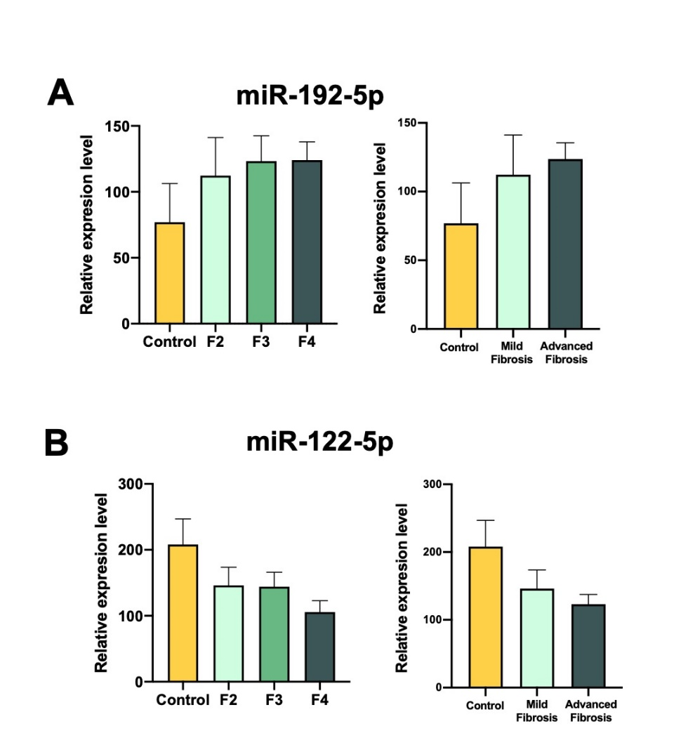
Figure S1. miRNAs expression patterns associated with fibrosis stage and severity in liver. a) miR-192-5p, and b) miR-122-5p. Data represent mean ± SEM (*p < 0.05; **p < 0.01).

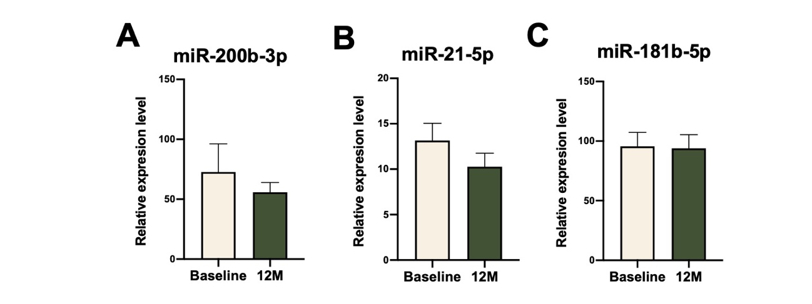Figure S2. miRNAs expression before and after pirfenidone intervention. a) miR-200b-3p, b) miR-21-5p, and c) miR-181b-5p. Data represent mean ± SEM (*p < 0.05). All patients (n=38) were screened at baseline and after 12 months of PR-PFD treatment.

