Figure S1. Q-Q plots and corresponding lambda values for EWAS results in whole blood.
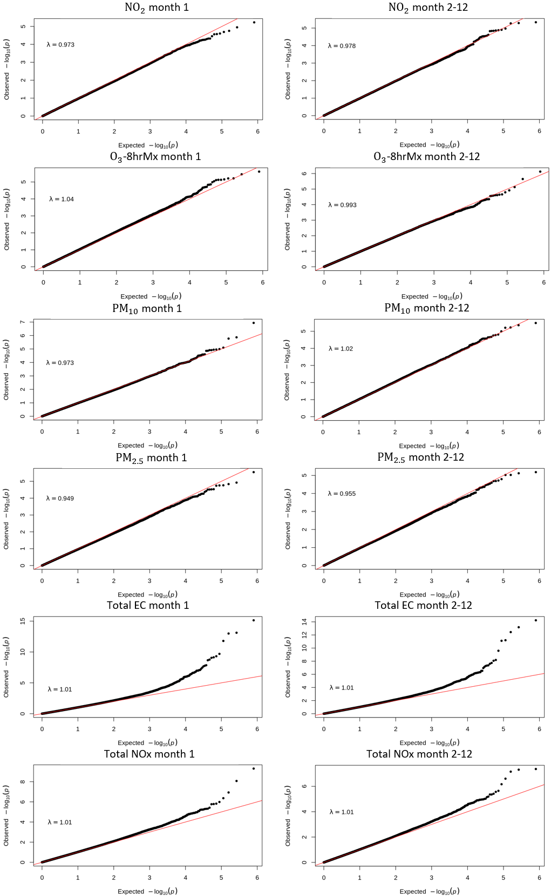
Figure S2. Q-Q plots and corresponding lambda values for EWAS results in CD4+ cells.
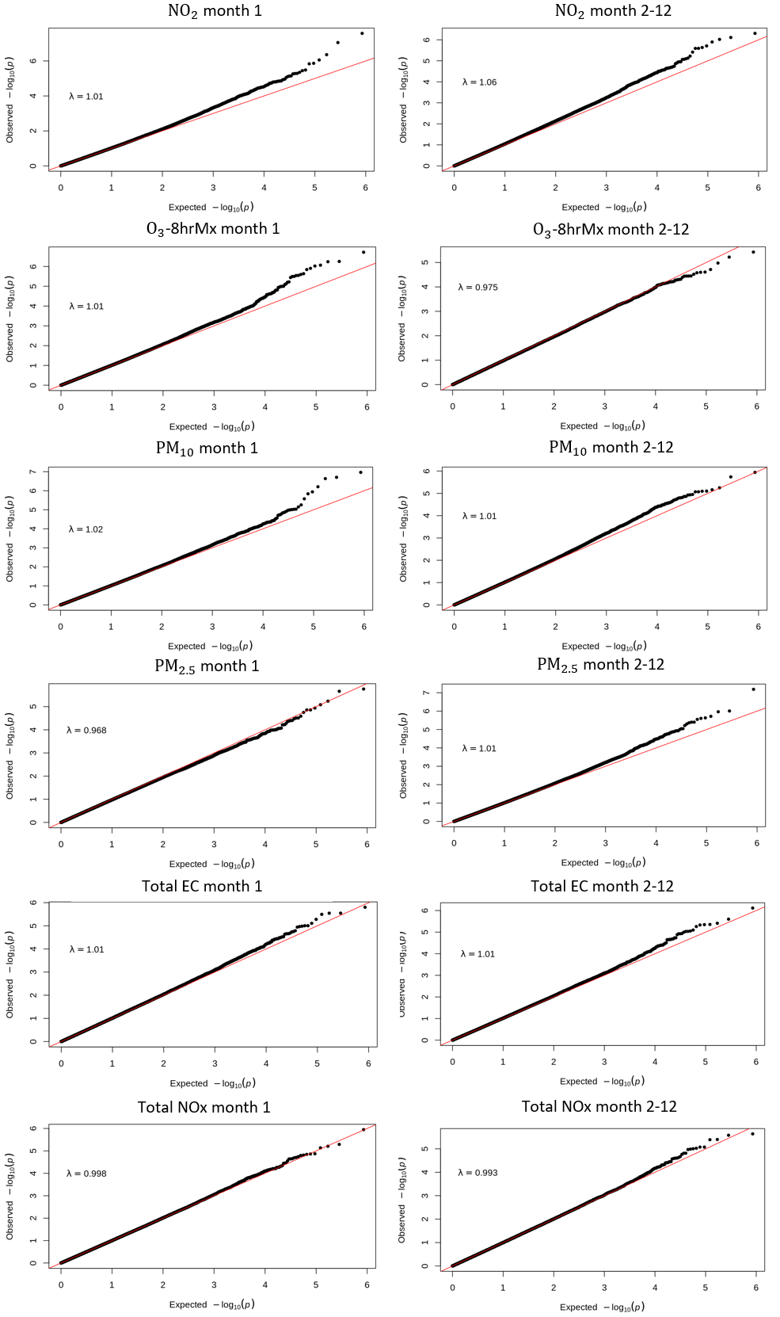

Table S1. Sensitivity analysis results for the associations between air pollutants and asthma control outcomes with p-values ≤ 0.05.
Air Pollutant | Asthma Control Type | Sample size | OR (95% CI) | P-value | FDR
PM₁₀ month 1 | Cough/wheeze without exercise | 524 | 1.98 (1.27, 3.15) | 0.0031 | 0.1867
PM₁₀ month 1 | Composite Asthma Control | 524 | 1.8 (1.17, 2.82) | 0.0088 | 0.2653
PM₁₀ month 1 | Albuterol use for asthma | 524 | 1.95 (1.16, 3.43) | 0.0147 | 0.2937
PM_{2.5} month 1 | Albuterol use for asthma | 572 | 1.83 (1.08, 3.18) | 0.0278 | 0.3606
PM10 month 2-12 | Composite Asthma Control | 555 | 0.54 (0.31, 0.94) | 0.0300 | 0.3606
O₃-8hrMx month 1 | Cough/wheeze without exercise | 595 | 1.34 (1.01, 1.79) | 0.0446 | 0.3935
PM_{2.5} month1 | Composite Asthma Control | 572 | 1.57 (1.01, 2.48) | 0.0461 | 0.3935

Table S2. Sensitivity analysis results for the associations between air pollutant-associated CpG sites and asthma control.
Sample | Air pollutant | Asthma Control Type | CpG | Chromosome | Position | Mapped Gene | Gene Region | OR | p-value
WB | Total NOx month 2-12 | Composite asthma control | cg03495011 | 20 | 61757175 | - | - | 0.3446 | 0.0371
CD4+ | PM_{2.5} month 2-12 | Composite asthma control | cg10022248 | 7 | 1686836 | - | - | 0.437 | 0.0084

