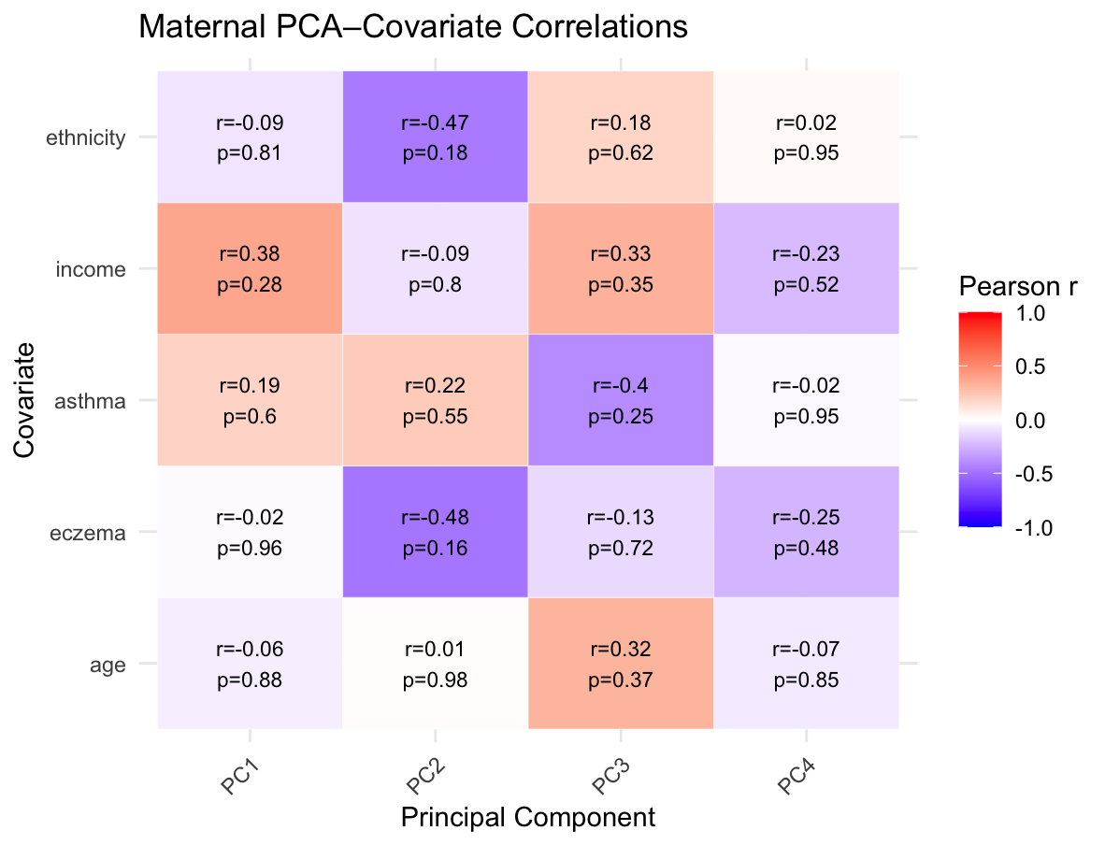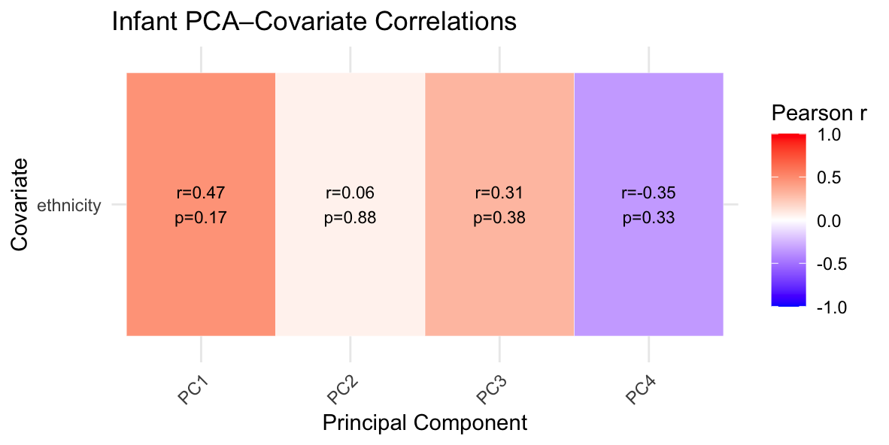
A
B
Supplementary Figure 1. No significant correlation was found between potential covariates and DNAm principal components in maternal PBMCs or infant CBMCs. (A) Pearson correlation coefficients between ethnicity, age, eczema status, asthma status, income and the first four DNAm principal components in maternal PBMCs. No correlation had a p-value < 0.05. (B) Pearson correlation coefficients between ethnicity and the first four DNAm principal components in infant CBMCs. No correlation had a p-value < 0.05.

Supplementary Table 1. Associated genes nearest the CpG sites with significant association with PM2.5 exposure in maternal PBMCs (24 CpGs) or infant CBMCs (18 CpGs).
Cell Source | CpG | Associated Gene(s)¹ | Functional Annotations
Maternal PBMCs | cg01388864 | VPS45 | TFBS, ATAC, HiC Capture, TSS
Maternal PBMCs | cg01865782 | ELK4 | TFBS, HiC Capture, Active Enhancer
Maternal PBMCs | cg02780177 | CALM2, EPCAM | TFBS, ATAC, HiC Capture, Active Enhancer
Maternal PBMCs | cg05428549 | SEMA5B | TFBS, ATAC, HiC Capture, Active Enhancer
Maternal PBMCs | cg05428550 | SEMA5B | TFBS, ATAC, HiC Capture, Active Enhancer
Maternal PBMCs | cg05428551 | SEMA5B | TFBS, ATAC, HiC Capture, Active Enhancer
Maternal PBMCs | cg05428552 | SEMA5B | TFBS, ATAC, HiC Capture, Active Enhancer
Maternal PBMCs | cg05428553 | SEMA5B | TFBS, HiC Capture, Active Enhancer
Maternal PBMCs | cg05959992 | BCL6, LPP | TFBS, ATAC, HiC Capture, TSS
Maternal PBMCs | cg06456582 | KLF3, PTTG2 | TFBS, HiC Capture, Poised Enhancer, Active Enhancer
Maternal PBMCs | cg07733481 | SEMA5B | TFBS, ATAC, HiC Capture, Active Enhancer
Maternal PBMCs | cg07852413 | TARS | TFBS, HiC Capture, TSS
Maternal PBMCs | cg08513685 | HINT1 | TFBS, ATAC, HiC Capture, TSS
Maternal PBMCs | cg09305830 | BTN3A2, HIST1H4H | TFBS, HiC Capture, TSS, Active Enhancer
Maternal PBMCs | cg09356738 | IER3, DDR1 | TFBS, HiC Capture, Active Enhancer
Maternal PBMCs | cg09368299 | DDAH2 | TFBS, ATAC, HiC Capture, TSS, Poised Enhancer
Maternal PBMCs, Infant CBMCs | cg15923968 | TH | TFBS, ATAC, Active Enhancer
Maternal PBMCs | cg15925804 | TH, ASCL2 | TFBS, ATAC, HiC Capture, TSS
Maternal PBMCs | cg16485061 | FOSL1 | TFBS, ATAC, HiC Capture, TSS
Maternal PBMCs | cg17669864 | COQ10A | TFBS, ATAC, HiC Capture, TSS
Maternal PBMCs | cg17691542 | HIST1H1C | TFBS, ATAC, HiC Capture, TSS
Maternal PBMCs | cg21129190 | CLEC16A, SOCS1 | TFBS, ATAC, HiC Capture, Poised Enhancer, Active Enhancer
Maternal PBMCs | cg23925898 | SGTA, THOP1 | TFBS, ATAC, HiC Capture
Maternal PBMCs | cg24501968 | LGALS7B, LGALS4 | TFBS, ATAC, HiC Capture, Active Enhancer
Infant CBMCs | cg01412740 | SNX27 | TFBS, ATAC, HiC Capture, TSS
Infant CBMCs | cg07497252 | KLKB1, CYP4V2 | TFBS, ATAC, HiC Capture, TSS, Active Enhancer
Infant CBMCs | cg07497255 | KLKB1, CYP4V2 | TFBS, ATAC, HiC Capture, TSS, Active Enhancer
Infant CBMCs | cg07646559 | NSUN2, SRD5A1 | TFBS, ATAC, Active Enhancer
Infant CBMCs | cg09066313 | SERPINB9, SERPINB6 | TFBS, ATAC, HiC Capture, Poised Enhancer, Active Enhancer
Infant CBMCs | cg09308162 | HMGN4, BTN1A1 | TFBS, ATAC, HiC Capture, TSS, Active Enhancer
Infant CBMCs | cg09329203 | ZSCAN9 | TFBS, ATAC, HiC Capture, TSS
Infant CBMCs | cg14610064 | PFKFB3 | TFBS, ATAC, HiC Capture, TSS
Infant CBMCs | cg14611734 | PFKFB3, PRKCQ | TFBS, Active Enhancer
Infant CBMCs | cg15285875 | PPIF, ZMIZ1 | TFBS, HiC Capture, Poised Enhancer, Active Enhancer
Infant CBMCs | cg18237549 | DIABLO, B3GNT4 | TFBS, ATAC, HiC Capture, TSS
Infant CBMCs | cg18254573 | C12orf65 | TFBS, ATAC, HiC Capture, TSS
Infant CBMCs | cg21019056 | ZNF205, ZSCAN10 | TFBS, TSS, Active Enhancer
Infant CBMCs | cg21019057 | ZNF205, ZSCAN10 | TFBS, TSS, Active Enhancer
Infant CBMCs | cg21019058 | ZNF205, ZSCAN10 | TFBS, TSS, Active Enhancer
Infant CBMCs | cg21315199 | KDM8 | TFBS, ATAC, HiC Capture, TSS
Infant CBMCs | cg23575960 | POLI | TFBS, ATAC, HiC Capture, TSS
1. Associated genes were derived from the GREAT tool. Functional annotations were shown by Morin et al. (2023) in the development of the Allergy&Asthma DNAm array.

