Figure 4B

HMGA1-1 HMGA1-2 HMGA1-3
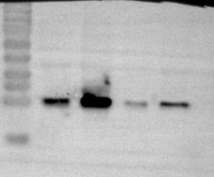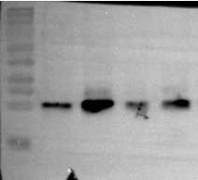

β-ACTIN-1 β-ACTIN-2 β-ACTIN-3
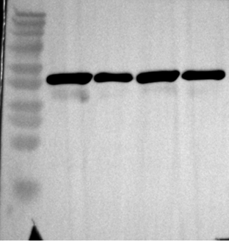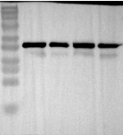

Figure 5B

HMGA1-1 HMGA1-2 HMGA1-3
β-ACTIN-1 β-ACTIN-2 β-ACTIN-3

Figure 5C

E-cadherin-1 E-cadherin-2 E-cadherin-3
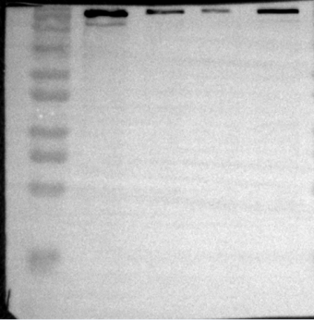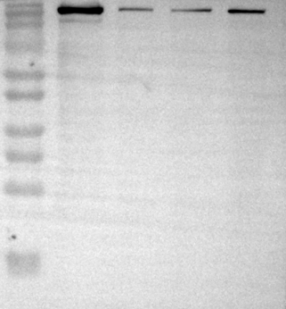

Vimentin-1 Vimentin-2 Vimentin-3
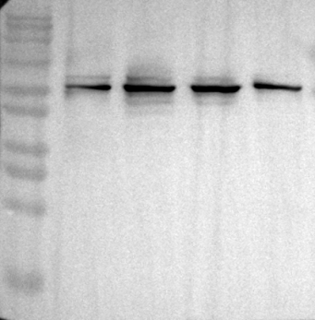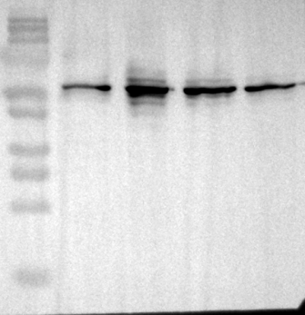

α-SMA-1 α-SMA-2 α-SMA-3
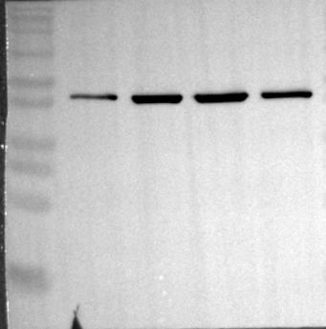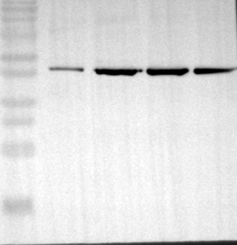

Tublin-1 Tublin-2 Tublin-3
