Description of Additional Supplementary File 1

File Name: Supplementary Figure 1
Description: Flowchart of the prospective cohort study population.

File Name: Supplementary Table 1
Description: Data aources for GWAS on cardiovascular diseases.

File Name: Supplementary Table 2
Description: Baseline characteristics of the prospective cohort study population.

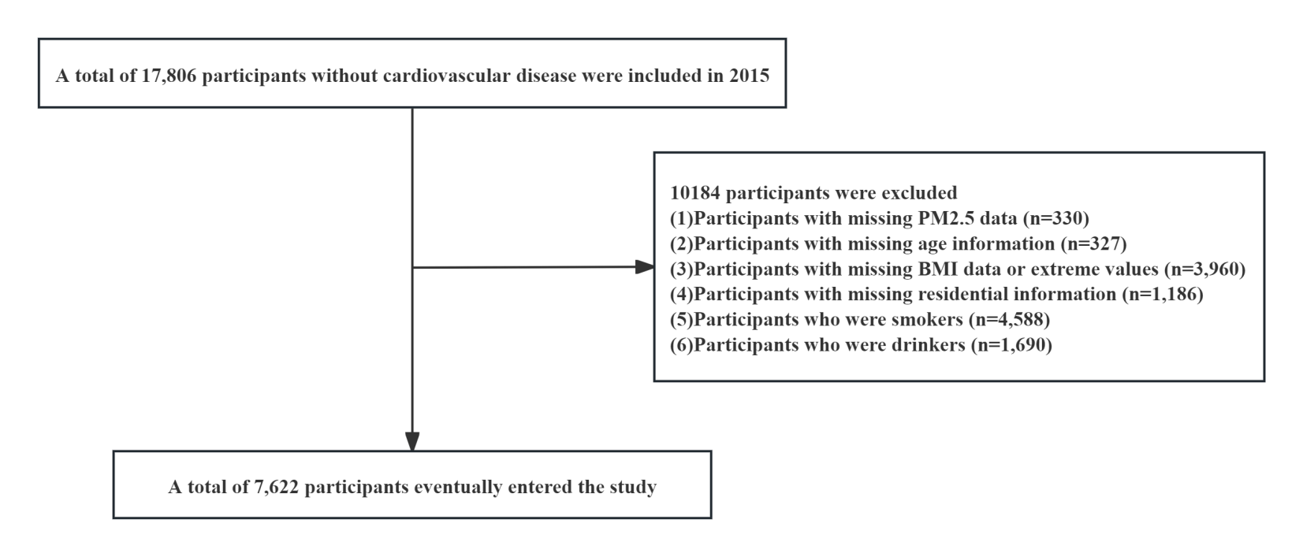
Figure S1. Flowchart of the prospective cohort study population.

Table S1 .Data aources for GWAS on cardiovascular diseases.
Trait | GWAS ID | Consortium | Sample size |  | Number of snps | Population | Case/Control
ANGINA | finngen_R11_I9_ANGINA | FinnGen Consortium | 418385 | 0.0965 | 20093700 | European | 40366/378019
CHD | finngen_R11_I9_CHD | FinnGen Consortium | 453733 | 0.1126 | 20094122 | European | 51098/402635
HF | finngen_R11_I9_HEARTFAIL_ALLCAUSE | FinnGen Consortium | 452488 | 0.0723 | 20094104 | European | 32733/419755
MI | finngen_R11_I9_MI_STRICT | FinnGen Consortium | 406565 | 0.0702 | 20093538 | European | 28546/378019

Table S2.Baseline characteristics of the prospective cohort study population.
Variables | Overall (N = 7622) | non-CVD (N = 6976) | CVD (N= 646) | P
Age, years | 57.42 (49.58, 65.25) | 56.92 (49.42, 65.00) | 61.29 (52.17, 67.75) | <0.001
BMI, kg/m2 | 23.88 (21.58, 26.38) | 23.78 (21.51, 26.28) | 24.68 (22.51, 27.29) | <0.001
Gender, n(%) |  |  |  | 0.018
Famale | 5824 (76.41) | 5306 (76.06) | 518 (80.19)
Male | 1798 (23.59) | 1670 (23.94) | 128 (19.81)
Residence, n(%) |  |  |  | 0.954
Rural | 1954 (25.64) | 1789 (25.65) | 165 (25.54)
Urban | 5668 (74.36) | 5187 (74.35) | 481 (74.46)
Smoke, n(%) |  |  |  | 0.418
Never | 6766 (88.77) | 6191 (88.75) | 575 (89.01)
Former | 312 (4.09) | 281 (4.03) | 31 (4.80)
Current | 544 (7.14) | 504 (7.22) | 40 (6.19)
Drink, n(%) |  |  |  | 0.121
Never | 5813 (76.27) | 5306 (76.06) | 507 (78.48)
Former | 350 (4.59) | 316 (4.53) | 34 (5.26)
Current | 1459 (19.14) | 1354 (19.41) | 105 (16.25)
Hypertension, n(%) | 3062 (40.17) | 2694 (38.62) | 368 (56.97) | <0.001
Diabetes, n(%) | 879 (11.53) | 769 (11.02) | 110 (17.03) | <0.001
Dyslipidemia, n(%) | 6230 (81.74) | 5656 (81.08) | 574 (88.85) | <0.001
PM _{2.5}, μg/m³ | 55.54 (41.31, 66.96) | 54.71 (41.01, 66.96) | 58.15 (43.12, 68.12) | <0.001
PM ₁₀, μg/m³ | 88.62 (66.26, 113.36) | 87.38 (66.26, 113.24) | 93.21 (69.33, 125.86) | <0.001
SO₂, μg/m³ | 26.08 (18.79, 39.94) | 25.60 (18.79, 38.46) | 27.15 (18.79, 44.43) | 0.005
NO₂, μg/m³ | 31.44 (22.69, 40.16) | 31.38 (22.69, 40.16) | 32.33 (24.58, 42.50) | 0.001

