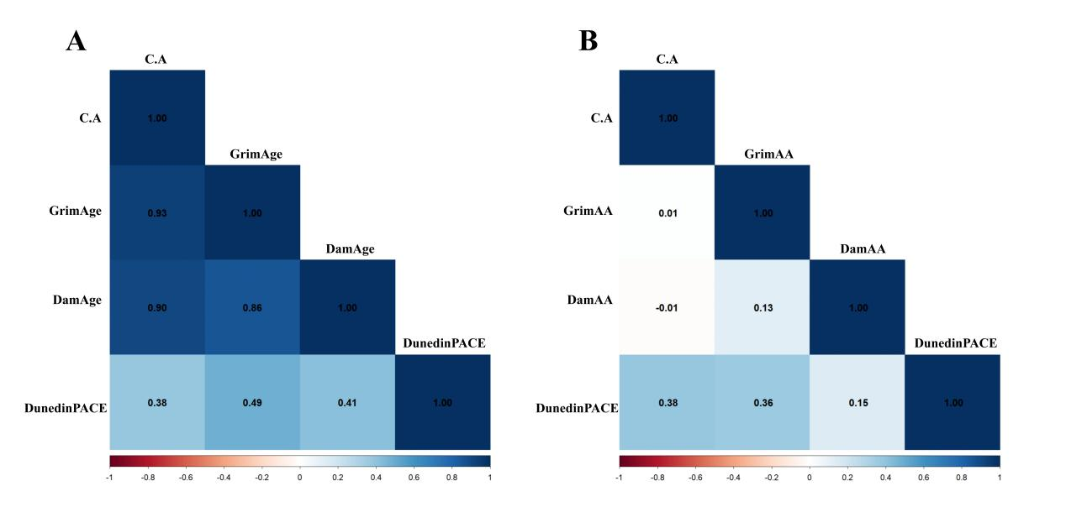
Supplemental Figure 1. Correlation Matrix Heatmap of epigenetic age metrics and chronological age
(A) Correlation Matrix of chronological age with epigenetic age.
(B) Correlation Matrix of chronological age with epigenetic age acceleration.
Values indicate Pearson correlation coefficients; color intensity represents effect magnitude.
Abbreviations: C. A, chronological age; GrimAA, GrimAge acceleration; DamAA, DamAge acceleration

