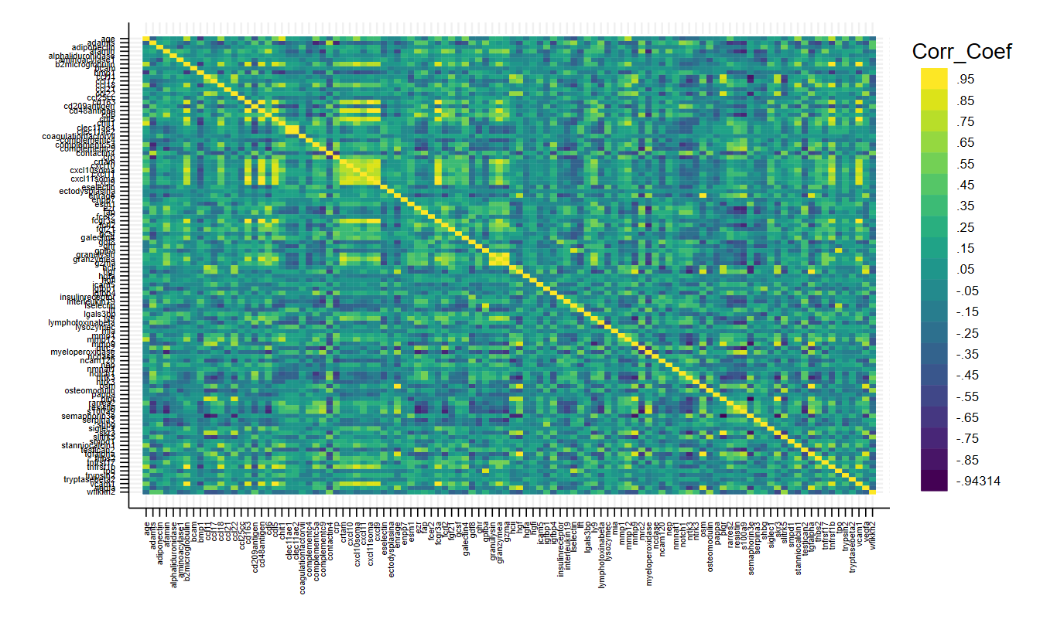
Supplemental Figure 1. Correlation matrix of age at blood draw and the Protein EpiScores. The Correlation matrix displays the correlation strengths between age at diagnosis (on far left/top) and the Protein EpiScores in alphabetical order.
Supplemental Table 1. Protein EpiScore associations with disease-free survival
 | Full model |  |  |  |  | Reduced model
Protein EpiScore | HR | CI_low | CI_high | p | fdr | HR | CI_low | CI_high | p | fdr
HCII | 1.71 | 1.29 | 2.28 | 0.0002 | 0.02 | 1.60 | 1.23 | 2.09 | 0.0005 | 0.06
VEGFA | 1.65 | 1.26 | 2.15 | 0.0002 | 0.02 | 1.58 | 1.24 | 2.03 | 0.0002 | 0.03
CCL17 | 1.62 | 1.24 | 2.12 | 0.0004 | 0.04 | 1.56 | 1.22 | 2.00 | 0.0004 | 0.04
LGALS3BP | 1.71 | 1.27 | 2.31 | 0.0004 | 0.04 | 1.58 | 1.21 | 2.07 | 0.0009 | 0.09
CCL11 | 1.55 | 1.20 | 2.01 | 0.0008 | 0.09 | 1.52 | 1.18 | 1.96 | 0.0011 | 0.11
PIGR | 1.49 | 1.18 | 1.88 | 0.0009 | 0.09 | 1.44 | 1.14 | 1.81 | 0.0020 | 0.20
HGF | 1.52 | 1.18 | 1.94 | 0.0010 | 0.10 | 1.47 | 1.17 | 1.85 | 0.0012 | 0.12
OSM | 1.51 | 1.18 | 1.95 | 0.0012 | 0.12 | 1.46 | 1.14 | 1.85 | 0.0022 | 0.22
TGFALPHA | 1.48 | 1.14 | 1.93 | 0.0033 | 0.33 | 1.42 | 1.11 | 1.82 | 0.0051 | 0.49
SEMAPHORIN3E | 0.70 | 0.55 | 0.89 | 0.0034 | 0.33 | 0.72 | 0.57 | 0.91 | 0.0056 | 0.53
FGF21 | 1.54 | 1.13 | 2.09 | 0.0057 | 0.55 | 1.52 | 1.13 | 2.03 | 0.0049 | 0.48
ICAM5 | 1.45 | 1.10 | 1.91 | 0.0077 | 0.74 | 1.44 | 1.10 | 1.87 | 0.0071 | 0.66
ENRAGE | 1.45 | 1.10 | 1.91 | 0.0080 | 0.76 | 1.39 | 1.08 | 1.79 | 0.0111 | 0.98
CCL22 | 1.41 | 1.09 | 1.82 | 0.0092 | 0.86 | 1.39 | 1.08 | 1.79 | 0.0109 | 0.98
INSULINRECEPTOR | 0.68 | 0.50 | 0.92 | 0.0128 | 0.99 | 0.73 | 0.55 | 0.97 | 0.0305 | 0.98
CRP | 1.45 | 1.08 | 1.94 | 0.0147 | 0.99 | 1.50 | 1.14 | 1.98 | 0.0042 | 0.41
MMP12 | 1.64 | 1.10 | 2.43 | 0.0151 | 0.99 | 1.50 | 1.04 | 2.16 | 0.0286 | 0.98
IGFBP4 | 1.41 | 1.07 | 1.86 | 0.0159 | 0.99 | 1.45 | 1.11 | 1.89 | 0.0064 | 0.60
GHR | 1.41 | 1.06 | 1.86 | 0.0174 | 0.99 | 1.35 | 1.03 | 1.76 | 0.0289 | 0.98
SHBG | 0.69 | 0.51 | 0.94 | 0.0186 | 0.99 | 0.77 | 0.58 | 1.01 | 0.0611 | 0.98
NTRK3 | 0.72 | 0.54 | 0.95 | 0.0189 | 0.99 | 0.70 | 0.53 | 0.92 | 0.0111 | 0.98
SKR3 | 1.36 | 1.05 | 1.76 | 0.0211 | 0.99 | 1.34 | 1.04 | 1.73 | 0.0226 | 0.98
THBS2 | 1.39 | 1.05 | 1.85 | 0.0226 | 0.99 | 1.43 | 1.09 | 1.87 | 0.0109 | 0.98
ADAMTS | 0.69 | 0.50 | 0.96 | 0.0271 | 0.99 | 0.65 | 0.49 | 0.87 | 0.0033 | 0.32
OSTEOMODULIN | 0.71 | 0.51 | 0.97 | 0.0327 | 0.99 | 0.72 | 0.54 | 0.96 | 0.0255 | 0.98
GDF8 | 0.70 | 0.50 | 0.99 | 0.0423 | 0.99 | 0.76 | 0.56 | 1.03 | 0.0809 | 0.98
MMP9 | 1.30 | 1.01 | 1.67 | 0.0439 | 0.99 | 1.28 | 1.00 | 1.63 | 0.0497 | 0.98
PAPPA | 0.75 | 0.55 | 1.01 | 0.0580 | 0.99 | 0.75 | 0.57 | 1.00 | 0.0538 | 0.98
NRTK3 | 0.76 | 0.56 | 1.01 | 0.0607 | 0.99 | 0.76 | 0.57 | 1.00 | 0.0478 | 0.98
SLITRK5 | 0.74 | 0.54 | 1.02 | 0.0628 | 0.99 | 0.81 | 0.62 | 1.06 | 0.1188 | 0.98
NCAM120 | 0.73 | 0.51 | 1.02 | 0.0674 | 0.99 | 0.77 | 0.57 | 1.04 | 0.0907 | 0.98
CCL21 | 1.29 | 0.98 | 1.70 | 0.0743 | 0.99 | 1.24 | 0.97 | 1.59 | 0.0838 | 0.98
LSELECTIN | 0.77 | 0.58 | 1.03 | 0.0825 | 0.99 | 0.74 | 0.56 | 0.97 | 0.0319 | 0.98
COMPLEMENTC4 | 0.78 | 0.60 | 1.03 | 0.0838 | 0.99 | 0.83 | 0.65 | 1.07 | 0.1607 | 0.98
BCAM | 0.79 | 0.60 | 1.04 | 0.0970 | 0.99 | 0.79 | 0.61 | 1.03 | 0.0796 | 0.98
GCSF | 1.27 | 0.95 | 1.71 | 0.1073 | 0.99 | 1.32 | 1.01 | 1.72 | 0.0395 | 0.98
CONTACTIN4 | 0.80 | 0.60 | 1.08 | 0.1430 | 0.99 | 0.77 | 0.58 | 1.02 | 0.0698 | 0.98
NMNAT1 | 0.81 | 0.61 | 1.08 | 0.1465 | 0.99 | 0.81 | 0.62 | 1.07 | 0.1370 | 0.98
BMP1 | 1.28 | 0.91 | 1.80 | 0.1499 | 0.99 | 1.26 | 0.92 | 1.74 | 0.1510 | 0.98
COMPLEMENTC5A | 1.24 | 0.92 | 1.66 | 0.1567 | 0.99 | 1.30 | 0.98 | 1.73 | 0.0730 | 0.98
LY9 | 0.81 | 0.60 | 1.09 | 0.1579 | 0.99 | 0.85 | 0.66 | 1.11 | 0.2322 | 0.98
FCER2 | 0.79 | 0.58 | 1.10 | 0.1632 | 0.99 | 0.79 | 0.58 | 1.07 | 0.1288 | 0.98
CD6 | 1.23 | 0.92 | 1.65 | 0.1703 | 0.99 | 1.18 | 0.89 | 1.55 | 0.2498 | 0.98
LFT | 0.82 | 0.63 | 1.09 | 0.1723 | 0.99 | 0.81 | 0.62 | 1.06 | 0.1180 | 0.98
HGFA | 0.83 | 0.64 | 1.08 | 0.1738 | 0.99 | 0.84 | 0.66 | 1.07 | 0.1558 | 0.98
AFAMIN | 1.23 | 0.91 | 1.67 | 0.1768 | 0.99 | 1.18 | 0.90 | 1.56 | 0.2298 | 0.98
FAP | 1.23 | 0.91 | 1.65 | 0.1768 | 0.99 | 1.16 | 0.87 | 1.54 | 0.3212 | 0.98
MMP1 | 1.22 | 0.91 | 1.62 | 0.1772 | 0.99 | 1.18 | 0.90 | 1.53 | 0.2257 | 0.98
CCL18 | 1.29 | 0.87 | 1.89 | 0.2009 | 0.99 | 1.33 | 0.92 | 1.93 | 0.1285 | 0.98
RARRES2 | 1.22 | 0.90 | 1.66 | 0.2020 | 0.99 | 1.27 | 0.95 | 1.70 | 0.1131 | 0.98
ENPP7 | 1.19 | 0.90 | 1.57 | 0.2248 | 0.99 | 1.28 | 0.98 | 1.67 | 0.0711 | 0.98
TRYPSIN2 | 1.23 | 0.88 | 1.71 | 0.2304 | 0.99 | 1.19 | 0.88 | 1.61 | 0.2493 | 0.98
STANNIOCALCIN1 | 1.23 | 0.85 | 1.79 | 0.2648 | 0.99 | 1.21 | 0.87 | 1.67 | 0.2520 | 0.98
IGFBP1 | 0.84 | 0.61 | 1.14 | 0.2662 | 0.99 | 0.90 | 0.69 | 1.18 | 0.4453 | 0.98
S100A9 | 1.19 | 0.87 | 1.64 | 0.2694 | 0.99 | 1.17 | 0.87 | 1.55 | 0.2953 | 0.98
WFIKKN2 | 0.83 | 0.61 | 1.15 | 0.2710 | 0.99 | 0.80 | 0.59 | 1.08 | 0.1447 | 0.98
ALPHALIDURONIDAS | 1.14 | 0.89 | 1.47 | 0.3055 | 0.99 | 1.12 | 0.88 | 1.44 | 0.3507 | 0.98
NOTCH1 | 0.86 | 0.62 | 1.19 | 0.3507 | 0.99 | 0.84 | 0.62 | 1.14 | 0.2597 | 0.98
LYMPHOTOXINABETA | 0.83 | 0.57 | 1.23 | 0.3561 | 0.99 | 0.87 | 0.66 | 1.15 | 0.3340 | 0.98
TPO | 0.88 | 0.68 | 1.15 | 0.3567 | 0.99 | 0.86 | 0.67 | 1.10 | 0.2344 | 0.98
CHIT1 | 1.31 | 0.74 | 2.32 | 0.3624 | 0.99 | 1.23 | 0.72 | 2.08 | 0.4503 | 0.98
GPIBA | 0.88 | 0.68 | 1.16 | 0.3737 | 0.99 | 0.85 | 0.66 | 1.10 | 0.2259 | 0.98
CXCL11 | 0.88 | 0.66 | 1.17 | 0.3883 | 0.99 | 0.87 | 0.65 | 1.14 | 0.3115 | 0.98
GALECTIN4 | 1.16 | 0.83 | 1.63 | 0.3903 | 0.99 | 1.23 | 0.90 | 1.69 | 0.1976 | 0.98
EZR | 1.13 | 0.84 | 1.53 | 0.4149 | 0.99 | 1.08 | 0.82 | 1.43 | 0.5772 | 0.98
AMINOACYLASE1 | 1.13 | 0.83 | 1.54 | 0.4202 | 0.99 | 1.10 | 0.85 | 1.44 | 0.4646 | 0.98
SMPD1 | 0.90 | 0.69 | 1.18 | 0.4587 | 0.99 | 0.92 | 0.70 | 1.20 | 0.5154 | 0.98
TNFRSF17 | 0.89 | 0.66 | 1.21 | 0.4686 | 0.99 | 0.96 | 0.72 | 1.28 | 0.7931 | 0.98
NEP | 1.11 | 0.83 | 1.48 | 0.4772 | 0.99 | 1.09 | 0.84 | 1.41 | 0.5315 | 0.98
MIA | 0.90 | 0.68 | 1.19 | 0.4779 | 0.99 | 0.91 | 0.70 | 1.18 | 0.4955 | 0.98
CXCL10SOMA | 0.88 | 0.62 | 1.25 | 0.4805 | 0.99 | 0.91 | 0.65 | 1.27 | 0.5634 | 0.98
LYSOZYMEC | 1.11 | 0.81 | 1.52 | 0.5014 | 0.99 | 1.11 | 0.84 | 1.47 | 0.4713 | 0.98
TESTICAN2 | 1.10 | 0.82 | 1.49 | 0.5168 | 0.99 | 1.06 | 0.80 | 1.41 | 0.6748 | 0.98
ADIPONECTIN | 0.90 | 0.65 | 1.25 | 0.5218 | 0.99 | 0.90 | 0.69 | 1.18 | 0.4547 | 0.98
CRTAM | 1.09 | 0.83 | 1.42 | 0.5265 | 0.99 | 1.11 | 0.86 | 1.43 | 0.4296 | 0.98
SERPINA3 | 0.92 | 0.70 | 1.20 | 0.5319 | 0.99 | 0.90 | 0.69 | 1.17 | 0.4215 | 0.98
NCDASE | 1.09 | 0.82 | 1.44 | 0.5654 | 0.99 | 1.06 | 0.81 | 1.39 | 0.6757 | 0.98
CLEC11AE1 | 1.09 | 0.80 | 1.48 | 0.5818 | 0.99 | 1.07 | 0.82 | 1.39 | 0.6202 | 0.98
COAGULATIONFACTO | 1.07 | 0.81 | 1.42 | 0.6331 | 0.99 | 1.04 | 0.81 | 1.35 | 0.7549 | 0.98
TNFRSF1B | 1.08 | 0.76 | 1.55 | 0.6616 | 0.99 | 1.12 | 0.80 | 1.56 | 0.5158 | 0.98
CD48ANTIGEN | 1.06 | 0.80 | 1.41 | 0.7007 | 0.99 | 1.05 | 0.80 | 1.38 | 0.7156 | 0.98
CCL25CC | 1.05 | 0.80 | 1.38 | 0.7190 | 0.99 | 1.04 | 0.80 | 1.35 | 0.7520 | 0.98
CXCL11SOMA | 1.05 | 0.79 | 1.39 | 0.7357 | 0.99 | 1.04 | 0.80 | 1.36 | 0.7575 | 0.98
CXCL9 | 1.05 | 0.80 | 1.38 | 0.7443 | 0.99 | 1.04 | 0.80 | 1.35 | 0.7570 | 0.98
HGFI | 0.96 | 0.73 | 1.27 | 0.7802 | 0.99 | 0.93 | 0.71 | 1.20 | 0.5693 | 0.98
GZMA | 1.04 | 0.79 | 1.37 | 0.7860 | 0.99 | 1.06 | 0.81 | 1.38 | 0.6915 | 0.98
GRANZYMEA | 1.04 | 0.78 | 1.38 | 0.8073 | 0.99 | 1.04 | 0.80 | 1.37 | 0.7527 | 0.98
VCAM1 | 1.04 | 0.75 | 1.43 | 0.8152 | 0.99 | 1.02 | 0.75 | 1.39 | 0.9128 | 0.98
TRYPTASEBETA2 | 0.97 | 0.75 | 1.26 | 0.8232 | 0.99 | 0.99 | 0.77 | 1.27 | 0.9406 | 0.98
CD163 | 1.03 | 0.78 | 1.37 | 0.8274 | 0.99 | 1.03 | 0.79 | 1.35 | 0.8106 | 0.98
ESELECTIN | 1.03 | 0.77 | 1.37 | 0.8349 | 0.99 | 1.01 | 0.77 | 1.33 | 0.9397 | 0.98
INTERLEUKIN19 | 1.03 | 0.77 | 1.37 | 0.8392 | 0.99 | 0.98 | 0.75 | 1.28 | 0.8821 | 0.98
CDL5 | 1.03 | 0.76 | 1.38 | 0.8557 | 0.99 | 1.02 | 0.77 | 1.36 | 0.8908 | 0.98
ECTODYSPLASINA | 0.98 | 0.74 | 1.28 | 0.8619 | 0.99 | 0.94 | 0.72 | 1.23 | 0.6573 | 0.98
FCGR3A | 0.98 | 0.73 | 1.31 | 0.8693 | 0.99 | 0.98 | 0.74 | 1.30 | 0.8884 | 0.98
CXCL10 | 1.02 | 0.78 | 1.33 | 0.8888 | 0.99 | 1.03 | 0.80 | 1.32 | 0.8478 | 0.98
ESM1 | 1.02 | 0.77 | 1.35 | 0.8939 | 0.99 | 1.03 | 0.78 | 1.35 | 0.8499 | 0.98
COMPLEMENTC9 | 0.98 | 0.74 | 1.30 | 0.8978 | 0.99 | 1.02 | 0.78 | 1.34 | 0.8580 | 0.98
SIGLEC1 | 0.98 | 0.75 | 1.28 | 0.9012 | 0.99 | 1.01 | 0.78 | 1.31 | 0.9563 | 0.98
FCRL2 | 1.02 | 0.76 | 1.35 | 0.9183 | 0.99 | 1.00 | 0.77 | 1.31 | 0.9713 | 0.98
MRC2 | 0.99 | 0.74 | 1.32 | 0.9205 | 0.99 | 0.96 | 0.73 | 1.26 | 0.7798 | 0.98
B2MICROGLOBULIN | 1.02 | 0.70 | 1.48 | 0.9247 | 0.99 | 1.01 | 0.71 | 1.43 | 0.9503 | 0.98
CD209ANTIGEN | 1.02 | 0.73 | 1.42 | 0.9300 | 0.99 | 0.99 | 0.74 | 1.32 | 0.9273 | 0.98
RESISTIN | 1.01 | 0.74 | 1.38 | 0.9537 | 0.99 | 1.05 | 0.79 | 1.41 | 0.7212 | 0.98
CLEC11AE2 | 1.00 | 0.73 | 1.36 | 0.9761 | 0.99 | 1.00 | 0.77 | 1.31 | 0.9814 | 0.98
GRANULYSIN | 1.00 | 0.76 | 1.33 | 0.9867 | 0.99 | 1.03 | 0.79 | 1.35 | 0.8367 | 0.98
MYELOPEROXIDASE | 1.00 | 0.73 | 1.36 | 0.9878 | 0.99 | 0.98 | 0.74 | 1.30 | 0.8917 | 0.98
Associations were estimated using Cox regression models, with time on study treated as the time-scale. The full model adjusts for age at diagnosis, sex, race, BMI group, tumor site, and stage at diagnosis; the reduced model only adjusts for age at diagnosis. FDR was calculated using the Benjamini-Hochberg method. Four patients did not receive surgery and were excluded from disease-free analyses.

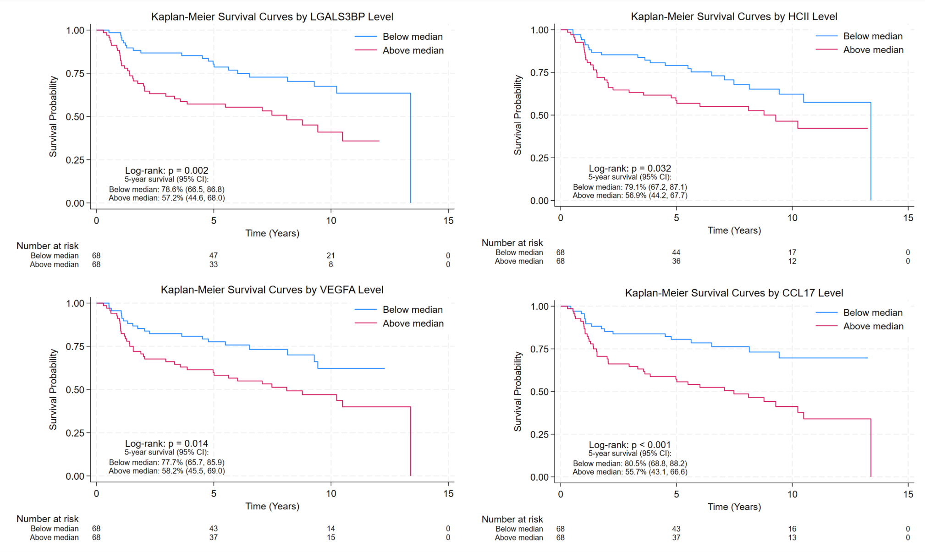
Supplemental Figure 2. Kaplan-Meier plots for the four top-performing Protein EpiScores with CRC disease-free survival. Protein EpiScores were dichotomized at their median value, allowing for a balanced sample size between the low and high groups. Log-rank P-values and 5-year survival percentage and corresponding confidence intervals are also reported.

Supplemental Table 2. Stratified associations of Protein EpiScores and disease-free survival
Protein EpiScore | Stratum | HR | CI_low | CI_high | p | P-interaction
 | Age at diagnosis
HCII | Age < 65 | 1.50 | 0.93 | 2.44 | 0.0992 | 0.41
HCII | Age >= 65 | 1.84 | 1.24 | 2.73 | 0.0023 | 0.41
VEGFA | Age < 65 | 1.41 | 0.86 | 2.31 | 0.1724 | 0.47
VEGFA | Age >= 65 | 1.73 | 1.23 | 2.42 | 0.0017 | 0.47
CCL17 | Age < 65 | 1.61 | 1.05 | 2.46 | 0.0291 | 0.91
CCL17 | Age >= 65 | 1.85 | 1.30 | 2.63 | 0.0007 | 0.91
LGALS3BP | Age < 65 | 1.80 | 1.03 | 3.14 | 0.0392 | 0.61
LGALS3BP | Age >= 65 | 1.80 | 1.24 | 2.61 | 0.0021 | 0.61
 | BMI group
HCII | BMI < 30 | 1.85 | 1.31 | 2.61 | 0.0004 | 0.71
HCII | BMI >= 30 | 1.59 | 0.83 | 3.04 | 0.1622 | 0.71
VEGFA | BMI < 30 | 1.81 | 1.30 | 2.53 | 0.0005 | 0.39
VEGFA | BMI >= 30 | 1.52 | 0.93 | 2.50 | 0.0977 | 0.39
CCL17 | BMI < 30 | 1.82 | 1.27 | 2.62 | 0.0011 | 0.38
CCL17 | BMI >= 30 | 1.45 | 0.94 | 2.25 | 0.0923 | 0.38
LGALS3BP | BMI < 30 | 1.77 | 1.25 | 2.51 | 0.0014 | 0.32
LGALS3BP | BMI >= 30 | 1.34 | 0.75 | 2.41 | 0.3241 | 0.32
 | Sex
HCII | Female | 1.79 | 1.21 | 2.65 | 0.0036 | 0.65
HCII | Male | 1.65 | 1.05 | 2.59 | 0.0298 | 0.65
VEGFA | Female | 1.47 | 1.01 | 2.14 | 0.0462 | 0.64
VEGFA | Male | 1.77 | 1.19 | 2.62 | 0.0047 | 0.64
CCL17 | Female | 1.53 | 1.00 | 2.33 | 0.0493 | 0.78
CCL17 | Male | 1.68 | 1.16 | 2.43 | 0.0065 | 0.78
LGALS3BP | Female | 1.71 | 1.06 | 2.75 | 0.0283 | 0.77
LGALS3BP | Male | 1.93 | 1.26 | 2.95 | 0.0026 | 0.77
 | Tumor site
HCII | Rectal | 1.40 | 0.95 | 2.06 | 0.0891 | 0.18
HCII | Colon | 2.53 | 1.54 | 4.14 | 0.0002 | 0.18
VEGFA | Rectal | 1.36 | 0.91 | 2.03 | 0.1375 | 0.15
VEGFA | Colon | 1.94 | 1.34 | 2.81 | 0.0005 | 0.15
CCL17 | Rectal | 1.46 | 0.99 | 2.16 | 0.0586 | 0.34
CCL17 | Colon | 2.24 | 1.46 | 3.45 | 0.0002 | 0.34
LGALS3BP | Rectal | 1.61 | 1.10 | 2.35 | 0.0146 | 0.44
LGALS3BP | Colon | 2.08 | 1.17 | 3.68 | 0.0122 | 0.44
Associations are estimated using Cox regression models, treating time on study as the time-scale. All models are adjusted for confounders (age at diagnosis, race, BMI group, tumor location, and stage). Four rectal patients did not receive surgery and were excluded from disease-free survival analyses.

Supplemental Table 3. Protein EpiScore associations with CRC overall survival
 | Full Model |  |  |  |  |  | Reduced model
Protein EpiScore | HR | CI_low | CI_high | p | fdr | HR |  | CI_low | CI_high | p | fdr
LGALS3BP | 1.80 | 1.29 | 2.51 | 0.0005 | 0.056 | 1.62 |  | 1.20 | 2.19 | 0.0016 | 0.17
VEGFA | 1.61 | 1.19 | 2.19 | 0.0023 | 0.24 | 1.61 |  | 1.20 | 2.15 | 0.0014 | 0.15
HCII | 1.57 | 1.14 | 2.17 | 0.0063 | 0.67 | 1.50 |  | 1.10 | 2.06 | 0.0115 | 0.97
OSM | 1.43 | 1.08 | 1.90 | 0.0131 | 0.99 | 1.42 |  | 1.08 | 1.87 | 0.0125 | 0.97
HGF | 1.39 | 1.06 | 1.84 | 0.0191 | 0.99 | 1.41 |  | 1.08 | 1.83 | 0.0102 | 0.97
CRP | 1.56 | 1.07 | 2.27 | 0.0220 | 0.99 | 1.57 |  | 1.10 | 2.25 | 0.0133 | 0.97
IGFBP4 | 1.41 | 1.04 | 1.92 | 0.0285 | 0.99 | 1.43 |  | 1.07 | 1.92 | 0.0169 | 0.97
CCL21 | 1.45 | 1.04 | 2.03 | 0.0295 | 0.99 | 1.40 |  | 1.06 | 1.87 | 0.0199 | 0.97
CCL22 | 1.35 | 1.03 | 1.79 | 0.0322 | 0.99 | 1.34 |  | 1.02 | 1.76 | 0.0362 | 0.97
ENRAGE | 1.41 | 1.03 | 1.93 | 0.0326 | 0.99 | 1.39 |  | 1.03 | 1.86 | 0.0295 | 0.97
TGFALPHA | 1.37 | 1.02 | 1.84 | 0.0379 | 0.99 | 1.37 |  | 1.03 | 1.82 | 0.0293 | 0.97
FGF21 | 1.44 | 1.02 | 2.03 | 0.0402 | 0.99 | 1.44 |  | 1.04 | 1.98 | 0.0258 | 0.97
LYSOZYMEC | 1.43 | 1.01 | 2.01 | 0.0433 | 0.99 | 1.43 |  | 1.05 | 1.95 | 0.0233 | 0.97
MMP12 | 1.57 | 0.99 | 2.48 | 0.0534 | 0.99 | 1.52 |  | 1.01 | 2.27 | 0.0427 | 0.97
PIGR | 1.31 | 1.00 | 1.71 | 0.0543 | 0.99 | 1.29 |  | 0.99 | 1.67 | 0.0595 | 0.97
CCL17 | 1.33 | 0.99 | 1.80 | 0.0607 | 0.99 | 1.33 |  | 1.01 | 1.74 | 0.0418 | 0.97
SHBG | 0.73 | 0.52 | 1.02 | 0.0654 | 0.99 | 0.78 |  | 0.57 | 1.06 | 0.1067 | 0.97
ICAM5 | 1.31 | 0.97 | 1.78 | 0.0753 | 0.99 | 1.32 |  | 0.97 | 1.78 | 0.0781 | 0.97
THBS2 | 1.32 | 0.95 | 1.83 | 0.0958 | 0.99 | 1.37 |  | 1.02 | 1.85 | 0.0381 | 0.97
CCL11 | 1.27 | 0.95 | 1.70 | 0.1034 | 0.99 | 1.26 |  | 0.96 | 1.67 | 0.0968 | 0.97
SEMAPHORIN3E | 0.80 | 0.61 | 1.06 | 0.1185 | 0.99 | 0.81 |  | 0.62 | 1.05 | 0.1105 | 0.97
CCL18 | 1.41 | 0.91 | 2.20 | 0.1251 | 0.99 | 1.56 |  | 1.02 | 2.39 | 0.0412 | 0.97
BCAM | 0.78 | 0.58 | 1.07 | 0.1261 | 0.99 | 0.80 |  | 0.60 | 1.07 | 0.1353 | 0.97
HGFA | 0.79 | 0.58 | 1.07 | 0.1265 | 0.99 | 0.85 |  | 0.65 | 1.11 | 0.2400 | 0.97
NRTK3 | 0.77 | 0.56 | 1.08 | 0.1322 | 0.99 | 0.78 |  | 0.57 | 1.06 | 0.1075 | 0.97
SMPD1 | 0.80 | 0.59 | 1.08 | 0.1380 | 0.99 | 0.82 |  | 0.61 | 1.11 | 0.2043 | 0.97
SKR3 | 1.24 | 0.92 | 1.67 | 0.1486 | 0.99 | 1.24 |  | 0.93 | 1.65 | 0.1353 | 0.97
IGFBP1 | 0.78 | 0.56 | 1.09 | 0.1506 | 0.99 | 0.84 |  | 0.63 | 1.12 | 0.2332 | 0.97
COMPLEMENTC4 | 0.81 | 0.60 | 1.08 | 0.1530 | 0.99 | 0.87 |  | 0.66 | 1.15 | 0.3171 | 0.97
STANNIOCALCIN1 | 1.35 | 0.89 | 2.05 | 0.1578 | 0.99 | 1.39 |  | 0.97 | 1.97 | 0.0707 | 0.97
NMNAT1 | 0.79 | 0.57 | 1.10 | 0.1703 | 0.99 | 0.80 |  | 0.59 | 1.09 | 0.1521 | 0.97
TNFRSF17 | 0.80 | 0.57 | 1.11 | 0.1776 | 0.99 | 0.85 |  | 0.61 | 1.18 | 0.3382 | 0.97
S100A9 | 1.26 | 0.88 | 1.79 | 0.2036 | 0.99 | 1.23 |  | 0.89 | 1.69 | 0.2039 | 0.97
COMPLEMENTC5A | 1.23 | 0.89 | 1.70 | 0.2058 | 0.99 | 1.30 |  | 0.95 | 1.78 | 0.1003 | 0.97
MMP9 | 1.20 | 0.90 | 1.59 | 0.2107 | 0.99 | 1.21 |  | 0.92 | 1.59 | 0.1719 | 0.97
PAPPA | 0.81 | 0.58 | 1.13 | 0.2214 | 0.99 | 0.80 |  | 0.59 | 1.09 | 0.1588 | 0.97
CD6 | 1.23 | 0.88 | 1.72 | 0.2288 | 0.99 | 1.20 |  | 0.88 | 1.62 | 0.2509 | 0.97
AFAMIN | 1.22 | 0.88 | 1.71 | 0.2348 | 0.99 | 1.20 |  | 0.89 | 1.62 | 0.2352 | 0.97
ENPP7 | 1.20 | 0.89 | 1.63 | 0.2378 | 0.99 | 1.32 |  | 0.98 | 1.76 | 0.0658 | 0.97
GCSF | 1.23 | 0.87 | 1.76 | 0.2444 | 0.99 | 1.28 |  | 0.94 | 1.74 | 0.1187 | 0.97
NCAM120 | 0.81 | 0.56 | 1.17 | 0.2645 | 0.99 | 0.88 |  | 0.63 | 1.23 | 0.4507 | 0.97
INSULINRECEPTOR | 0.84 | 0.62 | 1.15 | 0.2785 | 0.99 | 0.86 |  | 0.63 | 1.16 | 0.3169 | 0.97
ALPHALIDURONIDAS | 1.16 | 0.88 | 1.52 | 0.2959 | 0.99 | 1.15 |  | 0.89 | 1.50 | 0.2882 | 0.97
GALECTIN4 | 1.24 | 0.83 | 1.85 | 0.2999 | 0.99 | 1.38 |  | 0.95 | 2.00 | 0.0878 | 0.97
ADAMTS | 0.82 | 0.55 | 1.20 | 0.3039 | 0.99 | 0.74 |  | 0.53 | 1.04 | 0.0810 | 0.97
WFIKKN2 | 0.83 | 0.57 | 1.20 | 0.3198 | 0.99 | 0.77 |  | 0.55 | 1.07 | 0.1188 | 0.97
CLEC11AE1 | 1.18 | 0.85 | 1.63 | 0.3221 | 0.99 | 1.19 |  | 0.90 | 1.58 | 0.2204 | 0.97
LY9 | 0.85 | 0.61 | 1.18 | 0.3398 | 0.99 | 0.88 |  | 0.66 | 1.17 | 0.3763 | 0.97
RARRES2 | 1.17 | 0.83 | 1.65 | 0.3826 | 0.99 | 1.24 |  | 0.90 | 1.71 | 0.1953 | 0.97
SLITRK5 | 0.85 | 0.59 | 1.23 | 0.3993 | 0.99 | 0.85 |  | 0.63 | 1.13 | 0.2603 | 0.97
MIA | 0.87 | 0.64 | 1.20 | 0.4061 | 0.99 | 0.94 |  | 0.71 | 1.26 | 0.6868 | 0.97
CHIT1 | 1.32 | 0.68 | 2.53 | 0.4117 | 0.99 | 1.31 |  | 0.72 | 2.36 | 0.3768 | 0.97
NOTCH1 | 0.86 | 0.59 | 1.25 | 0.4281 | 0.99 | 0.83 |  | 0.58 | 1.18 | 0.2997 | 0.97
OSTEOMODULIN | 0.87 | 0.61 | 1.24 | 0.4450 | 0.99 | 0.81 |  | 0.60 | 1.11 | 0.1879 | 0.97
CD163 | 1.13 | 0.82 | 1.55 | 0.4522 | 0.99 | 1.13 |  | 0.85 | 1.52 | 0.4046 | 0.97
NEP | 1.12 | 0.82 | 1.54 | 0.4680 | 0.99 | 1.09 |  | 0.82 | 1.45 | 0.5427 | 0.97
MMP1 | 1.12 | 0.82 | 1.54 | 0.4687 | 0.99 | 1.07 |  | 0.80 | 1.44 | 0.6425 | 0.97
BMP1 | 1.15 | 0.79 | 1.67 | 0.4729 | 0.99 | 1.20 |  | 0.85 | 1.71 | 0.2960 | 0.97
GRANULYSIN | 0.89 | 0.65 | 1.22 | 0.4776 | 0.99 | 0.93 |  | 0.70 | 1.25 | 0.6439 | 0.97
GHR | 1.12 | 0.82 | 1.52 | 0.4866 | 0.99 | 1.10 |  | 0.82 | 1.48 | 0.5357 | 0.97
NTRK3 | 0.90 | 0.67 | 1.22 | 0.5093 | 0.99 | 0.88 |  | 0.65 | 1.18 | 0.3901 | 0.97
ECTODYSPLASINA | 0.90 | 0.66 | 1.23 | 0.5124 | 0.99 | 0.89 |  | 0.66 | 1.19 | 0.4206 | 0.97
CXCL11SOMA | 1.11 | 0.81 | 1.52 | 0.5135 | 0.99 | 1.09 |  | 0.81 | 1.46 | 0.5814 | 0.97
LFT | 0.91 | 0.67 | 1.24 | 0.5509 | 0.99 | 0.89 |  | 0.66 | 1.21 | 0.4623 | 0.97
FCER2 | 0.90 | 0.63 | 1.28 | 0.5539 | 0.99 | 0.88 |  | 0.63 | 1.22 | 0.4358 | 0.97
LYMPHOTOXINABETA | 0.88 | 0.57 | 1.35 | 0.5547 | 0.99 | 0.84 |  | 0.61 | 1.16 | 0.2859 | 0.97
ESELECTIN | 1.10 | 0.81 | 1.50 | 0.5561 | 0.99 | 1.08 |  | 0.80 | 1.46 | 0.6153 | 0.97
TPO | 1.09 | 0.81 | 1.49 | 0.5636 | 0.99 | 1.03 |  | 0.77 | 1.37 | 0.8523 | 0.97
SIGLEC1 | 1.09 | 0.81 | 1.48 | 0.5691 | 0.99 | 1.15 |  | 0.86 | 1.54 | 0.3369 | 0.97
EZR | 1.10 | 0.78 | 1.54 | 0.5893 | 0.99 | 1.07 |  | 0.79 | 1.46 | 0.6534 | 0.97
CD48ANTIGEN | 1.09 | 0.79 | 1.50 | 0.5946 | 0.99 | 1.08 |  | 0.80 | 1.47 | 0.5993 | 0.97
CLEC11AE2 | 1.09 | 0.78 | 1.53 | 0.6069 | 0.99 | 1.13 |  | 0.84 | 1.51 | 0.4177 | 0.97
TNFRSF1B | 1.11 | 0.74 | 1.68 | 0.6106 | 0.99 | 1.21 |  | 0.83 | 1.75 | 0.3298 | 0.97
CD209ANTIGEN | 0.91 | 0.63 | 1.31 | 0.6169 | 0.99 | 0.87 |  | 0.63 | 1.20 | 0.3987 | 0.97
TESTICAN2 | 1.09 | 0.77 | 1.53 | 0.6428 | 0.99 | 1.03 |  | 0.74 | 1.42 | 0.8690 | 0.97
GZMA | 0.93 | 0.69 | 1.26 | 0.6529 | 0.99 | 0.96 |  | 0.72 | 1.28 | 0.7728 | 0.97
FCRL2 | 0.94 | 0.69 | 1.26 | 0.6626 | 0.99 | 0.95 |  | 0.71 | 1.26 | 0.7063 | 0.97
GPIBA | 1.07 | 0.78 | 1.46 | 0.6756 | 0.99 | 1.01 |  | 0.75 | 1.36 | 0.9272 | 0.97
B2MICROGLOBULIN | 1.09 | 0.72 | 1.67 | 0.6840 | 0.99 | 1.11 |  | 0.76 | 1.63 | 0.5815 | 0.97
CXCL10SOMA | 0.92 | 0.62 | 1.37 | 0.6896 | 0.99 | 0.96 |  | 0.66 | 1.39 | 0.8305 | 0.97
GRANZYMEA | 0.94 | 0.68 | 1.29 | 0.6897 | 0.99 | 0.97 |  | 0.72 | 1.31 | 0.8509 | 0.97
COMPLEMENTC9 | 0.94 | 0.68 | 1.30 | 0.6977 | 0.99 | 0.97 |  | 0.72 | 1.31 | 0.8510 | 0.97
CONTACTIN4 | 0.93 | 0.66 | 1.32 | 0.7007 | 0.99 | 0.86 |  | 0.62 | 1.20 | 0.3812 | 0.97
AMINOACYLASE1 | 0.94 | 0.66 | 1.33 | 0.7117 | 0.99 | 1.01 |  | 0.75 | 1.37 | 0.9349 | 0.97
ADIPONECTIN | 1.07 | 0.73 | 1.58 | 0.7124 | 0.99 | 0.95 |  | 0.71 | 1.28 | 0.7529 | 0.97
MRC2 | 0.94 | 0.68 | 1.31 | 0.7171 | 0.99 | 0.91 |  | 0.67 | 1.23 | 0.5309 | 0.97
FAP | 1.06 | 0.76 | 1.48 | 0.7319 | 0.99 | 1.04 |  | 0.75 | 1.44 | 0.8144 | 0.97
TRYPSIN2 | 1.06 | 0.72 | 1.57 | 0.7525 | 0.99 | 1.12 |  | 0.80 | 1.59 | 0.5084 | 0.97
SERPINA3 | 0.95 | 0.71 | 1.28 | 0.7590 | 0.99 | 0.89 |  | 0.66 | 1.18 | 0.4108 | 0.97
TRYPTASEBETA2 | 1.04 | 0.79 | 1.37 | 0.7823 | 0.99 | 1.10 |  | 0.85 | 1.42 | 0.4760 | 0.97
INTERLEUKIN19 | 0.96 | 0.69 | 1.32 | 0.7880 | 0.99 | 0.96 |  | 0.71 | 1.30 | 0.7960 | 0.97
RESISTIN | 1.05 | 0.73 | 1.50 | 0.7960 | 0.99 | 1.11 |  | 0.80 | 1.53 | 0.5416 | 0.97
MYELOPEROXIDASE | 1.05 | 0.75 | 1.46 | 0.7962 | 0.99 | 1.01 |  | 0.74 | 1.37 | 0.9493 | 0.97
HGFI | 0.97 | 0.71 | 1.31 | 0.8238 | 0.99 | 0.95 |  | 0.72 | 1.26 | 0.7225 | 0.97
CXCL10 | 1.03 | 0.77 | 1.38 | 0.8330 | 0.99 | 1.04 |  | 0.79 | 1.38 | 0.7837 | 0.97
NCDASE | 1.03 | 0.75 | 1.42 | 0.8429 | 0.99 | 1.03 |  | 0.76 | 1.38 | 0.8669 | 0.97
CXCL9 | 1.03 | 0.76 | 1.41 | 0.8431 | 0.99 | 1.04 |  | 0.77 | 1.39 | 0.8107 | 0.97
CXCL11 | 0.97 | 0.71 | 1.32 | 0.8470 | 0.99 | 0.94 |  | 0.70 | 1.28 | 0.7059 | 0.97
VCAM1 | 1.03 | 0.72 | 1.46 | 0.8774 | 0.99 | 1.04 |  | 0.74 | 1.45 | 0.8343 | 0.97
FCGR3A | 1.03 | 0.74 | 1.41 | 0.8776 | 0.99 | 1.03 |  | 0.76 | 1.41 | 0.8439 | 0.97
CRTAM | 1.02 | 0.76 | 1.37 | 0.8881 | 0.99 | 1.05 |  | 0.80 | 1.38 | 0.7382 | 0.97
CDL5 | 0.98 | 0.70 | 1.36 | 0.8960 | 0.99 | 0.99 |  | 0.72 | 1.37 | 0.9711 | 0.97
ESM1 | 1.02 | 0.74 | 1.41 | 0.9001 | 0.99 | 1.07 |  | 0.78 | 1.47 | 0.6535 | 0.97
LSELECTIN | 0.98 | 0.70 | 1.38 | 0.9252 | 0.99 | 0.90 |  | 0.66 | 1.23 | 0.5069 | 0.97
CCL25CC | 1.01 | 0.75 | 1.37 | 0.9394 | 0.99 | 1.03 |  | 0.77 | 1.38 | 0.8411 | 0.97
COAGULATIONFACTO | 0.99 | 0.73 | 1.35 | 0.9581 | 0.99 | 0.93 |  | 0.70 | 1.25 | 0.6447 | 0.97
GDF8 | 1.00 | 0.71 | 1.41 | 0.9915 | 0.99 | 0.99 |  | 0.71 | 1.38 | 0.9641 | 0.97
Associations were estimated using Cox regression models, with time on study treated as the time-scale. The full model adjusts for age at diagnosis, sex, race, BMI group, tumor site, and stage at diagnosis; the reduced model only adjusts for age at diagnosis. FDR was calculated using the Benjamini-Hochberg method.

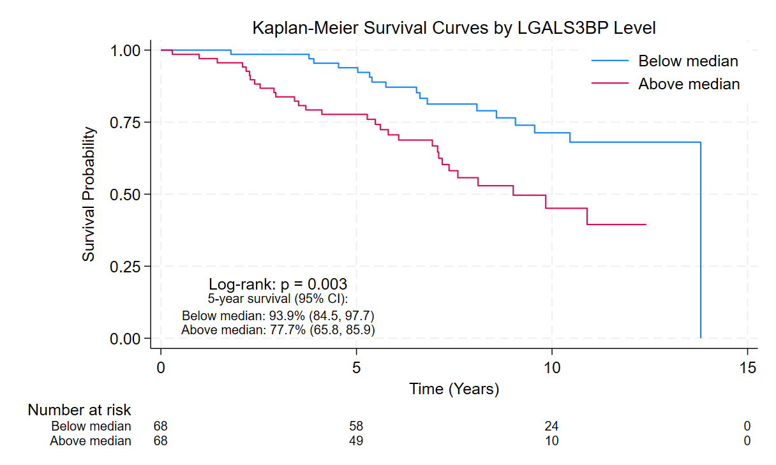
Supplemental Figure 3. Kaplan-Meier plots for the four top-performing Protein EpiScore with CRC overall survival. Protein EpiScore for LGALS3BP was dichotomized at its median value, allowing for a balanced sample size between the low and high groups. Log-rank P-values and 5-year survival percentage and corresponding confidence intervals are also reported.

Supplemental Table 4. Stratified associations of LGALS3BP and overall survival
Stratum | HR | CI_low | CI_high | p | P-interaction
Age at diagnosis
< 65 | 1.77 | 0.90 | 3.49 | 0.0995 | 0.98
≥ 65 | 1.92 | 1.30 | 2.85 | 0.0011 | 0.98
BMI Group
< 30 | 1.62 | 1.10 | 2.37 | 0.0136 | 0.98
≥ 30 | 1.95 | 0.95 | 4.01 | 0.0702 | 0.98
Sex
Female | 2.15 | 1.21 | 3.82 | 0.0089 | 0.62
Male | 1.65 | 1.10 | 2.48 | 0.0164 | 0.62
Tumor location
Rectum | 2.11 | 1.32 | 3.38 | 0.0019 | 0.33
Colon | 1.51 | 0.89 | 2.58 | 0.1299 | 0.33
Associations are estimated using Cox regression models, treating time on study as the time-scale. All models are adjusted for confounders (age at diagnosis, race, BMI group, tumor location, and stage)

Supplemental Table 5. C-index estimates for Protein EpiScore prediction of CRC disease-free and overall survival risk
Model components | C-index | 95% CI | P-diff
Disease-free survival
Age only | 0.597 | 0.523, 0.666 | ----
Age + sex | 0.599 | 0.530, 0.668 | 0.889
Age + sex + race | 0.617 | 0.544, 0.670 | 0.274
Age + sex + race + BMI | 0.619 | 0.547, 0.691 | 0.889
Age + sex + race + BMI + tumor site | 0.638 | 0.571, 0.706 | 0.352
All clinical risk factors | 0.641 | 0.576, 0.704 | 0.867
Risk factors + HCII, VEGFA, CCL17, LGALS3BP | 0.702 | 0.636, 0.768 | 0.030
Overall survival
Age only | 0.655 | 0.583, 0.727 | ----
Age + sex | 0.650 | 0.578, 0.723 | 0.654
Age + sex + race | 0.662 | 0.591, 0.734 | 0.555
Age + sex + race + BMI | 0.670 | 0.595, 0.745 | 0.644
Age + sex + race + BMI + tumor site | 0.677 | 0.602, 0.753 | 0.480
All clinical risk factors | 0.697 | 0.620, 0.774 | 0.379
Risk factors + LGALS3BP | 0.747 | 0.673, 0.821 | 0.024
Risk factors include age at diagnosis, sex, race, BMI group, tumor location, and stage at diagnosis. The 95% confidence intervals were generated from bootstrapped models. P-diff represents the P-value for difference from the model preceding it.

