Supplemental Figure 1. Plots of the top 4 probe-wise Pearson correlation analysis results, significant at the Bonferroni threshold, comparing DNA methylation levels (M-values) from all participants in dural tissue to DNA methylation in whole blood in infants with spina bifida.

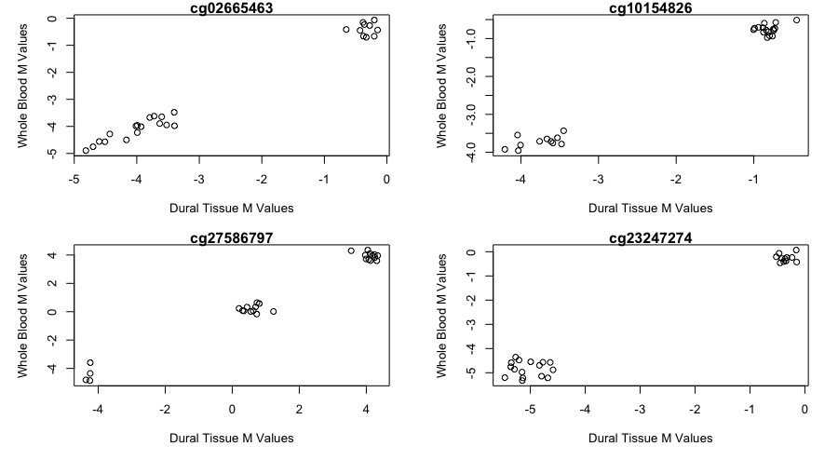

Supplemental Figure 2. Plots of the top 4 probe-wise Pearson correlation analysis results, significant at the Bonferroni threshold, comparing DNA methylation levels (M-values) from all participants in dural tissue to DNA methylation in buccal swabs in infants with spina bifida.

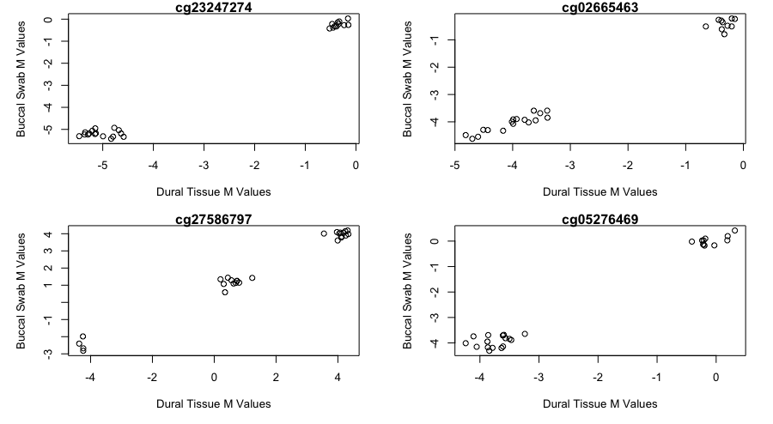

Supplemental Figure 3. Q-Q plots of the paired analysis results. The plots correspond to the models comparing DNA methylation levels (M-values) in A) dural tissue and whole blood and B) dural tissue and buccal swabs.

