Supplementary Information

1.1 DNA methylation assay by Infinium 450K Beadchip Array
AllPrep DNA/RNA Mini Kit (Qiagen) was used to isolate genomic DNA from oropharyngeal tumor and adjacent normal tissues. The purity and concentration were estimated using NanoDrop 2000 (Thermo Fisher Scientific). Approximately, 850 ng of each DNA sample was subjected to sodium bisulfite conversion using EZ DNA methylation kit (Zymo Research) following the manufacturer’s protocol. Paired tumor and adjacent normal tissue samples from the discovery subset and tumor tissue samples from the validation subset were assayed for DNA methylation. Illumina Infinium HumanMethylation450 BeadChip was used to perform the whole genome DNA methylation assay that interrogates 485,577 CpG sites per sample at single base resolution. The chips were scanned by Illumina iScan reader and raw data were generated as intensity data file (∗.idat) format. The raw data were further quality checked using the GenomeStudio (v2010.3) methylation module (v1.8.5) software (Illumina). DNA methylation was quantitatively represented by β value which is the ratio of fluorescent signal intensities from the methylated probes to the sum of the signal intensities from the methylated and unmethylated probes.
β = [M/(M + U + α)],
where M = methylated probe, U = unmethylated probe and α was assigned a value of 100 as recommended by the BeadChip manufacturer (Illumina). The β value ranged from 0 to 1. A β-value close to 0 and 1 represented unmethylated and fully methylated CpG loci respectively ^{[1]}.
1.2 Whole transcriptome sequence data generation protocol
Total RNA extraction from oropharyngeal tumor and adjacent normal tissue was performed using AllPrep DNA/RNA Mini Kit (Qiagen), which was followed by quality control and quantification of the isolated RNA by Agilent 2100 Bioanalyzer and NanoDrop 2000 (Thermo Fisher Scientific). RNA samples with OD 260/280 ratio ≥ 2 and RNA Integrity Number (RIN) ≥ 7 were selected for sequencing library preparation. Ribosomal RNA (rRNA) depletion from the selected whole RNA samples were performed using the Ribo-ZeroTM Magnetic Kit (Illumina). The purified RNA samples were used for preparation of sequencing libraries using TruSeq RNA Library Prep Kit v2 (Illumina). The sequencing libraries with unique barcodes prepared from each sample were pooled before loading in Illumina HiSeq – 2500 to generate 2 × 100 bp reads using Illumina TruSeq SBS V3 sequencing kit. Manufacturers’ supplied protocols were followed for all the assays.
1.3 Estimation of the power of the sample size
The power estimation of the sample size in this study was performed by conducting a simulation analysis considering the 14 tumour and respective paired adjacent normal samples with 2000 iterations of the simulation for CpGs with different mean methylation (μ) - unmethylated CpGs (μ= 0.1), hemimethylated CpGs (μ = 0.5), and highly methylated CpGs (μ = 0.8). The beta distribution was considered across three precisions (ɸ) - low (ɸ = 20), intermediate (ɸ = 50), and high (ɸ= 100). Higher ɸ indicates lower variance and a higher chance of true positive signals. Beta values (ꞵ) were simulated from a Beta (α, β’) distribution parameterized by mean (μ) and precision (ɸ), where α = [μ ✕ ɸ] and β’ = [(1-μ) ✕ ɸ]. Delta Beta (Δꞵ) is the change in μ between tumour and paired normal samples. Positive Δ indicates hypermethylation in the tumour, while negative Δ indicates hypomethylation in tumour samples. It was observed that for all kinds of CpGs (μ = 0.1, 0.5, 0.8) and all kinds of precisions (ɸ = 20, 50, 100), the sample size of this study was sufficient to capture the Δꞵ of more than ±0.2 (threshold of Δꞵ considered in the study for downstream analyses) with 100% confidence (empirical power = 1) (Supplementary Fig S3A). Moreover, even for much lower Δꞵ, such as ±0.05, the sample size of this study could successfully detect true positive signals with more than 80% confidence (empirical power > 0.8) (Supplementary Fig S3A).
At Δꞵ as low as ±0.05 and Δꞵ ±0.2; this study design can successfully differentiate the beta distribution (expected skewness) of normal and tumour samples for intermediate (ɸ = 50) and high (ɸ= 100) precision beta values, and for all three kinds of CpGs, emphasizing the robustness of the study design adopted (Supplementary Fig S3 B, C).

1.4 Detection of Human papillomavirus (HPV) in oropharyngeal tumour samples
1.4.1 PCR Amplification and HPV Genotyping
Human papillomavirus (HPV) detection and genotyping were performed using a nested multiplex PCR (NMPCR) assay targeting the E6/E7 gene region. Prior to amplification, the PCR workstation was disinfected using ultraviolet radiation for approximately 30 minutes to minimize the risk of contamination. Reagents including PCR buffer, MgCl₂ solution, and nuclease-free water were thawed at room temperature, while primers, dNTP mix, and DNA samples were thawed on ice for ~30 minutes before experiment setup. Two primer cocktails were prepared: Primer Cocktail 1 for the outer PCR using consensus primers (GP-E6-3F, GP-E6-5B and GP-E6-6B) ^{[2]}, and Primer Cocktail 2 for the inner NMPCR using HPV subtype-specific primers. A total reaction volume of 10 µL was prepared for both rounds of PCR. All samples were initially amplified using Primer Cocktail 1 under the HPV_E6/E7 consensus amplification program. The amplified products obtained from the first round served as the template for the inner NMPCR, which was carried out using Primer Cocktail 2 and the corresponding HPV subtype-specific amplification program. The amplicons obtained from the inner NMPCR were analysed by 2% agarose gel electrophoresis using a 100 bp DNA ladder as a molecular size reference. HPV subtypes were identified based on their characteristic signature amplicon sizes.
1.4.2 Detection of HPV from RNA Sequencing Reads
Human genome FASTA and annotation (GTF) were downloaded from GENCODE (GRCh37 / hg19 build). HPV-16 and HPV-18 complete genome FASTA and annotation (GFF3) files were obtained from NCBI / PaVE (the Papillomavirus Episteme). HPV GFF3 files were converted to GTF format with "gffread" so that both human and viral annotations were available in GTF format for splice-junction incorporation into the STAR index. Human FASTA and the HPV FASTA sequences and additionally human GTF and the converted HPV GTFs were concatenated respectively into a single FASTA and GTF file so that the aligner treats human and viral sequences as part of the same reference. Genome index was built from the combined FASTA and GTF using STAR ^{[3].} A total of 16 tumour RNA-seq samples (paired-end FASTQ files) were analyzed which included 14 oropharyngeal squamous cell carcinoma (OPSCC) samples and 2 cervical squamous cell carcinoma (CACX) tumour samples used as positive controls for HPV detection. Reads were aligned to the combined human + HPV reference using STAR with chimeric read detection enabled to identify reads spanning human–viral junctions (integration sites) or other fusion events. Downstream processing included chimeric junction counts - extraction of candidate human–HPV junctions from the chimeric output for validation and visualization, and counting reads per viral gene. Viral read quantification was performed from coordinate-sorted BAM files using HTSeq-count ^{[4]}. Read counting was carried out against the corresponding GENCODE human genome annotation.
From the NMPCRs a 457bp amplicon representing HPV 16 subtype had been observed only for Positive control. Thus, OPSCC samples were either HPV negative or had <5.56 HPV copies (Supplementary Fig S2). It was inferred from the RNA-seq data that none of the OPSCC samples contained HPV reads where as CaCx samples (positive control) contained significant amount of HPV-16 reads and additionally these samples had 30 and 54 human-HPV chimeric reads respectively (Supplementary_Table_S2).

1.5 Comparison with TCGA Data
Publicly available TCGA HNSCC data set includes data from all the anatomical subsites of HNSCC. Genebody specific DNA methylation status in OPSCC tissues from our data set was validated considering the data pertaining to 78 OPSCC patients in the TCGA dataset (raw .IDAT files were downloaded from the GDC Legacy Archive). The IDAT files of OPSCC TCGA data were processed following our DNA methylation data analysis pipeline and β values were calculated. Further, Spearman’s rank correlation was calculated between the β values in tumor of our data (N=24) and TCGA data (N=78) for 4566 hypermethylated and 1875 hypomethylated genebody specific DMPs. In both cases significant strong positive correlation (Spearman’s rank correlation ρ = 0.89; p-value < 2.2 × 10^{–16} for hypermethylated DMPs and ρ = 0.9; p-value < 2.2 × 10^{–16} for hypomethylated DMPs) (Supplementary Figure S7A-D) was inferred. Unsupervised hierarchical clustering and heatmap (Supplementary Figure S7E) of log normalized FPKM values of 14 pairs of tumour and adjacent normal tissues from our data and 78 OPSCC TCGA data of the DEGs (N=1538) revealed two major cluster - cluster I of normal samples and cluster II of our and TCGA data tumour samples. Further the cluster II divided into two sub-cluster of our and TCGA tumour data respectively that explains certain degree of similarly in the gene expression profile between TCGA and our data.
The evaluation of methylation and gene-expression profiles of the key genes TDO2 and KYNU demonstrated that both genes are significantly hypermethylated and upregulated in the OPSCC samples of our cohort compared with TCGA-OPSCC samples, irrespective of HPV status. For TDO2, the methylation differences (Δβ) observed were 0.22 (p = 4.7×10⁻⁵) and 0.21 (p = 1.8×10⁻⁶) relative to HPV-negative and HPV-positive TCGA-OPSCC samples, respectively. Similarly, methylation changes for KYNU were 0.11 (p = 0.013) and 0.20 (p = 0.0005) for the corresponding comparison groups. Statistical significance of methylation differences was assessed using the Wilcoxon rank-sum test. At the transcript level, TDO2 showed more than a two-fold upregulation in our OPSCC cohort compared with both HPV-negative (log₂FC = 1.54, p = 0.0003) and HPV-positive (log₂FC = 1.82, p = 2.8×10⁻⁵) TCGA-OPSCC samples. KYNU exhibited a more than six-fold increase in expression relative to HPV-negative (log₂FC = 3.5, p = 6.7×10⁻⁹) and HPV-positive (log₂FC = 3.4, p = 4.2×10⁻⁸) TCGA-OPSCC samples. Differential expression significance was assessed using unpaired t-tests (Supplementary Fig S8).

1.6 Impact of age and gender in genebody specific methylation changes in OPSCC tissues
To explore the effect of patients age and gender on genebody specific methylation changes in tumour tissues, Chi-square test was performed between cluster identity of patients [CIP] (Figure 1C) with age and gender respectively. None of them were found to be significant (CIP vs age quartile p-value = 0.5942 and CIP vs gender p-value = 0.5942). Further, to increase the robustness of the inferences by increasing sample size, along with discovery set patients validation set patients were considered (N=24). For all twenty-four patients, methylation index score (MIS) was calculated which was summation of Z-scores of all DMPs of a particular sample. Here, Z-score for each DMP was calculated as - (methylation level of each genebody DMP – mean value of methylation levels)/SD of methylation levels. Then sum of the Z-score of 5014 genebody DMPs were calculated giving one single value for each sample ^{[5]} (Supplementary_Table_S8). Simple linear regression analysis was performed between MIS with age, gender and tumour grade respectively but none of them were satisfied the significance level of p value < 0.05 (MIS vs age p-value = 0.6964, MIS vs gender p-value = 0.4579 and MIS vs tumour grade p-value = 0.6175). Thus, it could be concluded that age, gender and tumour grade have no effect on DNA methylation alterations in genebodies in OPSCC tissues.

1.7 Concurrent DNA methylation in gene promoter and genebody
Promoter and genebody methylation have a paradoxical effect on gene expression. In this study genes having genebody methylation which is devoid of any promoter methylation and has a positive correlation with gene expression has been identified (n=137). Additionally, there were genes (N=117) which had concurrent methylation alternations in both promoter and genebody with significant changes in gene expression (Supplementary_Table_S9). The tripartite effect of methylation - gene expression alteration identified in ~ 5.12% (N=6) genes which had promoter hypermethylation and genebody hypomethylation with downregulation of genes along with ~48% (N=56) genes that showed hypermethylation in both promoter and genebody with downregulation of genes. Additionally, ~38.5% (N=45) of genes were upregulated due to dual hypomethylation in promoter and genebody and only ~8.5% (N=10) had promoter hypomethylation and genebody hypermethylation with gene downregulation. Notable cancer associated genes identified were JAK3, LAG3 which are upregulated whereas KRT3, KRT5, ALDH3A1 were shown downregulation with dual methylation alteration in promoter and genebody.

Supplementary Table S1: Clinical characteristics of the discovery and validation set patients
Characteristics | Patient information
 | Discovery set | Validation set
Total patients | 14 | 10
Disease/ Normal | 14/ 14 | 10 Tumour
Age range (in years) | 34-73 | 34-72
Mean age (SD) (in years) | 52.76 (13.45) | 51.9 (14.42)
No. of males/females | 10/ 3 | 8/ 2
HPV: positive/negative | All Tumours HPV Negative
Tumour Grade
Grade 1 | 2 | 2
Grade 2 | 5 | 3
Grade 3 | 4 | 4

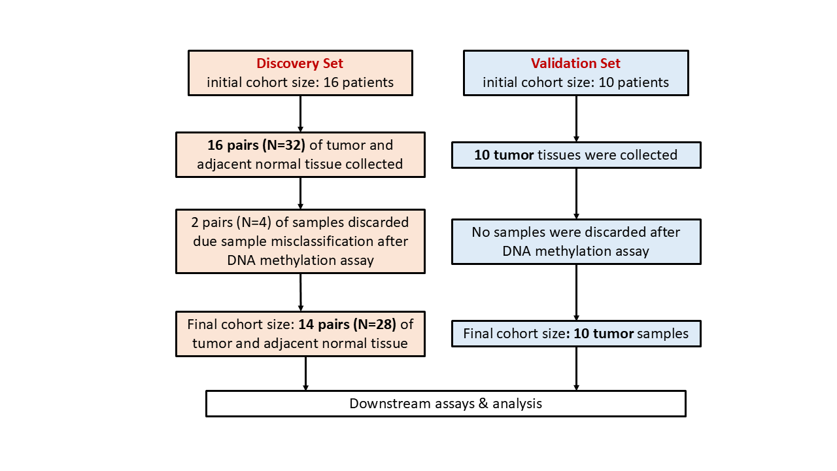
Supplementary Figures
Supplementary Fig S1: Illustrative flowchart of patient/sample inclusion, exclusion, and cohort allocation

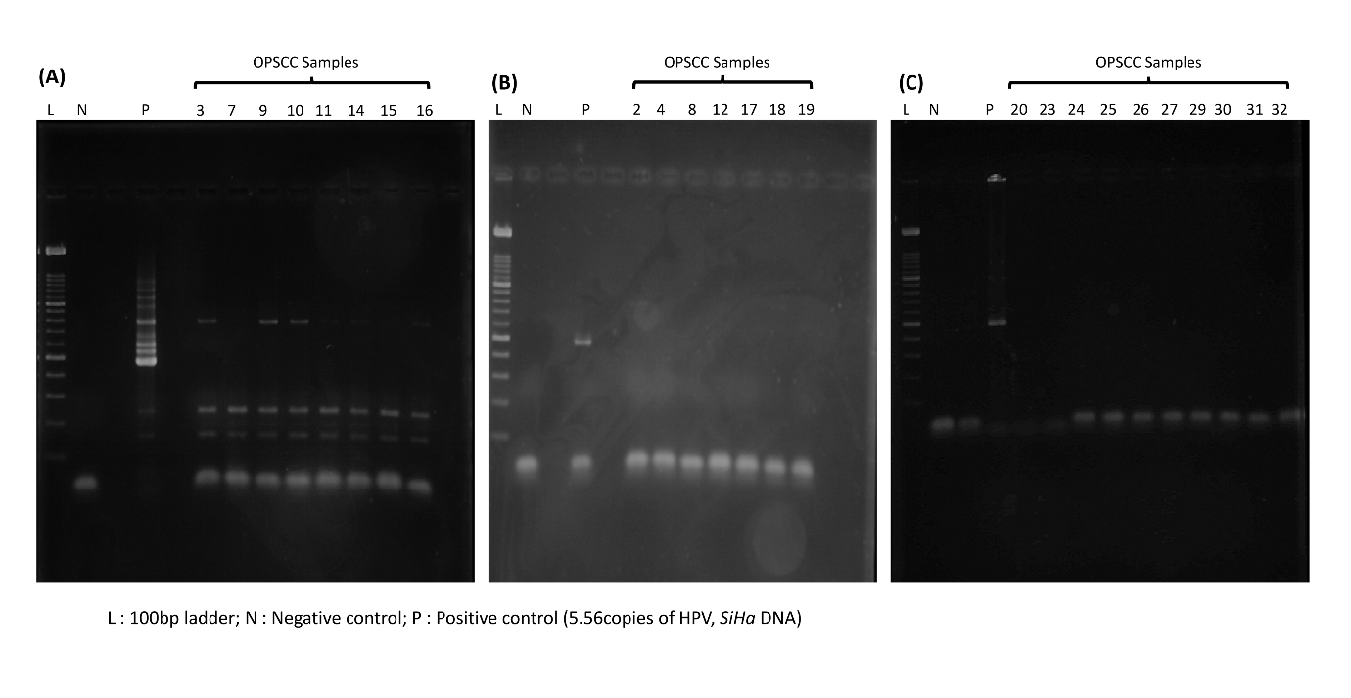Supplementary Fig S2: Detection and genotyping Human papillomavirus (HPV) by Nested Multiplex PCR. The gel images revealed (A-C) that LANE-1, LANE-2 and LANE-4 had 100bp ladder, negative control and 5.56copies of HPV (SiHa DNA - Positive control) respectively. (A) LANE-6 – LANE-13, (B) LANE-6 – LANE-14 and (C) LANE-5 – LANE-14 provided with 20ng/ul DNA samples from OPSCC tissues. A 457bp amplicon representing HPV 16 subtype has been observed only for Positive control in LANE-4 clearly explaining that the OPSCC samples were either HPV negative or has <5.56 HPV copies.

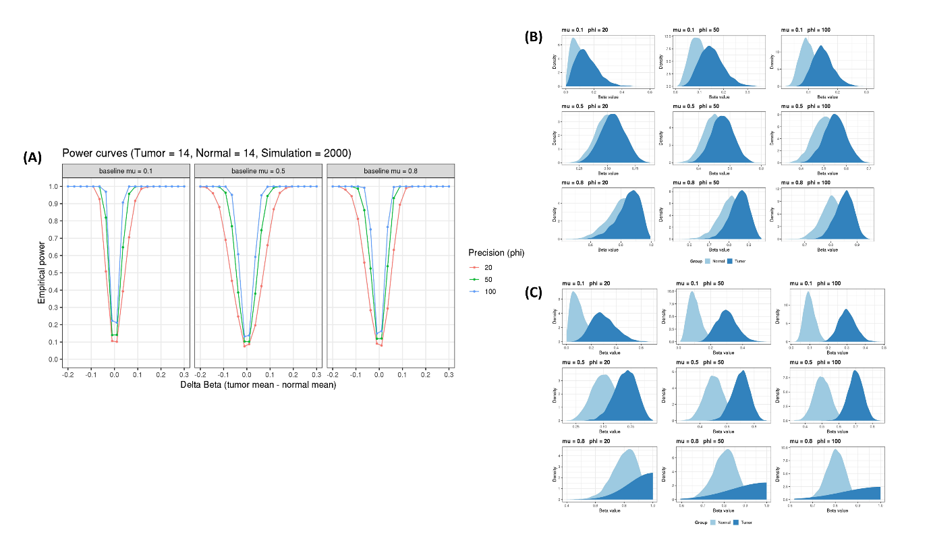Supplementary Fig S3: Power estimation of the sample size. (A) 2000 iterations of simulation considering 14 paired tumour and adjacent normal samples with the CpGs with different mean methylation (μ) levels revealed that all kinds of CpGs (μ = 0.1, 0.5, 0.8) at all kinds of precisions (ɸ = 20, 50, 100), the sample size of this study was sufficient to capture the Δꞵ of more than ±0.2 with 100% confidence. At Δꞵ ±0.05 (B) and Δꞵ ±0.2 (C) the study design successfully differentiates the beta distribution of normal and tumour samples for intermediate (ɸ = 50) and high (ɸ= 100) precision.
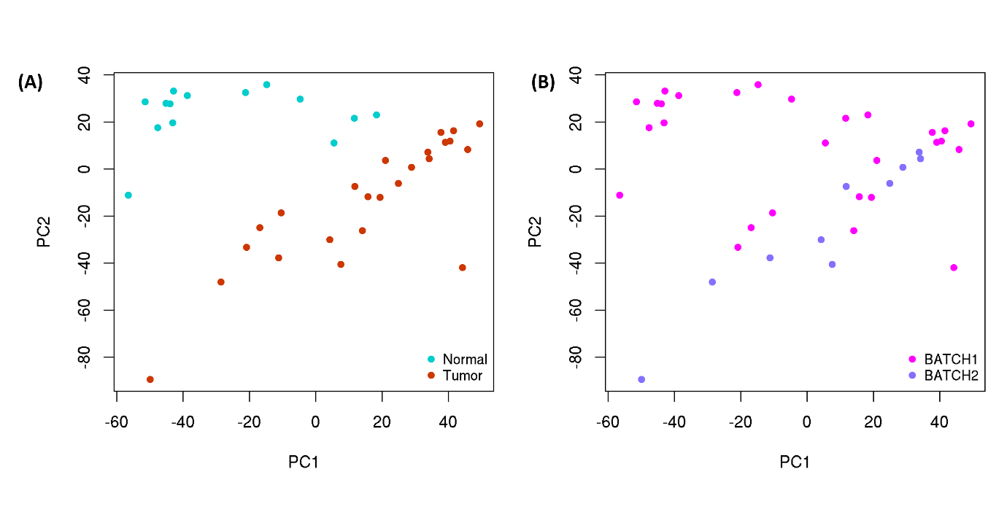Supplementary Fig S4: Principal component analysis (PCA) on all normalized beta (ꞵ) values of detection p-value cut-off satisfied CpG probes (N = ~450k) from 14 paired tumour and adjacent normal tissues and 10 only OPSCC tissues which ran on two separate batches respectively revealed that variation observed not due to batch effect (B) but only due to tumour and normal samples inherent distinct molecular signatures in terms of DNA methylation. Hence no batch effect observed.
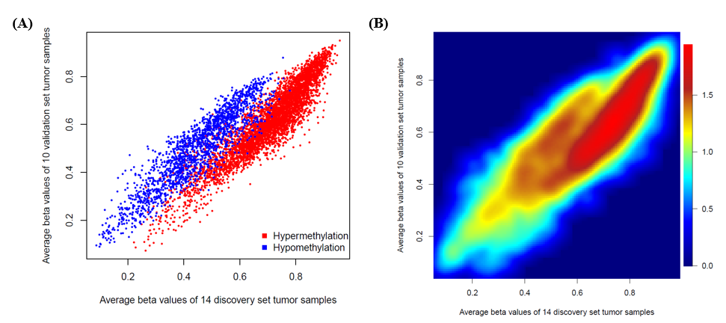

Supplementary Fig S5: Genebody specific DNA methylation profile of OPSCC tissues validated in independent set of tumour tissues of same cancer. (A) Tumour β values of 6,641 DMPs of discovery set (N=14) showed significantly strong correlation (Spearman ρ = 0.86 and P-value < 2.2e-¹⁶) with that of the β values of same in validation set (N=10). (B) The density scatter plot depicts CpG loci density in particular value position.
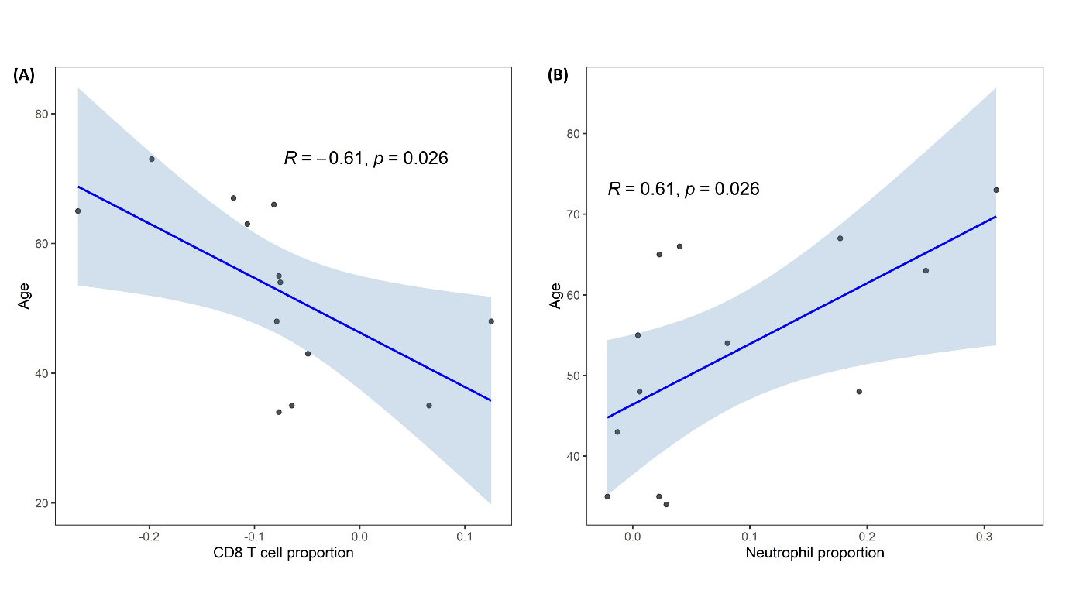
Supplementary Fig S6: Scatter plot of immune cell proportion (x-axis) and age (y-axis) with best-fit regression line revealed that the patients’ age has a significant effect on the differential proportions of cytotoxic CD8+ T cells (intercept: 0.1594, slope: –0.004484) (A) and neutrophils (intercept: -0.179874, slope: 0.005015) (B) in tumour tissues respectively.

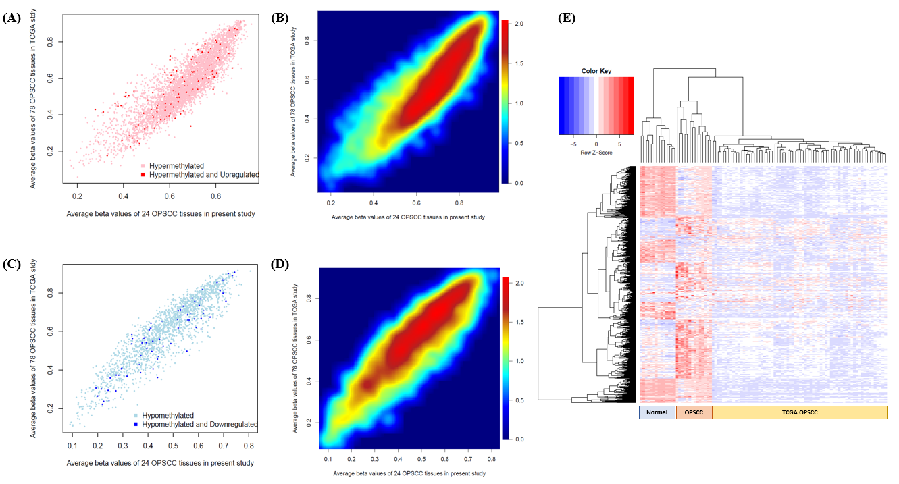
Supplementary Fig S7: Scatter plots of average β values in tumor of 24 OPSCC patients from North Eastern Indian states and publicly available 78 OPSCC patients from TCGA-HNSCC cohort considering genebody specific (A) 4566 hypermethylated and (C) 1875 hypomethylated DMPs revealed significant strong correlation (ρ = 0.8; p-value < 2.2x10⁻¹⁶ and ρ = 0.9; p-value < 2.2x10⁻¹⁶ respectively); (B,D) The density scatter plot depicts CpG loci density in particular value position for hypermethylated and hypomethylated DMPs; (E) Unsupervised hierarchical clustering and heatmap of log normalized FPKM values of 14 pairs of tumor and adjacent normal tissues and 78 OPSCC TCGA data of the DEGs (N=1538) revealed two major cluster - cluster I of normal samples and cluster II of all tumor samples.

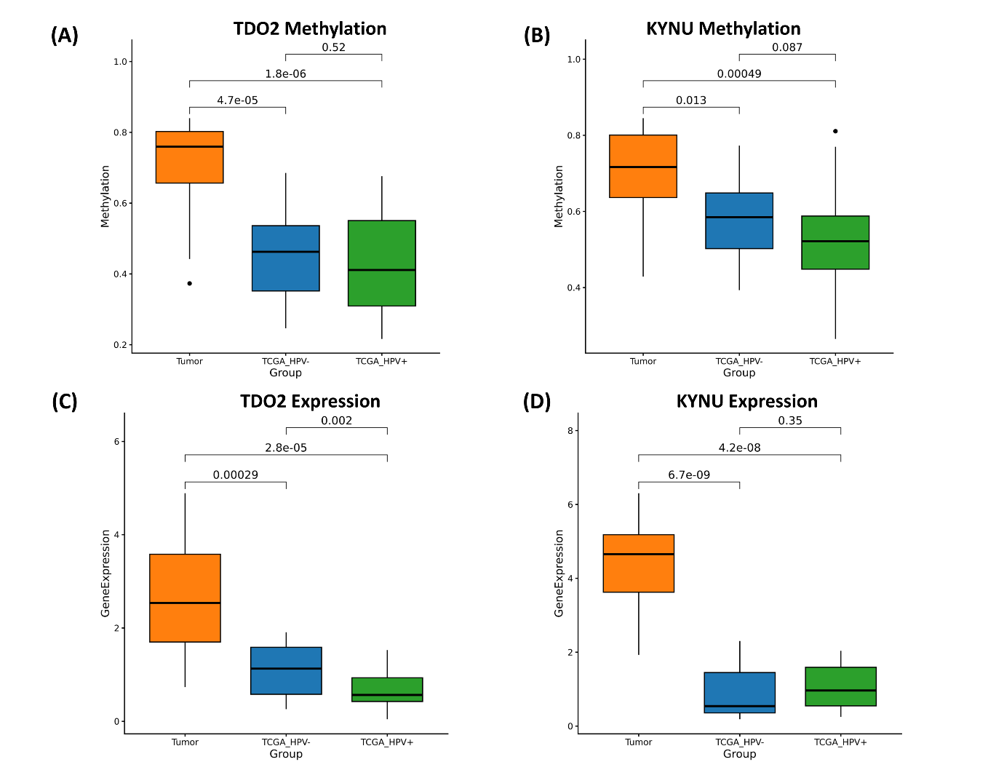
Supplementary Fig S8: Methylation and gene-expression profiles of the key genes TDO2 (A, C) and KYNU (B, D) demonstrated that both genes are significantly hypermethylated and upregulated in the OPSCC samples of our cohort compared with TCGA-OPSCC samples, irrespective of HPV status.

Supplementary References
- Bibikova M, Barnes B, Tsan C, Ho V, Klotzle B, Le JM, Delano D, Zhang L, Schroth GP, Gunderson KL, Fan JB, Shen R. High density DNA methylation array with single CpG site resolution. Genomics. 2011 Oct;98(4):288-95. doi: 10.1016/j.ygeno.2011.07.007. Epub 2011 Aug 2. PMID: 21839163.

- Ghosh A, Sinha A, Ghosh A, Roy S, Mallick S, Kumar V, Mathai S, Bhaumik J, Mukhopadhyay A, Sen S, Chandra A, Maitra A, Biswas NK, Majumder PP, Sengupta S. Biological and clinical relevance of correlated expression levels of coding and long noncoding RNAs in HPV16 positive cervical cancers. Hum Genomics. 2024 Aug 29;18(1):91. doi: 10.1186/s40246-024-00660-2. PMID: 39210444; PMCID: PMC11360852.

- Dobin A, Davis CA, Schlesinger F, Drenkow J, Zaleski C, Jha S, Batut P, Chaisson M, Gingeras TR. STAR: ultrafast universal RNA-seq aligner. Bioinformatics. 2013 Jan 1;29(1):15-21. doi: 10.1093/bioinformatics/bts635. Epub 2012 Oct 25. PMID: 23104886; PMCID: PMC3530905.

- Putri GH, Anders S, Pyl PT, Pimanda JE, Zanini F. Analysing high-throughput sequencing data in Python with HTSeq 2.0. Bioinformatics. 2022 May 13;38(10):2943-2945. doi: 10.1093/bioinformatics/btac166. PMID: 35561197; PMCID: PMC9113351.

- Klajic J, Fleischer T, Dejeux E, Edvardsen H, Warnberg F, Bukholm I, Lønning PE, Solvang H, Børresen-Dale AL, Tost J, Kristensen VN. Quantitative DNA methylation analyses reveal stage dependent DNA methylation and association to clinico-pathological factors in breast tumors. BMC Cancer. 2013 Oct 5;13:456. doi: 10.1186/1471-2407-13-456. PMID: 24093668; PMCID: PMC3819713.

