Supplementary methods

Supplementary Figures
Figure S1. The workflow to calculate the α-value and construct the classifier model.
Figure S2. The GO enrichment results of differential methylation regions.
Figure S3. Interpretation of the cMCD by SHAP.
Figure S4. The calibration curve (A) and decision curve analysis (B) of cMCD.
Figure S5. The risk score (A) and covariate analysis (B) of cMCD.
Figure S6. Interpretation of the cMCSS by SHAP.
Figure S7. The calibration curve (A) and decision curve analysis (B) of cMCSS.

Supplementary Tables
Table S1. List of 21 selected DMRs according to Methylome-Seq.
Table S2. The performance of the 21 individual biomarkers for the early detection of colorectal tumors.
Table S3. The performance of different methods for the combined detection of AA and all-stage CRC.
Table S4. The performance of the 21 individual biomarkers for the stage stratification of colorectal tumors.
Table S5. The performance of different methods for stage stratification.

Supplementary methods
Sample size calculation
As reported, the sensitivity of CEA for detecting colorectal cancer (CRC) is approximately 30%, which is also confirmed in our data. We hypothesized that the diagnostic sensitivity of the ctDNA methylation-based method could be increased to 60%. According to the following formula:
$n=\frac{P1*\left(1-P1\right)+P2*(1-P2)}{{(P2-P1)}^{2}}*f(α, β)$;
P1=30%, P2=80%. With a unqualified rate of 10%, a two-sided significance level at 0.05 (α=0.05), a power of 0.20 (β=0.20), f(α, β)=7.9. Thus, 89 patients were needed. In this study, a total of 726 patients met the inclusion criteria. However, 64 patients were excluded: 36 patients received tumor treatment prior to blood sample collection, 13 patients had other malignancies or inflammatory bowel disease, 7 patients received emergency surgery, 4 patients had abnormal liver and/or kidney function and 4 patients refused to provide blood samples. 662 blood samples were collected for ctDNA sequencing while 26 of them were identified as unqualified samples. Finally, 636 blood samples were included, meeting the sample size standard.

Methylome-seq data preprocessing
In this study, the methylome-seq data was preprocessed in four steps.
In step 1, the adapter sequence was removed and low-quality base was trimmed. Trimmomatic (Version 0.36) was used to trim the default Illumina adapters from the sequencing reads and perform a sliding window trimming, cutting once the average quality within the window falls below a threshold (using the options as --phred33 ILLUMINACLIP:TruSeq3-PE.fa:2:30:7:1:true MINLEN:36 TRAILING:3 SLIDINGWINDOW:4:15). The software fastp (v0.21.0) was used to visualize quality control results and make a summary HTML report.
In step 2, we performed paired-end sequencing reads merging, alignment and methylation calling. We first used pear (https://github.com/tseemann/PEAR) to merge read-1 and read-2 to form one fragment with default parameters. We then used BSMAP (v2.73) to align the merged reads to the reference genome hg19 (GRCh37). And then Samtools (version 1.19) was used to sort mapped reads with mapping locations. BSMAP’s methylation extractor ‘metratio.py’ was then used to call methylation of reach cytosine in the mapped reads.
In step 3, the chromosome-wise sequence alignment statistics and whole-methylome methylation statistics were summarized from the individual read information obtained in Step 2.
In step 4, tissue and PBMCs samples were sequenced and processed in the same manner as Methylome-Seq data.

Supplementary Figures
Figure S1. The workflow to calculate the α-value and construct the classifier model.
To identify tumor-specific DMRs across the whole genome, all reads with at least 5 CpG sites were collected. Comparisons between colorectal tumor tissue and adjacent normal tissue was performed. The background noise was filtered using PBMC samples. The α-value for each candidate markers in all cfDNA samples was calculated. Methylated read was defined as the mapped read containing at least two adjacent methylated CpG sites. Then, the classifier model was constructed with the DMRs.

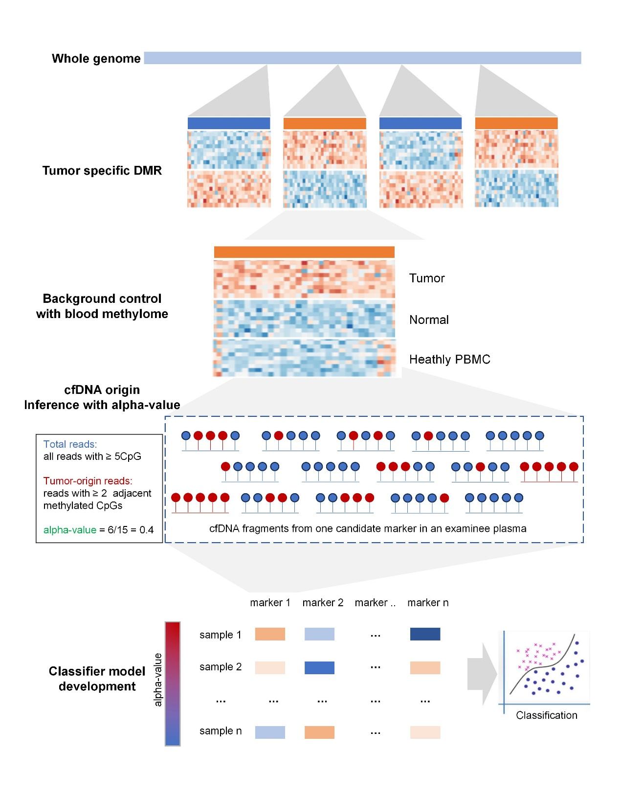

Figure S2. The GO enrichment results of differential methylation regions.
The GO enrichment analysis to predict potential biological functions and pathways associated with genes corresponding to DMRs. The size of the dot represents the number of differential genes, the color of the dot represents whether the adjusted P value is significant.
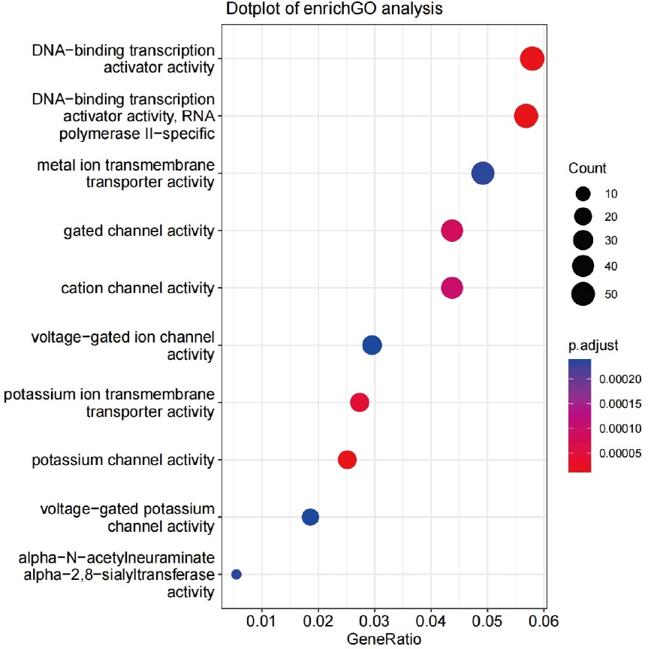

Figure S3. Interpretation of the cMCD by SHAP.
(A) Beeswarm summary plot of feature importance. This plot is designed to display an information-dense summary of how the selected biomarkers impact the cMCD’s output. Each observation in the data is represented by a single dot on each biomarker row. The vertical axis indicates the biomarkers. The placement of the dots along the biomarker row is dictated by the corresponding feature’s SHAP value, and the accumulation of dots within each feature row illustrates its density. The feature values determine the color of the dots: yellow represents a positive association with the early detection of colorectal tumor, while purple indicates a negative association. (B) Feature importance plot. Passing a matrix of SHAP values to the bar plot function creates a global feature importance plot, where the global importance of each feature is taken to be the mean absolute value for that feature across all the given samples. The biomarkers are ordered from top to bottom on the basis of their importance as predictors. SHPA SHapley Additive exPlanations.
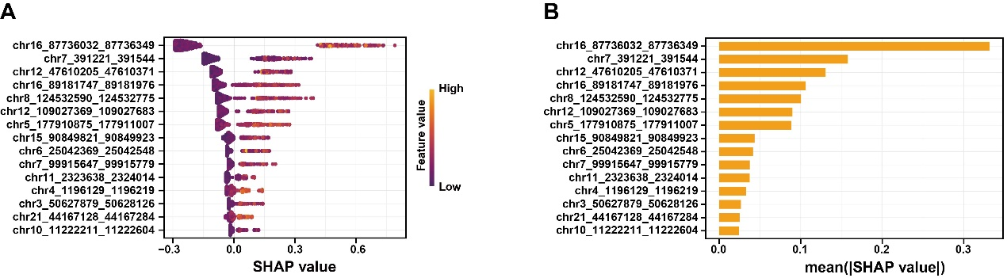

Figure S4. The calibration curve (A) and decision curve analysis (B) of cMCD.
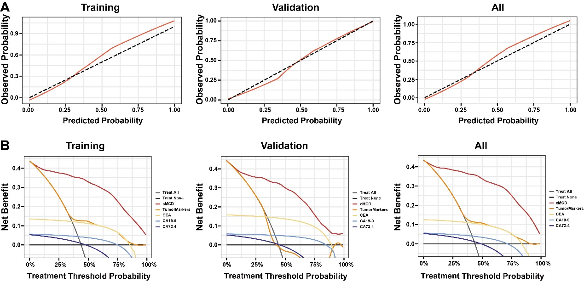

Figure S5. The risk score (A) and covariate analysis (B) of cMCD.
Age and tumor size significantly influence the sensitivity of cMCD in the diagnosis of colorectal tumors. NS, not significant; *p < 0.05; **p < 0.01; ***p < 0.001.
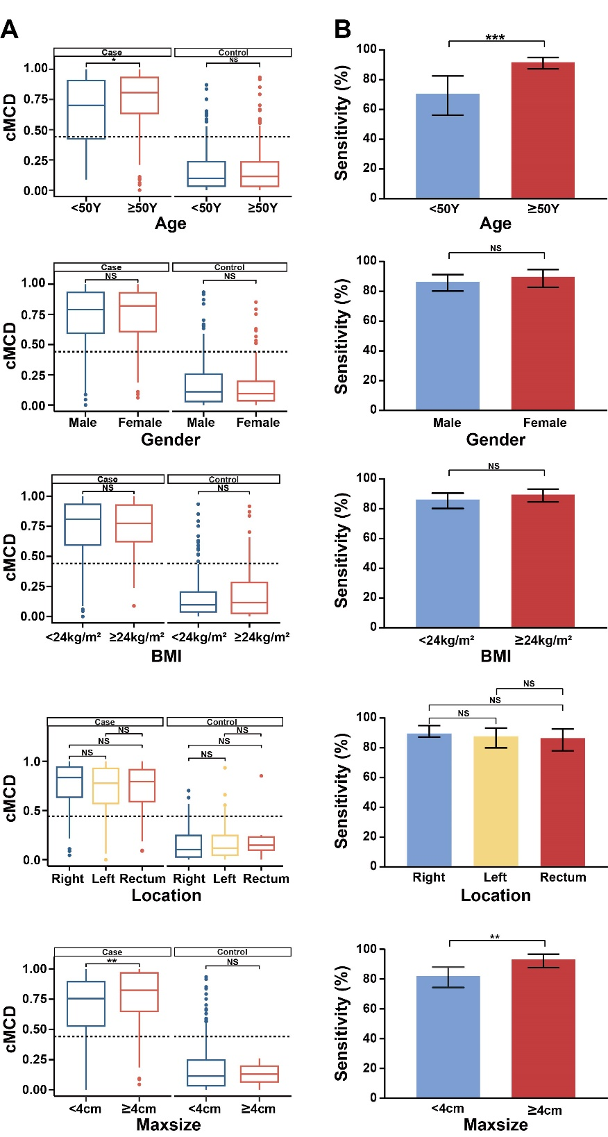

Figure S6. Interpretation of the cMCSS by SHAP.
(A) Beeswarm summary plot of feature importance. This plot is designed to display an information-dense summary of how the selected biomarkers impact the cMCD’s output. Each observation in the data is represented by a single dot on each biomarker row. The vertical axis indicates the biomarkers. The placement of the dots along the biomarker row is dictated by the corresponding feature’s SHAP value, and the accumulation of dots within each feature row illustrates its density. The feature values determine the color of the dots: yellow represents a positive association with the early detection of colorectal tumor, while purple indicates a negative association. (B) Feature importance plot. Passing a matrix of SHAP values to the bar plot function creates a global feature importance plot, where the global importance of each feature is taken to be the mean absolute value for that feature across all the given samples. The biomarkers are ordered from top to bottom on the basis of their importance as predictors. SHPA SHapley Additive exPlanations.
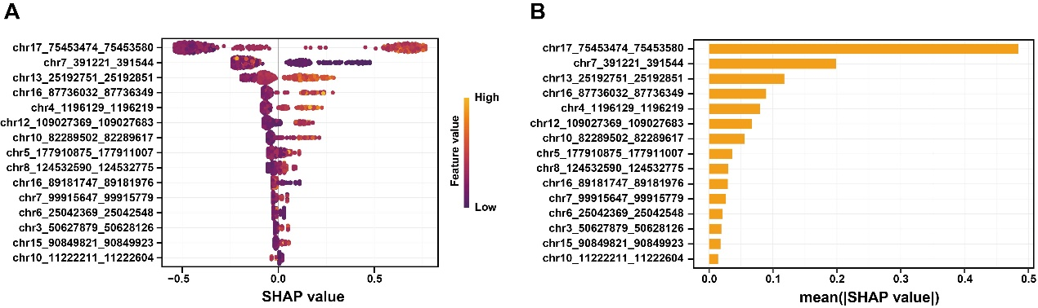

Figure S7. The calibration curve (A) and decision curve analysis (B) of cMCSS.
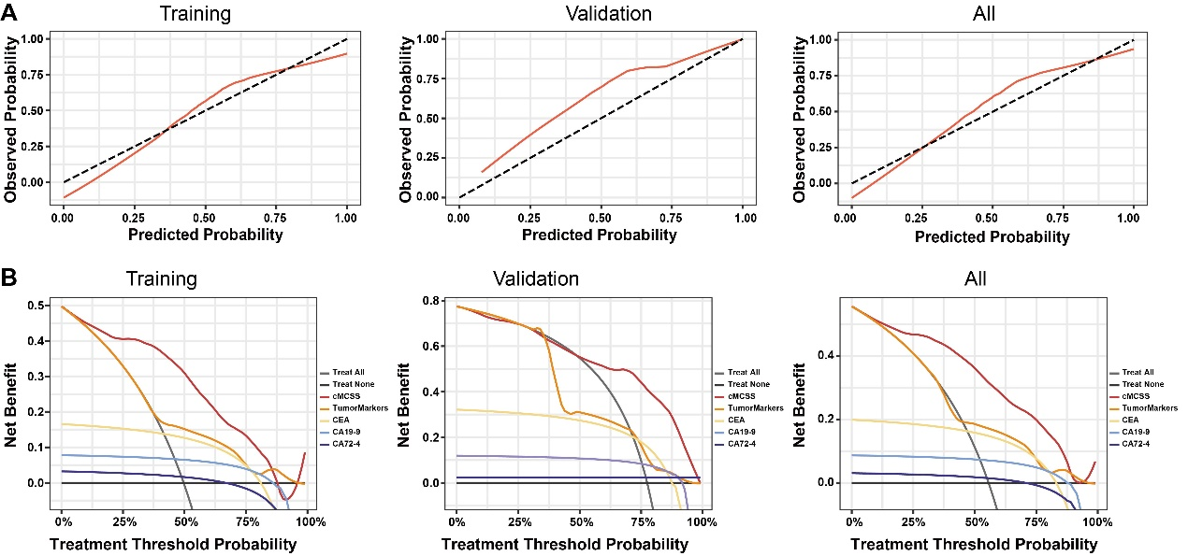

Supplementary Tables
Table S1. List of 21 selected DMRs according to Methylome-Seq.
Marker ID | |Δα|† | Adjusted P Value‡ | CpGs§ | Promoter | Exon | Intron
chr2_113874009_113874100 | 0.34 | 2.94e-51 | 7 | IL1RN | -- | --
chr3_50627879_50628126 | 0.55 | 7.85e-136 | 12 | -- | -- | --
chr4_1196129_1196219 | 0.58 | 1.24e-89 | 7 | -- | -- | LOC100130872  SPON2
chr5_177910875_177911007 | 0.36 | 2.83e-40 | 5 | -- | -- | COL23A1
chr6_25042369_25042548 | 0.56 | 1.585e-118 | 10 | FAM65B | FAM65B | --
chr7_391221_391544 | 0.63 | 5.01e-90 | 25 | -- | -- | --
chr7_99915647_99915779 | 0.64 | 7.80e-102 | 8 | -- | -- | SPDYE3
chr8_124532590_124532775 | 0.64 | 6.88e-114 | 9 | -- | -- | FBXO32
chr10_11222211_11222604 | 0.62 | 7.79e-217 | 19 | -- | -- | CELF2
chr10_82289502_82289617 | 0.51 | 4.54e-116 | 10 | LOC102723703 | LOC101929574 | LOC101929574
chr11_2323638_2324014 | 0.49 | 3.16e-173 | 15 | TSPAN32  C11orf21 | -- | TSPAN32  C11orf21
chr12_47610205_47610371 | 0.60 | 1.16e-90 | 7 | SELPLG  miR4496 | SELPLG | SELPLG
chr12_109027369_109027683 | 0.33 | 1.46e-117 | 12 | PCED1B-AS1 | PCED1B  PCED1B-AS1 | PCED1B
chr13_25192751_25192851 | 0.21 | 3.44e-24 | 5 | -- | -- | --
chr15_90849821_90849923 | 0.31 | 2.81e-43 | 6 | -- | -- | --
chr16_87736032_87736349 | 0.47 | 7.12e-131 | 12 | -- | -- | --
chr16_89181747_89181976 | 0.45 | 1.20e-149 | 14 | -- | -- | ACSF3
chr17_70715710_70715887 | 0.61 | 3.15e-114 | 9 | -- | -- | SLC39A11
chr17_75453474_75453580 | 0.62 | 1.87e-89 | 7 | -- | -- | SEPT9
chr19_55766833_55767204 | 0.42 | 1.48e-135 | 13 | -- | -- | PPP6R1
chr21_44167128_44167284 | 0.53 | 9.00e-73 | 6 | -- | -- | PDE9A
†, the absolute difference in the average α values between the tumor and control samples.
‡, the adjusted P values (obtained from 2D KS-test) were computed using the Benjamini–Hochberg method.
§, the number of cytosine-phosphoric-guanine (CpG) contained in the differential methylated region (DMR).

Table S2. The performance of 21 individual biomarkers for the early detection of colorectal tumors.
Marker ID | AUROC (95% CI) | Sensitivity (95% CI) | Specificity (95% CI) | Accuracy (95% CI)
chr2_113874009_113874100 | 0.74 (0.70-0.78) | 52.69%  (46.65%-58.67%) | 85.71%  (81.65%-89.17%) | 71.23%  (67.54%-74.72%)
chr3_50627879_50628126 | 0.73 (0.69-0.77) | 37.63%  (31.93%-43.61%) | 97.75%  (95.63%-99.02%) | 71.38%  (67.70%-74.87%)
chr4_1196129_1196219 | 0.74 (0.71-0.78) | 50.90%  (44.87%-56.90%) | 87.67%  (83.81%-90.90%) | 71.54%  (67.84%-75.02%)
chr5_177910875_177911007 | 0.71 (0.67-0.75) | 55.91%  (49.87%-61.83%) | 82.63%  (78.30%-86.42%) | 70.91%  (67.21%-74.42%)
chr6_25042369_25042548 | 0.71 (0.67-0.76) | 48.38%  (42.39%-54.42%) | 92.16%  (88.86%-94.72%) | 72.96%  (69.32%-76.37%)
chr7_391221_391544 | 0.76 (0.72-0.80) | 59.50%  (53.48%-65.31%) | 86.27%  (82.26%-89.67%) | 74.53%  (70.95%-77.87%)
chr7_99915647_99915779 | 0.72 (0.68-0.76) | 47.67%  (41.68%-53.71%) | 92.99%  (89.84%-95.42%) | 73.11%  (69.49%-76.52%)
chr8_124532590_124532775 | 0.72 (0.68-0.73) | 51.25%  (45.22%-57.26%) | 90.48%  (86.95%-93.31%) | 73.27%  (69.65%-76.67%)
chr10_11222211_11222604 | 0.74 (0.70-0.78) | 49.10%  (43.01%-55.13%) | 90.20%  (86.63%-93.10%) | 72.17%  (68.51%-75.62%)
chr10_82289502_82289617 | 0.77 (0.73-0.81) | 55.20%  (49.15%-61.13%) | 87.67%  (83.81%-90.90%) | 73.43%  (69.81%-76.82%)
chr11_2323638_2324014 | 0.75 (0.71-0.79) | 53.41%  (47.36%-59.37%) | 89.08%  (85.37%-92.12%) | 73.43%  (69.81%-76.82%)
chr12_47610205_47610371 | 0.75 (0.72-0.79) | 57.71%  (51.67%-63.57%) | 87.67%  (83.81%-90.90%) | 74.53%  (70.95%-77.87%)
chr12_109027369_109027683 | 0.76 (0.72-0.80) | 55.56%  (49.51%-61.48%) | 91.60%  (88.22%-94.26%) | 75.79%  (72.26%-79.07%)
chr13_25192751_25192851 | 0.67 (0.63-0.72) | 44.09%  (38.17%-50.13%) | 88.52%  (84.74%-91.63%) | 69.03%  (65.27%-72.60%)
chr15_90849821_90849923 | 0.73 (0.69-0.77) | 48.03%  (42.03%-54.06%) | 89.92%  (96.31%-92.84%) | 71.54%  (67.86%-75.02%)
chr16_87736032_87736349 | 0.77 (0.73-0.81) | 57.71%  (51.67%-63.57%) | 94.11%  (91.15%-96.32%) | 78.14%  (74.73%-81.30%)
chr16_89181747_89181976 | 0.74 (0.71-0.78) | 54.12%  (48.08%-60.08%) | 89.08%  (85.37%-92.12%) | 73.74%  (70.14%-77.12%)
chr17_70715710_70715887 | 0.73 (0.69-0.77) | 42.65%  (36.77%-48.69%) | 95.52%  (92.82%-97.42%) | 72.32%  (68.67%-75.77%)
chr17_75453474_75453580 | 0.77 (0.73-0.80) | 73.12%  (67.51%-78.23%) | 66.67%  (61.51%-71.54%) | 69.50%  (65.75%-73.06%)
chr19_55766833_55767204 | 0.74 (0.70-0.78) | 58.06%  (52.03%-63.92%) | 84.87%  (80.73%-88.43%) | 73.11%  (69.49%-76.52%)
chr21_44167128_44167284 | 0.74 (0.70-0.78) | 48.75%  (42.74%-54.78%) | 91.04%  (87.58%-93.79%) | 72.48%  (68.84%-75.92%)

Table S3. The performance of different methods for the combined detection of AA and all-stage CRC.
Methods | cMCD | TumorMarkers | CEA | CA19-9 | CA72-4
AUROC | 0.95 (0.93 to 0.97) | 0.65 (0.62 to 0.69) | 0.64 (0.61 to 0.67) | 0.55 (0.53 to 0.57) | 0.51 (0.49 to 0.64)
Sensitivity | 87.82% (83.39% to 91.41%) | 35.84% (30.21% to 41.71%) | 30.82% (25.46% to 36.61%) | 12.90% (9.20% to 17.41%) | 12.19% (8.59% to 16.61%)
Specificity | 91.88% (88.54% to 94.49%) | 93.84% (90.82% to 96.10%) | 95.80% (93.17% to 97.63%) | 96.64% (94.20% to 98.25%) | 89.64% (86.00% to 92.60%)
Accuracy | 89.85% (87.50% to 92.30%) | 68.40% (64.63% to 71.10%) | 67.30% (63.50% to 70.93%) | 59.91% (55.98% to 63.74%) | 55.66% (51.70% to 59.57%)
PPV | 89.42% (85.60% to 92.31%) | 81.97% (74.65% to 87.53%) | 85.15% (77.22% to 90.65%) | 75.00% (61.40% to 84.98%) | 47.89% (37.21% to 58.76%)
NPV | 90.61% (87.55% to 92.98%) | 65.18% (63.07% to 67.23%) | 63.93% (62.03% to 65.78%) | 58.67% (57.48% to 59.86%) | 56.64% (55.25% to 58.01%)
AUROC, the area under the receiver operating characteristic curve. PPV, positive predicted value; NPV, negative predicted value.

Table S4. The performance of 21 individual biomarkers for the stage stratification of colorectal tumors.
Marker ID | AUROC (95% CI) | Sensitivity (95% CI) | Specificity (95% CI) | Accuracy (95% CI)
chr2_113874009_113874100 | 0.48 (0.42-0.54) | 78.80%  (72.18%-84.47%) | 25.69%  (20.02%-32.02%) | 50.00%  (45.00%-55.00%)
chr3_50627879_50628126 | 0.53 (0.47-0.59) | 71.84%  (64.53%-78.38%) | 41.28%  (34.68%-48.13%) | 54.85%  (49.77%-59.85%)
chr4_1196129_1196219 | 0.61 (0.56-0.67) | 71.84%  (64.53%-78.38%) | 41.28%  (34.68%-48.13%) | 54.85%  (49.77%-59.85%)
chr5_177910875_177911007 | 0.54 (0.48-0.60) | 88.51%  (82.81%-92.84%) | 29.82%  (23.83%-36.36%) | 55.87%  (50.80%-60.85%)
chr6_25042369_25042548 | 0.48 (0.42-0.54) | 91.38%  (86.18%-95.10%) | 16.05%  (11.44%-21.62%) | 49.49%  (44.43%-54.55%)
chr7_391221_391544 | 0.44 (0.39-0.50) | 92.53%  (87.56%-95.96%) | 13.76%  (9.48%-19.06%) | 48.72%  (43.67%-53.79%)
chr7_99915647_99915779 | 0.52 (0.46-0.58) | 84.48%  (78.23%-89.52%) | 28.44%  (22.55%-34.92%) | 53.32%  (48.24%-58.34%)
chr8_124532590_124532775 | 0.55 (0.49-0.61) | 82.18%  (76.67%-87.56%) | 30.73%  (24.68%-37.32%) | 53.57%  (48.50%-58.59%)
chr10_11222211_11222604 | 0.49 (0.43-0.55) | 95.40%  (91.14%-97.99%) | 11.01%  (7.18%-15.94%) | 48.47%  (43.42%-53.54%)
chr10_82289502_82289617 | 0.57 (0.51-0.62) | 93.10%  (88.26%-93.39%) | 25.23%  (19.61%-31.54%) | 55.36%  (50.28%-60.35%)
chr11_2323638_2324014 | 0.55 (0.49-0.60) | 71.84%  (64.53%-78.38%) | 40.83%  (34.24%-47.67%) | 54.59%  (49.52%-59.60%)
chr12_47610205_47610371 | 0.61 (0.55-0.66) | 85.63%  (79.53%-90.48%) | 34.40%  (28.12%-41.12%) | 57.14%  (52.08%-62.01%)
chr12_109027369_109027683 | 0.59 (0.53-0.65) | 85.06%  (78.88%-90.00%) | 42.20%  (35.56%-49.06%) | 61.22%  (56.20%-66.07%)
chr13_25192751_25192851 | 0.67 (0.62-0.72) | 79.31%  (72.53%-85.07%) | 49.08%  (42.27%-55.92%) | 62.50%  (57.50%-67.31%)
chr15_90849821_90849923 | 0.56 (0.50-0.61) | 64.94%  (57.36%-72.01%) | 49.54%  (42.72%-56.37%) | 56.38%  (51.31%-61.35%)
chr16_87736032_87736349 | 0.62 (0.56-0.67) | 83.33%  (76.95%-88.54%) | 39.91%  (33.36%-46.74%) | 59.18%  (54.14%-61.09%)
chr16_89181747_89181976 | 0.51 (0.45-0.57) | 86.21%  (80.17%-90.95%) | 33.03%  (26.82%-39.70%) | 56.63%  (51.56%-61.60%)
chr17_70715710_70715887 | 0.48 (0.42-0.53) | 80.46%  (73.78%-86.07%) | 28.44%  (22.55%-36.92%) | 51.53%  (46.46%-56.58%)
chr17_75453474_75453580 | 0.77 (0.72-0.82) | 66.09%  (58.54%-73.08%) | 79.36%  (73.37%-84.53%) | 73.47%  (68.80%-77.78%)
chr19_55766833_55767204 | 0.46 (0.41-0.52) | 97.27%  (95.04%-98.64%) | 4.59%  (2.22%-8.27%) | 46.17%  (41.16%-51.25%)
chr21_44167128_44167284 | 0.57 (0.51-0.63) | 55.17%  (47.46%-62.70%) | 62.38%  (55.59%-68.84%) | 59.18%  (54.13%-61.09%)

Table S5. The performance of different methods for stage stratification.
Methods | cMCSS | TumorMarkers | CEA | CA19-9 | CA72-4
AUROC | 0.88  (0.85 to 0.92) | 0.66  (0.62 to 0.70) | 0.65  (0.60 to 0.71) | 0.55  (0.53 to 0.57) | 0.51  (0.49 to 0.54)
Sensitivity | 75.86% (68.81% to 82.02%) | 89.08% (83.47% to 93.30%) | 90.80% (85.50% to 94.65%) | 97.13% (93.42% to 99.06%) | 97.13% (93.42% to 99.06%)
Specificity | 89.45% (84.59% to 93.19%) | 41.74% (35.12% to 48.59%) | 35.77% (29.42% to 42.53%) | 15.60% (11.05% to 21.11%) | 5.50% (2.88% to 9.42%)
Accuracy | 83.42% (79.36% to 86.96%) | 62.76% (57.76% to 67.56%) | 60.20% (55.17% to 65.08%) | 51.77% (46.71% to 56.83%) | 46.17% (41.16% to 51.25%)
PPV | 85.16% (79.44% to 89.50%) | 54.96% (51.88% to 58.01%) | 53.02% (50.28% to 55.74%) | 47.88% (46.32% to 49.44%) | 45.07% (44.05% to 46.08%)
NPV | 82.28% (78.04% to 85.85%) | 82.73% (75.29% to 88.28%) | 82.98% (74.73% to 88.93%) | 87.18% (73.10% to 94.45%) | 70.59% (46.29% to 86.98%)
AUROC, the area under the receiver operating characteristic curve. PPV, positive predicted value; NPV, negative predicted value.

