Supplementary materials
A Targeted Epigenetic Clock for Simultaneous Assessment of Biological Aging and Cancer-Associated Methylation Drift

Contents
Supplementary methods
Supplementary methods 1. Primer Information, Design, and Synthesis
Supplementary methods 2. DNA Extraction and Bisulfite Conversion
Supplementary methods 3. Library Construction and Sequencing
Supplementary methods 4. Bioinformatic Analysis
Supplementary methods 5. Analysis of Age-Related Methylation Dynamics

Supplementary Text (Sensitivity Analysis)
Supplementary Text 1. Impact of Blood Collection Method on Age Prediction
Supplementary Text 2. Impact of Conversion Efficiency on Age Prediction Accuracy
Supplementary Text 3. Impact of Sequencing Platforms on Age Prediction Accuracy
Supplementary Text 4. Impact of Sequencing Data Volume on Age Prediction Accuracy

Supplementary Tables
Supplementary Table 1. Targeted Capture Region Information
Supplementary Table 2. CpG Sites Used for Model Construction in Epigenetic Clocks
Supplementary Table 3. Evaluation of the Predictive Performance of the Three Models
Supplementary Table 4. Analysis of the Predictive Performance of Biochemical Indicator-Based Models
Supplementary Table 5. Baseline Characteristics of Tumor Cohorts

Supplementary Figure
Supplementary Figure 1. Correlation Heatmap of Chronological Age, Hematological Parameters, and Biochemical Indicators
Supplementary Figure 2. Bubble Plot of Routine Blood and Biochemical Indicators Significantly Correlated with Chronological Age
Supplementary Figure 3. Sensitivity Analysis

Supplementary methods
Supplementary methods 1. Primer Information, Design, and Synthesis
Seven age-associated hotspot genes, including ELOVL2, FHL2, KLF14, TRIM59, CCDC102B, PDE4C and C1orf132, were initially selected for this study. During primer design, universal sequences were added to the 5’ ends of both forward and reverse primers for all seven genes.
The universal sequence for the forward primers was ACACTCTTTCCCTACACGACGCTCTTCCGATCT, and the universal sequence for the reverse primers was GTGACTGGAGTTCAGACGTGTGCTCTTCCGATCT, which were used for the first round of PCR amplification.
To complete the full library structure, primers for the second-round PCR were also designed and synthesized, incorporating dual 10-bp indices to distinguish and demultiplex samples. All primers were commercially synthesized by General Biol (Anhui, China).

Supplementary methods 2. DNA Extraction and Bisulfite Conversion
Genomic DNA was extracted from 200 μL of whole blood using the Blood Genomic DNA Extraction Kit (TIANGEN, China) according to the manufacturer's protocol. DNA concentration was measured using Qubit 4.0 (Thermo Fisher Scientific, USA). For each sample, 100 ng of DNA was bisulfite-converted using the EZ DNA Methylation Kit (Zymo Research, USA) under the following conditions: 98°C for 10 min, 64°C for 2.5 hours. Converted DNA was eluted in 50 μL and stored at -80°C.
Supplementary methods 3. Library Construction and Sequencing
A multiplex PCR strategy was used to simultaneously capture and sequence the target regions of seven genes within a single reaction system. The workflow was as follows:
First-round PCR:
The total reaction volume was 25 μL, containing 12.5 μL of 2× Multiplex PCR Mix (High GC) (E287, Nearshore Protein, China), 1 μL of primer mix (final concentration 0.025–0.2 μM per gene), and 11.5 μL of bisulfite-converted DNA. The thermal cycling conditions were:
• 94 °C for 1 min;
• 30 cycles of 95 °C for 15 s, 60 °C for 30 s, 72 °C for 30 s;
• 5 cycles of 95 °C for 15 s, 55 °C for 30 s, 72 °C for 30 s;
• 72 °C for 5 min, hold at 4 °C.
After amplification, purification was performed using 1.5× AMPure XP beads, and the purified product was eluted with 12 μL of water.

Second-round PCR:
The total reaction volume was 25 μL, containing 12.5 μL of 2× Multiplex PCR Mix (High GC), 1 μL of index primers (final concentration 0.2 μM), and 11.5 μL of purified PCR product. Cycling conditions were:
• 94 °C for 1 min;
• 5 cycles of 95 °C for 15 s, 60 °C for 30 s, 72 °C for 30 s;
• 72 °C for 5 min, hold at 4 °C.
After amplification, purification was performed using 1.0× AMPure XP beads, and the final library was eluted in 20 μL of water.
Sequencing was performed on an Illumina NovaSeq 6000 platform (Illumina, CA, USA) using a 2×150 bp strategy. Each sample generated approximately 0.2 Gb of data, with a minimum sequencing depth of >2000× per gene.

Supplementary methods 4. Bioinformatic Analysis
A standardized bioinformatics pipeline was employed to analyze DNA methylation data. Raw FASTQ sequencing data were quality-controlled using TrimGalore (v0.6.7) to remove adapter sequences and filter low-quality reads. Filtered reads were then aligned to the reference genome using Bismark (v0.24.2). The resulting BAM files were sorted and indexed with samtools (v1.16.1). Bedtools (v2.30.0) was used to calculate the average sequencing depth, and the script q30.py (https://github.com/dayedepps/q30) was applied to compute Q30 scores.
Target regions were extracted from the BAM files using custom scripts. Cytosines at CpG sites were identified, and the proportion of reads containing A, C, G, or T at each site was quantified to calculate methylation levels. To avoid double-counting CpG sites in overlapping regions of paired-end reads, the reads with higher sequencing depth were used to determine methylation levels in these regions. Methylation levels were calculated using the following formula:
$$Methylation level\left(\%\right)=\frac{C reads}{C reads+T reads}×100\%$$
To correct for incomplete bisulfite conversion, non-CpG cytosines in the seven targeted gene regions were analyzed. The average conversion efficiency of each gene region was calculated, and regions with an average conversion efficiency ≥99% were considered quality control (QC) compliant. The average conversion efficiency was calculated as:
$$Mean Conversion Efficiency (\%)=\frac{1}{n}\sum_{i=1}^{n}{\left(1-\frac{Ci}{Ci+Ti}\right)×100\%}$$
where C_i and T_i represent the number of cytosine and thymine reads at the i-th non-CpG site, respectively, and n is the total number of non-CpG cytosines in the targeted region.

Supplementary methods 5. Analysis of Age-Related Methylation Dynamics
The DEswan tool was used to analyze dynamic methylation changes. Using a sliding window approach with a 10-year time window, non-parametric statistical methods were applied to evaluate the association between DNAm levels and age. After multiple testing correction, CpG sites with adjusted p < 0.01 were considered significantly age-associated.

Supplementary Text (Sensitivity Analysis)
Supplementary Text 1. Impact of Blood Collection Method on Age Prediction
To streamline the sample collection process, this study evaluated the feasibility of using dried blood spot (DBS) cards from fingertip blood as an alternative to venous blood collected in EDTA tubes. Genomic DNA was extracted from DBS samples using a commercial DNA extraction kit (DP334, TIAGEN), and the resulting epigenetic age predictions were compared with those from venous blood samples. Results from the Elasticnet model showed no statistically significant difference in predicted age between the two blood collection methods (Paired-Samples t-Test, t = 0.695, P = 0.525). Bland-Altman agreement analysis further demonstrated a mean difference of -0.216 (95% limits of agreement: -1.578 to 1.146) between the two methods. The proximity of this mean value to zero confirms the absence of substantial systematic bias between the two sampling approaches. (Figure S3A).

Supplementary Text 2. Impact of Conversion Efficiency on Age Prediction Accuracy
In this study, 22 samples exhibited bisulfite conversion efficiency below 99% in one or more genes. Within this subset, the mean absolute error (MAE) of age prediction was 8.33, exceeding the MAE observed in the test set population. Furthermore, correlation analysis revealed a significant positive relationship between the number of genes with suboptimal conversion efficiency and prediction deviation (R² = 0.753, P < 0.001). (Figure S3B).
Supplementary Text 3. Impact of Sequencing Platforms on Age Prediction Accuracy
This study compared 48 volunteer samples (age range: 17-79 years) sequenced on the Illumina NovaSeq 6000 and the SURFSeq 5000 (GeneMind Co., Ltd., China) platforms at an equivalent data volume (0.2 Gb). Results demonstrated no significant differences in the mean methylation levels of the seven genes analyzed (P > 0.05). The maximum observed difference was for the TRIM59 gene (0.82%), the minimum for KLF14 (0.04%), with an average inter-platform difference of 0.32%. Elasticnet model predictions showed high concordance between platforms (R² = 0.993, P < 0.001). (Figure S3C).

Supplementary Text 4. Impact of Sequencing Data Volume on Age Prediction Accuracy
In this study, samples with an initial output data volume of 0.2 Gb were subjected to random down-sampling at ratios of 50%, 25%, 12.5%, and 6.25%. Age predictions were subsequently generated using the Elasticnet model. Results demonstrated an overall increase in prediction deviation with decreasing data volume. Friedman’s test indicated a statistically significant difference when data volume was reduced to 0.0125 Gb compared to the original 0.2 Gb (Z = -1.222, P = 0.045). (Figure S3D).

Supplementary Tables
Supplementary Table 1. Targeted Capture Region Information
Gene | Chromosomal Location(hg38) | CpG Units
ELOVL2 | Chr6:11044500-11044766 | 35
KLF14 | Chr7:130734314-130734434 | 6
TRIM59 | Chr3:160450152-160450267 | 11
C1orf132 | chr1:207823631-207823746 | 9
CCDC102B | chr18:68722153-68722266 | 2
FHL2 | chr2:105399220-105399411 | 15
PDE4C | chr19:18232858-18233125 | 26

Supplementary Table 2. CpG Sites Used for Model Construction in Epigenetic Clocks
CpG Sites | Lasso coefficient | Ridge coefficient | Elasticnet coefficient
C1orf132_CpG_1 | 7.052729599 | 4.294477046 | 6.732520352
C1orf132_CpG_2 | -3.865413584 | -3.681703898 | -3.826898695
C1orf132_CpG_3 | 0 | -2.817919627 | 0
C1orf132_CpG_4 | -0.683070084 | -2.212110974 | -0.560941219
C1orf132_CpG_5 | -12.45378666 | -7.471155926 | -12.20143849
C1orf132_CpG_6 | 0 | -0.897872223 | 0
C1orf132_CpG_7 | 0 | -0.24829082 | 0
C1orf132_CpG_8 | -0.727747501 | -4.107280576 | -1.094393277
C1orf132_CpG_9 | -13.09189695 | -7.755459371 | -12.80520322
CCDC102B_CpG_1 | -11.08147907 | -13.53130025 | -12.78112528
CCDC102B_CpG_2 | -24.44137305 | -14.96540057 | -22.58796062
ELOVL2_CpG_1 | 0 | 11.85351673 | 0
ELOVL2_CpG_4 | 28.26532273 | 24.57719279 | 27.91251435
ELOVL2_CpG_9 | 0 | 7.877794282 | 0
ELOVL2_CpG_10 | 0 | 1.148249051 | 0
ELOVL2_CpG_11 | -13.14520139 | -19.31815619 | -13.25672898
ELOVL2_CpG_12 | 48.38090182 | 47.809652 | 48.6688317
ELOVL2_CpG_13 | 5.338322618 | 8.793379638 | 5.459155936
ELOVL2_CpG_14 | 0 | -5.581506717 | 0
ELOVL2_CpG_15 | 47.5435055 | 35.64855303 | 46.97012244
ELOVL2_CpG_16 | -41.10835893 | -40.08462688 | -40.58222246
ELOVL2_CpG_17 | 8.47900688 | 10.50262247 | 8.093542593
ELOVL2_CpG_18 | 0 | -1.348507387 | 0
ELOVL2_CpG_19 | 0 | 3.803164898 | 0
ELOVL2_CpG_20 | 6.809344617 | 3.937510379 | 6.361960809
ELOVL2_CpG_21 | 0 | 2.204043158 | 0
ELOVL2_CpG_23 | 0 | -2.045042403 | 0
ELOVL2_CpG_24 | 6.063822383 | 4.773284552 | 5.64301889
ELOVL2_CpG_25 | 0 | -1.130662796 | 0
ELOVL2_CpG_26 | -7.597031408 | -3.819160537 | -6.958486993
ELOVL2_CpG_27 | 0 | 0.967548665 | 0
ELOVL2_CpG_28 | 4.647722313 | 4.499167114 | 4.329386403
ELOVL2_CpG_30 | -23.2574412 | -19.13043796 | -22.37965372
ELOVL2_CpG_31 | 21.22176945 | 22.05461386 | 21.29279222
FHL2_CpG_1 | 0 | -3.787974483 | 0
FHL2_CpG_2 | 8.364356656 | 13.40103366 | 8.442586893
FHL2_CpG_3 | 6.920033069 | 7.649812874 | 7.360567788
FHL2_CpG_4 | 12.71320936 | 8.969639545 | 12.53528559
FHL2_CpG_5 | 0 | 5.484122427 | 0
FHL2_CpG_6 | 10.91508092 | 8.445266512 | 10.76830058
FHL2_CpG_7 | 11.24744683 | 8.560674087 | 11.28845408
FHL2_CpG_8 | 0 | 5.713800748 | 0
FHL2_CpG_9 | 12.76520062 | 12.93606934 | 13.19327665
FHL2_CpG_10 | 0 | 4.356877881 | 0
FHL2_CpG_11 | 0 | 1.663322101 | 0
FHL2_CpG_12 | -19.30830637 | -18.49952421 | -19.35137727
FHL2_CpG_13 | 13.49071652 | 11.80273703 | 13.42889648
FHL2_CpG_14 | -28.62643122 | -37.10758704 | -28.74164127
KLF14_CpG_1 | 4.313728864 | 3.698504909 | 4.256474077
KLF14_CpG_2 | 0 | -0.582236967 | 0
KLF14_CpG_3 | 0.51403391 | 1.55987608 | 0.553214464
PDE4C_CpG_15 | 4.528581049 | 9.30978757 | 4.515169505
PDE4C_CpG_16 | -4.071060912 | -9.609912118 | -3.841113654
PDE4C_CpG_17 | 6.951315234 | 10.70957613 | 7.220164538
PDE4C_CpG_18 | 11.1289756 | 8.043553014 | 10.86016463
PDE4C_CpG_19 | 0 | 2.929752968 | 0
PDE4C_CpG_20 | 10.01231701 | 13.01415679 | 9.929402402
PDE4C_CpG_21 | 0 | -1.102549129 | 0
PDE4C_CpG_22 | -14.95374424 | -11.21272277 | -14.77579662
PDE4C_CpG_23 | 0 | -0.18474218 | 0
PDE4C_CpG_24 | 0 | 3.946170152 | 0
PDE4C_CpG_25 | -0.287571038 | -2.761286681 | -0.339383798
PDE4C_CpG_26 | 11.29973555 | 9.147110246 | 11.30477179
TRIM59_CpG_1 | 0 | 4.623506962 | 0
TRIM59_CpG_2 | 7.764806999 | 11.55323596 | 7.372754554
TRIM59_CpG_3 | 10.33990572 | 10.68568952 | 10.86876855
TRIM59_CpG_4 | 13.41453616 | 10.46015687 | 13.2147508
TRIM59_CpG_5 | 8.81127976 | 10.18993781 | 9.449669125
TRIM59_CpG_6 | 0 | 6.871889981 | 0
TRIM59_CpG_7 | 24.095585 | 11.24036781 | 22.3218299
TRIM59_CpG_8 | 3.806392929 | 10.13769553 | 5.253503355
TRIM59_CpG_9 | -8.577998072 | -9.259267691 | -8.426384761
TRIM59_CpG_10 | 0 | 3.322901434 | 0
TRIM59_CpG_11 | -12.83435388 | -13.83852839 | -12.94212175

Supplementary Table 3. Evaluation of the Predictive Performance of the Three Models
 | Training set |  |  | Testing set |  |  | External validation set
 | Lasso | Ridge | Elasticnet | Lasso | Ridge | Elasticnet | Lasso | Ridge | Elasticnet
MAE | 3.38 | 3.49 | 3.39 | 4.05 | 4.08 | 4.04 | 4.12 | 4.17 | 4.11
MAD | 3.92 | 4.14 | 3.97 | 4.22 | 4.11 | 4.15 | 4.31 | 4.36 | 4.31
MSE | 19.96 | 21.26 | 20.05 | 31.66 | 31.76 | 31.55 | 29.30 | 31.15 | 29.26
RMSE | 4.47 | 4.61 | 4.48 | 5.63 | 5.64 | 5.62 | 5.41 | 5.58 | 5.41
R2 | 0.95 | 0.95 | 0.95 | 0.93 | 0.93 | 0.93 | 0.89 | 0.88 | 0.89

Supplementary Table 4. Analysis of the Predictive Performance of Biochemical Indicator-Based Models
 | Dataset1(n=566) |  |  | Dataset2(n=165) |  |  | Dataset3(n=44)
 | Lasso | Ridge | Elasticnet | Lasso | Ridge | Elasticnet | Lasso | Ridge | Elasticnet
Trainingset
MAE | 15.25 | 15.24 | 15.26 | 12.19 | 12.48 | 12.25 | 14.11 | 12.98 | 13.62
MAD | 20.18 | 20.13 | 20.07 | 15.81 | 16.59 | 15.49 | 21.28 | 17.93 | 18.53
MSE | 339.37 | 338.14 | 339.48 | 226.53 | 233.32 | 228.55 | 291.32 | 273.91 | 276.48
RMSE | 18.42 | 18.39 | 18.43 | 15.05 | 15.27 | 15.12 | 17.07 | 16.55 | 16.63
R2 | 0.234 | 0.237 | 0.234 | 0.505 | 0.507 | 0.506 | 0.721 | 0.728 | 0.733
Testingset
MAE | 16.06 | 15.92 | 16.06 | 13.27 | 12.98 | 13.39 | 20.87 | 21.70 | 20.13
MAD | 22.42 | 22.43 | 22.56 | 17.55 | 17.17 | 17.70 | 33.27 | 22.99 | 27.86
MSE | 356.49 | 351.84 | 356.37 | 301.42 | 277.55 | 304.02 | 606.81 | 892.52 | 613.77
RMSE | 18.88 | 18.76 | 18.88 | 17.36 | 16.66 | 17.44 | 24.63 | 29.88 | 24.77
R2 | 0.270 | 0.282 | 0.271 | 0.338 | 0.360 | 0.326 | 0.464 | 0.221 | 0.431

Supplementary Table 5. Baseline Characteristics of Tumor Cohorts
Cancer Type | Sample Size | Age (Mean ± SD, years) | Stage
Leukemia | 9 | 38.44 ± 14.81 (18-66) | -
Gastric Cancer | 5 | 54.20 ± 6.61 (45-60) | IV
Lung Cancer | 6 | 48.17 ± 13.95 (29-65) | IV
Colorectal Cancer | 5 | 52.00 ± 11.90 (34-66) | IV
Breast Cancer | 4 | 44.25 ± 11.67 (34-60) | IV
Liver Cancer | 5 | 58.80 ± 10.76 (42-69) | IV

Supplementary Figures
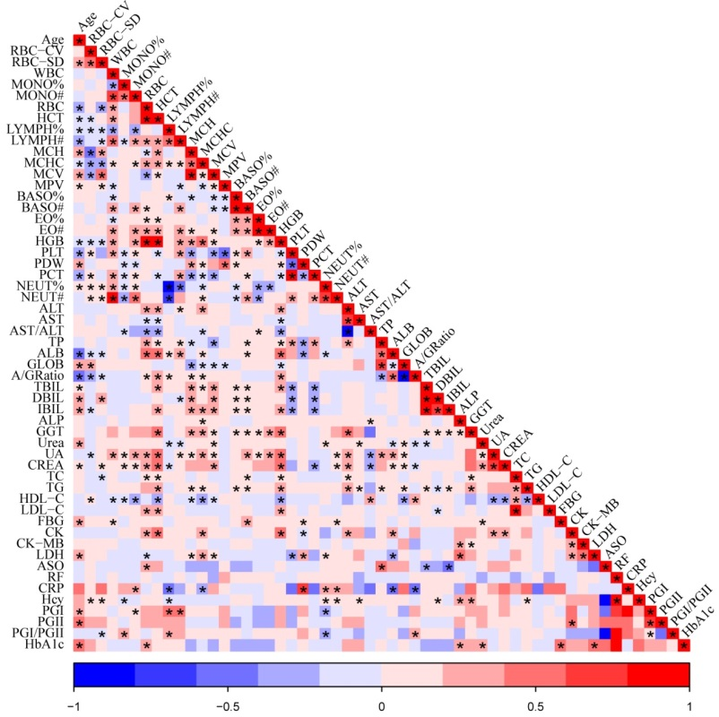
Supplementary Figure 1. Correlation Heatmap of Chronological Age, Hematological Parameters, and Biochemical Indicators
Spearman's correlation coefficient was used to analyze the relationships among age, hematological parameters, and biochemical indicators. An asterisk (*) denotes statistically significant correlations (r value) with P < 0.05. Red color indicates positive correlations, while blue represents negative correlations.

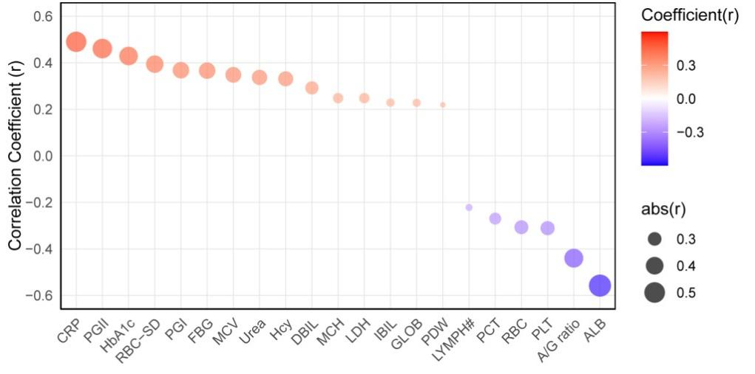
Supplementary Figure 2. Bubble Plot of Routine Blood and Biochemical Indicators Significantly Correlated with Chronological Age
The bubble size corresponds to the absolute value of the correlation coefficient, with larger bubbles indicating stronger correlations. Red color represents positive correlations, and blue indicates negative correlations.

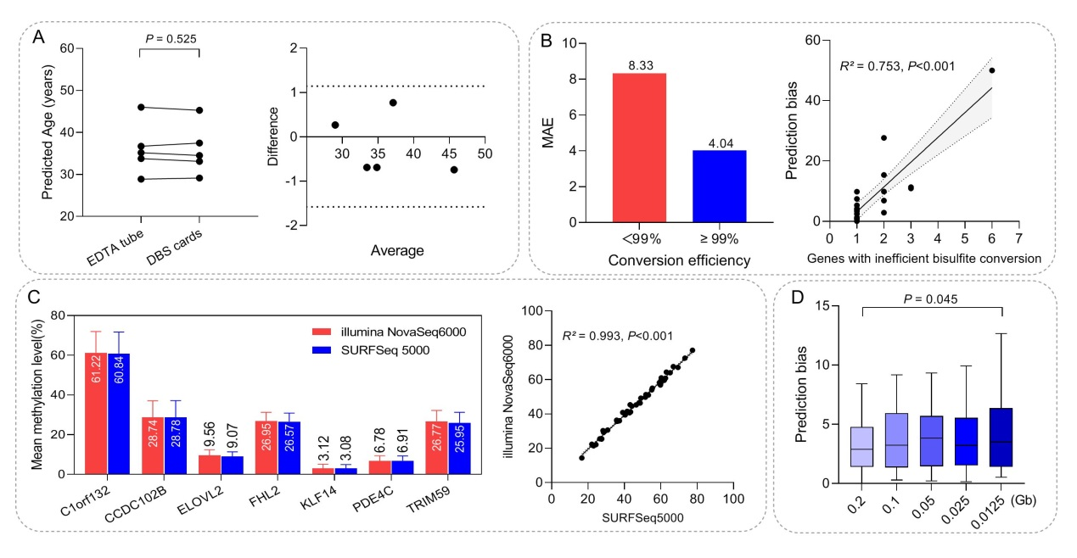
Supplementary Figure 3. Sensitivity Analysis
(A) Comparison of blood collection methods. Left panel: paired scatter plot comparing predicted ages between the two sampling methods; Right panel: Bland-Altman plot with the x-axis representing the mean of predicted ages from both methods (Average) and the y-axis representing the difference between them (Difference).
(B) Impact of conversion efficiency on age prediction accuracy. Left panel: bar chart showing the distribution of mean absolute error (MAE) across samples with different conversion efficiency thresholds (<99% vs. ≥99%); Right panel: scatter plot illustrating the correlation between the number of genes with suboptimal conversion efficiency and prediction deviation, where the x-axis represents the count of genes failing the efficiency threshold and the y-axis represents prediction error.
(C) Effect of sequencing platforms on age prediction. Left panel: bar chart displaying the distribution of mean methylation levels of the seven genes; Right panel: scatter plot showing the correlation between age predictions derived from the Illumina NovaSeq 6000 and SURFSeq 5000 platforms.
(D) Influence of sequencing data volume on age prediction. The x-axis indicates down-sampled data volumes, and the y-axis represents the corresponding prediction deviations.

