Supplementary Table 1. The mediating role of physical activity on four types of epigenetic clocks.
Outcome | Total effect  β (95% CI) | Path a  β (95% CI) | Path b  β (95% CI) | Mediation effect β | Mediated  Proportion （%）
IEAA | 0.23  (0.001 to 0.461) | -0.45  (-0.87 to -0.03 ) | -0.06  (-0.109 to -0.001) | 0.0248 | 10.74%
GrimAA | 0.37  (0.157 to 0.581) | -0.45  (-0.87 to -0.03 ) | -0.09  (-0.138 to -0.039) | 0.0401 | 10.88%
HannumAA | 0.27  (0.045 to 0.490) | -0.45  (-0.87 to -0.03 ) | -0.10  (-0.151 to -0.041) | 0.0433 | 16.22%
PhenoAA | 0.51  (0.237 to 0.775) | -0.45  (-0.87 to -0.03 ) | -0.12  (-0.183 to -0.058) | 0.0541 | 10.70%
Total effect: the effect of exposures on outcomes
Path a: the effect of exposures on mediators
Path b: the effect of mediators on outcomes
Mediation effect: the indirect effect of exposures on outcomes via mediators

Supplementary Figure 1.Multivariable Mendelian randomization estimates for the association between early-life BMI and physical activity

Supplementary Table 2. GWAS Used as Sources for 2-Sample Mendelian Randomization Analyses
Trait | Source | Setting | Country | Phenotype definition | No. of participants or No. of cases/ controls
Exposure
Early-life BMI | Vogelezang et al., 2020 | 26 Birth Cohorts of Children | Many, including European countries like France, Germany, and others. | Sex- and age-adjusted body mass index (BMI) standard deviation score (BMI-SDS) based on the latest measurement between ages 2 and 10 years (continuous; GWAS effect estimates per 1-SD increase in BMI-SDS) | 61,111
Childhood Obesity | Bradfield et al., 2012 | 20 Birth Cohorts of Children | Many, including European countries such as the UK, Germany, and others. | Binary trait (case–control): cases defined as BMI ≥95th percentile achieved before age 18; controls defined as BMI <50th percentile consistently throughout all childhood measurements (GWAS effect estimates reported as log-odds/odds ratios comparing cases vs controls). | 5,530/8,318
Visceral Adipose | Liu et al., 2021 | UK Biobank | UK | Abdominal MRI–derived visceral adipose tissue (VAT) and abdominal subcutaneous adipose tissue (ASAT) volumes (continuous; outcomes inverse-normal transformed in the source GWAS; effect estimates per 1-SD increase in the transformed trait). | 32,860
Abdominal Subcutaneous Adipose
Mediators
Physical activity | Klimentidis et al., 2018 | Many, including UK Biobank | Many, including European countries such as the UK. | Accelerometer-measured physical activity, defined as average acceleration (continuous; analyzed on a standardized scale with effect estimates per 1-SD increase; inverse-normal transformation applied in the source GWAS where applicable). | 385,790
Outcomes
Epigenetic Age | McCartney et al., 2021 | 30 population cohorts | Many, including European countries such as the UK. | DNA methylation–based epigenetic age acceleration (continuous; defined as age-adjusted residuals of epigenetic age in the source GWAS; effect estimates per 1-SD increase in age acceleration) | 40,905

Supplementary Table 3.Baseline characteristics of the participants.
Variable | Total | Normal | Overweight | Obesity I | Obesity II | Obesity III | p-value
Sex | 20337 | 6075 | 7133 | 4175 | 1803 | 1151 | <0.0001
Female | 9441(48.09) | 3103(56.73) | 2772(39.73) | 1840(41.65) | 991(55.02) | 735(62.53)
Male | 10896(51.91) | 2972(43.27) | 4361(60.27) | 2335(58.35) | 812(44.98) | 416(37.47)
Age_group |  |  |  |  |  |  | <0.0001
20-29 | 3393(18.11) | 1463(25.21) | 945(14.99) | 555(14.28) | 231(13.30) | 199(17.42)
30-39 | 3752(20.42) | 1175(21.88) | 1226(18.84) | 735(19.67) | 351(20.90) | 265(23.79)
40-49 | 3812(21.83) | 1012(19.74) | 1342(22.64) | 797(22.58) | 401(23.02) | 260(24.47)
50-59 | 3249(18.99) | 815(15.94) | 1186(20.32) | 710(20.07) | 316(21.25) | 222(21.12)
≥60 | 6131(20.66) | 1610(17.24) | 2434(23.21) | 1378(23.40) | 504(21.54) | 205(13.19)
Eth |  |  |  |  |  |  | <0.0001
Non-Hispanic White | 10538(74.53) | 3527(77.72) | 3677(74.68) | 2017(73.35) | 834(70.24) | 483(65.75)
Mexican American | 3429( 6.64) | 699(4.31) | 1370(7.45) | 847(8.08) | 322(7.86) | 191(8.10)
Non-Hispanic Black | 3564( 8.67) | 893( 6.91) | 1075( 7.42) | 810( 9.67) | 434(12.76) | 352(17.05)
Other Race | 2806(10.15) | 956(11.06) | 1011(10.45) | 501( 8.90) | 213( 9.13) | 125( 9.10)
Marital |  |  |  |  |  |  | <0.0001
Married/living with partner | 13033(67.80) | 3668(64.08) | 4800(70.51) | 2756(70.44) | 1156(70.41) | 653(58.81)
Never married | 3319(16.17) | 1272(20.51) | 960(13.58) | 579(13.34) | 248(12.48) | 260(23.25)
Widowed/Divorced/Separated | 3985(16.02) | 1135(15.41) | 1373(15.91) | 840(16.22) | 399(17.12) | 238(17.94)
Edu |  |  |  |  |  |  | <0.0001
Below | 4308(12.59) | 1139(11.39) | 1600(13.02) | 955(13.31) | 396(14.05) | 218(12.04)
High School | 4785(24.03) | 1324(21.18) | 1684(24.15) | 1036(26.29) | 440(25.80) | 301(29.14)
Above | 11244(63.38) | 3612(67.43) | 3849(62.83) | 2184(60.40) | 967(60.15) | 632(58.82)
PIR |  |  |  |  |  |  | <0.0001
<1.3 | 5064(16.34) | 1534(17.02) | 1647(14.40) | 1005(15.23) | 500(19.37) | 378(23.89)
1.3-3.49 | 7754(34.53) | 2211(33.43) | 2741(34.11) | 1652(35.94) | 694(35.28) | 456(37.31)
≥3.5 | 7519(49.14) | 2330(49.55) | 2745(51.48) | 1518(48.84) | 609(45.35) | 317(38.79)
Smoke |  |  |  |  |  |  | <0.0001
former | 5330(25.51) | 1249(19.76) | 2089(28.48) | 1231(29.29) | 508(27.50) | 253(23.71)
never | 10621(52.89) | 3161(53.65) | 3653(51.42) | 2166(51.62) | 973(55.83) | 668(57.66)
now | 4386(21.61) | 1665(26.59) | 1391(20.10) | 778(19.09) | 322(16.67) | 230(18.64)
Alcohol.user |  |  |  |  |  |  | <0.0001
former | 3095(12.41) | 739( 9.10) | 1075(12.62) | 749(14.75) | 340(17.08) | 192(14.73)
never | 2294( 9.04) | 689( 9.34) | 768( 8.49) | 461( 8.42) | 216( 9.42) | 160(12.45)
mild | 7317(38.20) | 2263(38.56) | 2658(39.40) | 1468(38.32) | 578(35.23) | 350(32.78)
moderate | 3352(18.47) | 1099(21.20) | 1107(17.55) | 665(16.74) | 286(16.70) | 195(17.34)
heavy | 4279(21.87) | 1285(21.81) | 1525(21.95) | 832(21.77) | 383(21.57) | 254(22.69)
HEI |  |  |  |  |  |  | <0.0001
Q1 | 6779(34.84) | 1879(31.12) | 2204(32.24) | 1489(39.19) | 730(44.02) | 477(42.76)
Q2 | 6779(33.15) | 1986(32.22) | 2414(34.64) | 1381(32.76) | 594(30.66) | 404(34.68)
Q3 | 6779(32.01) | 2210(36.65) | 2515(33.12) | 1305(28.06) | 479(25.32) | 270(22.56)
GPAQ（Met-min/week） |  |  |  |  |  |  | 0.58
Q1 | 5085(24.93) | 1515(24.85) | 1819(25.31) | 1009(23.75) | 447(24.59) | 295(27.95)
Q2 | 5085(24.99) | 1536(25.56) | 1771(24.19) | 1070(25.73) | 432(25.67) | 276(22.84)
Q3 | 5086(26.10) | 1557(26.26) | 1792(26.52) | 1012(25.42) | 452(25.98) | 273(25.19)
Q4 | 5081(23.97) | 1467(23.32) | 1751(23.98) | 1084(25.09) | 472(23.75) | 307(24.02)
DM |  |  |  |  |  |  | <0.0001
no | 16126(83.57) | 5426(92.78) | 5708(84.57) | 3076(77.83) | 1209(70.68) | 707(63.97)
yes | 4211(16.43) | 649( 7.22) | 1425(15.43) | 1099(22.17) | 594(29.32) | 444(36.03)
Hyperlipidemia |  |  |  |  |  |  | <0.0001
no | 5756(29.58) | 2653(45.79) | 1724(24.86) | 829(19.87) | 304(15.99) | 246(20.48)
yes | 14581(70.42) | 3422(54.21) | 5409(75.14) | 3346(80.13) | 1499(84.01) | 905(79.52)
Hypertension |  |  |  |  |  |  | <0.0001
no | 12378(66.26) | 4494(79.75) | 4332(65.66) | 2192(57.47) | 850(51.07) | 510(46.28)
yes | 7959(33.74) | 1581(20.25) | 2801(34.34) | 1983(42.53) | 953(48.93) | 641(53.72)
Cancer |  |  |  |  |  |  | 0.31
No | 18536(91.36) | 5556(91.85) | 6455(90.91) | 3809(91.08) | 1647(91.06) | 1069(92.94)
Yes | 1801( 8.64) | 519(8.15) | 678(9.09) | 366(8.92) | 156(8.94) | 82(7.06)

Supplementary Table 4.Primer sequences

Gene | Forward Primer | Reverse Primer
GAPDH | GCAAAGTGGAGATTGTTGCCAT | CCTTGACTGTGCCGTTGAATTT
CDKN2A | TGAGGCGCCCTTTGGTTATC | TCAGTGGTTGCTCACAATGC
CDKN1A | TCTTGTACCCTTGTGCCTCG | ATCTGTCATGCTGGTCTGCC
CDKN1B | AACGTGCGAGTGTCTAACG | TCCGACGGATCAGTCTTTG
TP53 | ACATGACGGAGGTCGTGAGA | TTTCCTTCCACCCGGATAAG

Supplementary Table 5. Sensitivity analysis between different exposures and outcomes.
Exposures | Outcome | Cochran Q test |  | MR-Egger |  | MR-PRESSO
Exposures | Outcome | Q value p value Intercept p value p value
Early-life  BMI | IEAAge  GrimAA  HannumAA  PhenoAA  IEAAge | 38.60 0.267 30.84 0.623 38.45 0.275 22.39 0.936  18.67 0.133 |  | -0.018  -0.035  -0.007  -0.017  -0.011 | 0.367  0.060  0.698  0.458  0.057 | 0.458  0.617  0.209  0.940  0.210
Childhood  Obesity | GrimAA  HannumAA  PhenoAA  IEAAge | 13.18  4.59  9.27  22.68 | 0.433  0.983  0.752  0.930 | -0.126 0.050 0.002 0.972 -0.034 0.557  0.028 0.243 |  | 0.541  0.951  0.815  0.945
Visceral  Adipose | GrimAA  HannumAA  PhenoAA  IEAAge | 35.60  25.35  26.23  50.66 | 0.392  0.858  0.827  0.025 | -0.015 0.528 -0.013 0.581 0.013 0.672  0.058 0.027 |  | 0.419  0.86  0.807  0.769
Abdominal  Subcutaneous  Adipose | GrimAA  HannumAA  PhenoAA  IEAAge | 35.16 0.366 39.50 0.20 42.06 0.133  46.25 0.339 |  | 0.004 0.839 0.011 0.647 0.030 0.349  0.0499 0.045 |  | 0.394  0.201  0.142  0.352
physical  activity | GrimAA  HannumAA  PhenoAA | 29.81  53.15  41.20 | 0.949  0.138  0.592 | -0.0139 0.560 0.0129 0.623  -0.011 0.72 |  | 0.896  0.133  0.230
Early-life  BMI | physical  activity | 5.66 0.958 |  | -0.023 0.566 |  | 0.954

MR Estimate
 |  |  | Inverse variance weighted MR Egger  Simple mode |  | Weighted median  Weighted mode
Intrinsic epigenetic age acceleration | 0.1  0.0 | 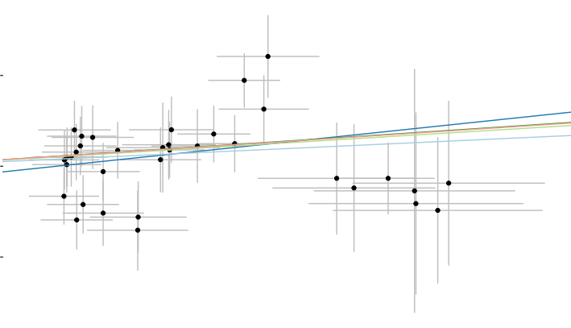
−0.1
0.05 0.10
SNP effect on Childhood body mass index

rs939584 rs2940288 rs9695734 rs6896578 rs72833479 rs10835360 rs4594227 rs62107261 rs114670539 rs13107325 rs79386556 rs12641981 rs41279738 rs80332495 rs56133711 rs1094647 rs4760647 rs12595534 rs10878359 rs71555258 rs7719067 rs12042908 rs7199285 rs62500888 rs61765651 rs7737449 rs7138803 rs7652876 rs11865086 rs11079830 rs571312 rs17817449 rs543874 rs4477562 rs11676272
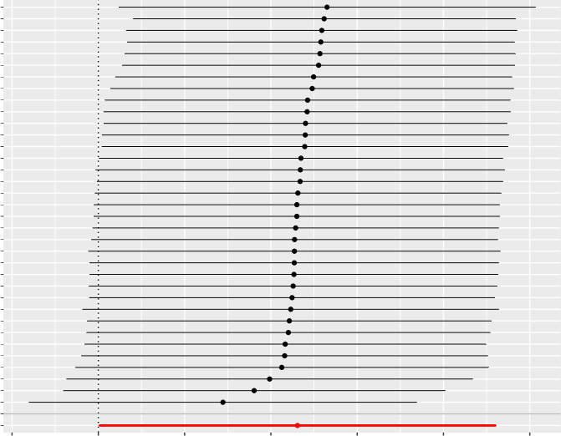
−0.1 0.0 0.1 0.2 0.3 0.4 0.5
MR leave−one−out sensitivity analysis for
Childhood body mass index on 'Intrinsic epigenetic age acceleration
All

rs4477562 rs11676272 rs11079830 rs11865086 rs543874 rs7652876 rs571312 rs7737449 rs17817449 rs7719067 rs61765651 rs62500888 rs71555258 rs7199285 rs7138803 rs12042908 rs12595534 rs10878359 rs4760647 rs56133711 rs1094647 rs939584 rs12641981 rs13107325 rs41279738 rs80332495 rs114670539 rs79386556 rs62107261 rs4594227 rs10835360 rs9695734 rs72833479 rs6896578 rs2940288  All − MR Egger All − Inverse variance weighted | 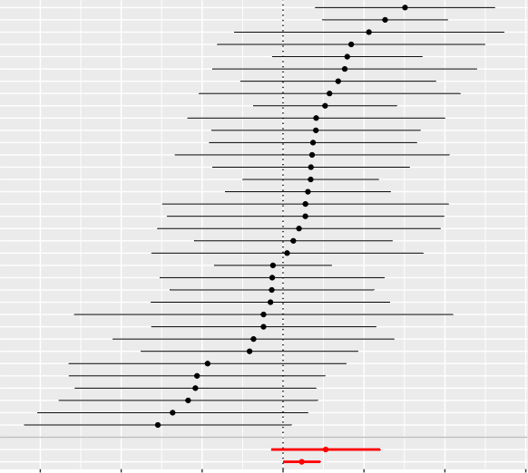  −3 −2 −1 0 1 2 3  MR effect size for  Childhood body mass index on Intrinsic epigenetic age acceleration

MR Estimate
0.05 0.10
SNP effect on Childhood body mass index
 |  |  | Inverse variance weighted MR Egger  Simple mode |  | Weighted median  Weighted mode
DNA methylation Gr imAge acceleration | 0.2  0.1  0.0 | 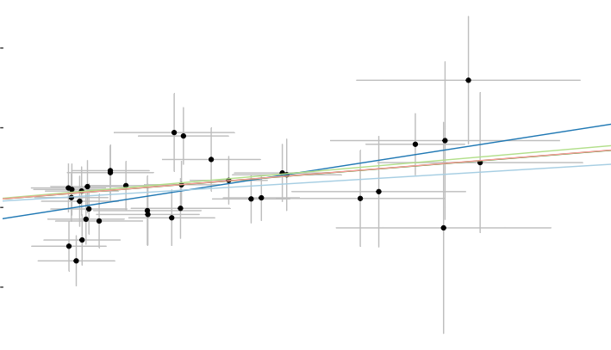
−0.1

rs10878359 rs4760647 rs2940288 rs56133711 rs11676272 rs7138803 rs7652876 rs7737449 rs9695734 rs61765651 rs10835360 rs13107325 rs6896578 rs80332495 rs114670539 rs11079830 rs1094647 rs41279738 rs7719067 rs12595534 rs11865086 rs4594227 rs4477562 rs12042908 rs79386556 rs62500888 rs17817449 rs543874 rs72833479 rs12641981 rs7199285 rs71555258 rs62107261 rs939584 rs571312
All
0.0 0.2 0.4 0.6
MR leave−one−out sensitivity analysis for
Childhood body mass index on DNA methylation GrimAge acceleration

rs71555258
rs571312
rs62107261
rs12641981
rs72833479
rs7199285
rs79386556
rs939584
rs4594227
rs11865086
rs12595534
rs62500888
rs543874
rs7719067
rs4477562
rs17817449
rs12042908
rs41279738
rs1094647
rs11079830
rs114670539
rs11676272
rs7138803
rs13107325
rs61765651
rs10835360
rs6896578
rs9695734
rs80332495
rs56133711
rs7737449
rs7652876
rs2940288
rs4760647
rs10878359
All − MR Egger
All − Inverse variance weighted
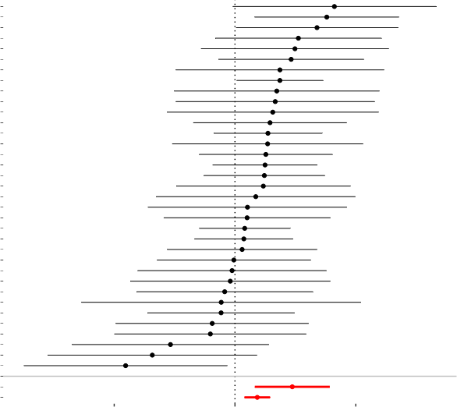
−2 0 2
MR effect size for
'Childhood body mass index on DNA methylation GrimAge acceleration

MR Estimate
 |  |  | Inverse variance weighted MR Egger  Simple mode |  | Weighted median  Weighted mode
DNA methylation Han num age acceleration | 0.1  0.0  −0.1  −0.2 | 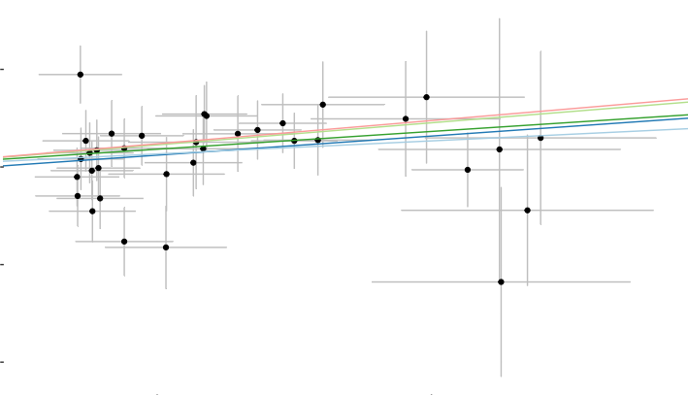
0.05 0.10
SNP effect on Childhood body mass index

rs72833479 rs6896578 rs939584 rs2940288 rs79386556 rs10835360 rs62107261 rs4760647 rs4594227 rs9695734 rs7719067 rs56133711 rs11865086 rs80332495 rs12595534 rs41279738 rs61765651 rs11079830 rs71555258 rs7737449 rs12641981 rs543874 rs10878359 rs11676272 rs13107325 rs7199285 rs7652876 rs114670539 rs62500888 rs17817449 rs571312 rs4477562 rs7138803 rs12042908 rs1094647
All
0.0 0.2 0.4
MR leave−one−out sensitivity analysis for
Childhood body mass index on DNA methylation Hannum age acceleration

rs1094647
rs12042908
rs571312
rs7652876
rs4477562
rs10878359
rs114670539
rs62500888
rs7138803
rs17817449
rs7199285
rs13107325
rs71555258
rs7737449
rs12641981
rs11079830
rs11676272
rs543874
rs61765651
rs41279738
rs12595534
rs80332495
rs56133711
rs939584
rs11865086
rs7719067
rs9695734
rs4594227
rs62107261
rs10835360
rs4760647
rs79386556
rs2940288
rs6896578
rs72833479
All − MR Egger
All − Inverse variance weighted
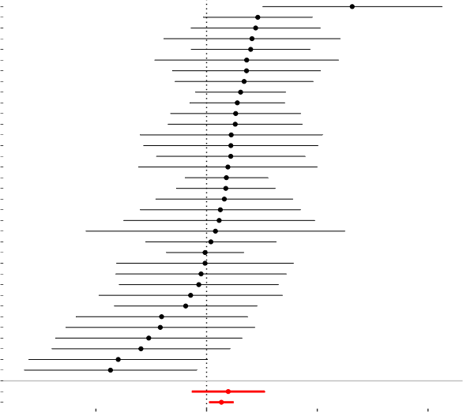
−2 0 2 4
MR effect size for
'Childhood body mass index on DNA methylation Hannum age acceleration

MR Estimate
DNA methylation PhenoAge acceleration
Inverse variance weighted MR Egger
Weighted median
Weighted mode
Simple mode

0.3

0.2

0.1

0.0

−0.1

−0.2

0.05 0.10
SNP effect on Childhood body mass index

rs13107325 rs2940288 rs61765651 rs9695734 rs7652876 rs7138803 rs10878359 rs7199285 rs939584 rs17817449 rs12595534 rs72833479 rs6896578 rs1094647 rs7737449 rs4760647 rs12042908 rs12641981 rs4594227 rs80332495 rs10835360 rs11079830 rs7719067 rs56133711 rs114670539 rs62500888 rs62107261 rs79386556 rs11676272 rs11865086 rs41279738 rs4477562 rs71555258 rs543874 rs571312
All
0.0 0.2 0.4 0.6 0.8
MR leave−one−out sensitivity analysis for
Childhood body mass index on DNA methylation PhenoAge acceleration

rs571312
rs71555258
rs79386556
rs11865086
rs41279738
rs80332495
rs62107261
rs4477562
rs114670539
rs543874
rs62500888
rs7719067
rs56133711
rs11079830
rs10835360
rs11676272
rs4594227
rs12641981
rs12042908
rs4760647
rs939584
rs17817449
rs7737449
rs1094647
rs6896578
rs7138803
rs72833479
rs7199285
rs12595534
rs61765651
rs10878359
rs9695734
rs7652876
rs2940288
rs13107325
All − MR Egger
All − Inverse variance weighted
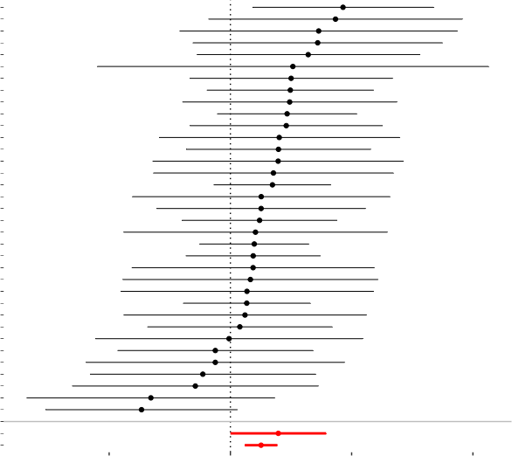
−2 0 2 4
MR effect size for
Childhood body mass index on DNA methylation PhenoAge acceleration

MR Estimate
 |  |  | Inverse variance weighted MR Egger  Simple mode |  | Weighted median  Weighted mode
Intrinsic ep igenet ic age acceleration | 0.15  0.10  0.05  0.00  −0.05 | 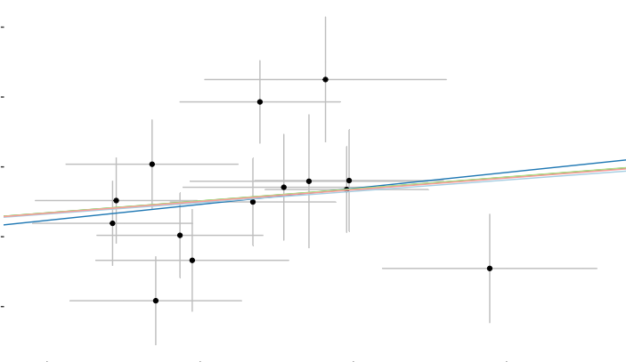
0.10 0.15 0.20 0.25
SNP effect on Childhood obesity

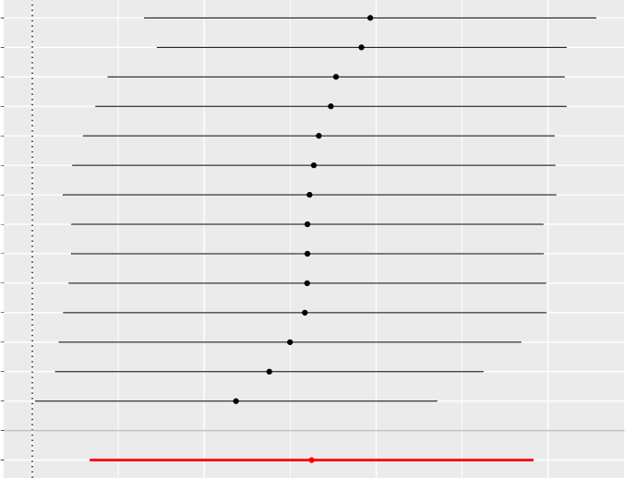
rs4854344
rs4864201
rs28636
rs13130484
rs256335
rs7138803
rs9941349
rs17697518
rs4833407
rs10913469
rs571312
rs9299
rs9568856
rs6752378

All
0.0 0.1 0.2 0.3
MR leave−one−out sensitivity analysis for
Childhood obesity Intrinsic epigenetic age acceleration

rs9568856 rs6752378 rs9299 rs17697518 rs4833407 rs571312 rs10913469 rs9941349 rs7138803 rs256335 rs13130484 rs4854344 rs28636 rs4864201  All − MR Egger All − Inverse variance weighted | 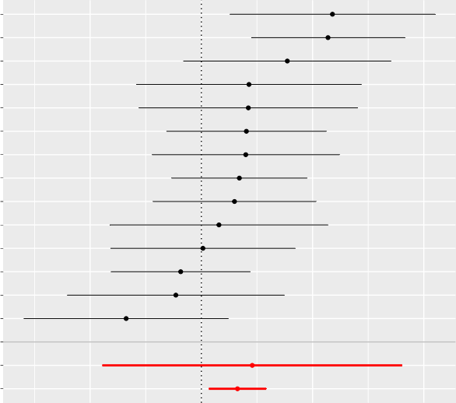  −0.5 0.0 0.5 1.0  MR effect size for  Childhood obesity on Intrinsic epigenetic age acceleration

MR Estimate
Inverse variance weighted MR Egger
Weighted median
Weighted mode
Simple mode

DNA methylation Gr imAge acceleration

0.10

0.05

0.00

−0.05

0.10 0.15 0.20 0.25

SNP effect on Childhood obesity

rs256335

rs28636

rs4833407

rs7138803

rs6752378

rs9941349

rs9299

rs17697518

rs13130484

rs10913469

rs9568856

rs571312
All
0.0 0.1 0.2 0.3
MR leave−one−out sensitivity analysis for
Childhood obesity on DNA methylation GrimAge acceleration

rs9568856 rs571312 rs10913469 rs13130484 rs17697518 rs9299 rs9941349 rs6752378 rs7138803 rs4833407 rs28636 rs256335  All − MR Egger All − Inverse variance weighted | 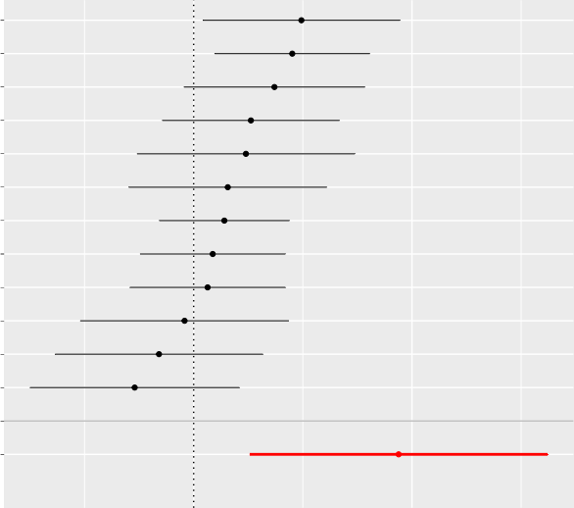  0 1  MR effect size for  'Childhood obesity on DNA methylation GrimAge acceleration

MR Estimate
Inverse variance weighted MR Egger
Weighted median
Weighted mode
Simple mode

0.10
DNA methylation Han num age acceleration

0.05

0.00

−0.05
0.10 0.15 0.20 0.25

SNP effect on Childhood obesity

rs4854344
rs4864201
rs4833407
rs9299
rs9941349
rs10913469
rs13130484
rs6752378
rs28636
rs256335
rs17697518
rs9568856
rs7138803
rs571312
All
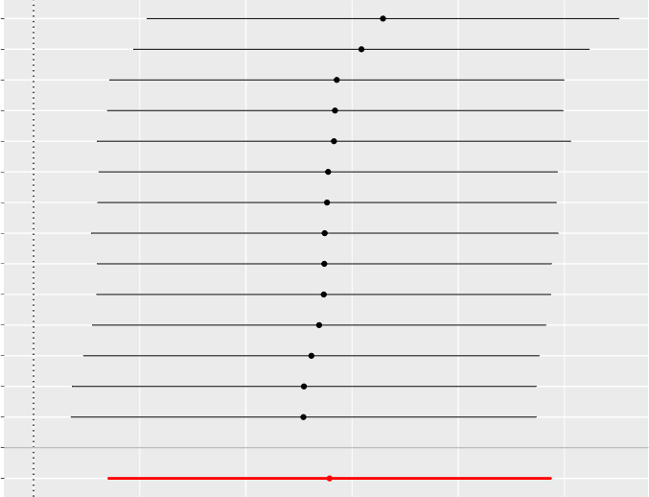
0.0 0.1 0.2
MR leave−one−out sensitivity analysis for
Childhood obesity on DNA methylation Hannum age acceleration

rs9568856 rs7138803 rs571312 rs17697518 rs256335 rs28636 rs6752378 rs13130484 rs10913469 rs9941349 rs9299 rs4833407 rs4854344 rs4864201  All − MR Egger All − Inverse variance weighted | 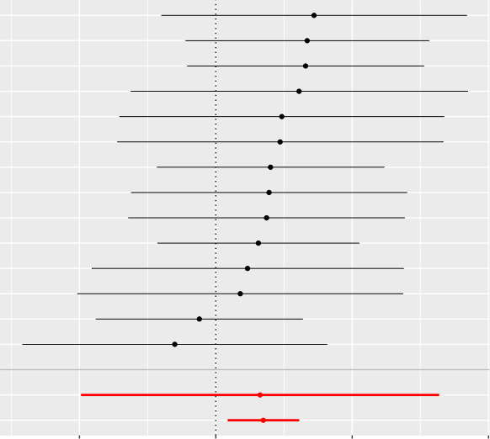  −0.4 0.0 0.4 0.8  MR effect size for  'Childhood obesity on DNA methylation Hannum age acceleration

MR Estimate
Inverse variance weighted MR Egger
Weighted median
Weighted mode
Simple mode

0.15

DNA methylation PhenoAge acceleration
0.10

0.05

0.00

−0.05

0.10 0.15 0.20 0.25

SNP effect on Childhood obesity

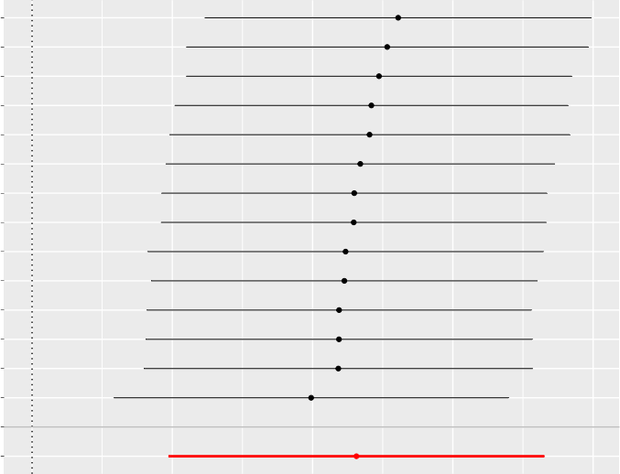
rs4864201
rs9941349
rs28636
rs7138803
rs4854344
rs13130484
rs256335
rs4833407
rs6752378
rs9299
rs17697518
rs9568856
rs10913469
rs571312

All
0.0 0.1 0.2 0.3 0.4
MR leave−one−out sensitivity analysis for
'Childhood obesity on DNA methylation PhenoAge acceleration

rs571312 rs17697518 rs9568856 rs10913469 rs9299 rs6752378 rs4833407 rs256335 rs13130484 rs4854344 rs7138803 rs9941349 rs28636 rs4864201  All − MR Egger All − Inverse variance weighted | 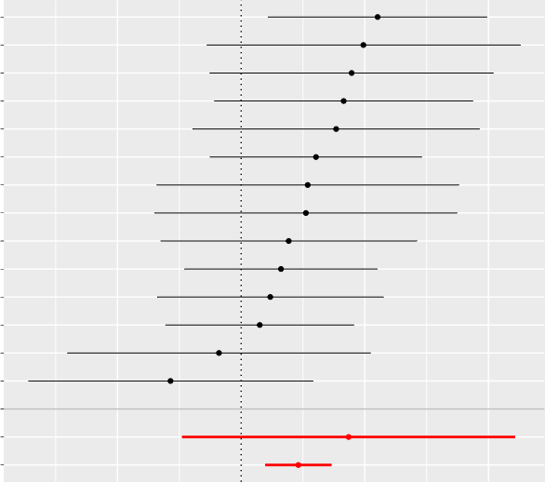  −0.5 0.0 0.5 1.0  MR effect size for  Childhood obesity on DNA methylation PhenoAge acceleration

MR Estimate
 |  |  | Inverse variance weighted MR Egger  Simple mode |  | Weighted median  Weighted mode
Intrinsic ep igenet ic age acceleration | 0.2  0.0  −0.2  −0.4 | 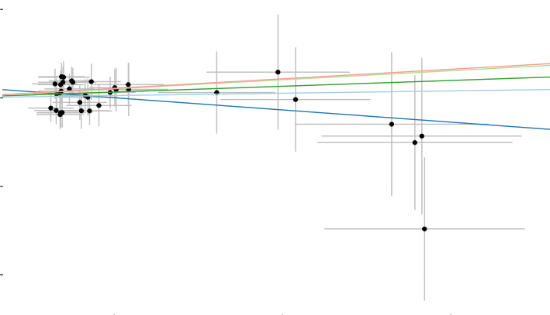
0.05 0.10 0.15
SNP effect on Visceral adipose tissue volume

rs142090665 rs153701 rs9321743 rs1328673 rs7648987 rs1040337 rs7020196 rs2838508 rs9817537 rs7738377 rs78034738 rs112620137 rs62109951 rs113358036 rs28457808 rs2159793 rs75940532 rs1047316 rs4868150 rs7842922 rs117768444 rs77915493 rs157845 rs10756564 rs73221948 rs2238499 rs7482346 rs4385054 rs1812736 rs3811640 rs1538311 rs11666808 rs17739187 rs62048402 rs6712908
All
−0.25 0.00 0.25 0.50
MR leave−one−out sensitivity analysis for
Visceral adipose tissue volume on Intrinsic epigenetic age acceleration

rs6712908
rs17739187
rs62048402
rs3811640
rs4385054
rs11666808
rs1538311
rs1812736
rs117768444
rs7482346
rs2238499
rs73221948
rs10756564
rs77915493
rs4868150
rs7842922
rs1047316
rs157845
rs75940532
rs2159793
rs28457808
rs113358036
rs62109951
rs7738377
rs112620137
rs78034738
rs153701
rs2838508
rs9817537
rs7020196
rs7648987
rs1328673
rs1040337
rs9321743
rs142090665
All − MR Egger
All − Inverse variance weighted
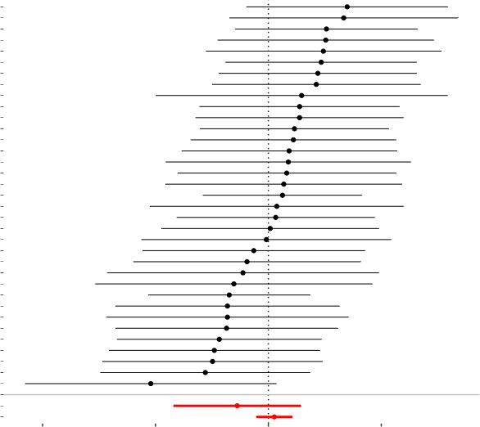
−4 −2 0 2
MR effect size for
Visceral adipose tissue volume on Intrinsic epigenetic age acceleration

MR Estimate
 |  |  | Inverse variance weighted MR Egger  Simple mode |  | Weighted median  Weighted mode
DNA methylation Gr imAge acceleration | 0.2  0.1  0.0  −0.1  −0.2  −0.3 | 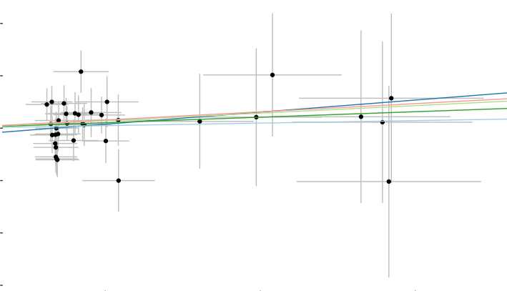
0.05 0.10 0.15
SNP effect on Visceral adipose tissue volume

rs1538311 rs6712908 rs1328673 rs4868150 rs1040337 rs7842922 rs73221948 rs62109951 rs9321743 rs78034738 rs3811640 rs1047316 rs10756564 rs9817537 rs112620137 rs75940532 rs1812736 rs117768444 rs4385054 rs11666808 rs153701 rs7482346 rs142090665 rs17739187 rs7738377 rs2838508 rs2159793 rs113358036 rs157845 rs77915493 rs62048402 rs7020196 rs2238499 rs7648987 rs28457808
All
−0.25 0.00 0.25 0.50
MR leave−one−out sensitivity analysis for
Visceral adipose tissue volume on DNA methylation GrimAge acceleration

rs28457808
rs7648987
rs7020196
rs2238499
rs77915493
rs113358036
rs62048402
rs2838508
rs7738377
rs2159793
rs157845
rs17739187
rs142090665
rs7482346
rs4385054
rs11666808
rs117768444
rs153701
rs112620137
rs75940532
rs1812736
rs9817537
rs10756564
rs3811640
rs9321743
rs1047316
rs73221948
rs62109951
rs78034738
rs7842922
rs1040337
rs1538311
rs6712908
rs1328673
rs4868150
All − MR Egger
All − Inverse variance weighted
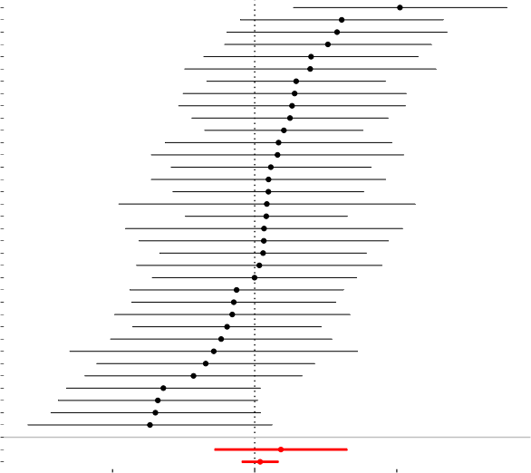
−2.5 0.0 2.5
MR effect size for
Visceral adipose tissue volume on DNA methylation GrimAge acceleration

MR Estimate
 |  |  | Inverse variance weighted MR Egger  Simple mode |  | Weighted median  Weighted mode
DNA methylation Han num age acceleration | 0.3  0.2  0.1  0.0  −0.1  −0.2 | 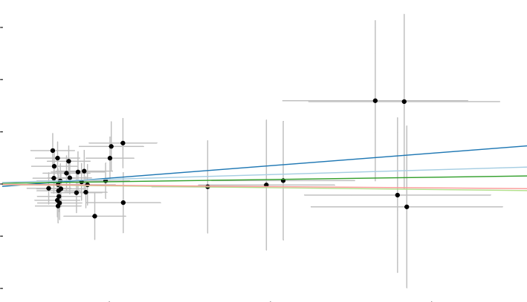
0.05 0.10 0.15
SNP effect on Visceral adipose tissue volume

rs7738377 rs1040337 rs1328673 rs7842922 rs6712908 rs153701 rs4868150 rs10756564 rs62109951 rs7020196 rs17739187 rs142090665 rs9817537 rs1538311 rs1812736 rs75940532 rs117768444 rs157845 rs2159793 rs113358036 rs3811640 rs11666808 rs7648987 rs2838508 rs28457808 rs2238499 rs78034738 rs112620137 rs1047316 rs73221948 rs77915493 rs9321743 rs62048402 rs7482346 rs4385054
All
−0.2 0.0 0.2 0.4
MR leave−one−out sensitivity analysis for
Visceral adipose tissue volume on DNA methylation Hannum age acceleration

rs4385054
rs9321743
rs7482346
rs77915493
rs112620137
rs62048402
rs78034738
rs1047316
rs73221948
rs28457808
rs2838508
rs2238499
rs7648987
rs11666808
rs3811640
rs157845
rs2159793
rs113358036
rs117768444
rs1538311
rs1812736
rs75940532
rs9817537
rs17739187
rs7020196
rs142090665
rs153701
rs10756564
rs62109951
rs4868150
rs6712908
rs7842922
rs1328673
rs1040337
rs7738377
All − MR Egger
All − Inverse variance weighted
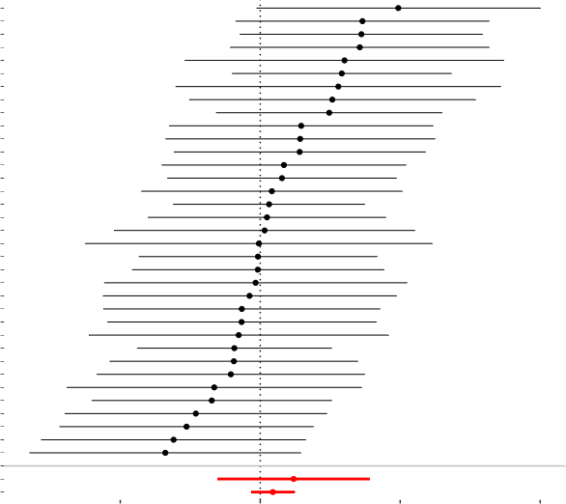
−2 0 2 4
MR effect size for
Visceral adipose tissue volume on DNA methylation Hannum age acceleration

MR Estimate
Inverse variance weighted MR Egger
Weighted median
Weighted mode
Simple mode

0.4
DNA methylation PhenoAge acceleration

0.2

0.0

−0.2

0.05 0.10 0.15

SNP effect on Visceral adipose tissue volume

rs1040337 rs73221948 rs10756564 rs11666808 rs75940532 rs1047316 rs9321743 rs7738377 rs4868150 rs142090665 rs157845 rs1538311 rs7842922 rs78034738 rs9817537 rs1328673 rs153701 rs117768444 rs7648987 rs1812736 rs6712908 rs3811640 rs112620137 rs7020196 rs2838508 rs77915493 rs62048402 rs2159793 rs113358036 rs62109951 rs7482346 rs2238499 rs17739187 rs4385054 rs28457808
All
−0.2 0.0 0.2 0.4 0.6 0.8
MR leave−one−out sensitivity analysis for
Visceral adipose tissue volume on DNA methylation PhenoAge acceleration

rs4385054
rs28457808
rs17739187
rs113358036
rs62109951
rs2238499
rs7482346
rs112620137
rs2838508
rs77915493
rs7020196
rs2159793
rs62048402
rs3811640
rs6712908
rs1812736
rs7648987
rs153701
rs117768444
rs1328673
rs157845
rs1538311
rs7842922
rs9817537
rs9321743
rs78034738
rs11666808
rs7738377
rs4868150
rs142090665
rs1047316
rs10756564
rs75940532
rs73221948
rs1040337
All − MR Egger
All − Inverse variance weighted
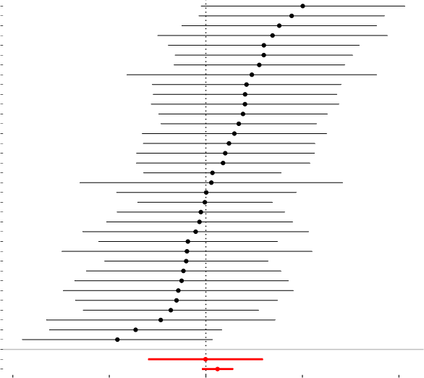
−5.0 −2.5 0.0 2.5 5.0
MR effect size for
Visceral adipose tissue volume on DNA methylation PhenoAge acceleration

MR Estimate
 |  |  | Inverse variance weighted MR Egger  Simple mode |  | Weighted median  Weighted mode
Intrinsic ep igenet ic age acceleration | 0.25  0.00  −0.25  −0.50 | 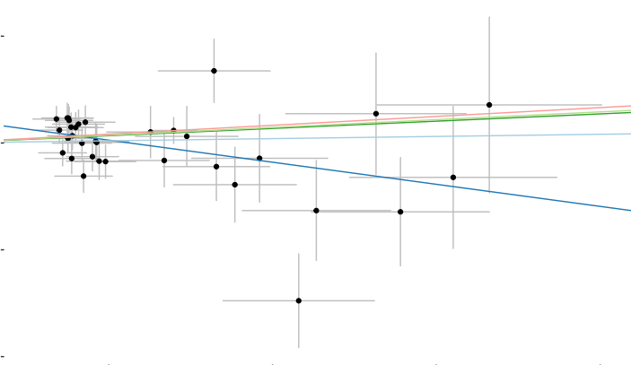
0.05 0.10 0.15 0.20
SNP effect on Abdominal subcutaneous adipose tissue volume

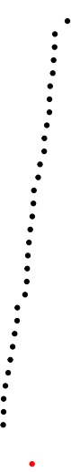
rs74574792 rs4819362 rs1752156 rs74877679 rs62120394 rs147620272 rs11242963 rs7957519 rs4793928 rs7020196 rs62106258 rs6302 rs78918171 rs144884331 rs62141888 rs28457808 rs79027662 rs2068902 rs9834829 rs7612538 rs77546365 rs79613976 rs6469351 rs1024029 rs10871777 rs2365661 rs72768171 rs806794 rs12855930 rs1421085 rs10166482 rs7491585 rs2785998 rs78764020
All

−0.2 0.0 0.2 0.4
MR leave−one−out sensitivity analysis for
Abdominal subcutaneous adipose tissue volume on 'Intrinsic epigenetic age acceleration

rs78764020 rs10166482 rs12855930 rs2785998 rs7491585 rs72768171 rs806794 rs2365661 rs10871777 rs1024029 rs7612538 rs79613976 rs6469351 rs1421085 rs77546365 rs9834829 rs2068902 rs79027662 rs28457808 rs62141888 rs144884331 rs78918171 rs6302 rs7020196 rs62106258 rs62120394 rs1752156 rs7957519 rs4793928 rs11242963 rs74877679 rs147620272 rs4819362 rs74574792  All − MR Egger All − Inverse variance weighted | 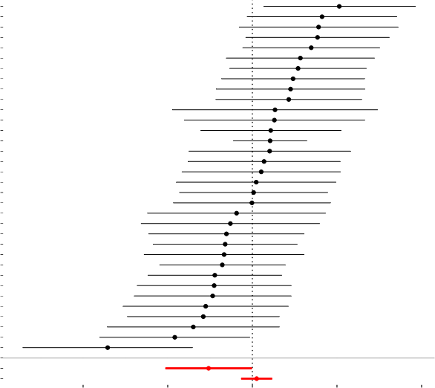  −4 −2 0 2 4  MR effect size for  Abdominal subcutaneous adipose tissue volume on 'Intrinsic epigenetic age acceleration

MR Estimate
 |  |  | Inverse variance weighted MR Egger  Simple mode |  | Weighted median  Weighted mode
DNA methylation Gr imAge acceleration | 0.4  0.2  0.0  −0.2  −0.4 | 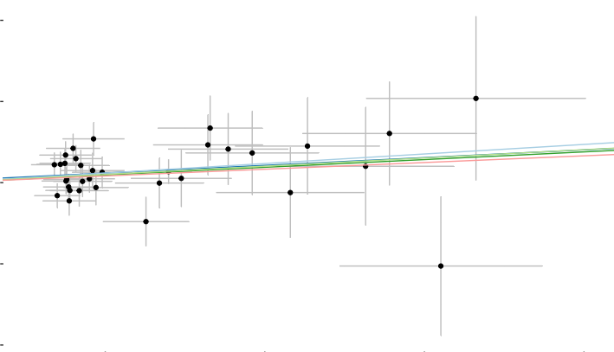
0.05 0.10 0.15 0.20
SNP effect on Abdominal subcutaneous adipose tissue volume

rs77546365 rs1024029 rs4793928 rs78918171 rs6469351 rs62141888 rs2365661 rs7957519 rs74574792 rs6302 rs2785998 rs72768171 rs1421085 rs62120394 rs7491585 rs2068902 rs79613976 rs1752156 rs79027662 rs144884331 rs147620272 rs11242963 rs74877679 rs7612538 rs4819362 rs78764020 rs12855930 rs10166482 rs7020196 rs62106258 rs806794 rs9834829 rs10871777 rs28457808
All
0.0 0.2 0.4 0.6 0.8
MR leave−one−out sensitivity analysis for
Abdominal subcutaneous adipose tissue volume on 'DNA methylation GrimAge acceleration

rs28457808
rs10871777
rs9834829
rs62106258
rs806794
rs10166482
rs12855930
rs7020196
rs7612538
rs78764020
rs4819362
rs11242963
rs74877679
rs147620272
rs144884331
rs79027662
rs1752156
rs1421085
rs79613976
rs62120394
rs7491585
rs2068902
rs2785998
rs72768171
rs6302
rs74574792
rs7957519
rs2365661
rs62141888
rs6469351
rs1024029
rs4793928
rs78918171
rs77546365
All − MR Egger
All − Inverse variance weighted
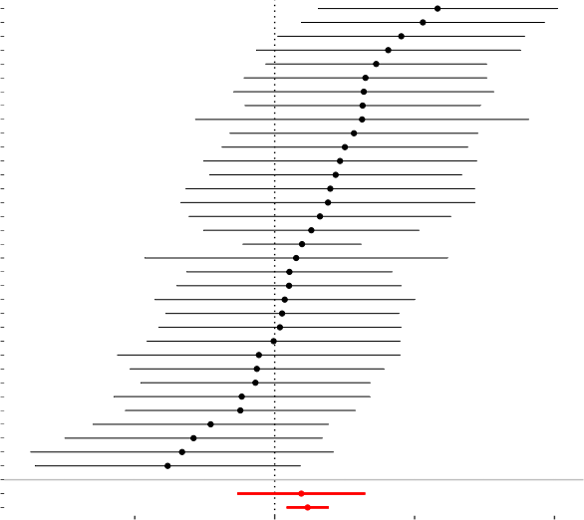
−2 0 2 4
MR effect size for
Abdominal subcutaneous adipose tissue volume on DNA methylation GrimAge acceleration

MR Estimate
Inverse variance weighted MR Egger
Weighted median
Weighted mode
Simple mode

0.4

DNA methylation Han num age acceleration

0.2

0.0

−0.2
0.05 0.10 0.15 0.20

SNP effect on Abdominal subcutaneous adipose tissue volume

rs4793928 rs77546365 rs6469351 rs11242963 rs62141888 rs62106258 rs74877679 rs1752156 rs7020196 rs147620272 rs7491585 rs74574792 rs79027662 rs6302 rs2068902 rs78918171 rs62120394 rs72768171 rs2785998 rs7612538 rs4819362 rs144884331 rs1024029 rs28457808 rs7957519 rs10166482 rs2365661 rs12855930 rs9834829 rs10871777 rs79613976 rs78764020 rs1421085 rs806794
All
0.0 0.2 0.4 0.6
MR leave−one−out sensitivity analysis for
Abdominal subcutaneous adipose tissue volume on DNA methylation Hannum age acceleration

rs806794
rs79613976
rs78764020
rs10871777
rs9834829
rs12855930
rs2365661
rs10166482
rs7957519
rs1421085
rs144884331
rs28457808
rs1024029
rs7612538
rs4819362
rs2785998
rs72768171
rs62120394
rs2068902
rs78918171
rs6302
rs7491585
rs79027662
rs7020196
rs1752156
rs74574792
rs147620272
rs74877679
rs62141888
rs62106258
rs11242963
rs6469351
rs77546365
rs4793928
All − MR Egger
All − Inverse variance weighted
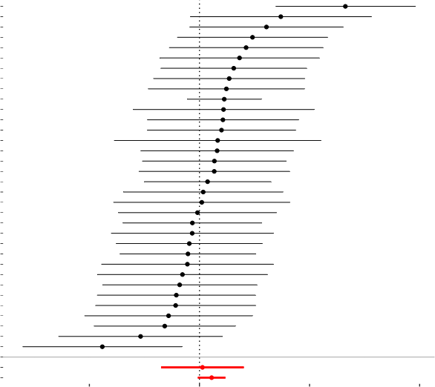
−2.5 0.0 2.5 5.0
MR effect size for
Abdominal subcutaneous adipose tissue volumeon DNA methylation Hannum age acceleration

MR Estimate
 |  |  | Inverse variance weighted MR Egger  Simple mode |  | Weighted median  Weighted mode
DNA methylation PhenoAge acceleration | 0.2  0.0  −0.2 | 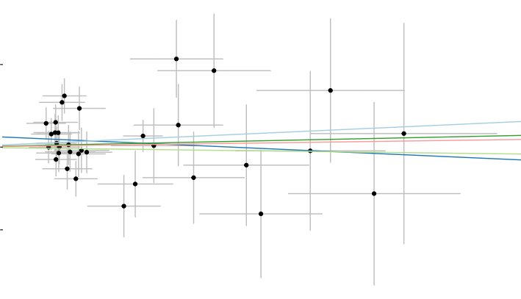
0.05 0.10 0.15 0.20
SNP effect on Abdominal subcutaneous adipose tissue volume

rs62120394 rs77546365 rs6302 rs62141888 rs2785998 rs147620272 rs11242963 rs1752156 rs78918171 rs4793928 rs72768171 rs79027662 rs74574792 rs7957519 rs6469351 rs1024029 rs79613976 rs2068902 rs4819362 rs7491585 rs7612538 rs62106258 rs1421085 rs12855930 rs74877679 rs7020196 rs2365661 rs144884331 rs9834829 rs10166482 rs28457808 rs78764020 rs10871777 rs806794
All
0.00 0.25 0.50 0.75
MR leave−one−out sensitivity analysis for
Abdominal subcutaneous adipose tissue volume on DNA methylation PhenoAge acceleration

rs806794 rs10871777 rs78764020 rs28457808 rs144884331 rs10166482 rs9834829 rs74877679 rs12855930 rs2365661 rs7020196 rs62106258 rs1421085 rs7491585 rs7612538 rs4819362 rs2068902 rs6469351 rs1024029 rs79613976 rs7957519 rs1752156 rs72768171 rs79027662 rs4793928 rs74574792 rs78918171 rs2785998 rs11242963 rs62141888 rs6302 rs147620272 rs62120394 rs77546365
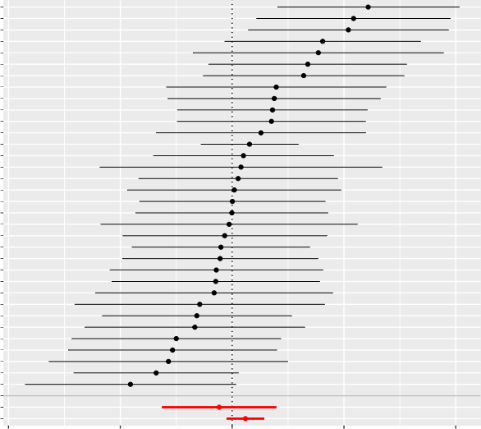
−5.0 −2.5 0.0 2.5 5.0
MR effect size for
Abdominal subcutaneous adipose tissue volume on DNA methylation PhenoAge acceleration
All − MR Egger All − Inverse variance weighted

