eFigure 1. Study flow diagram.

eFigure 2. Directed acyclic graph (DAG) depicting the relationships between the epigenetic age acceleration (EAA) and cardiometabolic disease. Green lines indicate causal or mediating paths. Pink lines indicate confounding paths. The minimally sufficient adjustment set (MSAS) for direct effect of EAA on cardiometabolic disease = BMI, alcohol use, ADI, SES, and tobacco use. Generated with daggity.net.

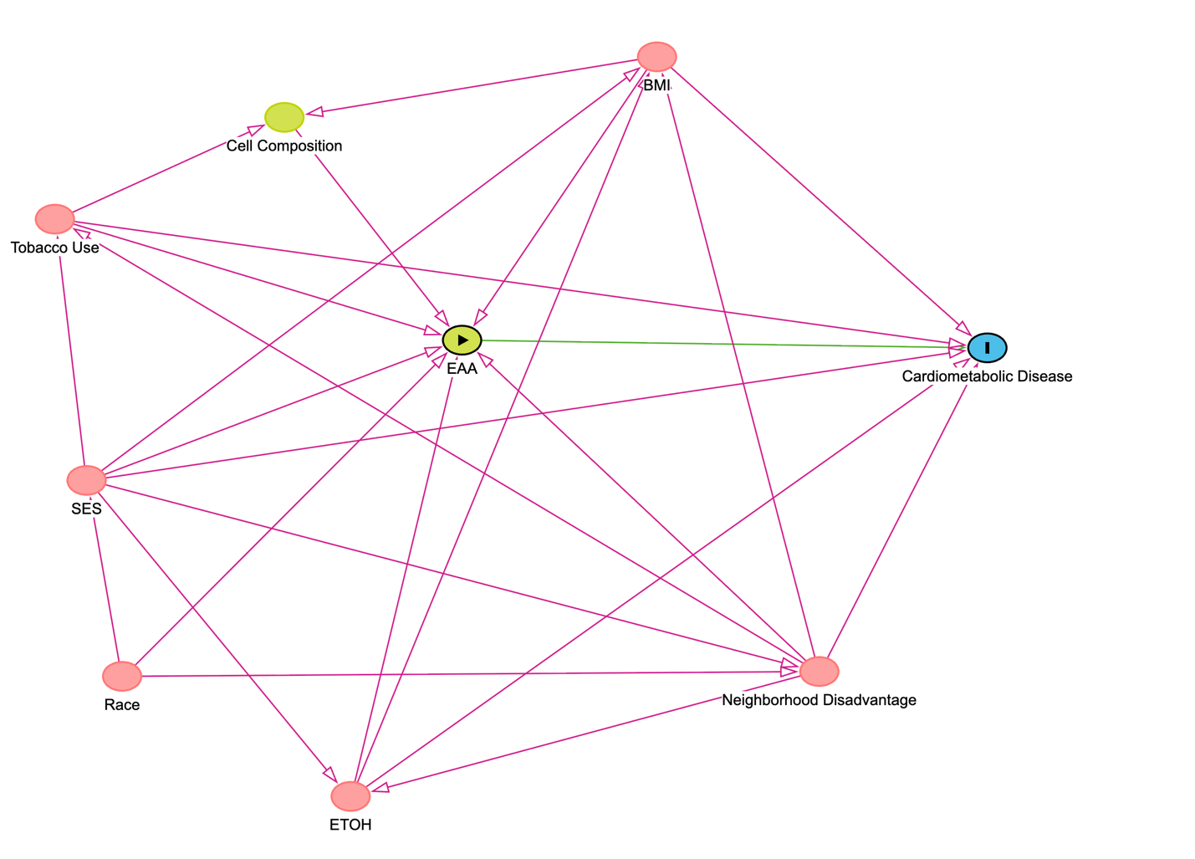
eTable 1. Bivariate associations between economic and neighborhood disadvantage and epigenetic age acceleration at Waves 1 and 3.
 | Wave | GrimAge2 acceleration |  | PhenoAge acceleration |  | Pace of Aging
 |  | β (95% CI) | p-value | β (95% CI) | p-value | β (95% CI) | p-value
SES | Wave 1 | -0.29 (-0.36 to -0.23) | <.001 | -0.16  (-0.23 to -0.01) | <.001 | -0.30  (-0.36 to -0.24) | <.001
ADI | Wave 1 | 0.16  (0.10 to 0.23) | <.001 | 0.50  (-0.02 to 0.12) | .15 | 0.23  (0.17 to 0.30) | <.001
SES | Wave 3 | -0.43  (-0.53 to -0.34) | <.001 | -0.18  (-0.28 to -0.07) | <.001 | -0.37  (-0.47 to -0.27) | <.001
ADI | Wave 3 | 0.32  (0.22 to 0.42) | <.001 | 0.14  (0.04 to 0.25) | .007 | 0.25  (0.15 to 0.35) | <.001
β (95% CI) represents standardized regression beta values and 95% confidence intervals.
eTable 2. Multivariate associations between economic and neighborhood disadvantage and epigenetic age acceleration at Waves 1 and 3, controlling for age, smoking, BMI, and cell composition.
 | Wave | GrimAge2 Acceleration |  | PhenoAge acceleration |  | Pace of Aging
 |  | β (95% CI) | p-value | β (95% CI) | p-value | β (95% CI) | p-value
SES | Wave 1 | -0.29  (-0.35 to -0.23) | <.001 | -0.17  (-0.22 to -0.11) | <.001 | -0.22  (-0.28 to -0.16) | <.001
ADI | Wave 1 | 0.15  (0.09 to 0.21) | <.001 | 0.07  (0.01 to 0.13) | .014 | 0.18  (0.12 to 0.24) | <.001
SES | Wave 3* | -0.43  (-0.53 to -0.34) | <.001 | -0.18  (-0.26 to -0.09) | <.001 | -0.29  (-0.38 to -0.20) | <.001
ADI | Wave 3* | 0.27  (0.18 to 0.37) | <.001 | 0.08  (-0.01 to 0.16) | .08 | 0.16  (0.07 to 0.025) | <.001
* Note that 3 participants missing BMI at Wave 3 were excluded from this analysis.
β (95% CI) represents standardized regression beta values and 95% confidence intervals.
eTable 3. Multivariable sensitivity analysis of age acceleration and both CVD and diabetes. Models controls for BMI, alcohol use, ADI, SES, and smoking, cell composition, and chronologic age.
 | Wave | GrimAge2 Acceleration |  | PhenoAge Acceleration |  | Pace of Aging
 |  | OR (95% CI) ⁺ | p-value | OR (95% CI) ⁺ | p-value | OR (95% CI) ⁺ | p-value
CVD | Wave 1 | 1.28  (1.08 to 1.52) | .006 | 1.43  (1.18 to 1.75) | <.001 | 1.30  (1.08 to 1.57) | .006
CVD | Wave 3* | 1.24  (0.94 to 1.65) | .14 | 1.24  (0.90 to 1.71) | .20 | 1.27  (0.95 to 1.71) | .10
Diabetes | Wave 1 | 1.42  (1.15 to 1.75) | <.001 | 1.75  (1.38 to 2.24) | <.001 | 1.62  (1.29 to 2.04) | <.001
Diabetes | Wave 3* | 1.89  (1.34 to 2.70) | <.001 | 1.65  (1.12 to 2.48) | .01 | 1.94  (1.36 to 2.81) | <.001
* Note that 3 participants missing BMI at Wave 3 were excluded from this analysis.
⁺OR (95% CI): Standardized Odds Ratio with 95% confidence intervals.
eTable 4: Characteristics of the baseline variables for retained and non-retained participants.
Characteristic | Wave 1  (N=865) | Retained  (N=348) | Non-retained (N=517) | p-value  (retained) | p-value  (non-retained)
Age, years (SD) | 46.9 (11.9) | 46.5 (11.0) | 47.2 (12.5) | .56 | .67
Race, No. (%)  Black  Native American  White  Other | 329 (38.0%)  19 (2.2%)  486 (56.2%)  30 (3.5%) | 132 (37.9%)  8 (2.3%)  204 (58.6%)  4 (1.1%) | 197 (38.1%)  11 (2.1%)  282 (54.5%)  26 (5.0 %) | .15 | .55
Employment, No. (%)  Unemployed  Retired  Part-time  Other  Full-time | 310 (35.8%)  88 (10.2%)  12 (1.4%)  103 (11.9%)  351 (40.6%) | 108 (31.0%)  33 (9.5%)  3 (0.9%)  50 (14.4%)  154 (44.3%) | 202 (39.1%)  55 (10.6%)  9 (1.7%)  53 (10.3%)  197 (38.1%) | .36 | .64
SES Index, unit (SD) | -0.15 (1.33) | 0.03 (1.33) | -0.26 (1.32) | .04 | .11
ADI, unit (SD) | 63.3 (19.6) | 61.61 (19.36) | 64.47 (19.73) | .17 | .30
Lifetime Smoking History, No. (%) | 314 (36.3%) | 102 (29.3%) | 212 (24.5%) | .02 | .09
Alcohol Use, No. (%)  Never  Former  Current | 393 (45.4%)  230 (26.6%)  238 (27.5%) | 153 (44.0%)  84 (24.1%)  110 (31.6%) | 240 (46.4%)  146 (28.2%)  128 (24.8%) | .34 | .52
BMI, kg/m² (SD) | 32.5 (9.12) | 32.94 (9.41) | 32.22 (8.93) | .46 | .56
CVD, No. (%) | 391 (45.2%) | 145 (41.7%) | 246 (47.6%) | .30 | .43
Diabetes, No. (%) | 135 (15.6%) | 58 (16.7%) | 77 (14.9%) | .70 | .77
Missing observations: 1 for Race at Wave 1, 1 for Employment at Wave 1, 2 for ADI at both waves, 4 for Alcohol use at Wave 1 and 1 at Wave 3, 1 for CVD at both waves, and 1 for Diabetes at both waves.

eTable 5: Sociodemographic differences associated with CVD and diabetes at Wave 3.
Characteristic | CVD  OR (95% CI) | p-value | Diabetes  OR (95% CI) | p-value
Age | 1.04 (1.02 to 1.07) | <.001 | 1.00 (1.00 to 1.05) | .03
Race  Black  Native American  White  Other | 2.07 (1.32 to 3.27) 2.17 (0.50 to 9.45) [reference]  0.72 (0.04 to 5.78) | .002  .28  NA  .78 | 1.69 (0.97 to 2.93)  1.76 (0.25 to 8.04) [reference]  1.76 (0.09 to 14.25) | .06  .50  NA  .63
Employment  Unemployed  Retired  Part-time  Other  Full-time | 2.09 (0.08 to 5.59)  1.88 (1.05 to 3.38)  1.38 (0.77 to 2.46)  0.43 (0.16 to 0.98)  [reference] | .13  .03  .28  .06  NA | 2.45 (0.85 to 6.67)  1.09 (0.52 to 2.20)  1.05 (0.50 to 2.11)  0.37 (0.09 to 1.13)  [reference] | .08  .81  .89  .11  NA
SES Index | 0.78 (0.67 to 0.91) | .001 | 0.76 (0.63 to 0.91) | .004
ADI | 1.01 (1.00 to 1.03) | .02 | 1.01 (1.00 to 1.03) | .08
Lifetime Smoking History | 1.35 (0.84 to 2.17) | .21 | 0.86 (0.46 to 1.55) | .63
Alcohol Use  Never  Former  Current | [reference]  1.26 (0.66 to 2.39)  0.59 (0.36 to 0.98) | NA  .48  .04 | [reference]  1.27 (0.59 to 2.68)  0.78 (0.42 to 1.45) | NA  .53  .42
BMI* | 1.00 (0.98 to 1.03) | .75 | 1.02 (0.99 to 1.05) | .23

SES = socioeconomic status; ADI = area deprivation index; BMI = body mass index
P-values are computed from bivariate logistic regressions comparing the disease group to those without CVD or diabetes
* Note that 3 participants missing BMI at Wave 3 were excluded from this analysis.

