Supplementary Documents
Table of contents

Supplementary Figure S1. Flowchart of the UK Biobank study.
Supplementary Figure S2. Associations of Life’s Essential 8 score and phenotypic age acceleration with the risks of chronic respiratory diseases based on restricted cubic spline models. (A) LE8 and overall CRDs; (B) LE8 and COPD; (C) LE8 and asthma; (D) LE8 and IPF; (E) PhenoAgeAccel and overall CRDs; (F) PhenoAgeAccel and COPD; (G) PhenoAgeAccel and asthma; (H) PhenoAgeAccel and IPF.
Supplementary Figure S3. Associations between Life’s Essential 8 score and chronic respiratory diseases stratified by phenotypic age acceleration. (A) overall CRDs; (B) COPD; (C) Asthma; and (D) IPF.
Supplementary Figure S4. Subgroup analysis of the association between Life’s Essential 8 score and chronic respiratory diseases. (A) Overall CRDs; (B) COPD; (C) Asthma; and (D) IPF.
Supplementary Figure S5. Pearson correlations among Life’s Essential 8 components and phenotypic age acceleration.

Supplementary Figure S1. Flowchart of the UK Biobank study.

Abbreviations: ALP, alkaline phosphatase; BMI, body mass index; CRDs, chronic respiratory diseases; CRP, C-reactive protein; LE8, Life’s Essential 8; MCV, mean corpuscular volume; PhenoAge, phenotypic age; PhenoAgeAccel, phenotypic age acceleration; RCS, restricted cubic spline; RDW, red cell distribution width; WBC, white blood cell count; WQS, weighted quantile sum.
Supplementary Figure S2. Associations of Life’s Essential 8 score and phenotypic age acceleration with the risks of chronic respiratory diseases based on restricted cubic spline models. (A) LE8 and overall CRDs; (B) LE8 and COPD; (C) LE8 and asthma; (D) LE8 and IPF; (E) PhenoAgeAccel and overall CRDs; (F) PhenoAgeAccel and COPD; (G) PhenoAgeAccel and asthma; (H) PhenoAgeAccel and IPF.
Restricted cubic spline functions were fitted within Cox proportional hazards models using three knots placed at the 10th, 50th, and 90th percentiles of the LE8 score and PhenoAgeAccel. Solid lines indicate estimated HRs, and shaded areas indicate 95% CIs. Models were adjusted for age, sex, ethnicity, Townsend Deprivation Index, educational attainment, household income, NO2, NOX, PM10, and PM2.5. Abbreviations: CI, confidence interval; COPD, chronic obstructive pulmonary disease; CRDs, chronic respiratory diseases; HR, hazard ratio; IPF, idiopathic pulmonary fibrosis; LE8, Life’s Essential 8; NO2, nitrogen dioxide; NOX, nitrogen oxides; PhenoAgeAccel, phenotypic age acceleration; PM10, particulate matter with an aerodynamic diameter ≤10 μm; PM2.5, particulate matter with an aerodynamic diameter ≤2.5 μm; RCS, restricted cubic spline.
Supplementary Figure S3. Associations between Life’s Essential 8 score and chronic respiratory diseases stratified by phenotypic age acceleration. (A) overall CRDs; (B) COPD; (C) Asthma; and (D) IPF.
Models were adjusted for age, sex, ethnicity, Townsend Deprivation Index, educational attainment, household income, NO₂, NO_{X}, PM₁₀, and PM_{2.5}. Abbreviations: CI, confidence interval; COPD, chronic obstructive pulmonary disease; CRDs, chronic respiratory diseases; CVH, cardiovascular health; HR, hazard ratio; IPF, idiopathic pulmonary fibrosis; NO₂, nitrogen dioxide; NO_{X}, nitrogen oxides; PM₁₀, particulate matter with an aerodynamic diameter ≤10 μm; PM_{2.5}, particulate matter with an aerodynamic diameter ≤2.5 μm.
Supplementary Figure S4. Subgroup analysis of the association between Life’s Essential 8 score and chronic respiratory diseases.
(A) Overall CRDs; (B) COPD; (C) Asthma; and (D) IPF.
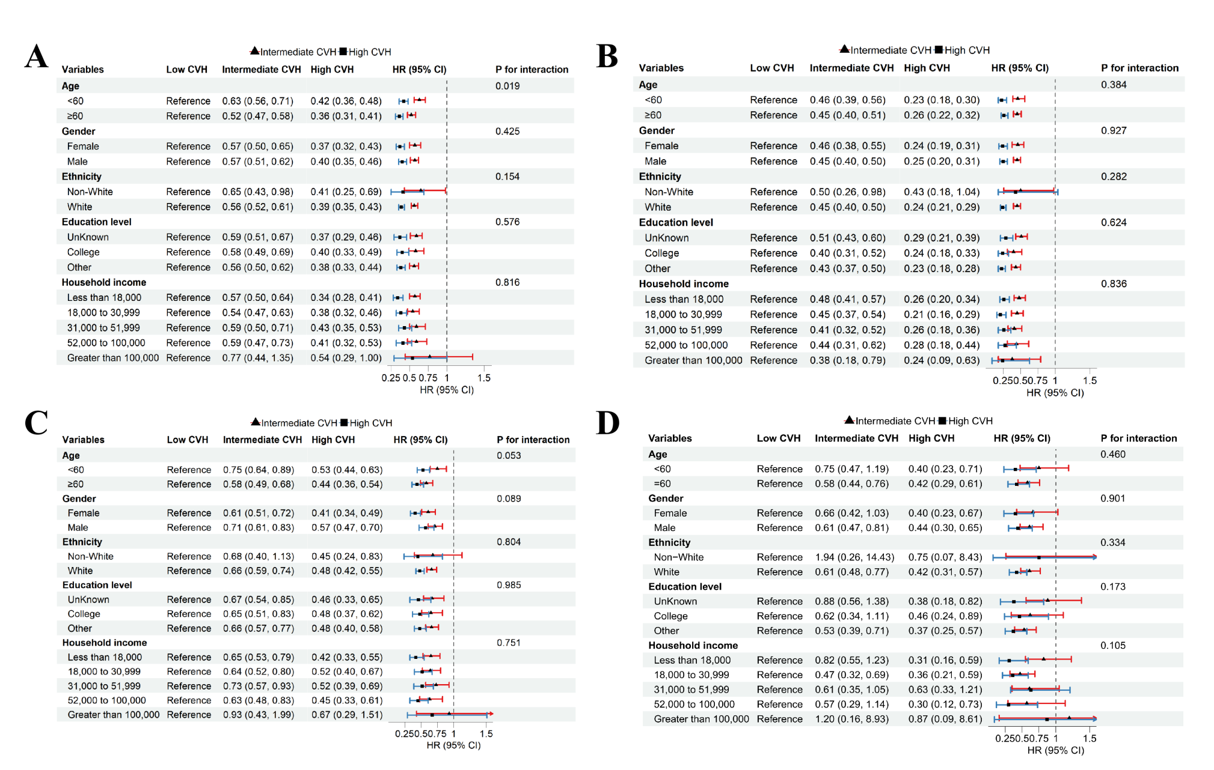
Models were adjusted for age, sex, ethnicity, Townsend Deprivation Index, educational attainment, household income, NO₂, NO_{X}, PM₁₀, and PM_{2.5}. Abbreviations: CI, confidence interval; COPD, chronic obstructive pulmonary disease; CRDs, chronic respiratory diseases; CVH, cardiovascular health; HR, hazard ratio; IPF, idiopathic pulmonary fibrosis; NO₂, nitrogen dioxide; NO_{X}, nitrogen oxides; PM₁₀, particulate matter with an aerodynamic diameter ≤10 μm; PM_{2.5}, particulate matter with an aerodynamic diameter ≤2.5 μm.
Supplementary Figure S5. Pearson correlations among Life’s Essential 8 components and phenotypic age acceleration.

Abbreviations: BMI = body mass index; PhenoAgeAccel = phenotypic age acceleration

