Additional file
Table 1. Factor loading of the items included in the three questionnaires measuring each sub-component of Meaning in Life. Only coefficients >0.30 are reported.
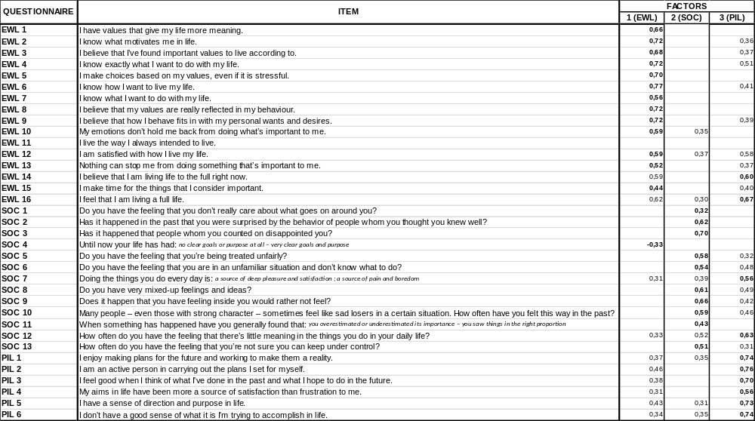

Normality tests and graphics of distribution of the scores obtained by participants in the three Meaning in life subcomponent questionnaires:
 | Kolmogorov-Smirnov |  |  | Shapiro-Wilk
 | Statistic | gl | Sig. | Statistic | gl | Sig.
EwL | ,099 | 1081 | ,000 | ,937 | 1081 | ,000
SoC | ,072 | 1081 | ,000 | ,974 | 1081 | ,000
PiL | ,125 | 1081 | ,000 | ,903 | 1081 | ,000

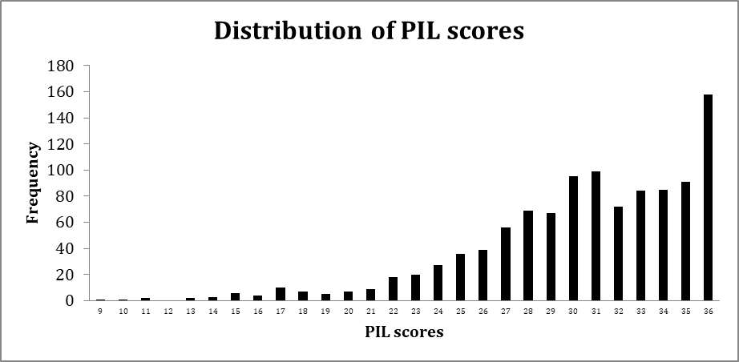
Mean (SD) = 30.3 (4.9)
Range = 9 – 36

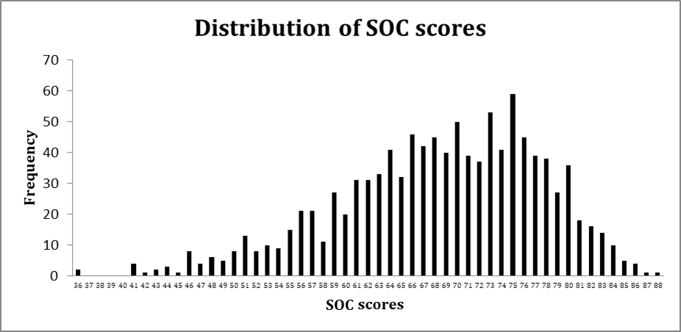
Mean (SD) = 68.4 (9.2)
Range = 36 – 8
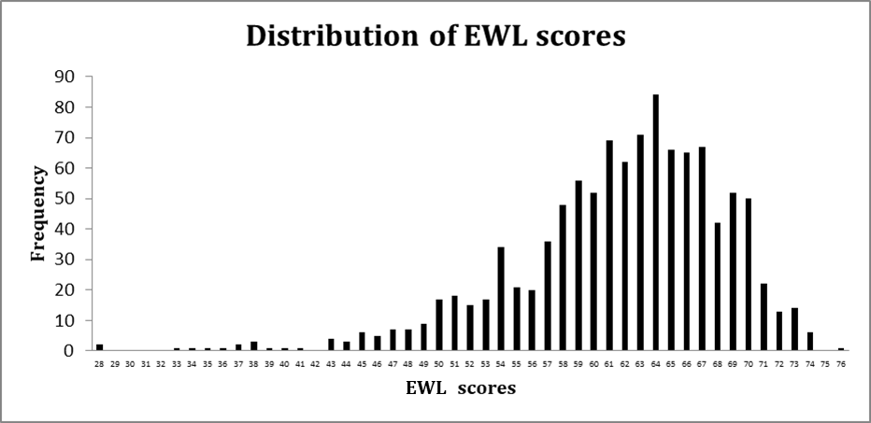Mean (SD) = 61.5 (6.93)
Range = 28 - 76

