Table S1. Sociodemographic, genetic and mood descriptive data in the MRI sample
 | Non-SCD | SCD- | SCD+
N | 423 | 37 | 72
Age M (SD) | 56.91 (7.30) | 56.67 (6.69) | 62.04 (7.12)^{ab}
Education M (SD) | 13.76 (3.55) | 14.14 (3.75) | 12.69 (3.42) ª
Females n (%) | 250 (59.1%) | 23 (62.2%) | 46 (63.9%)
APOE-ε4 Carriers n (%) | 216 (51.1%) | 9(24.3%) ª | 47 (65.3%) ^{ab}
GADS- Anxiety M (SD) | .48 (1.07) | 1.00 (1.80) ª | .93 (1.52) ª
GADS- Depression M (SD) | .14 (.58) | .49 (1.04) ª | .49 (1.01) ª
ªp<.05 as compared to Non-SCD; pairwise (HSD Tukey) ANOVA/Chi-square test.
^{b}p<.05 as compared to SCD-; pairwise (HSD Tukey) ANOVA/Chi-square test.
SCD-, SCD with 3 or less SCDplus features; SCD+, SCD with more than 3 SCDplus features; GADS, Goldberg Anxiety and Depression Scale.

Table S2. Frequency of co-occurrence of SCDplus features in subjects with SCD in the whole sample (n=572)
 | Memory Complaint | Decline last 2y | Age over 60 | Worry | Confirmation by Inf. | E4 Carriers
Memory Complaint | *
Decline last 2y | 412 | *
Age over 60 | 195 | 146 | *
Worry | 388 | 299 | 122 | *
Confirmation by Inf. | 159 | 118 | 60 | 116 | *
E4 Carriers | 196 | 145 | 60 | 139 | 57 | *

Table S3. Frequency of co-occurrence of SCDplus features in subjects with SCD in the MRI subsample (n=109)
 | Memory Complaint | Decline last 2y | Age over 60 | Worry | Confirmation by Inf. | E4 Carriers
Memory Complaint | *
Decline last 2y | 85 | *
Age over 60 | 53 | 43 | *
Worry | 83 | 66 | 42 | *
Confirmation by Inf. | 39 | 31 | 21 | 31 | *
E4 Carriers | 56 | 46 | 28 | 43 | 19 | *

Table S4. Brain regions showing statistically significant negative associations between the number of SCDplus features met and GM volume
 | Label | MNI coordinates |  |  | Cluster | Peak | pFWE-corr
 |  | x | y | z | size | Z-score | peak | cluster
Cluster 1 | Left Temporal Inferior | -36 | -23 | -38 | 1744 | 4.87 | 0.007 | 0.025
 | Left Fusiform
 | Left Temporal Pole Superior
 | Left Temporal Superior
Cluster 2 | Left Temporal Superior | -60 | -35 | 14 | 2043 | 4.33 | 0.061 | 0.015
 | Left Temporal Middle
 | Left Temporal Inferior
Cluster 3 | Right Temporal Superior | 71 | -30 | 0 | 217 | 4.31 | 0.066 | 0.622
 | Right Temporal Middle
Cluster 4 | Right Frontal Superior | 24 | 27 | 42 | 544 | 4.25 | 0.084 | 0.295
 | Right Frontal Middle
Cluster 5 | Right Frontal Inferior Operc. | 51 | 8 | 18 | 592 | 4.13 | 0.127 | 0.264
 | Right Rolandic Operculum
 | Right Frontal Inferior Triang.
Cluster 6 | Vermis | -2 | -57 | -14 | 3885 | 4.00 | 0.194 | 0.001
 | Left Precuneus
 | Left Cerebellum
Left Cuneus
Right Cerebellum
Cluster 7 | Right Rolandic Operculum | 50 | -24 | 32 | 2724 | 3.96 | 0.219 | 0.005
 | Right Postcentral
 | Right Temporal Superior
 | Right Supramarginal
 | Right Insula
 | Right Heschl
Cluster 8 | Left Postcentral | -51 | -21 | 30 | 469 | 3.87 | 0.282 | 0.350
 | Left Supramarginal
 | Left Parietal Inferior
Cluster 9 | Right Frontal Superior Medial | 3 | 48 | 32 | 1286 | 3.77 | 0.372 | 0.060
 | Left Frontal Superior Medial
 | Right Frontal Superior
 | Right Cingulate Anterior
Cluster 10 | Right Cerebellum Crus | 35 | -74 | -27 | 1150 | 3.72 | 0.426 | 0.079
 | Right Cerebellum
Cluster 11 | Right Fusiform | 50 | -24 | -20 | 777 | 3.70 | 0.441 | 0.174
 | Right Temporal Inferior
Cluster 12 | Left Cerebellum | -11 | -63 | -48 | 955 | 3.59 | 0.563 | 0.119
 | Right Cerebellum
 | Vermis
Cluster 13 | Right Insula | 36 | 24 | -6 | 153 | 3.52 | 0.637 | 0.714
 | Right Frontal Inferior Orb.
Cluster 14 | Left Rectus | -8 | 41 | -18 | 439 | 3.49 | 0.664 | 0.375
 | Left Frontal Medial Orb.
MNI: Montreal Neurological Institute; only labels accounting for more than 5% of the cluster volume are reported

Figure S1. Frequency of SCD subjects by number of criteria met in the whole sample
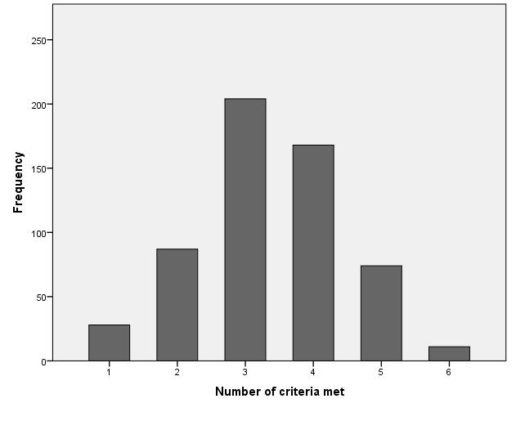

Figure S2. Frequency of SCD subjects by number of criteria met in the MRI subsample
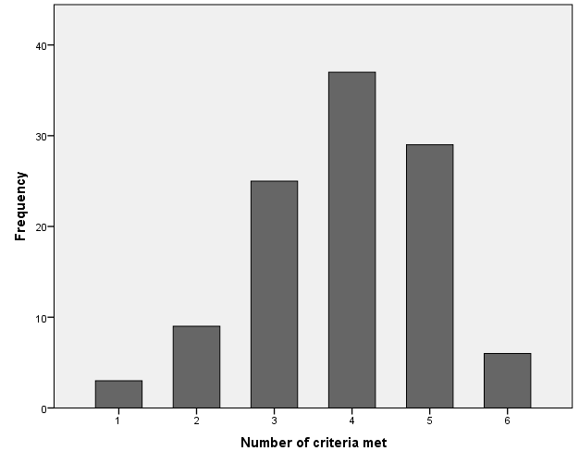

Figure S3. Brain regions showing a negative linear relation between number of SCDplus features met and GM volume in SCD subjects

