Table S1. Demographic and baseline characteristics of the end-stage renal disease (ESRD) and non-ESRD population in the sensitivity analyses, for which dementia is diagnosed by neurologists and psychiatrists.
 | Non-ESRD population | ESRD population | P value
Number of patients | 927,514 | 100,492 | -
Age, No (%)
Mean (SD) | 32.25 (19.68) | 61.75 (14.25) | <0.0001
≤ 18 years | 242,490 (26.14) | 264 (0.26) | <0.0001
18-29 years | 208,898 (22.52) | 1,937 (1.93)
30-39 years | 168,818 (18.20) | 4,809 (4.79)
40-49 years | 132,854 (14.32) | 12,795 (12.73)
50-59 years | 70,888 (7.64) | 21,745 (21.64)
60-69 years | 57,402 (6.19) | 25,681 (25.56)
70-79 years | 35,380 (3.81) | 23,883 (23.77)
≥ 80 years | 10,784 (1.16) | 9,378 (9.33)
Sex, No of male (%) | 475,469 (51.26) | 49,861 (49.62) | <0.0001
Median (IQR) length of follow-up (years) | 13.00 (0.00-0.00) | 2.88 (4.22) | <0.0001
Comorbidities, No (%)
Diabetes mellitus | 16,873 (1.82) | 52,833 (52.57) | <0.0001
Stroke | 3,242 (0.35) | 11,088 (11.03) | <0.0001
Anemia | 3,982 (0.43) | 53,329 (53.07) | <0.0001
Heart failure | 2,216 (0.24) | 29,228 (29.08) | <0.0001
Hypertension | 35,188 (3.79) | 78,220 (77.84) | <0.0001
Hyperlipidemia | 4,317 (0.47) | 27,155 (27.02) | <0.0001
Coronary artery disease | 4,494 (0.48) | 24,615 (24.49) | <0.0001
Peripheral vascular disease | 406 (0.04) | 5,225 (5.20) | <0.0001
Malignancy | 3,922 (0.42) | 8,506 (8.46) | <0.0001
Depression | 527 (0.06) | 3,156 (3.14) | <0.0001
Obstructive sleep apnea | 65 (0.01) | 268 (0.27) | <0.0001
Insomnia | 452 (0.05) | 12,074 (12.01) | <0.0001
Alcoholism | 1,148 (0.12) | 1,066 (1.06) | <0.0001
Traumatic brain injury | 7,850 (0.85) | 1,554 (1.55) | <0.0001
Parkinson’s disease | 418 (0.05) | 1,317 (1.31) | <0.0001
Myocardial infarction | 778 (0.08) | 4,339 (4.32) | <0.0001
Atrial fibrillation | 960 (0.10) | 3,407 (3.39) | <0.0001
Hyperthyroidism | 460 (0.05) | 809 (0.81) | <0.0001
Hypothyroidism | 108 (0.01) | 1,054 (1.05) | <0.0001
SD, standard deviation.

Table S2. International Classification of Disease, Ninth Edition (ICD-9-CM) codes used to identify the associated comorbidities in the study.
Clinical diagnosis | The associated ICD-9-CM codes
Diabetes | 250, 357.2, 362.0X, and 366.41.
Hypertension | 401-402, 405, and A codes 260 and 269.
Cardiovascular disease:  Congestive heart failure  Coronary artery disease  Myocardial infarction  Peripheral vascular disease | 398.91, 425, 428, 402.X1, 404.X1, and 404.X3.  414.  410.X, 412.  440–444, 447.1.
Stroke  Ischemic stroke  Hemorrhagic stroke | 433.xx, 434.xx, and 436.xx.  430.xx, 431.xx, and 432.xx.
Anemia  Hyperlipidemia | 280-285.  272.0-272.4 and A code 189.
Malignancy | 140-208, 230-234 and 209.0-209.3.
Depression | 296.2, 296.3, 296.82, 300.4, 309.0, 309.1, 311.
Obstructive sleep apnea | 780.51, 780.53, 780.57.
Insomnia | 307.4, 780.5.
Alcoholism | 291, 303, 305.0, 357.5, 425.5, 571.0, 571.1, 571.2, 571.3, 980.0, V11.3.
Traumatic brain injury | 800-804, and 850-854.
Parkinson’s disease | 332.
Atrial fibrillation | 427.3.
Hyperthyroidism | 242.
Hypothyroidism | 244.

Table S3. Overall and age- and sex-specific incidence rates (IRs) of dementia between end-stage renal disease (ESRD) and non-ESRD population in the sensitivity analyses, for which dementia is diagnosed by neurologists and psychiatrists.

Characteristics | Non-ESRD population |  | ESRD population |  | P value
Characteristics | No. of events | Incidence rates (per 1,000 patient-years) and 95% CI | No. of events | Incidence rates (per 1,000 patient-years) and 95% CI
Male
Age (years)
≤ 18 years | 134 | 0.08 (0.07-0.10) | 0 | 0.00 (0.00-0.00)
18-29 years | 238 | 0.19 (0.17-0.22) | 2 | 0.31 (0.04-1.12)
30-39 years | 274 | 0.27 (0.23-0.30) | 7 | 0.48 (0.19-0.99)
40-49 years | 368 | 0.45 (0.40-0.50) | 41 | 1.26 (0.91-1.71)
50-59 years | 557 | 1.33 (1.22-1.44) | 119 | 2.67 (2.21-3.20)
60-69 years | 1,652 | 5.15 (4.90-5.40) | 278 | 6.69 (5.92-7.52)
70-79 years | 1,802 | 10.69 (10.20-11.19) | 381 | 13.03 (11.75-14.41)
≥ 80 years | 448 | 16.23 (14.76-17.81) | 164 | 21.97 (18.73-25.60)
Total | 5,473 | 0.97 (0.94-0.99) | 992 | 5.60 (5.26-5.96) | <0.0001
Female
Age (years)
≤ 18 years | 84 | 0.06 (0.04-0.07) | 0 | 0.00 (0.00-0.00)
18-29 years | 91 | 0.07 (0.06-0.09) | 2 | 0.40 (0.05-1.46)
30-39 years | 111 | 0.11 (0.09-0.13) | 10 | 0.75 (0.36-1.38)
40-49 years | 300 | 0.36 (0.32-0.40) | 37 | 1.05 (0.74-1.44)
50-59 years | 666 | 1.51 (1.39-1.63) | 129 | 2.89 (2.42-3.44)
60-69 years | 1,600 | 5.07 (4.82-5.33) | 418 | 8.33 (7.55-9.17)
70-79 years | 1,710 | 11.61 (11.07-12.17) | 552 | 15.52 (14.25-16.87)
≥ 80 years | 462 | 13.64 (12.43-14.94) | 181 | 19.39 (16.67-22.43)
Total | 5,024 | 0.91 (0.88-0.93) | 1,329 | 6.86 (6.49-7.24) | <0.0001
Overall IR | 10,497 | 0.94 (0.92-0.96) | 2,321 | 6.26 (6.01-6.52) | <0.0001
SD, standard deviation; CI, confidence interval.

Table S4. Estimated cause-specific hazard and subdistribution hazard ratios for risk of dementia and all-cause mortality using multivariable Cox regression models in the sensitivity analyses, for which dementia is diagnosed by neurologists and psychiatrists.

Covariates | Overall |  | Alzheimer’s disease |  | Vascular dementia |  | Unspecified dementia
 | Dementia  aHR* (95% CI) | Mortality  aHR* (95% CI) | Dementia  aHR* (95% CI) | Mortality  aHR* (95% CI) | Dementia  aHR* (95% CI) | Mortality  aHR* (95% CI) | Dementia  aHR* (95% CI) | Mortality  aHR* (95% CI)
Cause-specific hazard models*
ESRD vs. non-ESRD | 2.24 (2.09-2.39) | 3.98 (3.91-4.05) | 2.90 (2.20-3.84) | 3.86 (3.79-3.93) | 2.06 (1.74-2.44) | 3.88 (3.81-3.95) | 2.25 (2.09-2.42) | 3.94 (3.87-4.01)
Subdistribution hazard models*
ESRD vs. non-ESRD | 0.53 (0.50-0.57) | 3.63 (3.56-3.69) | 0.56 (0.44-0.70) | 3.83 (3.77-3.9) | 0.43 (0.37-0.49) | 3.82 (3.75-3.89) | 0.56 (0.52-0.60) | 3.65 (3.59-3.72)
*HRs were adjusted for age, sex, and selected comorbidities (diabetes mellitus, stroke, anemia, heart failure, hypertension, hyperlipidemia, coronary artery disease, peripheral vascular disease, malignancy, depression, obstructive sleep apnea, insomnia, alcoholism, traumatic brain injury, Parkinson’s disease, myocardial infarction, atrial fibrillation, hyperthyroidism and hypothyroidism).
aHR, adjusted hazard ratio; CI, confidence interval; ESRD, end-stage renal disease.

Figure S1. Cumulative incidence rates of dementia after accounting for competing risk of mortality between patients with and without end-stage renal disease (ESRD), for which dementia is diagnosed by neurologists and psychiatrists.

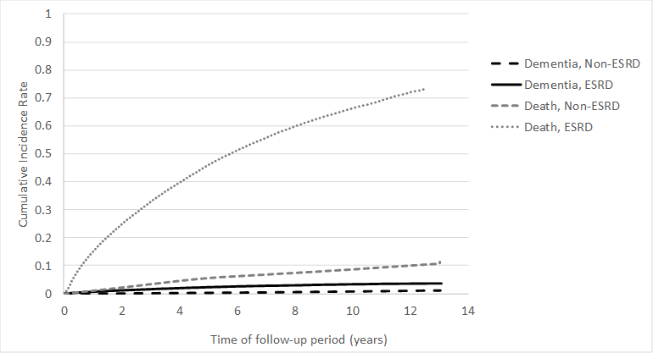

Figure S2. Stratified analysis of risk for dementia between the end-stage renal disease (ESRD) and non-ESRD population by using multivariable subdistribution hazard models*.
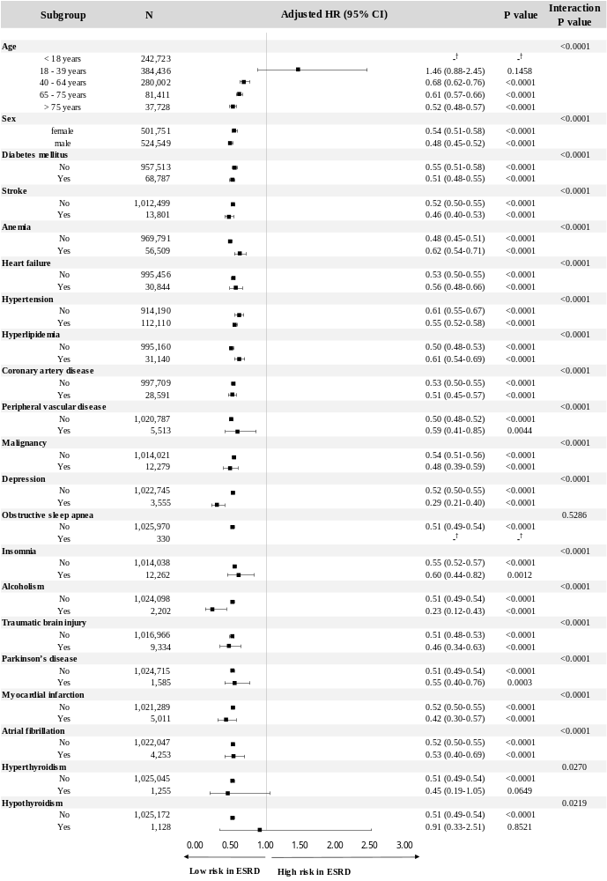
* Hazard Ratios were adjusted for age, sex, and diabetes mellitus, stroke, anemia, heart failure, hypertension, hyperlipidemia, coronary artery disease, peripheral vascular disease, malignancy, depression, obstructive sleep apnea, insomnia, alcoholism, traumatic brain injury, Parkinson’s disease, myocardial infarction, atrial fibrillation, hyperthyroidism and hypothyroidism.
† No Hazard ratio (HR) was estimated because no dementia event occurred in the ESRD group.

Figure S3. Stratified analysis of risk for dementia between the end-stage renal disease (ESRD) and non-ESRD population by using multivariable cause-specific* (Figure e-3A) and subdistribution* (Figure e-3B) hazard models in the sensitivity analyses, for which dementia is diagnosed by neurologists and psychiatrists.
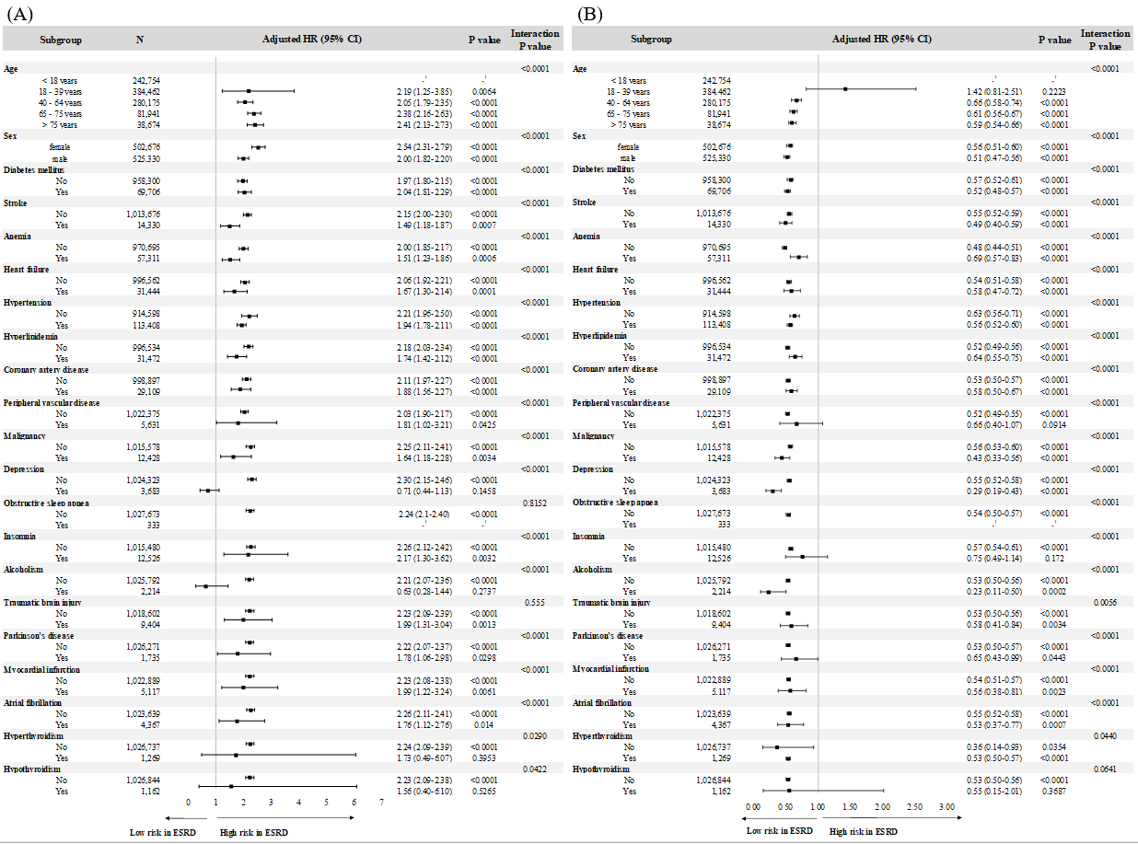
* Hazard Ratios were adjusted for age, sex, and diabetes mellitus, stroke, anemia, heart failure, hypertension, hyperlipidemia, coronary artery disease, peripheral vascular disease, malignancy, depression, obstructive sleep apnea, insomnia, alcoholism, traumatic brain injury, Parkinson’s disease, myocardial infarction, atrial fibrillation, hyperthyroidism and hypothyroidism.
† No Hazard ratio (HR) was estimated because no dementia event occurred in the ESRD group.

