Figure 1.1: Counseling and medication prescription in patients with MCI
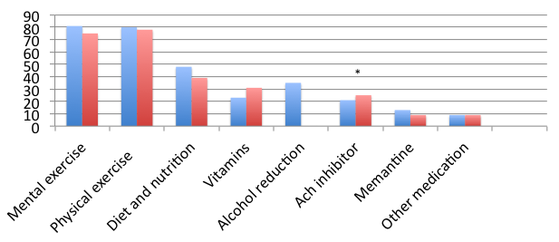
Frequency of response (%) in EAN/EADC survey (blue column) and AAN survey (red column) who routinely counsel on the above topics.
Differences frequencies between EAN/EADC and AAN members were tested using chi-square. *p<0.01

Figure 1.2: Benefits and drawbacks of MCI as clinical diagnosis

Blue bars are frequencies (in %)of respondents of EAN/EADC. Red bars are frequencies (in %) of respondents of the AAN survey. Frequency (%) of respondents that strongly or somewhat agreed on the above statements. Abbreviations: EAN, European Academy of Neurology; EADC, European Alzheimer’s Disease Consortium; AAN, American Academy of Neurology.
Figure 1.3: Counseling and medication prescription in patients with and without prodromal AD
Frequency (%) of respondents that routinely counseled or prescribed treatment in patients with ‘prodromal AD’ (blue column) or no prodromal AD’(red column). Differences frequencies between ‘prodromal AD’ and ‘ no prodromal AD’ were tested using chi-square. *p<0.01

