Supplementary figures

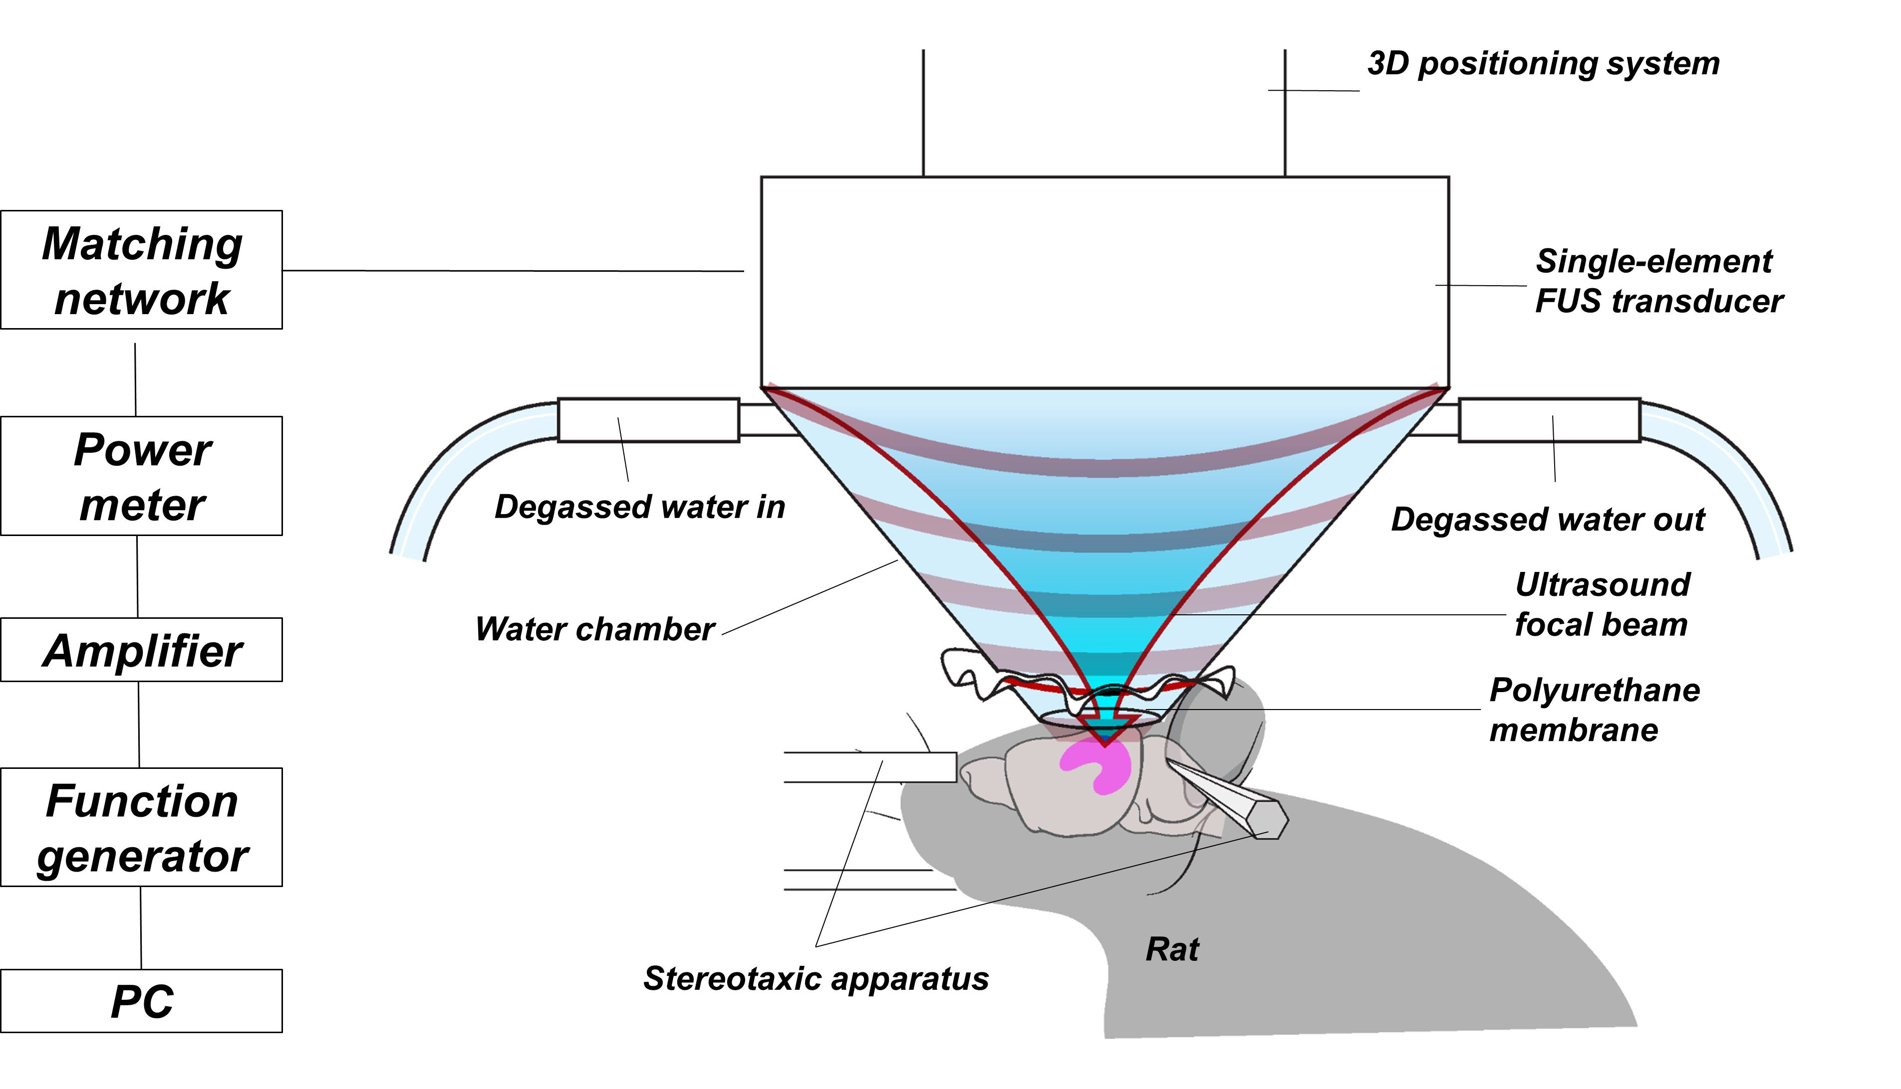

Fig. S1. The schematic of the FUS experimental setup.

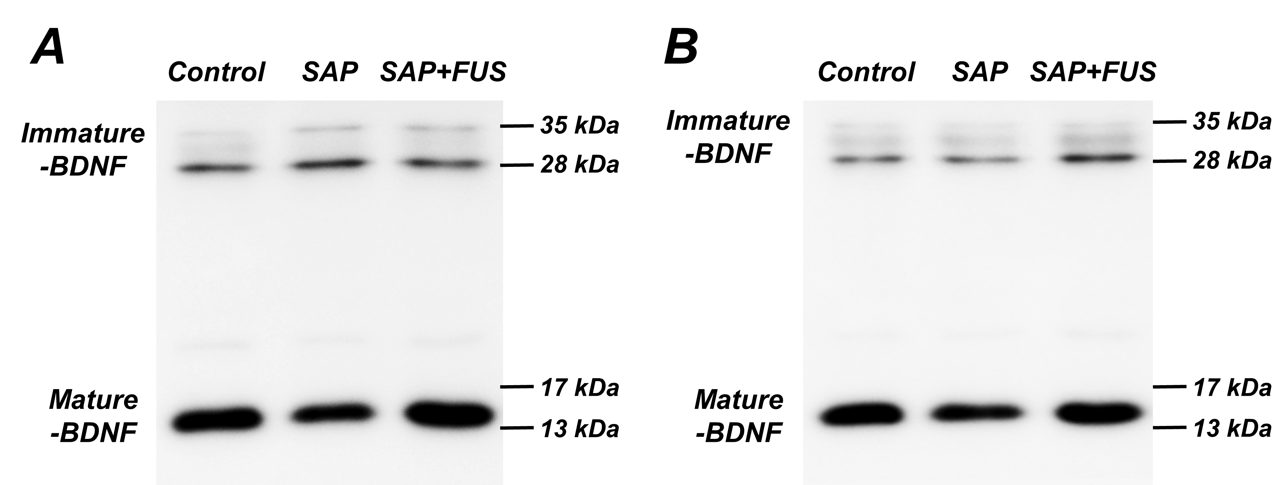

Fig. S2. Immunoblot of BDNF of multiple bands at mature-BDNF (~13 kDa) and immature-BDNF (17~32 kDa) were observed at (A) twenty-four hours after sonication and (B) eighteen days after sonication

