Supplement Contents

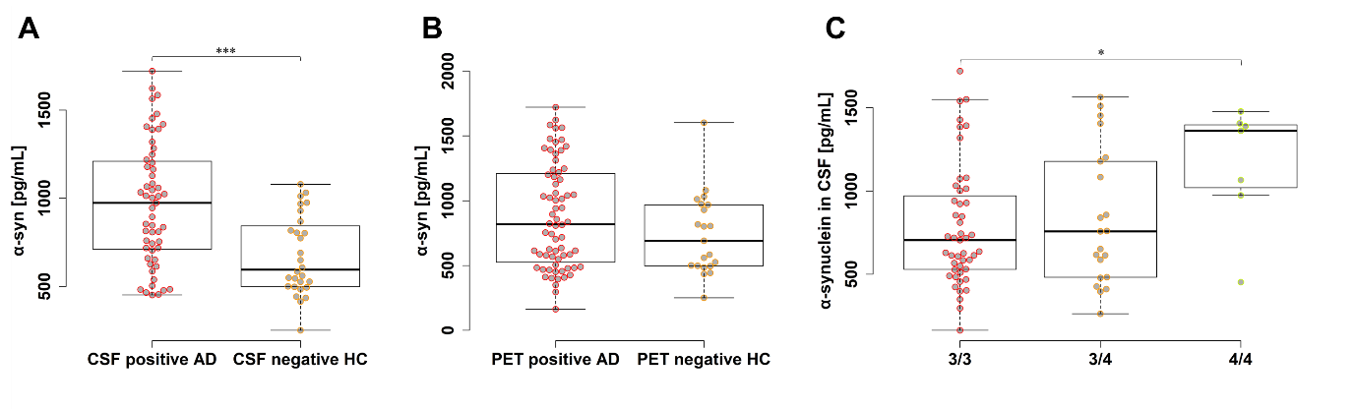
Supplement Figure 1 The levels of α-syn between two groups selected by CSF biomarker value, the visual PET reading, and APOEε genotype. (A) AD patients with all positive CSF triple marker levels were sorted as CSF-positive. Oppositely, the CSF-negative group involves HC with all negative CSF triple marker levels. (B) PET-positive and -negative groups were classified through visual PET reading from AD and HC, respectively. (C) groups were divided by APOEε genotype. Abbreviation: α-syn, α-synuclein; CSF, cerebrospinal fluid; PET, positron emission tomography; AD, Alzheimer’s disease; HC, healthy control.

Supplement Figure 2 Correlation with cognitive decline and biomarkers. (A) T-tau and MMSE. (B) T-tau/α-syn ratio and MMSE. (C) T-tau and CDR. (D) T-tau/α-syn ratio and CDR. Abbreviation: MMSE, Mini Mental State Examination; CDR, Clinical Dementia Rating; EOAD, early-onset Alzheimer’s disease; LOAD, late-onset Alzheimer’s disease; MCI, mild cognitive impairment; SCD, subjective cognitive decline; PD, Parkinson’s disease; HC, healthy control; T-tau, total tau; P-tau₁₈₁, phosphorylated tau 181; α-syn, α-synuclein.

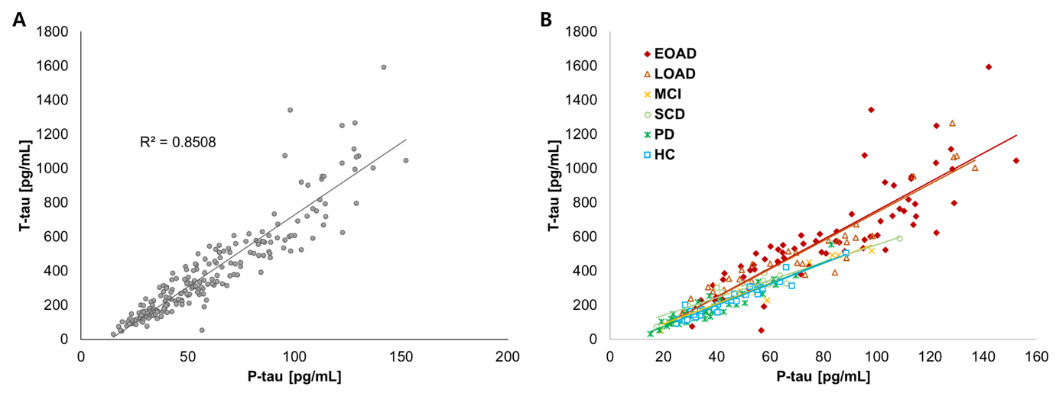
Supplement Figure 3 Correlation between T-tau and P-tau₁₈₁. (A) T-tau and P-tau₁₈₁. (B) T-tau and P-tau₁₈₁ in each group.
Abbreviation: EOAD, early-onset Alzheimer’s disease; LOAD, late-onset Alzheimer’s disease; MCI, mild cognitive impairment; SCD, subjective cognitive decline; PD, Parkinson’s disease; HC, healthy control; T-tau, total tau; P-tau₁₈₁, phosphorylated tau 181.

Supplement Table 1 Quadruple CSF biomarkers profiles and characteristics
ATN profiles |  | Characteristics
A-T-N- | N/αS- | Normal AD biomarkers
A-T-N- | N/αS+ | Possible neurodegenerative change with tau and α-synuclein pathophysiology
A+T-N- | N/αS- | Alzheimer’s pathologic change or concomitant with synucleinopathies
A+T-N- | N/αS+ | Alzheimer’s pathologic change with tau and α-synuclein pathophysiology
AD | N/αS- | AD with over-production/secretion of α-synuclein or concomitant with other neurodegenerative disorders
AD | N/αS+ | AD with tau and α-synuclein pathophysiology
A+T-N+ | N/αS- | -
A+T-N+ | N/αS+ | Alzheimer’s and concomitant suspected non-Alzheimer’s pathologic change with tau and α-synuclein pathophysiology
SNAP | N/αS- | Non-Alzheimer’s pathologic change with over-production/secretion of α-synuclein
SNAP | N/αS+ | Possibly preclinical AD with over-production/secretion of Aβ₄₂
Abbreviations: AD, Alzheimer’s disease; Pre-AD, preclinical Alzheimer’s disease; SNAP, suspected non-Alzheimer’s disease pathophysiology.

Supplement Table 2 Quadruple CSF biomarkers profiles and characteristics
 | T-tau | P-tau₁₈₁ | Aβ₄₂/  P-tau₁₈₁ | T-tau/  α-syn | P-tau₁₈₁/  α-syn | Combined
Aβ₄₂ | 0.775 | 0.273 | 0.009 | 0.261 | 0.031 | 0.009
T-tau |  | 0.002 | 0.035 | 0.197 | 0.215 | 0.006
P-tau₁₈₁ |  |  | <0.001 | 0.011 | 0.791 | <0.001
Aβ₄₂/  P-tau₁₈₁ |  |  |  | 0.336 | 0.001 | 0.318
T-tau/  α-syn |  |  |  |  | 0.014 | 0.069
P-tau₁₈₁/  α-syn |  |  |  |  |  | <0.001
*The values with P < 0.05 are underlined.
*Combined means ‘Aβ₄₂/P-tau₁₈₁, T-tau/α-syn’

