Additional file 5. Trajectories of subjective cognitive decline (SCD) during the first 4 years of the study, with each grey line in the figure representing the trajectory for individual participant over Year 1 to Year 4.
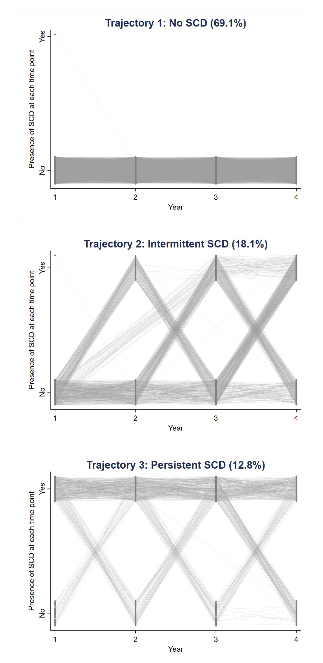
Note: To improve clarity, only those with high probabilities (>0.70) of belonging to a trajectory are shown in the figures.

