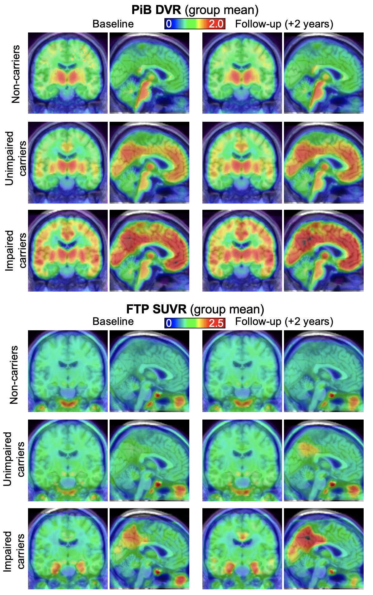
Supplementary Figure 1. Mean images of PiB DVR (top) and FTP SUVR (bottom) for each group at baseline (left) and follow-up (right).

