Supplementary Materials

A novel age-informed approach for genetic association analysis in Alzheimer’s disease

Authors: Yann Le Guen¹, PhD, Michael E. Belloy¹, PhD, Valerio Napolioni², PhD, Sarah J. Eger¹, BA, Gabriel Kennedy¹, BS, Ran Tao³, PhD, Zihuai He^{1,4}, PhD, and Michael D. Greicius¹, MD, MPH, for the Alzheimer’s Disease Neuroimaging Initiative*.

¹Department of Neurology and Neurological Sciences, Stanford University, Stanford, CA, 94304, USA
²School of Biosciences and Veterinary Medicine, University of Camerino, Camerino, 62032, Italy
³Department of Biostatistics and Vanderbilt Genetic Institute, Vanderbilt University, Nashville, TN, 37203, USA
⁴Quantitative Sciences Unit, Department of Medicine, Stanford University, Stanford, CA, 94304, USA

*Data used in preparation of this article were obtained from the Alzheimer’s Disease Neuroimaging Initiative (ADNI) database (adni.loni.usc.edu). As such, the investigators within the ADNI contributed to the design and implementation of ADNI and/or provided data but did not participate in analysis or writing of this report. A complete listing of ADNI investigators can be found at:
http://adni.loni.usc.edu/wp-content/uploads/how_to_apply/ADNI_Acknowledgement_List.pdf
Corresponding Author
Yann Le Guen
Department of Neurology and Neurological Sciences – FIND lab
Stanford University
290 Jane Stanford Way, Stanford, CA, USA
Tel: 650 498 4624
Email: yleguen@stanford.edu

Figure S1. Power of different association models for two additional specific simulation outcomes.
Figure S2. Power differences between association models on simulated case-control data, considering the age-related risk effect estimate of Alzheimer’s disease (OR 1.16).
Figure S3. Type I error rate control for the four tested models.
Figure S4. Manhattan plots for the two model adjustments of the logistic regression adjusted by age.
Figure S5. Manhattan plots for the two model adjustments of the logistic regression not adjusted by age.
Figure S6. Manhattan plots for the two model adjustments of the multivariate Cox regression.
Figure S7. Manhattan plots for the two model adjustments on the two AD-age scores linear regression.
Figure S8. QQ plots of the logistic regression adjusted by age corresponding to Figure S3.
Figure S9. QQ plots of the standard logistic regression corresponding to Figure S4.
Figure S10. QQ plots of the multivariate Cox regression corresponding to Figure S5.
Figure S11. QQ plots of the linear regression on the AD-age score corresponding to Figure S6.
Figure S12. Comparison between exp(β), OR (odds ratio), HR (hazard ratio) for associations suggestive in any models.
Figure S13. Comparison between -log(p) between logistic regression, linear regression on the AD-age score and multivariate Cox regression.

Table S1. Demographics per cohort in the discovery sample.
Table S2. Demographics per cohort in the replication sample.
Table S3. Number of individuals, minor allele frequency and imputation quality for the suggestive variants in the discovery outside of the APOE region.
Table S4. Lambda medians for each main model and model adjustments.
Table S5. All suggestive association results in the discovery outside of the APOE region.
Table S6. Meta-analysis of the replicated exonic associations.
Table S7. Differential expression between AD and control individuals for mapped genes reported in Table 2.
Table S8. Review of the main genome-wide or exome-wide association studies linking these genes or variants to AD diagnosis.

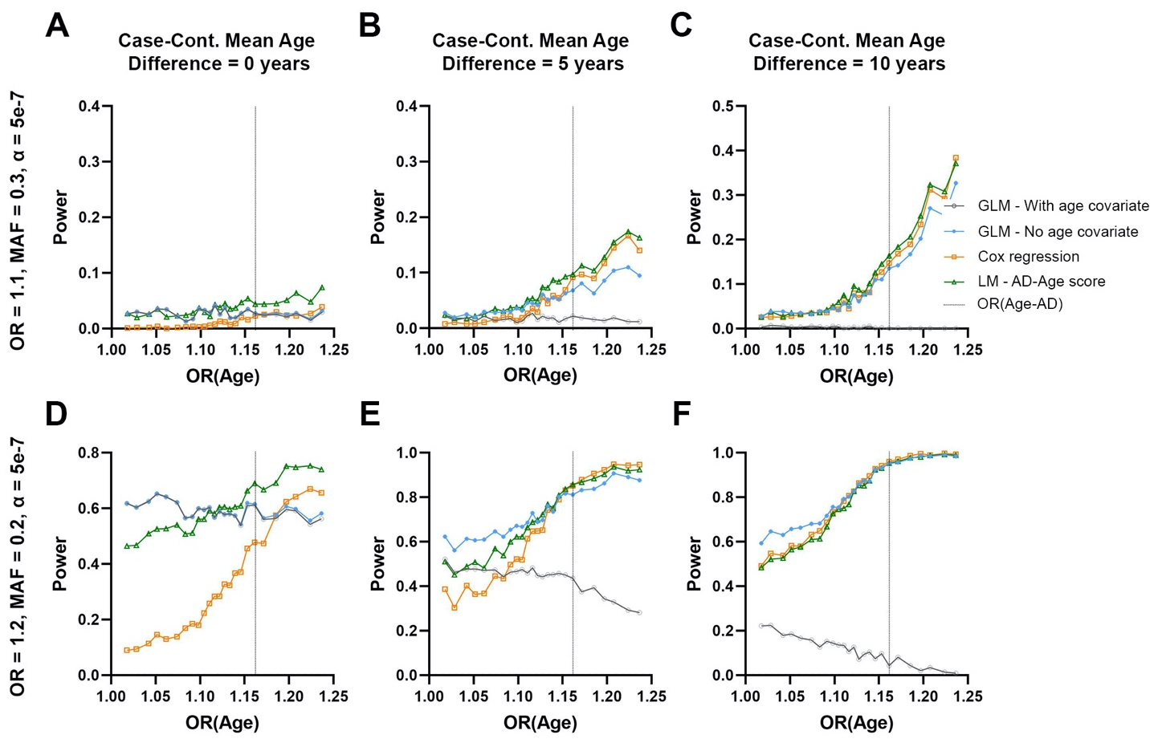
Figure S1. Power of different association models for two additional specific simulation outcomes. A-C) A highly common variant with small effect size, evaluated in 5000 cases and 5000 controls at a significance level of α = 5e⁻⁷. D-F) A common variant with moderate effect size, evaluated in 5000 cases and 5000 controls at a significance level of α = 5e⁻⁷. Panels show power on the y-axis and age-related effect estimates on the x-axis. Outcomes for four models are shown (cf. legend) and the age-related effect estimate for AD [OR(Age-AD)] is marked by a vertical grey dotted line. From left to right, panels show simulation results for increasing mean age differences between cases and controls (cases being younger where applicable). Note for F), which mimics the ADSP WES study design, that for a common variant with moderate effect, there is no clear difference between logistic regression not adjusted for age, Cox regression, or the AD-age score. This is consistent with the expectation of ADSP’s study design to increase statistical power by selecting for young cases versus old controls.

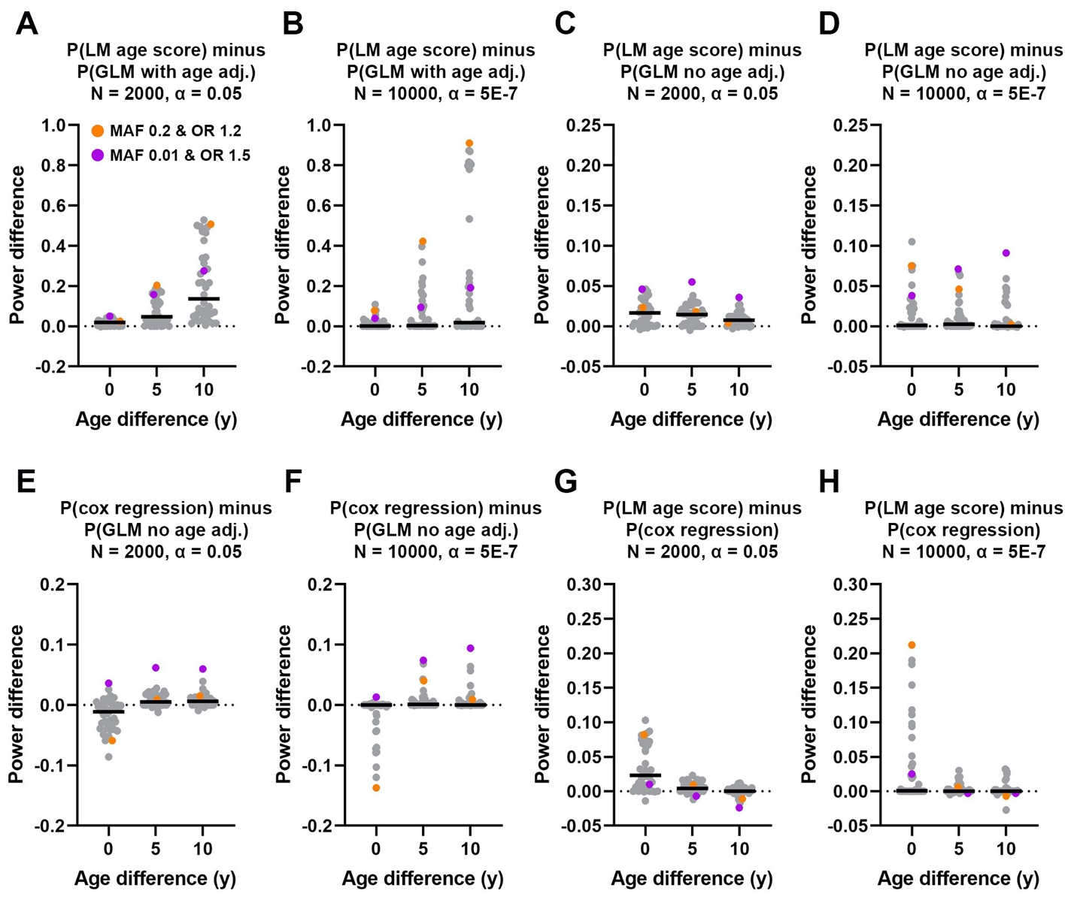
Figure S2. Power differences between association models on simulated case-control data, considering the age-related risk effect estimate of Alzheimer’s disease (OR 1.16). Paired model comparisons and parameters are indicated on panel titles, where N = 2000 indicates 1000 cases and 1000 controls, and N = 10000 indicates 5000 cases and 5000 controls. Each panel displays power differences (y-axis) for each individual combination of simulated variant MAF and OR (single dot) and their averages (black line), stratified according to the mean age differences between cases and controls (x-axis). Orange and purple dots on each panel indicate power differences for conditions matching those presented in Figure 1. A-B) Critical power gain was observed when not adjusting for age in logistic regression analyses. C-D) There was on average 10% increase in power when using the AD-age score compared to logistic regression analyses not adjusting for age. This overall effect diminishes in a larger sample (N = 10000), but some conditions (e.g. purple dot) still display power gain. There was never any power loss. E-F) There was limited power gain when using the Cox regression and power loss was observed when there was no mean age difference between cases and controls. G-H) AD-age score always outperformed Cox regression.

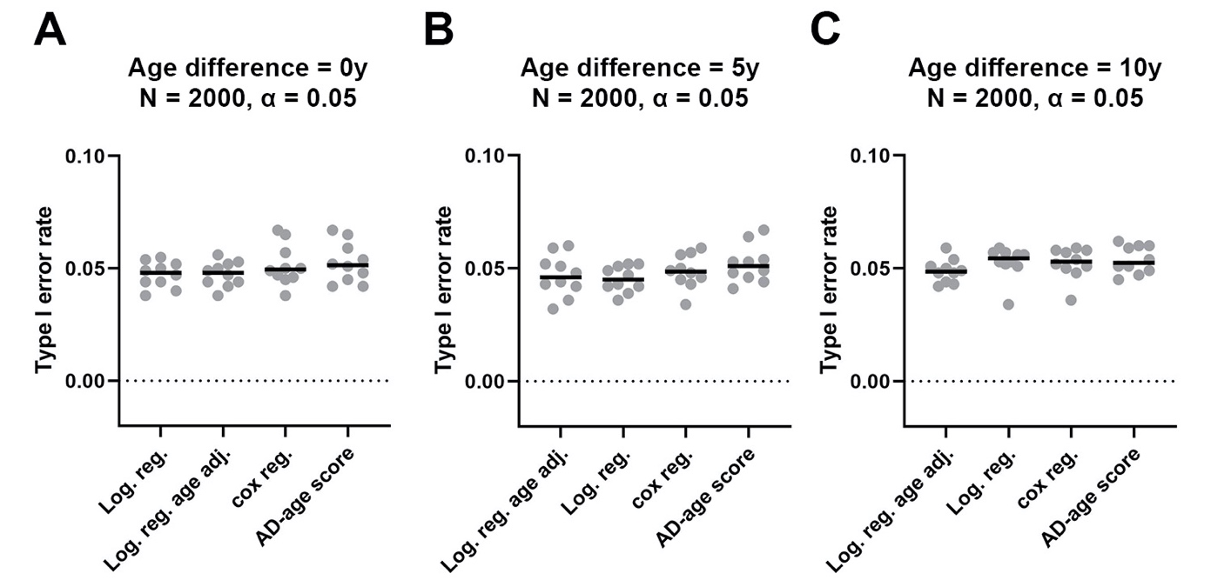
Figure S3. Type I error rate control for the four tested models. Paired model comparisons and parameters are indicated on panel titles, where N = 2000 indicates 1000 cases and 1000 controls. Each panel displays power differences (y-axis) for each individual combination of simulated variant MAF (single dot) and their averages (black line), stratified according to the mean age differences between cases and controls (x-axis).

Figure S4. Manhattan plots for the two model adjustments of the logistic regression adjusted by age. The age adjusted logistic regression has no suggestive association (dashed line, p < 1×10⁻⁵).

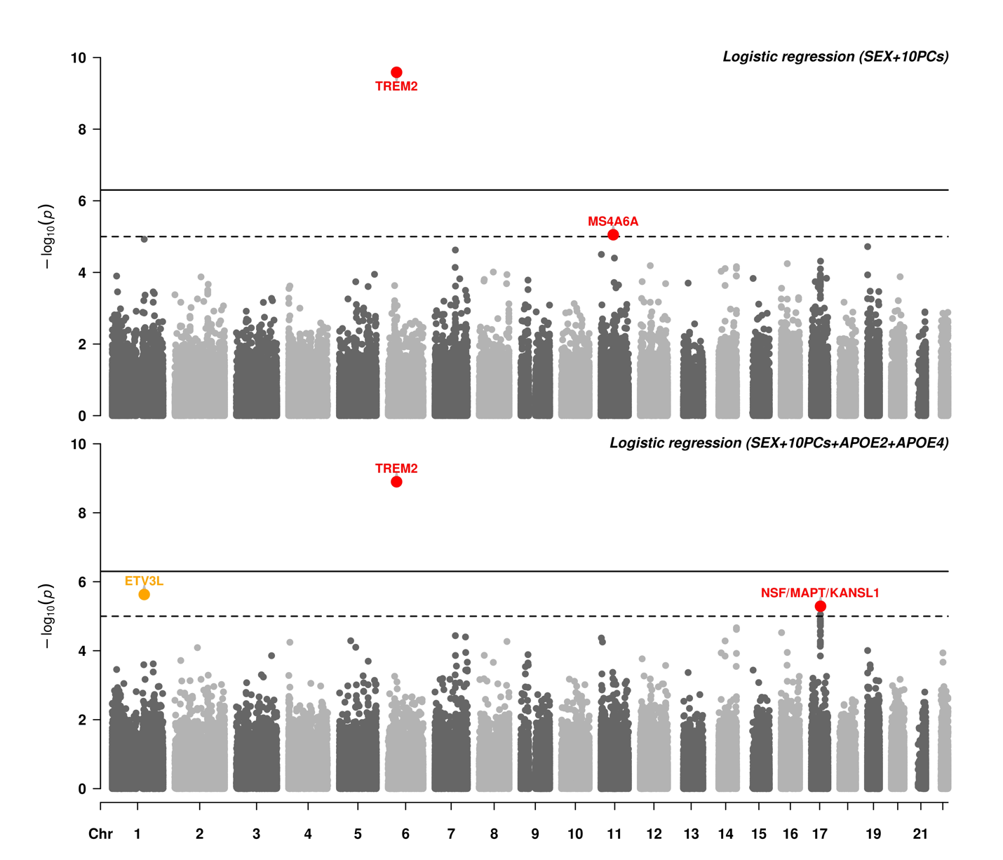
Figure S5. Manhattan plots for the two model adjustments of the logistic regression not adjusted by age. The main causal variant on TREM2 is exome wide significant (solid line, p < 5×10⁻⁷). Among suggestive associations (dashed line, p < 1×10⁻⁵), (i) known AD associations are in red, (ii) novel associations which replicate (p < 0.05) in an independent dataset (cf Table 3) are in blue, (iii) likely spurious associations with discordant direction of effect in the replication are in yellow (cf Table S5).
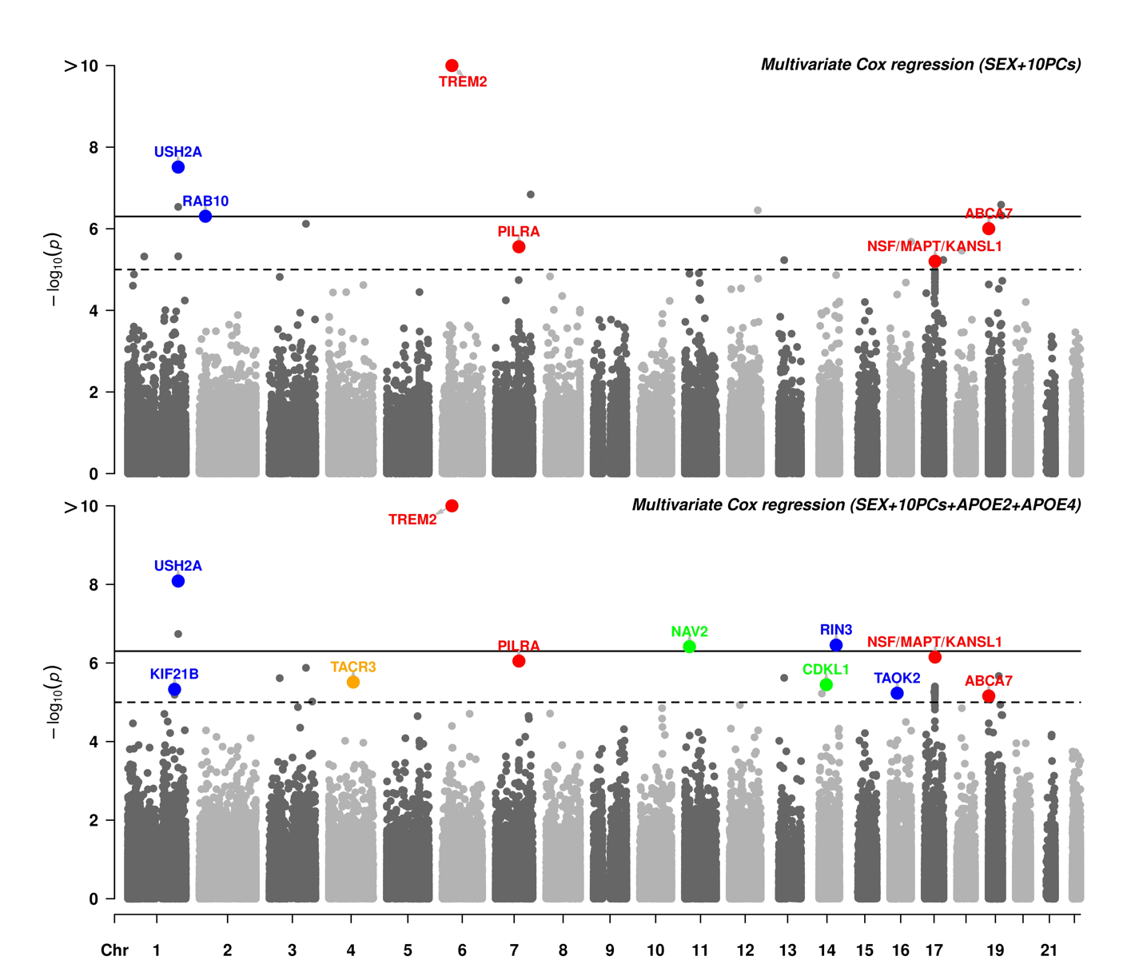
Figure S6. Manhattan plots for the two model adjustments of the multivariate Cox regression. The main causal variant on TREM2 is exome wide significant (solid line, p < 5×10⁻⁷). Among suggestive associations (dashed line, p < 1×10⁻⁵), (i) known AD associations are in red, (ii) novel associations which replicate (p < 0.05) in an independent dataset (cf Table 3) are in blue, (iii) associations with concordant direction of effect in the replication which failed to reach nominal significance are in green, (iv) likely spurious associations with discordant direction of effect in the replication are in yellow (cf Table S5).

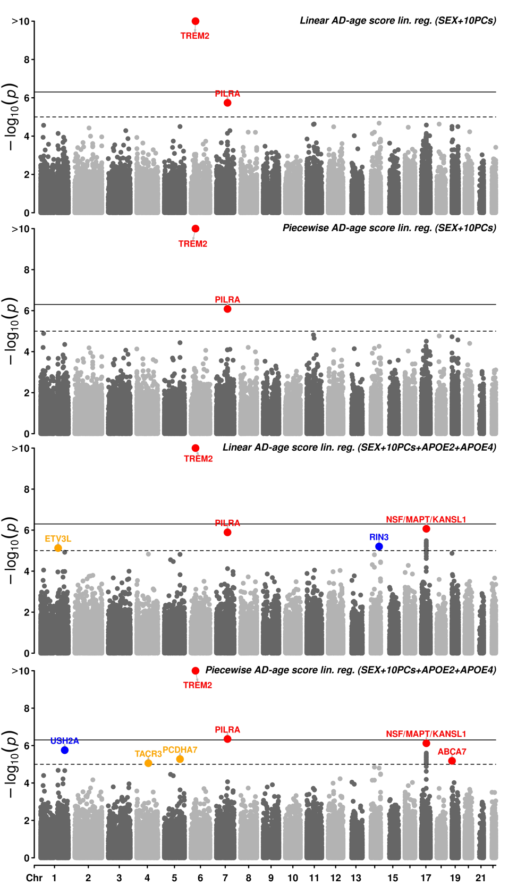
Figure S7. Manhattan plots for the two model adjustments on the two AD-age scores linear regression. The main causal variant on TREM2 is exome wide significant (solid line, p < 5×10⁻⁷). Among suggestive associations (dashed line, p < 1×10⁻⁵), (i) known AD associations are in red, (ii) novel associations which replicate (p < 0.05) in an independent dataset (cf Table 3) are in blue, (iii) likely spurious associations with discordant direction of effect in the replication are in yellow (cf Table S5). P-values are reported prior to bootstrap based inference, here.
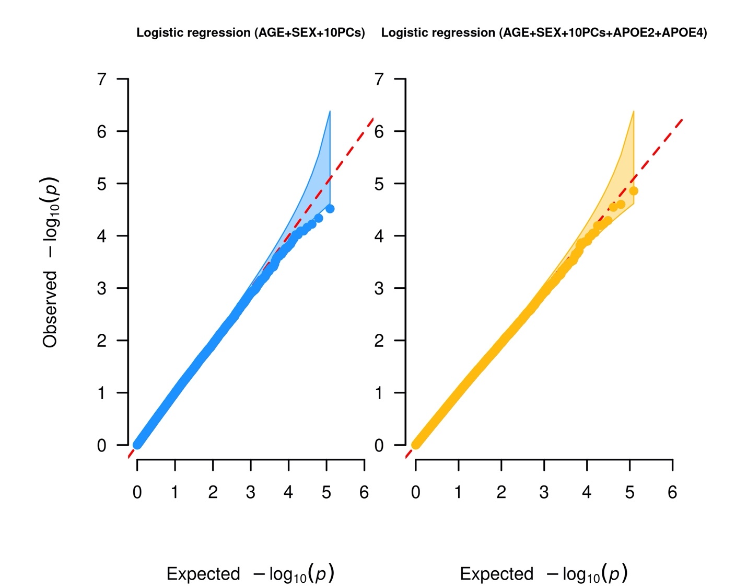
Figure S8. QQ plots for the logistic regression adjusted by age corresponding to Figure S3.

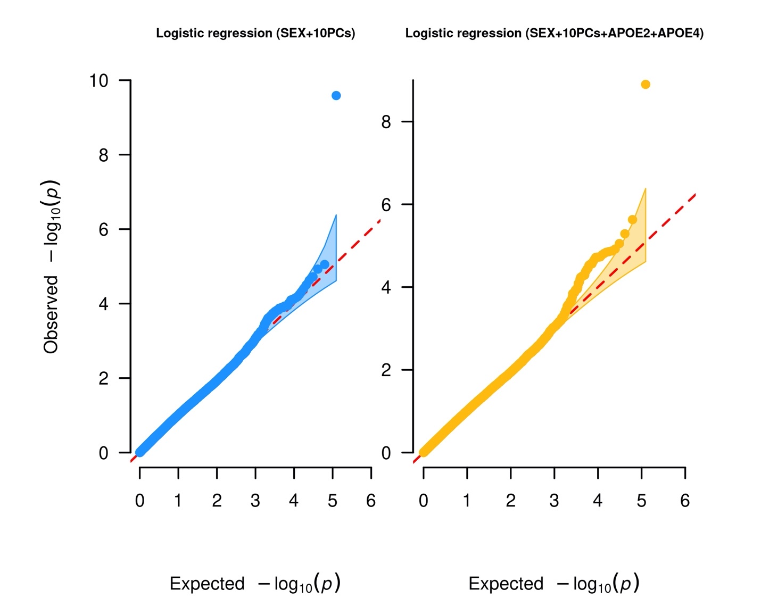
Figure S9. QQ plots for the standard logistic regression corresponding to Figure S4.
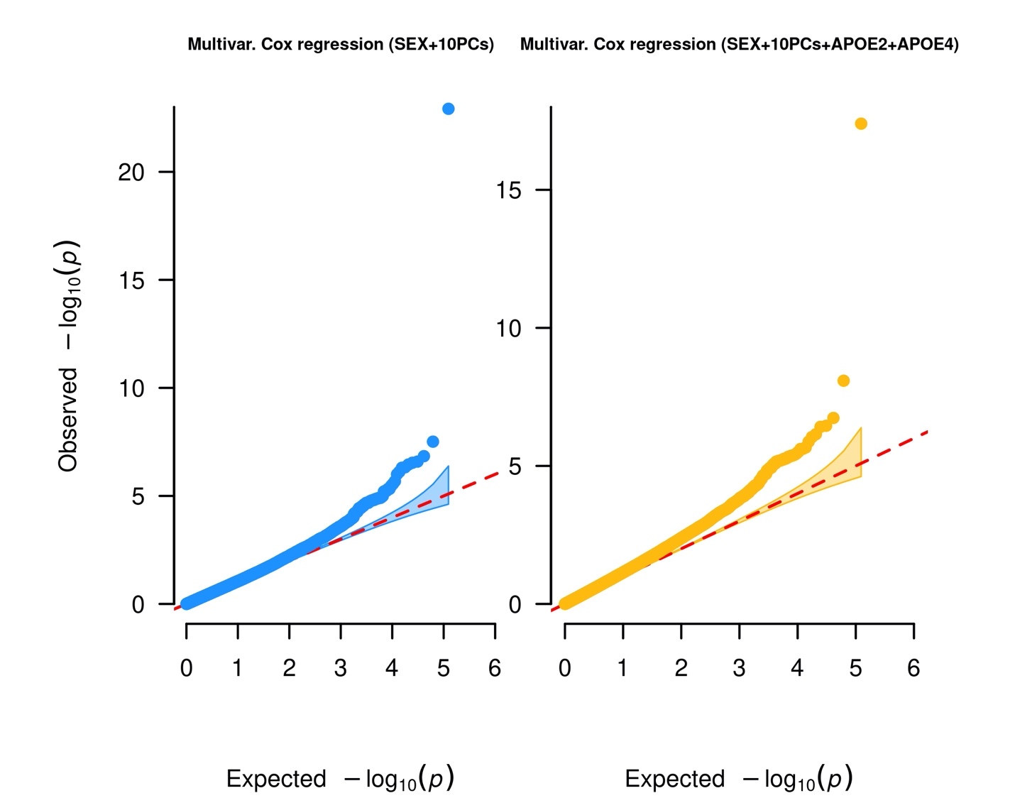
Figure S10. QQ plots for the multivariate Cox regression corresponding to Figure S5.

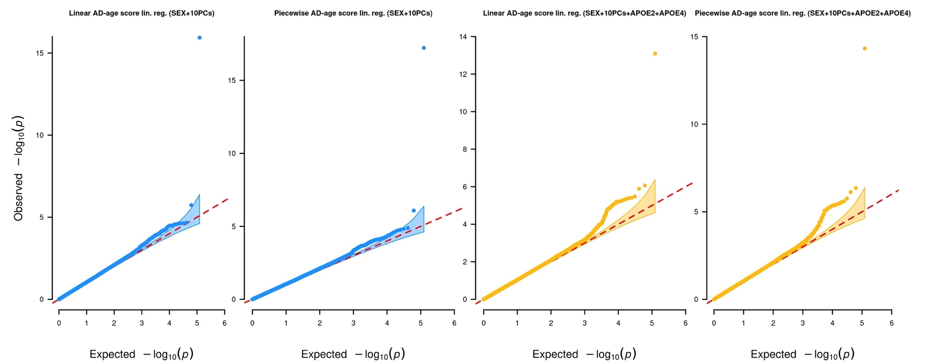
Figure S11. QQ plots for the linear regression on the AD-age score corresponding to Figure S6.

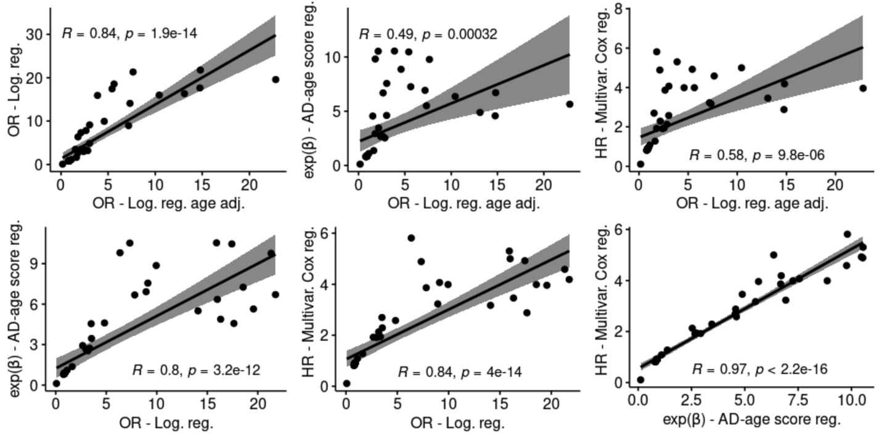Figure S12. Comparison between exp(β), OR (odds ratio), HR (hazard ratio) for associations suggestive in any models.

Figure S13. Comparison of -log(p) between logistic regression, linear regression on the AD-age score and multivariate Cox regression. Seven out of the ten replicated variants were most significant in the linear regression on the AD-age score, while only three had better results in the other models (two in the Cox regression (on KIF21B and TAOK2) and one in the logistic regression (on MS4A6A)). y = x line is represented, variants above this line are most significant in the model on the y-axis.

Table S1. Demographics per cohort in the discovery sample.
Sample | N  (% females) | Age  μ (σ) | ε3/ε3  (%) | ε3/ε4  (%) | ε4/ε4  (%) | ε2/ε3  (%) | ε2/ε4  (%) | ε2/ε2  (%)
Total Discovery
Controls | 5075 (59.0) | 85.2 (5.4) | 66.13 | 13.93 | 0.51 | 17.12 | 1.52 | 0.79
AD cases | 6052 (57.8) | 76.3 (8.2) | 47.54 | 39.29 | 4.23 | 6.08 | 2.46 | 0.4
Discovery
ADSP WES _{controls} | 4056 (59.2) | 86.6 (3.7) | 66.62 | 12.25 | 0.35 | 18.34 | 1.48 | 0.96
ADSP WES _{cases} | 4775 (57.8) | 75.9 (8.2) | 50.68 | 37.72 | 2.62 | 6.32 | 2.24 | 0.42
ADSP WGS _{controls} | 677 (60.0) | 78.4 (6.4) | 62.92 | 23.04 | 1.18 | 10.64 | 2.07 | 0.15
ADSP WGS _{cases} | 698 (49.7) | 76.3 (7.7) | 30.09 | 48.57 | 15.04 | 2.72 | 3.44 | 0.14
AMP-AD WGS _{controls} | 342 (54.4) | 81.2 (8.2) | 66.67 | 15.79 | 1.17 | 15.5 | 0.88 | 0
AMP-AD WGS _{cases} | 579 (68.0) | 79.7 (8.0) | 42.66 | 41.11 | 4.49 | 8.12 | 3.11 | 0.52

Table S2. Demographics per cohort in the replication sample. Each cohort corresponds to a pair of AD study and SNP Array. ADNI_1/O25/OE are part of ADNI. ADM_O/Q are part of ADDNEUROMED. UVM_A/B/C are part of UVM-VU-MSSM. ROSMAP_1B/1T/2 are part of ROSMAP. MAYO_1/2 are part of MAYO. MIRAGE_370/610 are part of MIRAGE. HBTRC_PERL/ILL are part of the HBTRC.

Sample | N  (% females) | Age  μ (σ) | ε3/ε3  (%) | ε3/ε4  (%) | ε4/ε4  (%) | ε2/ε3  (%) | ε2/ε4  (%) | ε2/ε2  (%)
Total Replication
Controls | 10539 (59.4) | 76.7 (8.5) | 60.98 | 22.01 | 2.07 | 12.11 | 2.18 | 0.65
AD cases | 11092 (60.5) | 73.3 (9.3) | 32.83 | 44.37 | 16.21 | 3.69 | 2.79 | 0.1
Replication
ACT _{controls} | 938 (54.6) | 79.4 (5.9) | 62.47 | 21 | 1.28 | 13.22 | 1.71 | 0.32
ACT _{cases} | 289 (64.7) | 81.1 (6.2) | 28.72 | 50.17 | 11.42 | 3.46 | 6.23 | 0
ADC1 _{controls} | 285 (60.0) | 75.8 (11.2) | 55.79 | 28.07 | 2.46 | 11.58 | 1.05 | 1.05
ADC1 _{cases} | 942 (53.9) | 69.0 (11.0) | 24.52 | 46.5 | 24.95 | 2.12 | 1.8 | 0.11
ADC2 _{controls} | 92 (69.6) | 78.0 (9.2) | 58.7 | 16.3 | 3.26 | 15.22 | 5.43 | 1.09
ADC2 _{cases} | 326 (54.3) | 73.0 (7.5) | 25.46 | 43.25 | 25.46 | 2.76 | 3.07 | 0
ADC3 _{controls} | 397 (65.0) | 76.9 (8.7) | 59.95 | 23.17 | 1.76 | 10.83 | 3.02 | 1.26
ADC3 _{cases} | 478 (57.3) | 70.9 (11.2) | 27.41 | 45.61 | 19.67 | 2.93 | 4.18 | 0.21
ADC4 _{controls} | 360 (61.7) | 77.9 (8.5) | 57.5 | 21.94 | 3.06 | 14.72 | 2.22 | 0.56
ADC4 _{cases} | 236 (53.0) | 72.1 (10.3) | 33.9 | 38.14 | 19.07 | 4.66 | 4.24 | 0
ADC5 _{controls} | 410 (65.1) | 79.1 (8.1) | 60 | 21.46 | 2.44 | 13.41 | 2.44 | 0.24
ADC5 _{cases} | 250 (56.8) | 74.4 (9.3) | 32 | 45.6 | 16 | 3.2 | 3.2 | 0
ADC6 _{controls} | 298 (66.4) | 78.2 (8.3) | 62.42 | 26.17 | 1.68 | 8.39 | 1.01 | 0.34
ADC6 _{cases} | 409 (55.0) | 64.5 (12.4) | 38.63 | 39.36 | 16.38 | 3.42 | 1.96 | 0.24
ADC7 _{controls} | 745 (64.0) | 77.5 (7.8) | 59.33 | 26.98 | 1.88 | 8.99 | 2.28 | 0.54
ADC7 _{cases} | 492 (53.3) | 73.0 (7.7) | 32.32 | 44.72 | 14.43 | 5.28 | 3.25 | 0
ADMO _{controls} | 113 (55.8) | 77.6 (7.2) | 70.8 | 16.81 | 0.88 | 7.96 | 2.65 | 0.88
ADMO _{cases} | 125 (67.2) | 74.5 (6.8) | 44 | 40 | 8.8 | 4 | 3.2 | 0
ADMQ _{controls} | 71 (59.2) | 74.5 (5.1) | 57.75 | 26.76 | 2.82 | 11.27 | 1.41 | 0
ADMQ _{cases} | 127 (62.2) | 71.6 (6.4) | 38.58 | 42.52 | 14.17 | 3.94 | 0.79 | 0
ADNI1 _{controls} | 72 (40.3) | 78.4 (6.1) | 61.11 | 20.83 | 5.56 | 11.11 | 0 | 1.39
ADNI1 _{cases} | 235 (42.6) | 75.2 (7.6) | 29.79 | 46.38 | 18.3 | 2.55 | 2.98 | 0
ADNI_DOD _{controls} | 79 (0.0) | 70.2 (5.3) | 56.96 | 20.25 | 2.53 | 18.99 | 1.27 | 0
ADNI_O25 _{controls} | 18 (38.9) | 80.0 (8.6) | 72.22 | 22.22 | 0 | 5.56 | 0 | 0
ADNI_O25 _{cases} | 27 (40.7) | 70.1 (11.1) | 33.33 | 51.85 | 14.81 | 0 | 0 | 0
ADNI_OE _{controls} | 97 (57.7) | 76.1 (5.9) | 56.7 | 27.84 | 1.03 | 11.34 | 3.09 | 0
ADNI_OE _{cases} | 118 (43.2) | 73.2 (7.4) | 26.27 | 46.61 | 19.49 | 5.08 | 2.54 | 0
CIDR _{controls} | 95 (62.1) | 77.1 (8.2) | 69.47 | 14.74 | 3.16 | 11.58 | 1.05 | 0
CIDR _{cases} | 50 (66.0) | 77.1 (6.8) | 56 | 30 | 6 | 6 | 2 | 0
GenADA _{controls} | 769 (64.2) | 73.5 (7.9) | 63.46 | 20.16 | 1.56 | 11.7 | 2.6 | 0.52
GenADA _{cases} | 779 (57.6) | 72.6 (8.6) | 32.86 | 46.34 | 13.35 | 4.36 | 3.08 | 0
HBTRC_A _{controls} | 81 (24.7) | 65.3 (9.6) | 59.26 | 28.4 | 3.7 | 6.17 | 2.47 | 0
HBTRC_A _{cases} | 181 (59.7) | 70.2 (8.5) | 39.23 | 45.3 | 7.18 | 3.87 | 4.42 | 0
HBTRC_B _{controls} | 52 (21.2) | 61.9 (7.8) | 48.08 | 30.77 | 11.54 | 7.69 | 1.92 | 0
HBTRC_B _{cases} | 101 (49.5) | 70.4 (8.7) | 46.53 | 34.65 | 6.93 | 7.92 | 3.96 | 0
LOAD _{controls} | 445 (60.7) | 75.9 (8.3) | 57.3 | 25.84 | 1.8 | 11.24 | 3.37 | 0.45
LOAD _{cases} | 1422 (65.9) | 73.3 (7.2) | 21.94 | 51.41 | 22.22 | 2.04 | 2.25 | 0.14
MARS _{controls} | 148 (77.0) | 82.5 (7.8) | 62.84 | 18.92 | 0.68 | 12.84 | 3.38 | 1.35
MARS _{cases} | 70 (80.0) | 85.1 (7.6) | 58.57 | 27.14 | 1.43 | 11.43 | 1.43 | 0
MAYO _{controls} | 1069 (50.8) | 73.1 (4.5) | 58.19 | 24.23 | 1.87 | 11.79 | 3.27 | 0.65
MAYO _{cases} | 495 (61.6) | 74.0 (5.0) | 25.25 | 47.68 | 22.63 | 1.82 | 2.63 | 0
MAYO2 _{controls} | 130 (46.2) | 77.5 (8.3) | 64.62 | 16.92 | 0.77 | 16.15 | 0.77 | 0.77
MAYO2 _{cases} | 4 (50.0) | 71.2 (14.3) | 75 | 25 | 0 | 0 | 0 | 0
MIRAGE_370 _{controls} | 146 (64.4) | 71.6 (7.0) | 47.26 | 36.3 | 5.48 | 8.9 | 2.05 | 0
MIRAGE_370 _{cases} | 79 (49.4) | 65.7 (9.3) | 36.71 | 37.97 | 21.52 | 3.8 | 0 | 0
MIRAGE_610 _{controls} | 534 (56.0) | 71.9 (7.1) | 54.87 | 29.21 | 6.18 | 8.05 | 1.5 | 0.19
MIRAGE_610 _{cases} | 233 (63.1) | 67.9 (9.6) | 33.05 | 41.63 | 18.03 | 3.43 | 3.86 | 0
OHSU _{controls} | 217 (53.5) | 86.9 (7.5) | 59.45 | 18.43 | 1.38 | 17.97 | 2.76 | 0
OHSU _{cases} | 68 (57.4) | 85.4 (9.2) | 51.47 | 36.76 | 2.94 | 7.35 | 1.47 | 0
ROSMAP2 _{controls} | 143 (75.5) | 85.3 (7.2) | 65.03 | 16.08 | 1.4 | 15.38 | 1.4 | 0.7
ROSMAP2 _{cases} | 74 (79.7) | 85.5 (5.8) | 67.57 | 21.62 | 4.05 | 5.41 | 1.35 | 0
ROSMAP1B _{controls} | 484 (73.3) | 87.1 (7.2) | 64.88 | 14.26 | 1.24 | 18.18 | 1.03 | 0.41
ROSMAP1B _{cases} | 418 (72.5) | 83.7 (6.9) | 56.7 | 28.47 | 2.39 | 10.53 | 1.67 | 0.24
ROSMAP1T _{controls} | 34 (52.9) | 83.0 (7.1) | 70.59 | 14.71 | 0 | 14.71 | 0 | 0
ROSMAP1T _{cases} | 116 (63.8) | 84.8 (5.4) | 50 | 37.07 | 2.59 | 6.9 | 3.45 | 0
TGEN _{controls} | 398 (48.0) | 80.2 (8.9) | 62.81 | 17.84 | 1.76 | 12.06 | 2.26 | 3.27
TGEN _{cases} | 752 (65.8) | 72.6 (8.0) | 30.59 | 45.21 | 17.55 | 3.06 | 3.32 | 0.27
UPITT _{controls} | 879 (63.0) | 75.5 (6.1) | 65.98 | 16.38 | 1.14 | 13.88 | 2.05 | 0.57
UPITT _{cases} | 1301 (63.3) | 73.3 (6.6) | 38.28 | 45.35 | 9.76 | 3.54 | 2.84 | 0.23
UVM_A _{controls} | 453 (68.2) | 73.0 (6.7) | 60.71 | 22.74 | 1.55 | 12.58 | 1.77 | 0.66
UVM_A _{cases} | 82 (62.2) | 73.3 (6.6) | 10.98 | 45.12 | 43.9 | 0 | 0 | 0
UVM_B _{controls} | 235 (60.4) | 74.6 (9.2) | 67.66 | 18.72 | 0.85 | 9.79 | 2.13 | 0.85
UVM_B _{cases} | 240 (70.0) | 77.1 (9.1) | 46.67 | 34.58 | 12.08 | 4.58 | 2.08 | 0
UVM_C _{controls} | 109 (47.7) | 75.8 (9.1) | 67.89 | 18.35 | 0.92 | 9.17 | 1.83 | 1.83
UVM_C _{cases} | 278 (62.9) | 72.2 (7.5) | 32.01 | 46.04 | 17.99 | 2.16 | 1.8 | 0
WASHU _{controls} | 143 (61.5) | 76.9 (8.5) | 62.94 | 20.98 | 4.2 | 9.79 | 1.4 | 0.7
WASHU _{cases} | 295 (56.9) | 75.3 (9.9) | 39.32 | 42.37 | 8.14 | 6.44 | 3.73 | 0

Table S3. Sample sizes, minor allele frequency and imputation quality for the suggestive variants in the discovery. MAF: Minor allele frequency; R-square (Rsq): Imputation quality.

Gene(s) | RS id | SNP (hg19) | Discovery |  | Replication
Gene(s) | RS id | SNP (hg19) | N | MAF | N | MAF | Rsq
ANKRD13C | rs777614616 | 1:70801760:A:C | 11096 | 0.00054 | 6495 | 0.00064 | 0.83
ETV3L | rs16838078 | 1:157069261:A:C | 9746 | 0.02427 | 21631 | 0.02724 | 0.96
KIF21B | rs2297911 | 1:200959302:G:A | 11006 | 0.17391 | 21631 | 0.1769 | 1
USH2A | rs111033333 | 1:216270469:G:A | 11126 | 0.00085 | 19544 | 0.00132 | 0.81
RAB10 | rs149622307 | 2:26332640:T:C | 11057 | 0.00045 | 9833 | 0.00076 | 0.85
ZNF197 | rs140904465 | 3:44685500:T:G | 11126 | 0.00094 | 20403 | 0.00132 | 0.86
VEPH1 | rs138491831 | 3:157178046:G:A | 11126 | 0.00054 | 16219 | 0.00101 | 0.86
CHRD | rs3749228 | 3:184099342:G:C | 10793 | 0.0504 | 21631 | 0.05688 | 0.96
TACR3 | rs144292455 | 4:104577415:C:T | 11105 | 0.00081 | 17657 | 0.001 | 0.86
PCDHA7 | rs143048298 | 5:140215922:A:G | 11122 | 0.00067 | 15845 | 0.00074 | 0.92
TREM2 | rs75932628 | 6:41129252:C:T | 11076 | 0.00591 | 21176 | 0.00606 | 0.93
PILRA | rs2405442 | 7:99971313:T:C | 11022 | 0.29836 | 21631 | 0.30567 | 0.94
GIMAP2 | rs778956614 | 7:150389837:TC:T | 11126 | 0.00045 | 17015 | 0.00081 | 0.87
NAV2 | rs11828836 | 11:19735325:C:A | 11105 | 0.00045 | 9235 | 0.00045 | 0.9
MS4A6A | rs12453 | 11:59945745:T:C | 11114 | 0.3941 | 21481 | 0.39015 | 0.99
COQ5 | rs74578594 | 12:120947933:G:C | 11126 | 0.00049 | 13736 | 0.00075 | 0.94
DGKH | rs147914294 | 13:42761244:C:A | 11126 | 0.0031 | 21486 | 0.00322 | 0.94
HEATR5A | rs28396248 | 14:31790886:T:G | 10673 | 0.04572 | 21631 | 0.06432 | 0.99
CDKL1 | rs61981931 | 14:50856882:C:T | 11110 | 0.04977 | 21631 | 0.04392 | 0.81
RIN3 | rs150221413 | 14:93022240:G:T | 11020 | 0.00082 | 17652 | 0.00131 | 0.8
TAOK2 | rs4077410 | 16:29998200:A:G | 11063 | 0.47966 | 21631 | 0.48195 | 0.94
MC1R | rs34158934 | 16:89985950:C:T | 11024 | 0.00082 | 13553 | 0.00062 | 0.77
AOC2 | rs201046755 | 17:40997372:G:A | 10206 | 0.00054 | 14425 | 0.00058 | 0.85
NSF/MAPT/KANSL1 | rs199533 | 17:44828931:G:A | 11094 | 0.20367 | 21631 | 0.19931 | 0.99
RFNG | rs112510774 | 17:80008395:G:A | 11073 | 0.00117 | 21070 | 0.00204 | 0.77
C18orf8 | rs112277818 | 18:21083647:C:A | 11110 | 0.00302 | 21015 | 0.0031 | 0.86
ABCA7 | rs547447016 | 19:1047507:AGGAGCAG:A | 11006 | 0.00313 | 18356 | 0.00311 | 0.88
CAMSAP3 | rs144062687 | 19:7682224:G:A | 11087 | 0.00198 | 19642 | 0.00285 | 0.69
SRRM5 | rs200590643 | 19:44116708:A:G | 10127 | 0.00049 | 14411 | 0.00109 | 0.66
ZNF765 | rs140062377 | 19:53912054:T:C | 11122 | 0.00216 | 18673 | 0.00194 | 0.6
SSC5D | rs776353690 | 19:56005235:A:G | 11087 | 0.0005 | 18005 | 0.00089 | 0.85

Table S4. Lambda medians for each main model and model adjustments.

Model | Lambda median
Logistic regression (AGE+SEX+10PCs) | 1.02
Logistic regression (AGE+SEX+10PCs+APOE2+APOE4) | 1.01
Logistic regression (SEX+10PCs) | 1.06
Logistic regression (SEX+10PCs+APOE2+APOE4) | 1.05
Multivariate Cox regression (SEX+10PCs) | 1.09
Multivariate Cox regression (SEX+10PCs+APOE2+APOE4) | 1.19
Linear AD-age score lin. reg. (SEX+10PCs) | 1.08
Piecewise AD-age score lin. reg. (SEX+10PCs) | 1.07
Linear AD-age score lin. reg. (SEX+10PCs+APOE2+APOE4) | 1.06
Piecewise AD-age score lin. reg. (SEX+10PCs+APOE2+APOE4) | 1.06

Table S5. All suggestive association results in the discovery. Effect corresponds to OR (odds ratio) for logistic regression on AD status not adjusted by age (LogReg), exp(β) for linear regression on AD-age score (LinReg), and HR (hazard ratio) for multivariate Cox regression on age-at-onset (CoxReg). Correlation between these measures is high for suggestive associations as shown on Figure S11. P: p-value. m: model subversion. Subversion codes are: (1) adjusted for sex and 10 first principal components of population structure and (2) additionally adjusted for APOE ε2/ε4 alleles. Two types of weighted AD-age score were used with (A) corresponding to a linear effect of age between 60 and 100 and (B) accounting for the changes in AD prevalence slope in this age range. P-values are reported here before bootstrapping for LinReg.

SNP (hg19) | Discovery |  |  |  |  |  |  |  |  | Replication
SNP (hg19) | LogReg |  |  | LinReg |  |  | CoxReg |  |  | LogReg |  |  | LinReg |  |  | CoxReg
SNP (hg19) | OR | P | m | exp(β) | P | m | HR | P | m | OR | P | m | exp(β) | P | m | HR | P | m
1:70801760:A:C | 9.95 | 0.03 | 1 | 8.86 | 2.10⁻⁴ | B1 | 4.00 | 5.10⁻⁶ | 1 | 0.58 | 40.46 | 2 | 0.63 | 0.33 | A2 | 0.80 | 0.65 | 2
1:157069261:A:C | 1.62 | 2.10⁻⁶ | 2 | 1.37 | 7.10⁻⁶ | A2 | 1.28 | 2.10⁻⁵ | 2 | 0.92 | 0.14 | 1 | 0.92 | 0.11 | A1 | 0.94 | 0.14 | 1
1:200959302:G:A | 0.87 | 2.10⁻⁴ | 2 | 0.88 | 6.10⁻⁵ | B2 | 0.89 | 5.10⁻⁶ | 2 | 0.96 | 0.13 | 1 | 0.95 | 0.04 | B1 | 0.96 | 0.02 | 2
1:216270469:G:A | 9.12 | 4.10⁻³ | 2 | 7.56 | 2.10⁻⁶ | B2 | 4.07 | 8.10⁻⁹ | 2 | 1.58 | 0.14 | 1 | 1.70 | 0.04 | A1 | 1.33 | 0.12 | 1
2:26332640:T:C | 17.4 | 0.06 | 1 | 10.5 | 3.10⁻⁴ | B1 | 4.92 | 5.10⁻⁷ | 1 | 4.50 | 0.05 | 1 | 5.03 | 3.10⁻³ | B1 | 2.69 | 6.10⁻⁴ | 1
3:44685500:T:G | 17.64 | 5.10⁻³ | 2 | 4.57 | 2.10⁻⁴ | B2 | 2.88 | 2.10⁻⁶ | 2 | 0.74 | 0.28 | 1 | 0.89 | 0.63 | B1 | 0.86 | 0.46 | 2
3:157178046:G:A | 21.76 | 0.04 | 1 | 6.71 | 5.10⁻⁵ | A1 | 4.19 | 8.10⁻⁷ | 1 | 1.16 | 0.72 | 2 | 0.91 | 0.79 | B1 | 1.24 | 0.43 | 2
3:184099342:G:C | 0.83 | 2.10⁻³ | 1 | 0.81 | 2.10⁻⁴ | B2 | 0.82 | 1.10⁻⁵ | 2 | 0.95 | 0.29 | 2 | 0.98 | 0.51 | B2 | 0.97 | 0.31 | 1
4:104577415:C:T | 8.94 | 4.10⁻³ | 2 | 6.92 | 9.10⁻⁶ | B2 | 3.23 | 3.10⁻⁶ | 2 | 0.72 | 0.34 | 1 | 0.81 | 0.54 | B1 | 1.29 | 0.32 | 2
5:140215922:A:G | 0.069 | 1.10⁻³ | 2 | 0.11 | 5.10⁻⁶ | B2 | 0.107 | 2.10⁻³ | 2 | 1.14 | 0.76 | 2 | 1.24 | 0.5 | A2 | 0.93 | 0.79 | 2
6:41129252:C:T | 4.83 | 3.10⁻¹⁰ | 1 | 4.60 | 6.10⁻¹⁸ | B1 | 2.58 | 1.10⁻²³ | 1 | 2.32 | 2.10⁻⁹ | 1 | 2.46 | 1.10⁻¹⁵ | A1 | 1.95 | 2.10⁻¹⁸ | 2
7:99971313:T:C | 0.88 | 2.10⁻⁵ | 1 | 0.87 | 4.10⁻⁷ | B2 | 0.90 | 9.10⁻⁷ | 2 | 0.92 | 6.10⁻⁵ | 1 | 0.90 | 2.10⁻⁶ | B1 | 0.93 | 5.10⁻⁷ | 1
7:150389837:TC:T | 15.9 | 0.07 | 1 | 10.5 | 3.10⁻⁴ | B1 | 5.3 | 1.10⁻⁷ | 1 | 1.40 | 0.42 | 2 | 0.75 | 0.42 | A1 | 0.83 | 0.46 | 1
11:19735325:C:A | 16.0 | 0.07 | 1 | 6.35 | 3.10⁻⁴ | A1 | 5.0 | 4.10⁻⁷ | 2 | 1.88 | 0.61 | 2 | 1.84 | 0.50 | B2 | 2.20 | 0.17 | 2
11:59945745:T:C | 0.88 | 9.10⁻⁶ | 1 | 0.89 | 1.10⁻⁵ | B1 | 0.92 | 1.10⁻⁵ | 1 | 0.89 | 1.10⁻⁸ | 1 | 0.89 | 7.10⁻⁹ | B1 | 0.93 | 2.10⁻⁸ | 1
12:120947933:G:C | 6.36 | 0.02 | 1 | 9.81 | 3.10⁻⁴ | B1 | 5.81 | 4.10⁻⁷ | 1 | 1.12 | 0.83 | 2 | 1.83 | 0.14 | A2 | 1.61 | 0.13 | 1
13:42761244:C:A | 2.98 | 2.10⁻⁴ | 1 | 2.66 | 7.10⁻⁵ | B1 | 1.91 | 2.10⁻⁶ | 2 | 1.13 | 0.54 | 2 | 1.13 | 0.39 | A2 | 0.99 | 0.96 | 2
14:31790886:T:G | 0.77 | 9.10⁻⁵ | 1 | 0.82 | 5.10⁻⁵ | A2 | 0.81 | 6.10⁻⁶ | 2 | 1.01 | 0.88 | 2 | 0.99 | 0.82 | A1 | 0.98 | 0.40 | 2
14:50856882:C:T | 0.77 | 5.10⁻⁵ | 2 | 0.78 | 1.10⁻⁵ | B2 | 0.82 | 4.10⁻⁶ | 2 | 0.94 | 0.20 | 1 | 0.94 | 0.13 | A1 | 0.95 | 0.10 | 1
14:93022240:G:T | 16.3 | 7.10⁻³ | 2 | 4.88 | 6.10⁻⁶ | A2 | 3.46 | 4.10⁻⁷ | 2 | 1.95 | 0.04 | 2 | 1.69 | 0.05 | B2 | 1.59 | 0.01 | 2
16:29998200:A:G | 1.12 | 6.10⁻⁵ | 1 | 1.09 | 3.10⁻⁵ | A1 | 1.09 | 6.10⁻⁶ | 2 | 1.04 | 0.07 | 2 | 1.05 | 3.10⁻³ | A2 | 1.05 | 4.10⁻⁴ | 2
16:89985950:C:T | 14.1 | 0.01 | 1 | 5.50 | 4.10⁻⁴ | B1 | 3.17 | 2.10⁻⁶ | 1 | 1.28 | 0.67 | 1 | 1.38 | 0.49 | A2 | 1.32 | 0.46 | 2
17:40997372:G:A | 19.6 | 0.05 | 1 | 5.64 | 5.10⁻⁴ | A1 | 3.96 | 5.10⁻⁶ | 2 | 0.69 | 0.53 | 1 | 0.65 | 0.42 | A1 | 0.73 | 0.49 | 1
17:44828931:G:A | 0.85 | 5.10⁻⁶ | 2 | 0.86 | 8.10⁻⁷ | B2 | 0.89 | 7.10⁻⁷ | 2 | 0.97 | 0.02 | 2 | 0.97 | 0.017 | A2 | 0.98 | 0.018 | 2
17:80008395:G:A | 3.50 | 0.01 | 1 | 4.55 | 2.10⁻⁴ | B1 | 2.70 | 6.10⁻⁶ | 1 | 0.68 | 0.08 | 1 | 0.87 | 0.46 | A1 | 0.95 | 0.75 | 2
18:21083647:C:A | 2.66 | 7.10⁻⁴ | 1 | 2.93 | 2.10⁻⁵ | B1 | 1.92 | 3.10⁻⁶ | 1 | 0.64 | 0.02 | 1 | 0.77 | 0.15 | B1 | 0.86 | 0.32 | 1
19:1047507:AGGAGCAG:A | 3.36 | 1.10⁻⁴ | 2 | 2.73 | 7.10⁻⁶ | B2 | 1.94 | 1.10⁻⁶ | 1 | 1.36 | 0.12 | 1 | 1.33 | 0.14 | B1 | 1.22 | 0.13 | 2
19:7682224:G:A | 3.18 | 2.10⁻³ | 1 | 2.54 | 2.10⁻⁴ | A1 | 2.13 | 9.10⁻⁶ | 2 | 1.18 | 0.47 | 2 | 1.14 | 0.50 | B2 | 1.16 | 0.32 | 2
19:44116708:A:G | 7.33 | 0.06 | 1 | 10.53 | 3.10⁻⁴ | B1 | 4.89 | 2.10⁻⁶ | 2 | 1.09 | 0.81 | 1 | 0.86 | 0.61 | A2 | 0.98 | 0.93 | 2
19:53912054:T:C | 3.54 | 7.10⁻⁴ | 1 | 3.45 | 3.10⁻⁵ | B1 | 2.29 | 3.10⁻⁷ | 1 | 0.81 | 0.47 | 1 | 0.81 | 0.40 | A1 | 1.22 | 0.35 | 2
19:56005235:A:G | 21.3 | 0.04 | 1 | 9.78 | 2.10⁻⁴ | B1 | 4.58 | 5.10⁻⁷ | 1 | 1.91 | 0.12 | 1 | 1.59 | 0.17 | A1 | 1.21 | 0.41 | 1

Table S6. Meta-analysis of the replicated exonic associations. Effect corresponds to OR (odds ratio) for logistic regression on AD status not adjusted by age (LogReg), exp(β) for linear regression on AD-age score (LinReg), and HR (hazard ratio) for multivariate Cox regression on age-at-onset (CoxReg). In every model, σ corresponds to the standard error of the parameter estimate (i.e, log(OR) for LogReg, β for LinReg, and log(HR) for CoxReg).

Part A.
SNP (hg19) / Gene | Discovery |  |  |  |  |  | Replication
SNP (hg19) / Gene | LogReg |  | LinReg |  | CoxReg |  | LogReg |  | LinReg |  | CoxReg
SNP (hg19) / Gene | OR | σ | exp(β) | σ | 1/HR | σ | OR | σ | exp(β) | σ | HR | σ
1:200959302:G:A / KIF21B | 0.87 | 0.04 | 0.90 | 0.02 | 0.89 | 0.02 | 0.96 | 0.03 | 0.96 | 0.02 | 0.96 | 0.02
1:216270469:G:A / USH2A | 9.12 | 0.76 | 6.76 | 0.35 | 4.07 | 0.24 | 1.58 | 0.31 | 1.70 | 0.27 | 1.33 | 0.19
2:26332640:T:C / RAB10 | 17.43 | 1.52 | 10.46 | 0.34 | 4.92 | 0.32 | 4.50 | 0.76 | 5.03 | 0.48 | 2.69 | 0.29
6:41129252:C:T / TREM2 | 4.83 | 0.25 | 3.22 | 0.10 | 2.58 | 0.09 | 2.32 | 0.14 | 2.69 | 0.12 | 1.95 | 0.08
7:99971313:T:C / PILRA | 0.88 | 0.03 | 0.87 | 0.03 | 0.90 | 0.02 | 0.92 | 0.02 | 0.90 | 0.02 | 0.93 | 0.01
11:59945745:T:C / MS4A6A | 0.88 | 0.03 | 0.91 | 0.02 | 0.92 | 0.02 | 0.89 | 0.02 | 0.89 | 0.02 | 0.93 | 0.01
14:93022240:G:T / RIN3 | 16.32 | 1.04 | 6.54 | 0.32 | 3.46 | 0.24 | 1.95 | 0.33 | 1.69 | 0.23 | 1.59 | 0.18
16:29998200:A:G / TAOK2 | 1.12 | 0.03 | 1.08 | 0.02 | 1.09 | 0.02 | 1.04 | 0.02 | 1.05 | 0.02 | 1.05 | 0.01
17:44828931:G:A / NSF/MAPT/KANSL1 | 0.85 | 0.04 | 0.89 | 0.02 | 0.89 | 0.02 | 0.97 | 0.03 | 0.97 | 0.02 | 0.98 | 0.02
19:1047507:AGGAGCAG:A / ABCA7 | 3.36 | 0.31 | 2.18 | 0.16 | 1.94 | 0.14 | 1.36 | 0.20 | 1.33 | 0.18 | 1.22 | 0.13

Part B.

SNP (hg19) / Gene |  | Meta-analysis
SNP (hg19) / Gene | LogReg |  |  | LinReg |  |  | CoxReg
SNP (hg19) / Gene | OR | σ | p | exp(β) | σ | p | 1/HR | σ | p
1:200959302:G:A / KIF21B | 0.93 | 0.02 | 9.6.10⁻⁴ | 0.93 | 0.02 | 2.1.10⁻⁵ | 0.94 | 0.01 | 3.6.10⁻⁶
1:216270469:G:A / USH2A | 2.02 | 0.28 | 1.3.10⁻² | 2.90 | 0.21 | 7.1.10⁻⁷ | 2.01 | 0.15 | 2.2.10⁻⁶
2:26332640:T:C / RAB10 | 5.92 | 0.68 | 9.3.10⁻³ | 8.16 | 0.28 | 3.1.10⁻¹⁴ | 3.54 | 0.21 | 3.4.10⁻⁹
6:41129252:C:T / TREM2 | 2.76 | 0.12 | 8.8.10⁻¹⁷ | 3.00 | 0.08 | 1.6.10⁻⁴⁵ | 2.17 | 0.06 | 2.5.10⁻³⁹
7:99971313:T:C / PILRA | 0.91 | 0.02 | 1.1.10⁻⁸ | 0.89 | 0.02 | 1.9.10⁻¹² | 0.92 | 0.01 | 3.2.10⁻¹²
11:59945745:T:C / MS4A6A | 0.89 | 0.02 | 5.0.10⁻¹³ | 0.90 | 0.01 | 6.8.10⁻¹³ | 0.92 | 0.01 | 1.3.10⁻¹²
14:93022240:G:T / RIN3 | 2.37 | 0.31 | 6.0.10⁻³ | 2.69 | 0.19 | 1.4.10⁻⁷ | 2.11 | 0.15 | 4.0.10⁻⁷
16:29998200:A:G / TAOK2 | 1.07 | 0.02 | 9.8.10⁻⁵ | 1.06 | 0.01 | 1.3.10⁻⁶ | 1.06 | 0.01 | 2.9.10⁻⁸
17:44828931:G:A / NSF/MAPT/KANSL1 | 0.92 | 0.02 | 1.9.10⁻⁴ | 0.93 | 0.02 | 7.8.10⁻⁶ | 0.95 | 0.01 | 6.2.10⁻⁵
19:1047507:AGGAGCAG:A / ABCA7 | 1.77 | 0.17 | 6.5.10⁻⁴ | 1.75 | 0.12 | 3.2.10⁻⁶ | 1.52 | 0.09 | 7.9.10⁻⁶

Table S7. Brain cis-eQTL associations with common synonymous variants reported in Table 2. We queried the largest brain cis-eQTL meta-analysis which included 1,433 post-mortem brain samples from the AMP-AD and CommonMind Consortium. Only nominal significant eQTL associations (p < 0.05) and associations with mapped gene are reported below. Associations are sorted by locus and significance, in bold is the eQTL association with the mapped gene(s). (DOI: 10.7303/syn16984815.1).
SNP / Mapped gene | Gene | P-val | FDR | Beta | Expression  Increasing Allele | Gene Biotype
rs2297911 / KIF21B | TMEM9 | 3.00E-02 | 3.36E-01 | -0.10 | G | protein coding
rs2297911 / KIF21B | TIMM17A | 4.08E-02 | 3.92E-01 | -0.09 | G | protein coding
rs2297911 / KIF21B | DDX59 | 4.09E-02 | 3.92E-01 | -0.10 | G | protein coding
rs2297911 / KIF21B | KIF21B | 4.71E-02 | 4.20E-01 | 0.09 | A | protein coding
rs2405442 / PILRA | PVRIG | 1.05E-24 | 2.00E-22 | -0.52 | T | protein coding
rs2405442 / PILRA | STAG3L5P | 3.83E-14 | 3.87E-12 | 0.31 | C | transcribed unprocessed pseudogene
rs2405442 / PILRA | PILRB | 2.12E-13 | 2.03E-11 | 0.31 | C | protein coding
rs2405442 / PILRA | STAG3 | 1.71E-11 | 1.41E-09 | -0.26 | T | protein coding
rs2405442 / PILRA | PILRA | 8.61E-07 | 3.92E-05 | 0.21 | C | protein coding
rs2405442 / PILRA | AP4M1 | 2.95E-06 | 1.22E-04 | -0.19 | T | protein coding
rs2405442 / PILRA | TRIM4 | 4.29E-06 | 1.71E-04 | -0.19 | T | protein coding
rs2405442 / PILRA | MBLAC1 | 3.46E-05 | 1.14E-03 | 0.17 | C | protein coding
rs2405442 / PILRA | GIGYF1 | 8.43E-05 | 2.54E-03 | -0.16 | T | protein coding
rs2405442 / PILRA | AZGP1 | 4.77E-04 | 1.17E-02 | -0.15 | T | protein coding
rs2405442 / PILRA | PMS2P1 | 7.85E-03 | 1.14E-01 | -0.11 | T | unprocessed pseudogene
rs2405442 / PILRA | GATS | 1.75E-02 | 1.98E-01 | -0.10 | T | protein coding
rs2405442 / PILRA | MCM7 | 1.75E-02 | 1.98E-01 | -0.10 | T | protein coding
rs2405442 / PILRA | MEPCE | 2.51E-02 | 2.49E-01 | -0.09 | T | protein coding
rs2405442 / PILRA | VGF | 2.72E-02 | 2.61E-01 | 0.09 | C | protein coding
rs2405442 / PILRA | SLC12A9 | 3.49E-02 | 3.03E-01 | -0.09 | T | protein coding
rs2405442 / PILRA | TSC22D4 | 3.66E-02 | 3.11E-01 | -0.09 | T | protein coding
rs2405442 / PILRA | AP1S1 | 4.09E-02 | 3.31E-01 | 0.09 | C | protein coding
rs2405442 / PILRA | MUC12 | 4.58E-02 | 3.52E-01 | 0.09 | C | protein coding
rs12453 / MS4A6A | PRPF19 | 2.85E-03 | 7.27E-02 | -0.11 | T | protein coding
rs12453 / MS4A6A | MS4A4A | 6.12E-02 | 4.71E-01 | -0.10 | T | protein coding
rs12453 / MS4A6A | MS4A6A | 5.17E-01 | 8.98E-01 | -0.02 | T | protein coding
rs4077410 / TAOK2 | INO80E | 3.10E-80 | 5.95E-77 | -0.62 | A | protein coding
rs4077410 / TAOK2 | SMG1P5 | 1.27E-11 | 1.60E-09 | 0.32 | G | transcribed unprocessed pseudogene
rs4077410 / TAOK2 | MAPK3 | 1.40E-09 | 1.40E-07 | -0.22 | A | protein coding
rs4077410 / TAOK2 | TBX6 | 1.43E-09 | 1.43E-07 | 0.29 | G | protein coding
rs4077410 / TAOK2 | TMEM219 | 7.67E-08 | 6.01E-06 | -0.20 | A | protein coding
rs4077410 / TAOK2 | PPP4C | 6.26E-06 | 3.54E-04 | -0.17 | A | protein coding
rs4077410 / TAOK2 | ENSG00000250616 | 7.37E-06 | 4.10E-04 | -0.17 | A | antisense
rs4077410 / TAOK2 | YPEL3 | 1.10E-05 | 5.88E-04 | 0.16 | G | protein coding
rs4077410 / TAOK2 | NPIPB12 | 3.18E-04 | 1.17E-02 | 0.13 | G | protein coding
rs4077410 / TAOK2 | GDPD3 | 3.69E-03 | 8.80E-02 | -0.11 | A | protein coding
rs4077410 / TAOK2 | KCTD13 | 9.57E-03 | 1.73E-01 | -0.09 | A | protein coding
rs4077410 / TAOK2 | CDIPT | 1.38E-02 | 2.19E-01 | 0.09 | G | protein coding
rs4077410 / TAOK2 | DOC2A | 1.56E-02 | 2.36E-01 | -0.09 | A | protein coding
rs4077410 / TAOK2 | ASPHD1 | 1.67E-02 | 2.46E-01 | 0.09 | G | protein coding
rs4077410 / TAOK2 | TAOK2 | 2.67E-02 | 3.24E-01 | -0.08 | A | protein coding
rs4077410 / TAOK2 | ITGAL | 2.95E-02 | 3.42E-01 | -0.08 | A | protein coding
rs4077410 / TAOK2 | CORO1A | 3.18E-02 | 3.56E-01 | -0.08 | A | protein coding
rs4077410 / TAOK2 | C16orf92 | 3.32E-02 | 3.64E-01 | -0.19 | A | protein coding
rs4077410 / TAOK2 | TBC1D10B | 3.49E-02 | 3.73E-01 | 0.08 | G | protein coding
rs4077410 / TAOK2 | NPIPB11 | 4.10E-02 | 4.04E-01 | -0.07 | A | protein coding
rs199533 / NSF/MAPT/KANSL1 | KANSL1-AS1 | 8.99E-214 | 1.60E-210 | 1.45 | A | antisense
rs199533 / NSF/MAPT/KANSL1 | ARL17A | 5.47E-185 | 3.87E-182 | 1.12 | A | protein coding
rs199533 / NSF/MAPT/KANSL1 | LRRC37A | 1.56E-145 | 5.67E-143 | 1.05 | A | protein coding
rs199533 / NSF/MAPT/KANSL1 | LRRC37A2 | 1.64E-136 | 5.89E-134 | 1.01 | A | protein coding
rs199533 / NSF/MAPT/KANSL1 | KANSL1 | 6.65E-84 | 1.65E-81 | 0.85 | A | protein coding
rs199533 / NSF/MAPT/KANSL1 | ENSG00000262879 | 4.27E-24 | 5.47E-22 | 0.48 | A | processed transcript
rs199533 / NSF/MAPT/KANSL1 | CRHR1 | 1.70E-18 | 1.74E-16 | 0.55 | A | protein coding
rs199533 / NSF/MAPT/KANSL1 | WNT3 | 3.18E-13 | 2.59E-11 | 0.36 | A | protein coding
rs199533 / NSF/MAPT/KANSL1 | STH | 2.29E-10 | 1.48E-08 | 0.32 | A | protein coding
rs199533 / NSF/MAPT/KANSL1 | SPPL2C | 1.89E-09 | 1.09E-07 | 0.76 | A | protein coding
rs199533 / NSF/MAPT/KANSL1 | MAPT-IT1 | 2.84E-09 | 1.62E-07 | 0.38 | A | sense intronic
rs199533 / NSF/MAPT/KANSL1 | ENSG00000262881 | 2.73E-04 | 7.81E-03 | -0.19 | G | antisense
rs199533 / NSF/MAPT/KANSL1 | LRRC37A17P | 1.16E-03 | 2.77E-02 | -0.16 | G | transcribed unprocessed pseudogene
rs199533 / NSF/MAPT/KANSL1 | ARL17B | 1.02E-02 | 1.53E-01 | 0.12 | A | protein coding
rs199533 / NSF/MAPT/KANSL1 | ENSG00000274883 | 3.59E-02 | 3.38E-01 | 0.15 | A | misc RNA
rs199534 / NSF/MAPT/KANSL2 | MAPT | 2.58E-01 | 7.62E-01 | 0.06 | A | protein coding
rs199535 / NSF/MAPT/KANSL3 | NSF | 3.31E-01 | 8.12E-01 | 0.05 | A | protein coding

Table S7. Differential expression between AD and control individuals for mapped genes reported in Table 2. We queried the AMP-AD fixed-effect meta-analysis of differential expression between AD and control individuals across brain tissues in the ROSMAP, MAYO and MSBB databases (DOI: 10.7303/syn11914606).

Gene | TE | σ | lowerTE | upperTE | Z | P-val | Q | tau | H | I2 | FDR
TREM2 | 0.37 | 0.07 | 0.24 | 0.50 | 5.67 | 1.43E-08 | 6.37 | 0.02 | 1.03 | 0.06 | 3.71E-07
TAOK2 | -0.37 | 0.07 | -0.49 | -0.24 | -5.55 | 2.83E-08 | 8.14 | 0.10 | 1.16 | 0.26 | 6.41E-07
KANSL1 | 0.32 | 0.07 | 0.20 | 0.45 | 4.93 | 8.23E-07 | 19.95 | 0.26 | 1.82 | 0.70 | 1.02E-05
RAB10 | 0.32 | 0.07 | 0.19 | 0.44 | 4.82 | 1.47E-06 | 5.56 | 0.04 | 1.00 | 0.00 | 1.64E-05
MS4A6A | 0.22 | 0.07 | 0.09 | 0.35 | 3.40 | 6.79E-04 | 6.96 | 0.09 | 1.08 | 0.14 | 2.64E-03
RIN3 | 0.18 | 0.07 | 0.05 | 0.30 | 2.67 | 7.48E-03 | 15.52 | 0.22 | 1.61 | 0.61 | 1.95E-02
PILRA | 0.14 | 0.07 | 0.01 | 0.27 | 2.13 | 3.30E-02 | 15.26 | 0.22 | 1.59 | 0.61 | 6.70E-02
ABCA7 | 0.11 | 0.07 | -0.02 | 0.24 | 1.70 | 8.87E-02 | 7.67 | 0.10 | 1.13 | 0.22 | 1.51E-01
MAPT | -0.11 | 0.07 | -0.24 | 0.02 | -1.65 | 9.89E-02 | 10.06 | 0.14 | 1.30 | 0.40 | 1.66E-01
NSF | -0.10 | 0.07 | -0.23 | 0.03 | -1.53 | 1.27E-01 | 16.70 | 0.23 | 1.67 | 0.64 | 2.03E-01
KIF21B | -0.09 | 0.07 | -0.21 | 0.04 | -1.30 | 1.92E-01 | 19.28 | 0.25 | 1.79 | 0.69 | 2.83E-01

Table S8. Review of the main genome-wide or exome-wide association studies linking these genes or variants to AD diagnosis.
Note that the NSF/MAPT/KANSL1 locus is significant in our analyses adjusted by APOE2* and APOE4* dosages and is genome-wide significant in the stratified APOE4- (non APOE4 carriers) analysis in Jun et al, but not in the APOE4+.

Gene(s) | RS id  SNP (hg19) | Bis et al. (2020) [1] | Kunkle et al. (2019)[2] | Jansen et al. (2019)[3] | Lambert et al. (2013)[4] | Other important  publication
KIF21B | rs2297911  1:200959302:G:A | Protective  P = 10⁻⁴ | Protective  P = 10⁻⁵ | Protective  P = 0.01 | Missing | /
USH2A | rs111033333  1:216270469:G:A | Increase risk  P = 10⁻³ | MAF cut off | Increase risk  P = 0.15 | MAF cut off | /
RAB10 | rs149622307  2:26332640:T:C | MAC cut off | MAF cut off | MAF cut off | MAF cut off | /
TREM2 | rs75932628  6:41129252:C:T | Increase risk  P = 10⁻¹² | Increase risk  P = 10⁻¹² | Increase risk  P = 10⁻¹⁵ | MAF cut off | Well established AD gene
PILRA | rs2405442  7:99971313:T:C | Protective  P = 10⁻⁷ | Protective  P = 10⁻⁵ | Protective  P = 10⁻¹⁵ | Protective  P = 10⁻⁹ | Well established AD locus/cluster
MS4A6A | rs12453  11:59945745:T:C | Protective  P = 10⁻⁶ | Protective  P = 10⁻¹⁵ | Protective  P = 10⁻¹⁵ | Protective  P = 10⁻¹⁴ | Well established AD locus/cluster
RIN3 | rs150221413  14:93022240:G:T | Increase risk  P = 0.02 | MAF cut off | MAF cut off | MAF cut off | SLC24A4/RIN3 locus in Bellenguez et al. [5]
TAOK2 | rs4077410  16:29998200:A:G | Increase risk  P = 10⁻⁵ | Increase risk  P = 0.07 | Increase risk  P = 10⁻⁴ | Increase risk  P = 0.03 | Part of DOC2A locus in Bellenguez et al. [5]
NSF/MAPT/ KANSL1 | rs199533  17:44828931:G:A | Protective  P = 10⁻⁶ | Protective  P = 0.01 | Protective  P = 0.06 | Protective  P = 0.01 | Genome-wide significant in APOE4- stratum in Jun et al.[6]
ABCA7 | rs547447016  19:1047507:AGGAGCAG:A | Increase risk  P = 10⁻⁵ | MAF cut off | MAF cut off | MAF cut off | Well established AD gene

References for Table S8:
[1] Bis JC, Jian X, Kunkle BW, Chen Y, Hamilton-Nelson KL, Bush WS, et al. Whole exome sequencing study identifies novel rare and common Alzheimer’s-Associated variants involved in immune response and transcriptional regulation. Molecular Psychiatry 2020;25:1859–75. https://doi.org/10.1038/s41380-018-0112-7.
[2] Kunkle BW, Grenier-Boley B, Sims R, Bis JC, Damotte V, Naj AC, et al. Genetic meta-analysis of diagnosed Alzheimer’s disease identifies new risk loci and implicates Aβ, tau, immunity and lipid processing. Nature Genetics 2019;51:414–30. https://doi.org/10.1038/s41588-019-0358-2.
[3] Jansen IE, Savage JE, Watanabe K, Bryois J, Williams DM, Steinberg S, et al. Genome-wide meta-analysis identifies new loci and functional pathways influencing Alzheimer’s disease risk. Nature Genetics 2019;51:404–13. https://doi.org/10.1038/s41588-018-0311-9.
[4] Lambert J-C, Sorbi S, Matthews F, Moebus S, Beekly D, Owen MJ, et al. Meta-analysis of 74,046 individuals identifies 11 new susceptibility loci for Alzheimer’s disease. Nature Genetics 2013;45:1452–8. https://doi.org/10.1038/ng.2802.
[5] Bellenguez C, Küçükali F, Jansen I, Andrade V, Moreno-Grau S, Amin N, et al. New insights on the genetic etiology of Alzheimer’s and related dementia. MedRxiv 2020:2020.10.01.20200659. https://doi.org/10.1101/2020.10.01.20200659.
[6] Jun G, Ibrahim-Verbaas CA, Vronskaya M, Lambert J-C, Chung J, Naj AC, et al. A novel Alzheimer disease locus located near the gene encoding tau protein. Molecular Psychiatry 2016;21:108–17. https://doi.org/10.1038/mp.2015.23.

