SUPPLEMENTAL MATERIAL

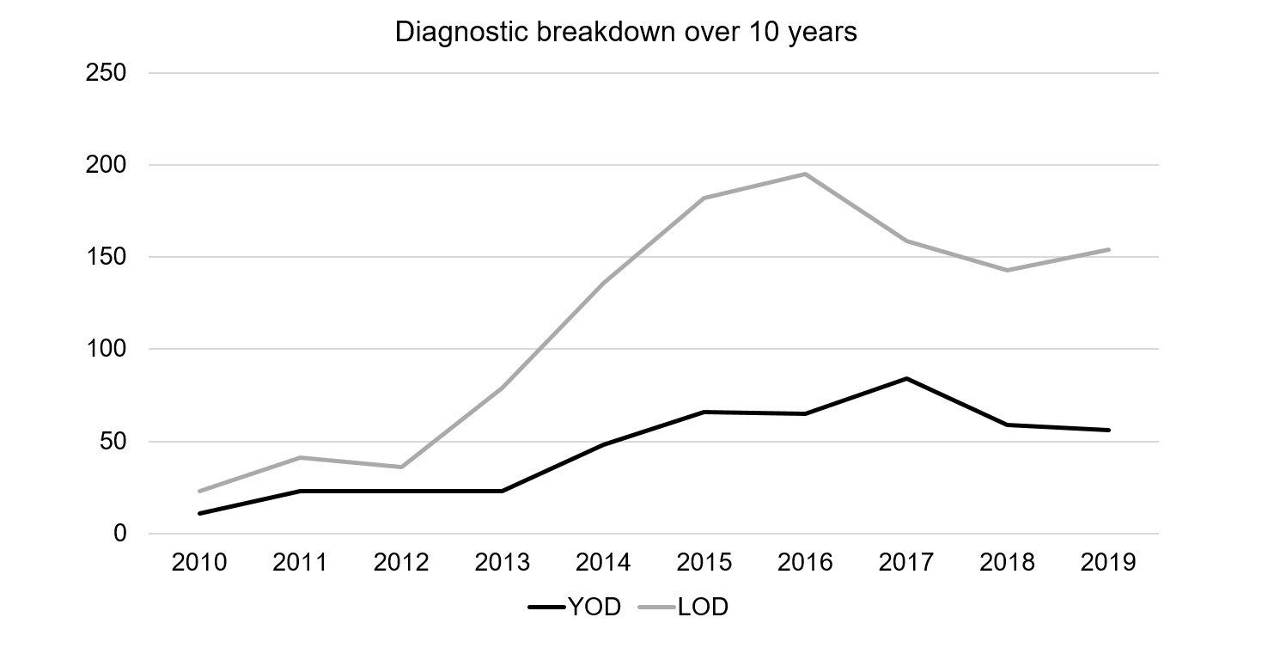
Supplementary Figure 1. Number of young-onset and late-onset patients in a tertiary dementia clinic over 10 years.
There was an increasing trend of patients in the young-onset and late-onset groups over the time period.
Abbreviations: YOD, young-onset dementia; LOD, late-onset dementia
Supplementary Figure 2. Mini Mental State Examination score over time for young and late-onset dementia.
Young-onset dementia patients had a higher MMSE score at baseline but showed a steeper decline in MMSE scores over time compared to the late-onset dementia group.
Abbreviations: YOD, young-onset dementia; LOD, late-onset dementia; MMSE, Mini Mental State Examination

