Supplementary Online Content
Degrush E, Shazeeb MS, Drachman D, et al. Cumulative effects of simvastatin, L-arginine, and tetrahydrobiopterin on cerebral blood flow and cognitive function in Alzheimer’s disease

eTable 1. Psychometric assessments
eTable 2. Individual ADAS-cog 13 scores and group assignment
eFigure 1. Regions of interest (ROIs) for cerebral perfusion assessment and brain volumetric measurements.

eTable 1. Individual ADAS-cog 13 scores and group assignment
Patient ID | Baseline | 16-week | Delta | Delta by group
Subject 1 | 24.0 | 22.6 | -1.4 | -3.6±2.4 | Group 1
Subject 2 | 35.6 | 29.3 | -6.3 | -3.6±2.4 | Group 1
Subject 3 | 33.3 | 30.3 | -3.0 | -3.6±2.4 | Group 1
Subject 4 | 30.0 | 30.0 | 0 | +0.1±0.1 | Group 2
Subject 5 | 24.0 | 24.0 | 0 | +0.1±0.1 | Group 2
Subject 6 | 32.0 | 32.3 | +0.3 | +0.1±0.1 | Group 2
Subject 7 | 32.0 | 34.0 | +2 | +5.8±2.0 | Group 3
Subject 8 | 20.0 | 27.0 | +7 | +5.8±2.0 | Group 3
Subject 9 | 43.3 | 54.0 | +10.7 | +5.8±2.0 | Group 3
Subject 10 | 36.0 | 39.3 | +3.3 | +5.8±2.0 | Group 3
Psychometric assessment of study participants is shown using Alzheimer’s Disease Assessment Scale-Cognitive 13 (ADAS-cog 13) scores. Data are mean ± standard error mean (SEM).

eTable 2. Psychometric assessments
Baseline 4 weeks 8 weeks 16 weeks
ADAS-cog 13 31.0±6.9 - - 32.3±9.0
CAST 31.4±5.5 - - -
CDR 0.8 (0.5-1.0) - - 0.8 (0.5-1.0)
CIBIC plus - -0.1±0.3 0.6±0.8 0.1±1.3
MMSE 24.2±3.2 25.4±2.2 26.0±3.1 26.0±2.7
Data are mean±sd or median (25th - 75th percentile). Dashes indicate that this test was not performed at this time-point. ADAS-cog 13 indicates Alzheimer’s Disease Assessment Scale-Cognitive 13; CAST, Cognitive Assessment Screening Test; CDR, Clinical Dementia Rating scale; CIBIC-plus, Clinician Interview Based Impression of Change plus caregiver input; MMSE, Mini Mental State Examination.

eFigure 1. Regions of interest (ROIs) for cerebral perfusion assessment and brain volumetric measurements.
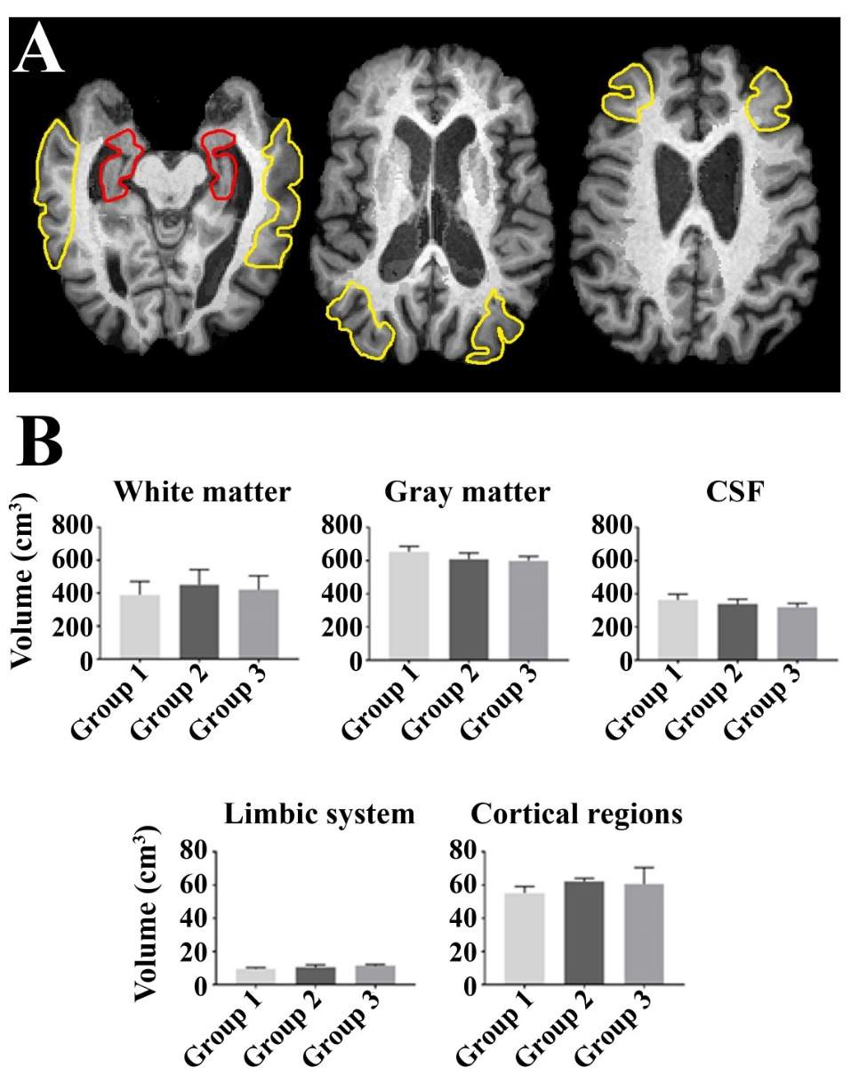

(A) Depiction of the ROIs chosen for the assessment of cerebral perfusion measures including the limbic system (red) and cortical areas (yellow). (B) At baseline, there was no significant difference in brain volumetrics between Subjects with improved (Group 1), stable (Group 2), and worsened (Group 3) cognition as defined by the Alzheimer’s Disease Assessment Scale-Cognitive 13 score change from baseline to 16 weeks. CSF indicates cerebrospinal fluid. Data are mean ± standard error mean (SEM).

