Supplementary tables

Supplementary Table 1A

 | Participants with 2 MRI scans (n=87) |  |  |  | Participants with > 2 MRI scans (n=308)
 | Pearson correlation coefficient | T value | P value | Pearson correlation coefficient |  | T value | P value
Age at baseline | -0.142 |  | 0.189 | -0.084 |  |  | 0.141
Male sex |  | -2.6 | 0.012 |  |  | -2.0 | 0.049
Years of education | 0.066 |  | 0.544 | 0.072 |  |  | 0.207
ICV | -0.258 |  | 0.016 | -0.147 |  |  | 0.010
WML volume | -0.222 |  | 0.052 | -0.139 |  |  | 0.015
APOEε4 allele |  | -1.2 | 0.236 |  |  | -2.5 | 0.013
Low CSF Aβ42/40 ratio |  | -1.5 | 0.135 |  |  | -3.8 | <0.001
CSF P-tau181 | -0.153 |  | 0.157 | -0.245 |  |  | <0.001
CSF NfL | -0.365 |  | <0.001 | -0.322 |  |  | <0.001
CSF sTREM2 | -0.114 |  | 0.303 | -0.046 |  |  | 0.425
CSF neurogranin | -0.045 |  | 0.684 | -0.125 |  |  | 0.030
CSF GFAP | -0.111 |  | 0.316 | -0.166 |  |  | 0.004
Smoking (current or former) |  | 1.3 | 0.213 |  |  | -0.78 | 0.437
Hypertension |  | 0.11 | 0.914 |  |  | 1.3 | 0.181
Hyperlipidaemia |  | 0.84 | 0.404 |  |  | 0.52 | 0.605
Diabetes mellitus |  | -0.46 | 0.646 |  |  | 0.068 | 0.946
Ischemic heart disease |  | 0.46 | 0.650 |  |  | -0.46 | 0.648
Atrial fibrillation | - | - | - |  |  | -0.93 | 0.354
Congestive heart failure |  | 0.66 | 0.513 |  |  | 0.18 | 0.860
Stroke/TIA |  | -0.51 | 0.645 |  |  | -1.3 | 0.205

Supplementary Table 1B

 | Participants with 2 cognitive test visits (n=40) |  |  | Participants with > 2 cognitive test visits (n=355)
 | Pearson correlation coefficient | T value | P value | Pearson correlation coefficient | T value | P value
Age at baseline | -0.041 |  | 0.801 | -0.122 |  | 0.022
Male sex |  | -2.3 | 0.027 |  | -2.4 | 0.016
Years of education | 0.083 |  | 0.610 | 0.031 |  | 0.565
ICV | -0.404 |  | 0.010 | -0.145 |  | 0.006
WML volume | -0.154 |  | 0.371 | -0.162 |  | 0.002
APOEε4 allele |  | -1.2 | 0.231 |  | -2.5 | 0.015
Low CSF Aβ42/40 ratio |  | -1.4 | 0.173 |  | -3.8 | <0.001
CSF P-tau181 | -0.173 |  | 0.287 | -0.227 |  | <0.001
CSF NfL | -0.301 |  | 0.063 | -0.346 |  | <0.001
CSF sTREM2 | -0.199 |  | 0.225 | -0.048 |  | 0.372
CSF neurogranin | -0.090 |  | 0.584 | -0.096 |  | 0.075
CSF GFAP | -0.275 |  | 0.090 | -0.137 |  | 0.010
Smoking (current or former) |  | 0.61 | 0.550 |  | -0.39 | 0.698
Hypertension |  | 0.64 | 0.525 |  | 0.87 | 0.386
Hyperlipidaemia |  | 1.0 | 0.305 |  | 0.46 | 0.647
Diabetes mellitus |  | 0.13 | 0.899 |  | -0.45 | 0.650
Ischemic heart disease |  | 0.60 | 0.549 |  | -0.49 | 0.623
Atrial fibrillation | - | - | - |  | -0.84 | 0.404
Congestive heart failure |  | 0.51 | 0.616 |  | 0.23 | 0.819
Stroke/TIA |  | 0.52 | 0.604 |  | -1.6 | 0.121

Supplementary Tables 1A and B. Bivariate analyses. Associations between the residual measure and demographic, co-morbidity, and biomarker variables. Results are presented separately for participants with two and more than two MRI scans or cognitive visits. No participants in the “2 MRI scans” or “2 cognitive test visits” groups had atrial fibrillation. Corresponds to Table 2 in the main manuscripts.
Abbreviations: ICV – intracranial volume; WML – white matter lesion; Aβ – β-amyloid; P-tau – phosphorylated tau; NfL – neurofilament light; sTREM2 – soluble triggering receptor expressed on myeloid cells 2; GFAP – glial fibrillary acidic protein; TIA – transient ischemic attack.
Supplementary Table 2

 | Standardized beta coefficient | P value
Age at baseline | 0.003 | 0.962
Male sex | 0.012 | 0.847
ICV | -0.104 | 0.118
WML volume | -0.003 | 0.967
APOEε4 allele | -0.044 | 0.417
Abnormal CSF Aβ42/40 | -0.127 | 0.044
CSF P-tau181 | -0.043 | 0.541
CSF NfL | -0.217 | <0.001
CSF GFAP | -0.011 | 0.856

Supplementary Table 2. Multivariate analysis. Multivariate linear regression model with the residual measure as dependent variable and the variables statistically significant in bivariate analyses (Table 2) as independent variables, controlling for presence/absence of subjective cognitive decline, and intercept for mean whole brain cortical thickness and mPACC5. Corresponds to Table 3 from the main manuscript.
Abbreviations: ICV – intracranial volume; WML – white matter lesion; Aβ – β-amyloid; P-tau – phosphorylated tau; NfL – neurofilament light; GFAP – glial fibrillary acidic protein; mPACC5 – modified Preclinical Alzheimer´s Cognitive Composite 5.

Supplementary Table 3

 | Age |  |  | Sex |  |  | Education
 |  | B | P value |  | B | P value |  | B | P value
ICV | Age*ICV | 0.012 | 0.859 | Sex*ICV | 0.717 | 0.453 | Education*ICV | -0.085 | 0.404
WML volume | Age*WML volume | -0.003 | 0.822 | Sex*WML volume | 0.055 | 0.721 | Education*WML volume | 0.024 | 0.236
APOEε4 | Age*APOEε4 | -0.006 | 0.775 | Sex*APOEε4 | 0.191 | 0.355 | Education*APOEε4 | -0.016 | 0.572
Abnormal Aβ42/40 | Age*pathological Aβ42/40 | 0.011 | 0.584 | Sex*abnormal Aβ42/40 | -0.131 | 0.534 | Education*abnormal Aβ42/40 | -0.034 | 0.228
P-tau181 | Age*P-tau181 | 0.071 | 0.163 | Sex*P-tau181 | -0.934 | 0.103 | Education*P-tau181 | -0.099 | 0.218
NfL | Age*NfL | 0.011 | 0.793 | Sex*NfL | 0.824 | 0.095 | Education*NfL | -0.011 | 0.849
GFAP | Age*GFAP | 0.037 | 0.470 | Sex*GFAP | -0.114 | 0.854 | Education*GFAP | 0.032 | 0.728

Supplementary Table 3. Results from linear regression models including the respective predictors and interaction term, controlling for presence/absence of subjective cognitive decline, baseline mean whole brain cortical thickness, and baseline mPACC5.
Abbreviations: ICV – intracranial volume; WML – white matter lesion; Aβ – β-amyloid; P-tau – phosphorylated tau; NfL – neurofilament light; GFAP – glial fibrillary acidic protein; mPACC5 – modified Preclinical Alzheimer´s Cognitive Composite 5.

Supplementary Table 4

 | Sex | ICV | WML volume | APOEε4 | Abnormal Aβ42/40 | P-tau181 | NfL | GFAP
Age | t = -0.47, p = 0.636 | r = 0.04, p = 0.447 | r = 0.42, p < 0.001 | t = 1.51, p = 0.133 | t = -1.67, p = 0.095 | r = 0.23, p < 0.001 | r = 0.38, p < 0.001 | r = 0.35, p < 0.001
Sex | - | t = 14.88, p < 0.001 | t = 2.76, p = 0.006 | Χ² = 1.45, p = 0.229 | Χ² = 2.29, p = 0.130 | t = 1.45, p = 0.150 | t = 3.73, p < 0.001 | t = 0.37, p = 0.712
ICV | - | - | r = 0.35, p < 0.001 | t = -0.94, p = 0.348 | t = -1.27, p = 0.208 | r = -0.06, p = 0.259 | r = 0.19, p < 0.001 | r = 0.12, p = 0.024
WML volume | - | - | - | t = 1.24, p = 0.217 | t = -1.65, p = 0.099 | r = -0.04, p = 0.445 | r = 0.32, p < 0.001 | r = 0.23, p < 0.001
APOEε4 | - | - | - | - | Χ² = 75.1, p < 0.001 | t = -4.44, p < 0.001 | t = -1.87, p = 0.062 | t = -1.81, p = 0.071
Abnormal Aβ42/40 | - | - | - | - | - | t = -10.00, p < 0.001 | t = -4.92, p < 0.001 | t = -5.02, p < 0.001
P-tau181 | - | - | - | - | - | - | r = 0.48, p < 0.001 | r = 0.49, p < 0.001
NfL | - | - | - | - | - | - | - | r = 0.48, p < 0.001

Supplementary Table 4. Associations between all variables significantly associated with the residual measure in bivariate analyses (Table 2). For associations between two binary variables, Chi-Square test, between one binary and one continuous variable, independent samples t test, and between two continuous variables Pearson correlation was used.
Abbreviations: ICV – intracranial volume; WML – white matter lesion; Aβ – β-amyloid; P-tau – phosphorylated tau; NfL – neurofilament light; GFAP – glial fibrillary acidic protein.

Supplementary figures

Supplementary Figure 1A

Supplementary Figure 1B
Supplementary Figure 1. Spaghetti plots showing individual trajectories over time for mean whole brain cortical thickness (A) and mPACC5 (B). For visualization purposes, we show 100 participants per plot.
Abbreviations: mPACC5 – modified Preclinical Alzheimer´s Cognitive Composite 5.

Supplementary Figure 2

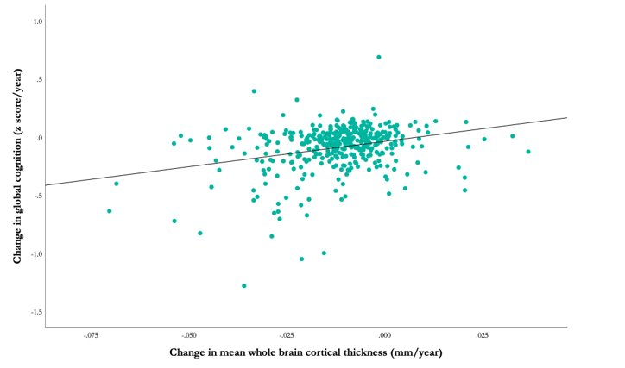

Supplementary Figure 2. Scatterplot showing the positive association between change in mean whole brain cortical thickness and change in global cognition.
Supplementary Figure 3

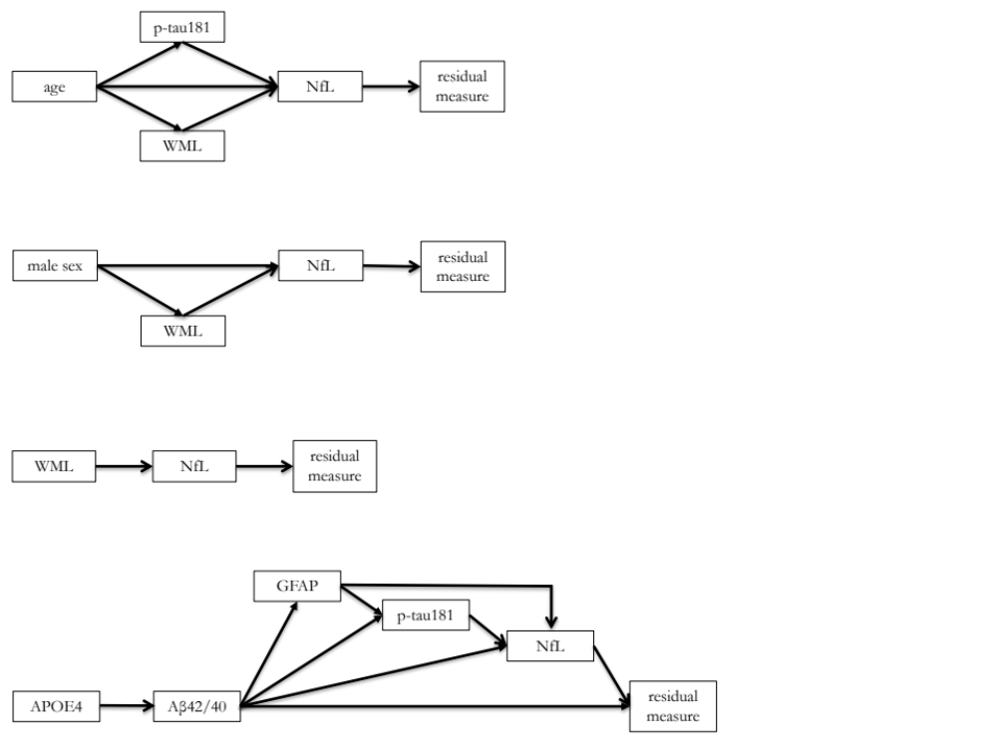

Supplementary Figure 3. Directed acyclic graphs (DAGs) constructed for inclusion of variables in mediation analyses.
Abbreviations: P-tau – phosphorylated tau; WML – white matter lesion; NfL – neurofilament light; Aβ – β-amyloid; GFAP – glial fibrillary acidic protein.

