Supplementary Material
Effects of non-modifiable risk factors of Alzheimer’s disease on intracortical myelin content
Marina Fernandez-Alvarez^{1,2}, Mercedes Atienza^{1,2}, Jose L. Cantero^{1,2*}

Supplementary material, Figure 1
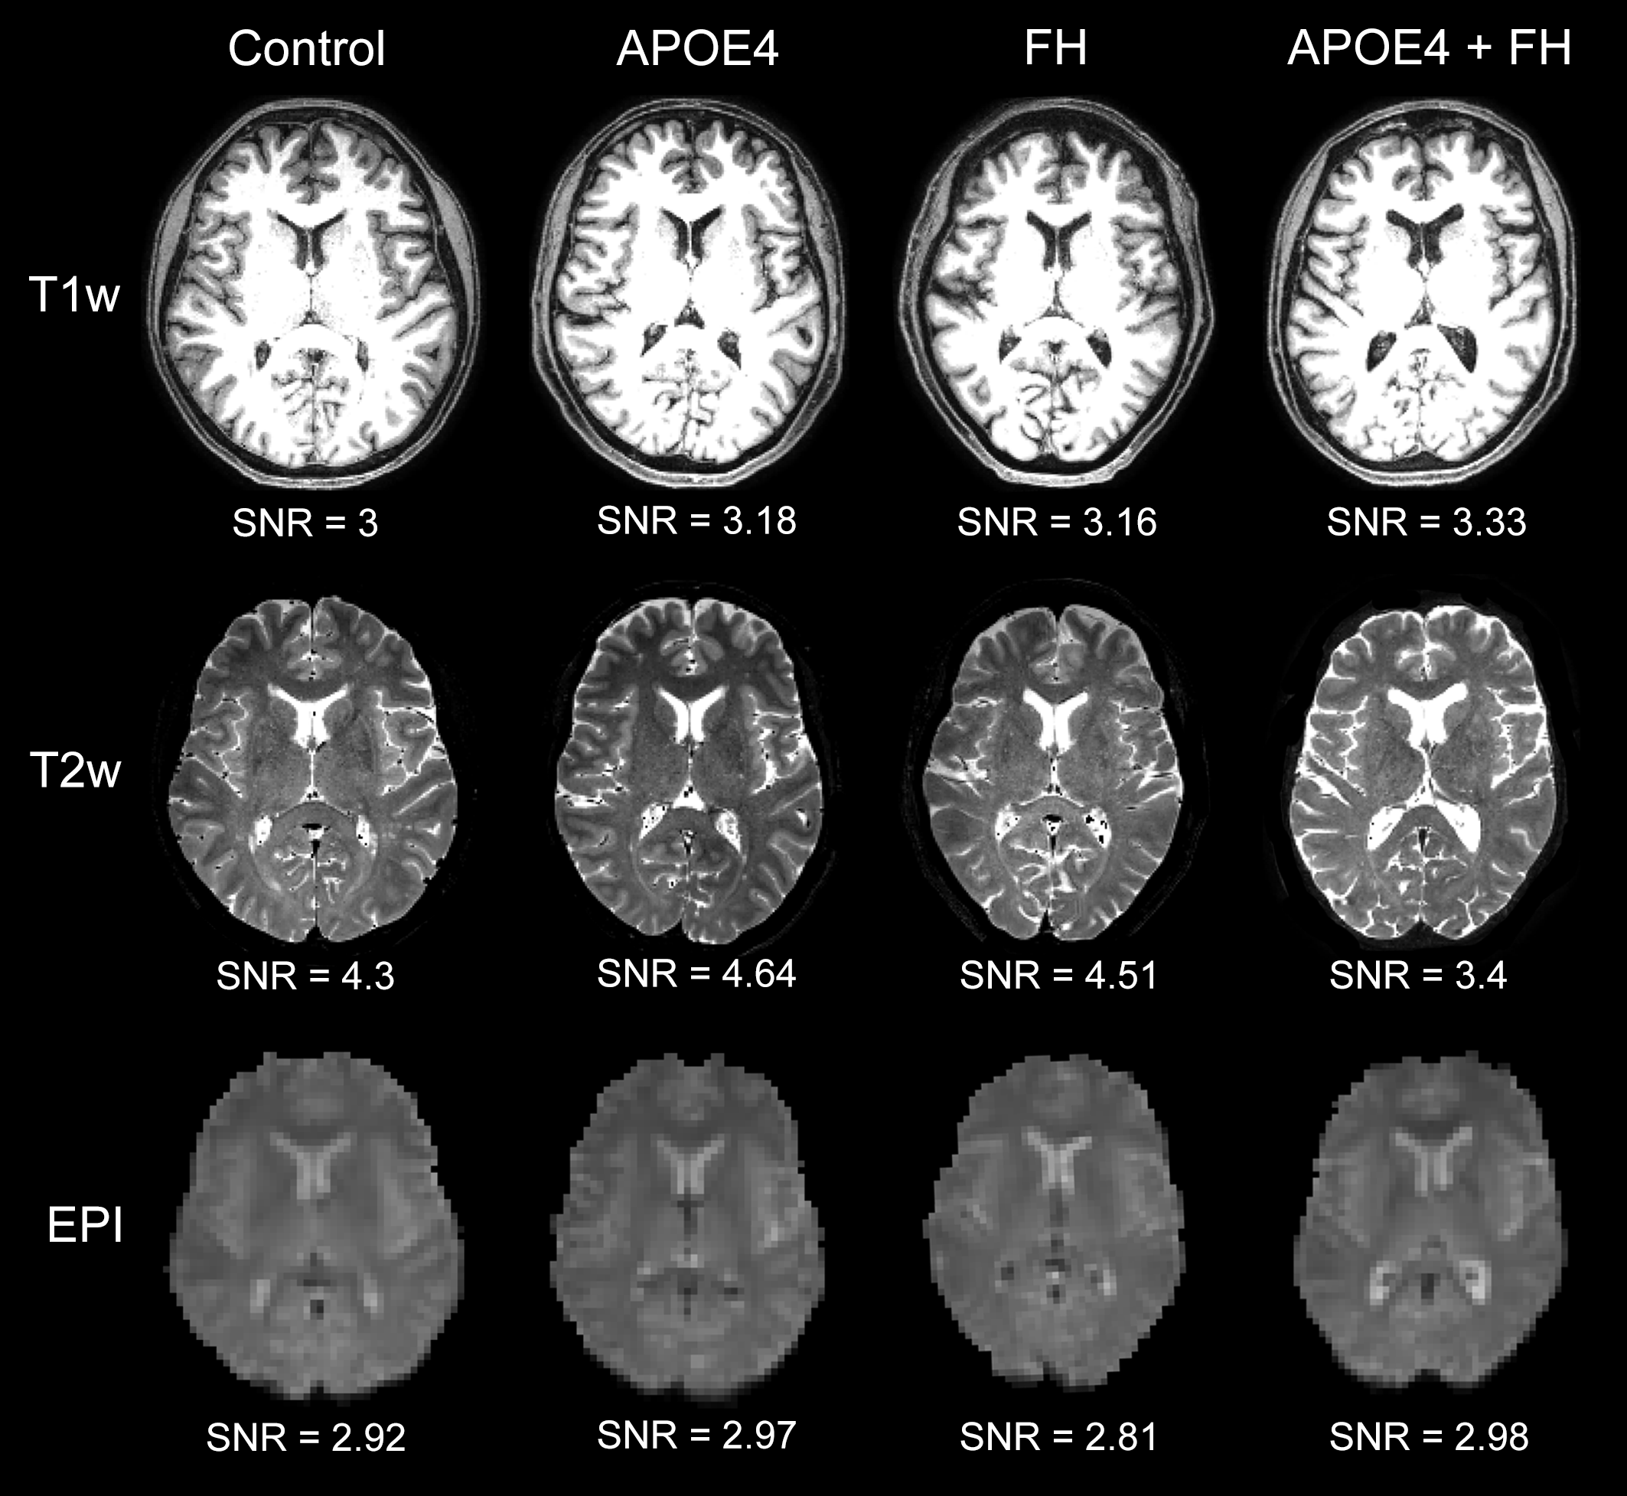
Axial views of T1w, T2w, and EPI images for one representative subject of each group together with their corresponding signal-to-noise ratio (SNR). The SNR for T1w and T2w scans was calculated as the mean divided by the standard deviation of voxel intensities within a gray matter (GM) mask obtained from the Freesurfer aparc+aseg segmentation atlas. This GM mask included the complete cerebral and cerebellar volume and pons. The spatial SNR was similarly computed for the mean EPI map.

