Additional file 1

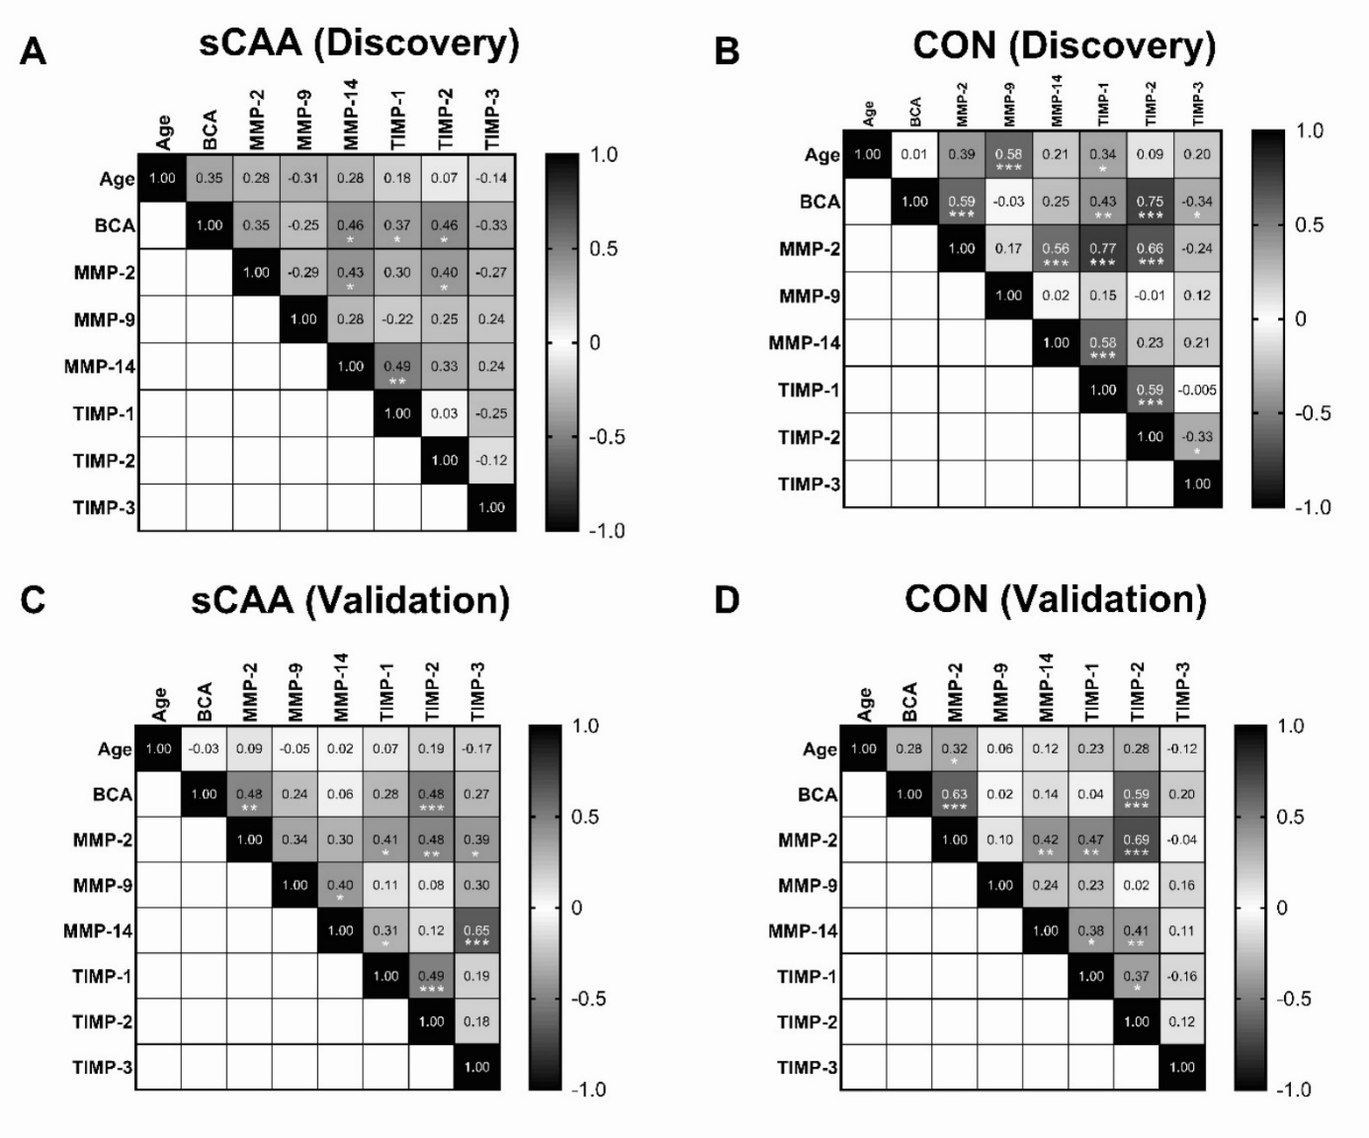
Figure A1: Correlation heatmaps of variables in sCAA patients (sCAA) and control subjects (CON) in the discovery and validation cohorts. Heatmaps of Spearman r values are shown for all correlations between the variables age, and CSF levels of total protein, MMP-2, MMP-9, MMP-14, TIMP-1, TIMP-2, and TIMP-3 in quadrants. Separate correlation quadrants are shown for the sCAA groups (A-C) and for the control groups (B-D) of both the discovery and the validation cohort, respectively. Grayscales (legend on right-hand side of each quadrant) signify correlation coefficients between 1.0 (black) and -1.0 (white). Significance of correlations are signified as follows: * p < 0.05, ** p < 0.01, *** p < 0.001.

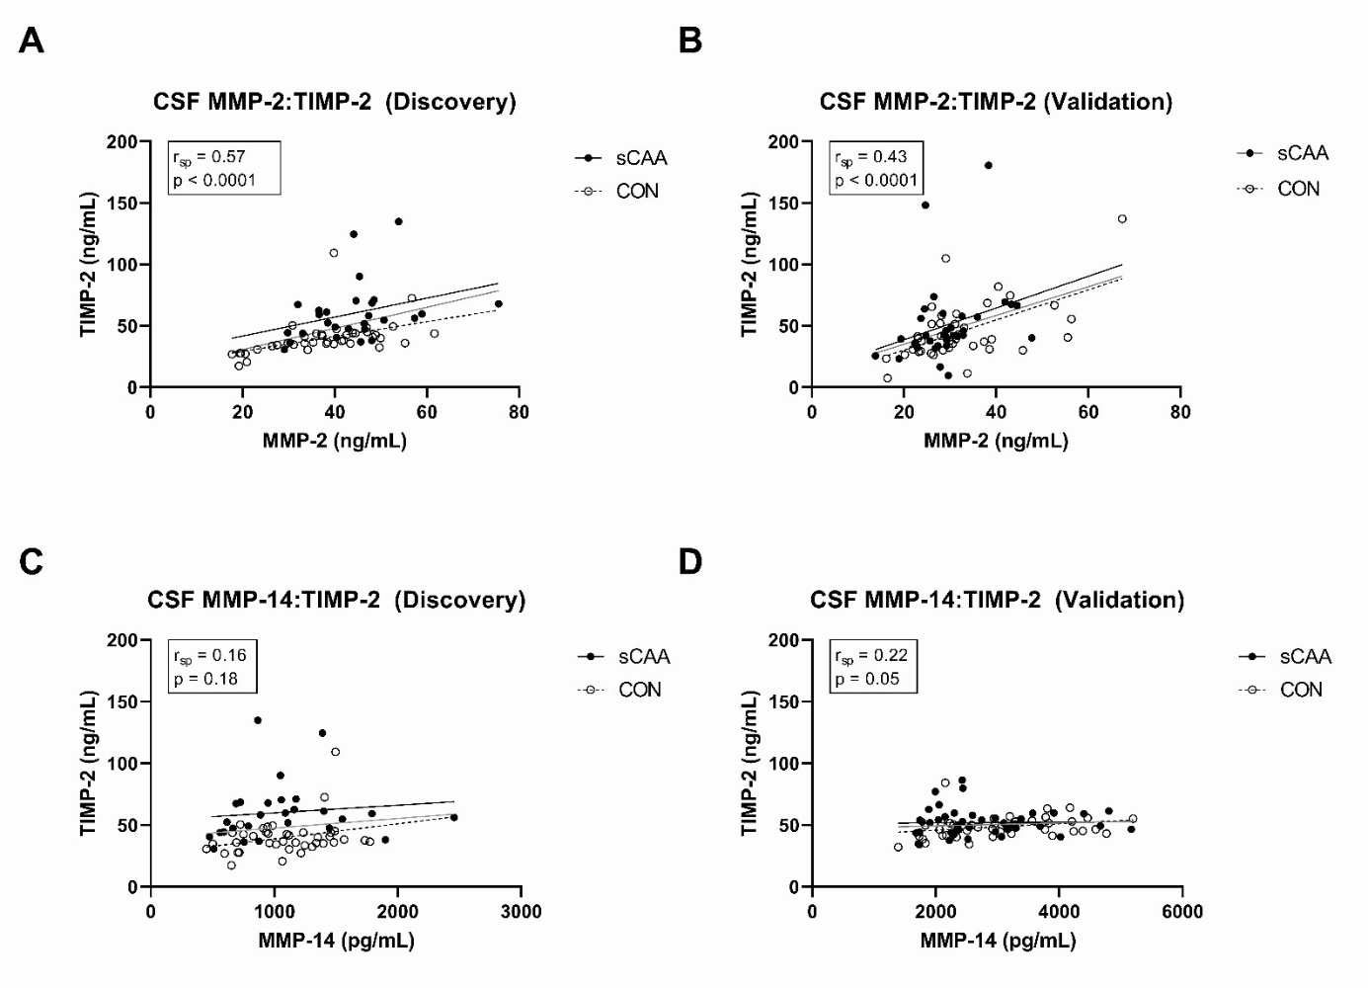

Figure A2: Correlation scatterplots of MMP-2/TIMP-2 and MMP-14/TIMP-2 levels in CSF of sCAA and control subjects in the discovery and validation cohorts. Spearman correlation analyses between MMP-2 and TIMP-2, and between MMP-14 and TIMP-2 in de discovery and validation cohorts. Correlation coefficients shown were calculated for combined sCAA and control groups. MMP-2 and TIMP-2 levels were found to be highly significantly correlated in sCAA patients and control subjects (r_{sp} ≥ 0.43 and r_{sp} = 0.57; both p < 0.001). On the other hand, MMP-14 and TIMP-2 levels were found to be not correlated, or only minutely correlated (r_{sp} = 0.16 and r_{sp} = 0.22; p = 0.18 and p = 0.05 respectively).

