Additional file 1
Table 3 Individual ADNC scores in participants by clinical dementia status at scan
ID | A THAL | B BRAAK | C  CERAD | NIA-AA  ADNC (ABC score) | Clinical Diagnosis at scan | Diagnostic  Changes
1 | A2 | B1 | C0 | Low ADNC | CN | Stable
2 | A0 | B1 | C0 | Not AD | CN | Stable
3 | A3 | B3 | C3 | Intermediate ADNC | CN | Stable
4 | A3 | B3 | C2 | Intermediate ADNC | CN | Converted to MCI
5 | A1 | B1 | C0 | Low ADNC | CN | Stable
6 | A4 | B4 | C3 | Intermediate ADNC | CN | Converted to MCI
7 | A2 | B1 | C0 | Low ADNC | CN | Converted to MCI
8 | A2 | B2 | C1 | Low ADNC | CN | Stable
9 | A2 | B2 | C0 | Low ADNC | MCI | Converted to AD
10 | A4 | B6 | C2 | High ADNC | MCI | Converted to AD
11 | A5 | B4 | C3 | Intermediate ADNC | MCI | Converted to AD
12 | A4 | B5 | C3 | High ADNC | MCI | Converted to AD
13 | A5 | B5 | C2 | High ADNC | MCI | Converted to AD
14 | A2 | B3 | C1 | Low ADNC | MCI | Stable
15 | A4 | B6 | C3 | High ADNC | MCI | Converted to AD
16 | A4 | B5 | C2 | High ADNC | MCI | Converted to AD
17 | A4 | B4 | C2 | Intermediate ADNC | MCI | Converted to AD
18 | A5 | B6 | C3 | High ADNC | AD | Stable
19 | A5 | B5 | C3 | High ADNC | AD | Stable
20 | A5 | B5 | C3 | High ADNC | AD | Stable
21 | A4 | B5 | C3 | High ADNC | AD | Stable
22 | A4 | B5 | C3 | High ADNC | AD | Stable
23 | A5 | B5 | C3 | High ADNC | AD | Stable
24 | A5 | B4 | C1 | Intermediate ADNC | AD | Stable
25 | A5 | B6 | C3 | High ADNC | AD | Stable
26 | A4 | B5 | C3 | High ADNC | AD | Stable
27 | A5 | B6 | C3 | High ADNC | AD | Stable
28 | A4 | B6 | C3 | High ADNC | AD | Stable
29 | A1 | B2 | C0 | Low ADNC | AD | Stable
30 | A5 | B6 | C3 | High ADNC | AD | Stable
31 | A5 | B6 | C3 | High ADNC | AD | Stable
32 | A4 | B5 | C3 | High ADNC | AD | Stable
33 | A5 | B6 | C2 | High ADNC | AD | Stable
34 | A5 | B6 | C3 | High ADNC | AD | Stable
35 | A3 | B4 | C3 | Intermediate ADNC | AD | Stable
36 | A4 | B6 | C2 | High ADNC | AD | Stable
37 | A5 | B6 | C3 | High ADNC | AD | Stable
38 | A5 | B6 | C3 | High ADNC | AD | Stable
39 | A5 | B6 | C3 | High ADNC | AD | Stable
40 | A5 | B5 | C3 | High ADNC | AD | Stable
41 | A4 | B5 | C3 | High ADNC | AD | Stable
42 | A5 | B4 | C2 | Intermediate ADNC | AD | Stable
43 | A4 | B3 | C2 | Intermediate ADNC | AD | Stable
THAL= Thal phase for amyloid plaques (A score); BRAAK= Braak stage for neurofibrillary degeneration (B score); CERAD= Density of neocortical neuritic plaques (CERAD score) (C score).
Table 4 Non-cortical neuropathological changes
ID | CDS | ADNC | WMr | ACW | LCh | CAA
1 | CN | Low ADNC | None | None | None | Mild
2 | CN | Not AD | Severe | Moderate | Mild | Mild
3 | CN | Intermediate ADNC | Moderate | Moderate | None | Mild
4 | CN | Intermediate ADNC | None | Severe | None | None
5 | CN | Low ADNC | Moderate | Mild | None | None
6 | CN | Intermediate ADNC | None | None | None | Mild
7 | CN | Low ADNC | None | Mild | None | None
8 | CN | Low ADNC | None | Severe | None | None
9 | MCI | Low ADNC | None | - | - | Moderate
10 | MCI | High ADNC | Moderate | Severe | Moderate | Severe
11 | MCI | Intermediate ADNC | None | None | Severe | Mild
12 | MCI | High ADNC | Moderate | Mild | Moderate | None
13 | MCI | High ADNC | Mild | Moderate | None | None
14 | MCI | Low ADNC | Moderate | Moderate | None | Mild
15 | MCI | High ADNC | Moderate | Mild | Severe | Severe
16 | MCI | High ADNC | Moderate | Moderate | None | Moderate
17 | MCI | Intermediate ADNC | Moderate | Mild | Severe | None
18 | AD | High ADNC | None | None | Severe | Severe
19 | AD | High ADNC | None | Mild | None | Mild
20 | AD | High ADNC | None | Mild | None | Mild
21 | AD | High ADNC | None | Mild | None | Moderate
22 | AD | High ADNC | None | None | None | Mild
23 | AD | High ADNC | None | - | - | Moderate
24 | AD | Intermediate ADNC | None | - | - | Mild
25 | AD | High ADNC | None | None | None | Mild
26 | AD | High ADNC | Mild | Mild | Severe | Mild
27 | AD | High ADNC | Moderate | Mild | Moderate | Severe
28 | AD | High ADNC | Moderate | Severe | Moderate | Mild
29 | AD | Low ADNC | Mild | None | Moderate | None
30 | AD | High ADNC | Mild | Mild | Moderate | Mild
31 | AD | High ADNC | Mild | Severe | Severe | Mild
32 | AD | High ADNC | Moderate | Moderate | Mild | Mild
33 | AD | High ADNC | None | Moderate | Moderate | Moderate
34 | AD | High ADNC | None | Mild | Severe | Mild
35 | AD | Intermediate ADNC | Severe | Severe | None | Mild
36 | AD | High ADNC | Moderate | Mild | Severe | Severe
37 | AD | High ADNC | Mild | None | Severe | Severe
38 | AD | High ADNC | Moderate | Severe | Severe | Severe
39 | AD | High ADNC | None | Mild | Moderate | Mild
40 | AD | High ADNC | Moderate | Mild | Mild | Mild
41 | AD | High ADNC | None | Mild | Moderate | Mild
42 | AD | Intermediate ADNC | Mild | Mild | Moderate | Mild
43 | AD | Intermediate ADNC | None | None | Moderate | Moderate
CDS= Clinical diagnosis at the scan; ADNC= Alzheimer's disease neuropathologic change (ADNC); WMr= white matter rarefaction; ACW= Atherosclerosis of circle of Willis; LCh= Locus Coeruleus hypopigmentation; CAA= Cerebral amyloid angiopathy.

Figure A1
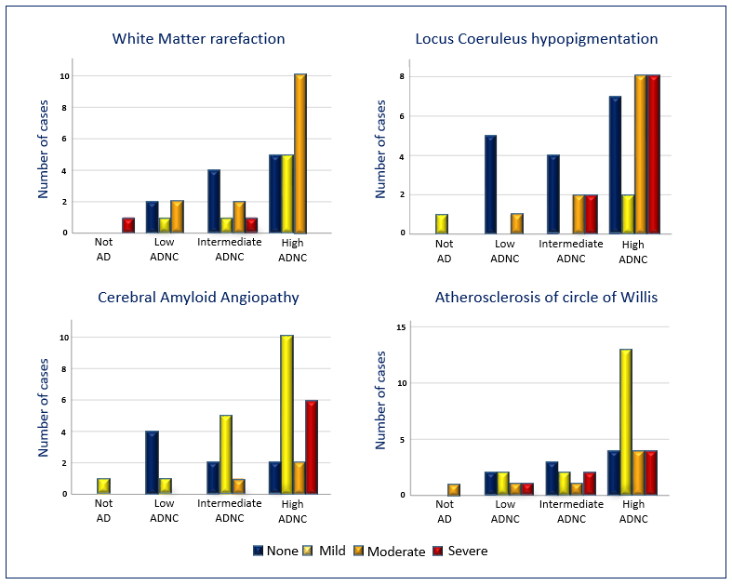
Figure A1 Co-occurrence of non-cortical changes. Co-pathology prevalence increases at higher levels of ADNC.

Table 5 Coexistent pathologies
ID | CDS | ADNC | VP | TDP-43 | LB | CJD | PSP | CBD | PiD | HS | ALS
1 | CN | Low ADNC | X | - | - | - | - | - | - | - | -
2 | CN | Not AD | X | - | - | - | - | - | - | - | -
3 | CN | Intermediate ADNC | - | - | - | - | - | - | - | - | -
4 | CN | Intermediate ADNC | X | - | - | - | - | - | - | - | -
5 | CN | Low ADNC | X | - | - | - | - | - | - | - | -
6 | CN | Intermediate ADNC | X | - | - | - | - | - | - | - | -
7 | CN | Low ADNC | X | - | - | - | - | - | - | - | -
8 | CN | Low ADNC | X | - | - | - | - | - | - | - | -
9 | MCI | Low ADNC | X | - | X | - | - | - | - | - | -
10 | MCI | High ADNC | X | - | - | - | - | - | - | - | -
11 | MCI | Intermediate ADNC | X | - | X | - | - | - | - | - | -
12 | MCI | High ADNC | X | X | - | - | - | - | - | - | -
13 | MCI | High ADNC | X | - | - | - | - | - | - | - | -
14 | MCI | Low ADNC | X | - | - | - | - | - | - | - | -
15 | MCI | High ADNC | X | - | X | - | - | - | - | X | -
16 | MCI | High ADNC | X | - | - | - | - | - | - | X | -
17 | MCI | Intermediate ADNC | X | X | - | - | - | - | X | X | -
18 | AD | High ADNC | X | X | X | - | - | - | - | - | -
19 | AD | High ADNC | X | - | X | - | - | - | - | - | -
20 | AD | High ADNC | X | X | - | - | - | - | - | - | -
21 | AD | High ADNC | X | - | - | - | - | - | - | - | -
22 | AD | High ADNC | X | - | - | - | - | - | - | - | -
23 | AD | High ADNC | X | - | X | - | - | - | - | - | -
24 | AD | Intermediate ADNC | X | X | X | - | - | - | - | - | -
25 | AD | High ADNC | X | - | X | - | - | - | - | - | -
26 | AD | High ADNC | X | X | - | - | - | - | - | - | -
27 | AD | High ADNC | X | - | X | - | - | - | - | - | -
28 | AD | High ADNC | X | - | - | - | - | - | - | - | -
29 | AD | Low ADNC | X | - | X | - | - | - | - | - | -
30 | AD | High ADNC | X | - | - | - | - | - | - | - | -
31 | AD | High ADNC | X | X | - | - | - | - | - | X | -
32 | AD | High ADNC | X | X | - | - | - | - | - | - | -
33 | AD | High ADNC | X | - | - | - | - | - | - | - | -
34 | AD | High ADNC | X | X | - | - | - | - | - | - | -
35 | AD | Intermediate ADNC | X | - | - | - | - | - | - | X | -
36 | AD | High ADNC | X | - | - | - | - | - | - | - | -
37 | AD | High ADNC | X | X | - | - | - | - | - | - | -
38 | AD | High ADNC | X | X | X | - | - | - | - | X | -
39 | AD | High ADNC | X | X | - | - | - | - | - | - | -
40 | AD | High ADNC | X | X | - | - | - | - | - | - | -
41 | AD | High ADNC | X | - | - | - | - | - | - | - | -
42 | AD | Intermediate ADNC | X | X | X | - | - | - | - | - | -
43 | AD | Intermediate ADNC | X | - | X | - | - | - | - | - | -
CDS= Clinical diagnosis at the scan; AD= Histopathologically defined AD; VP= Vascular pathology; TDP-43= TAR DNA-binding protein 43 pathology; LB= Lewy body disease; CJD= Creutzfeldt-Jakob disease and other prion encephalopathies; PSP= Progressive supranuclear palsy; CBD= Corticobasal degeneration; PiD= Pick's disease; HS= Hippocampal sclerosis; ALS= Amyotrophic lateral sclerosis.

