Supplementary Tables
ST1. Mean cognitive scores for participants in the study over follow-up, by stroke status (n=19,114)
 | No stroke  n=18,299 |  |  |  | Stroke  n=815
 | 3MS | HVLT-R | SDMT | COWAT | 3MS | HVLT-R | SDMT | COWAT
Year 1 | 94.2  (4.7) | 8.2  (3.0) | 37.0  (10.1) | 13.2  (4.8) | 93.5  (5.1) | 7.8  (3.3) | 33.8  (10.4) | 12.9  (5.1)
Year 2* | 84.4  (9.0) | 5.2  (3.7) | 27.8  (12.2) | 11.3  (4.9) | 82.5  (12.0) | 4.0  (2.8) | 25.0  (0) | 6.0  (1.4)
Year 3 | 93.9  (5.3) | 8.2  (3.2) | 36.1  (10.1) | 13.4  (4.9) | 92.8  (6.7) | 7.6  (3.5) | 32.6  (10.4) | 12.7  (5.3)
Year 4 | 94.1  (5.6) | 8.2  (3.2) | 36.1  (10.3) | 13.4  (4.8) | 92.3  (7.6) | 7.4  (3.7) | 30.8  (11.8) | 13.1  (5.3)
Year 5 | 93.8  (6.1) | 8.2  (3.3) | 35.3  (10.1) | 13.6  (5.1) | 92.4  (8.2) | 7.5  (3.4) | 30.6  (10.4) | 13.0  (5.5)
Year 6 | 94.0  (6.3) | 8.4  (3.2) | 35.1 (10.3) | 13.6  (5.1) | 92.5  (7.4) | 7.7  (3.5) | 30.8 (10.6) | 12.8  (4.9)
Year 7 | 93.9  (6.6) | 8.3  (3.3) | 34.2  (10.2) | 13.5  (5.1) | 92.9  (6.5) | 7.8  (3.2) | 30.4  (10.6) | 11.7  (5.8)
Year 8 | 93.7  (6.9) | 8.4  (3.3) | 33.4  (10.3) | 13.6  (5.2) | 92.1  (7.9) | 7.8  (3.5) | 29..3  (10.5) | 12.0  (5.2)
Year 9 | 93.4  (7.0) | 8.3  (3.3) | 32.7  (10.5) | 13.6  (5.3) | 92.8  (6.7) | 7.7  (3.3) | 27.4  (9.8) | 11.9  (5.2)
Year 10 | 93.3  (7.5) | 8.3  (3.5) | 31.9  (10.1) | 13.7  (5.4) | 92.9  (7.6) | 7.8  (3.9) | 29.3  (9.6) | 13.2  (5.2)
Year 11 | 93.0  (8.9) | 8.3  (3.3) | 31.7  (10.6) | 13.6  (5.2) | 91.8  (7.5) | 8.7  (2.3) | 30.9  (9.9) | 12.7  (6.7)
Note:
* Year 2 cognitive assessments not included in the analysis
Abbreviations: n – sample size; 3MS – Modified Mini-Mental State exam; HVLT-R – Hopkins verbal learning test-revised; SDMT – symbol digit modalities test; COWAT – single letter controlled oral word association test.

ST2. Stroke and change in cognitive performance over time (n=19,114) [complete model – including covariates]
 |  | 3MS  (Global cognition) | HVLT-R  (Episodic memory) | SDMT  (Processing speed) | COWAT  (Verbal fluency)
Overall cognitive change over time |  | -0.20  [-0.21, -0.18] | -0.04  [-0.04, -0.03] | -0.68  [-0.70, -0.67] | 0.09  [0.08, 0.10]
Acute cognitive change after stroke |  | -1.03  [-1.45, -0.60] | -0.47  [-0.70, -0.24] | -2.82  [-3.57, -2.08] | -0.67  [-1.04, -0.29]
Cognitive change over time after stroke |  | -0.75  [-0.98, -0.53] | -0.12  [-0.70, -0.24] | -0.30  [-0.56, -0.05] | -0.17  [-0.28, -0.07]
Age |  | -0.21  [-0.23, -0.20] | -0.16  [-0.16, -0.15] | -0.72  [-0.75, -0.70] | -0.06  [-0.07, -0.04]
Sex | [Female] | 1.40  [1.27, 1.52] | 1.09  [1.01, 1.17] | 2.91  [2.65, 3.17] | 1.40  [1.28, 1.52]
Country and Ethnicity | [Aus/white] | Ref | Ref | Ref | Ref
Country and Ethnicity | [US/white] | 0.52  [0.27, 0.77] | 0.09  [-0.06, 0.25] | 1.41  [0.89, 1.92] | -0.79  [-1.03, -0.54]
Country and Ethnicity | [Afr/Amer] | -2.68  [-2.98, -2.38] | -1.31  [-1.49, -1.12] | -5.88  [-6.49, -5.26] | -2.19  [-2.49, -1.90]
Country and Ethnicity | [Other] | -2.71  [-3.08, -2.33] | -0.29  [-0.53, -0.06] | -2.63  [-3.39, -1.87] | -1.51  [-1.87, -1.15]
Education | [≥12yrs] | 1.82  [1.69, 1.94] | 0.81  [0.73, 0.88] | 4.40  [4.15, 4.66] | 2.04  [1.92, 2.16]
Smoking | [Current] | Ref | Ref | Ref | Ref
Smoking | [Former] | 0.75  [0.43, 1.07] | 0.16  [-0.04, 0.36] | 2.89  [2.22, 3.53] | 0.52  [0.20, 0.83]
Smoking | [Never] | 0.85  [0.53, 1.17] | 0.25  [0.05, 0.45] | 3.08  [2.43, 3.73] | 0.38  [0.07, 0.69]
Alcohol | [Current] | Ref | Ref | Ref | Ref
Alcohol | [Former] | -1.03  [-1.29, -0.78] | -0.49  [-0.65, -0.33] | -2.24  [-2.77, -1.71] | -0.42  [-0.67, -0.17]
Alcohol | [Never] | -0.74  [-0.90, -0.57] | -0.42  [-0.52, -0.31] | -1.36  [-1.70, -1.03] | -0.67  [-0.82, -0.44]
Hypertension | [Yes] | -0.28  [-0.42, -0.14] | -0.08  [-0.17, 0.00] | -0.73  [-1.01, -0.45] | -0.24  [-0.37, -0.11]
Diabetes | [Yes] | -0.65  [-0.84, -0.45] | -0.32  [-0.52, -0.31] | -1.35  [-1.75, -0.95] | -0.62  [-0.82, -0.44]
Dyslipidemia | [Yes] | -0.07  [-0.20, 0.05] | -0.03  [-0.11, 0.05] | 0.26  [-0.00, 0.52] | 0.11  [-0.02, 0.23]
Depression symptoms* | [Yes] | -0.71  [-0.91, -0.51] | -0.35  [-0.47, -0.22] | -1.59  [-2.00, -1.19] | -0.32  [-0.51, -0.12]
Note: This table includes mixed linear regression results with participant-specific random intercept and slope
Bold represents significant result p<0.05
Abbreviations: n – sample size; 3MS – Modified Mini-Mental State exam; HVLT-R – Hopkins verbal learning test-revised; SDMT – symbol digit modalities test; COWAT – single letter controlled oral word association test, Letter F; Aus, Australia; US, United States; Afr/Amer, African American; yrs – years.

ST3. Stroke and change in cognitive performance over time after excluding individuals who have died (n=16,086)
 | 3MS  (Global cognition) | HVLT-R  (Episodic memory) | SDMT  (Processing speed) | COWAT  (Verbal fluency)
Cognitive change over time* | -0.14  [-0.15, -0.12] | -0.03  [-0.03, -0.02] | -0.66  [-0.67, -0.64] | 0.09  [0.08, 0.10]
Acute cognitive change after stroke# | -0.88  [-1.33, -0.44] | -0.40  [-0.64, -0.15] | -2.59  [-3.39, -1.79] | -0.68  [-1.09, -0.28]
Cognitive change over time after stroke^ | -0.47  [-0.67, -0.28] | -0.12  [-0.16, -0.14] | -0.31  [-0.59, -0.03] | -0.16  [-0.27, -0.05]
Note:
This table includes mixed linear regression results with participant-specific random intercept and slope adjusting for age, sex, country and ethnicity, education, smoking, alcohol, diabetes, depressive symptoms and including time (years) and a time-varying stroke variable (all participants were event-free at baseline), and a time variable representing the time (years) after a stroke
Bold represents significant result p<0.05
* This effect size shows the annual change in cognitive scores on each of the four tests.
# This effect size shows the acute change in cognitive scores after an incident stroke (compared to pre-stroke).
^ This effect size shows the annual change in cognitive scores on each of the four tests after a stroke
Abbreviations: n – sample size; 3MS – Modified Mini-Mental State exam; HVLT-R – Hopkins verbal learning test-revised; SDMT – symbol digit modalities test; COWAT – single letter controlled oral word association test.

ST4. Stroke and change in cognitive performance over time after excluding individuals who had a dementia diagnosis (n=17,897)
 | 3MS  (Global cognition) | HVLT-R  (Episodic memory) | SDMT  (Processing speed) | COWAT  (Verbal fluency)
Cognitive change over time* | -0.04  [-0.05, -0.03] | -0.00  [-0.01, 0.00] | -0.63  [-0.64, -0.61] | 0.11  [0.09, 0.11]
Acute cognitive change after stroke# | -0.62  [-1.00, -0.23] | -0.36  [-0.59, -0.13] | -2.75  [-3.35, -1.99] | -0.50  [-0.89, -0.11]
Cognitive change over time after stroke^ | -0.47  [-0.64, -0.29] | -0.10  [-0.18, -0.01] | -0.25  [-0.49, 0.00] | -0.18  [-0.28, -0.07]
Note:
This table includes mixed linear regression results with participant-specific random intercept and slope adjusting for age, sex, country and ethnicity, education, smoking, alcohol, diabetes, depressive symptoms and including time (years) and a time-varying stroke variable (all participants were event-free at baseline), and a time variable representing the time (years) after a stroke
Bold represents significant result p<0.05
* This effect size shows the annual change in cognitive scores on each of the four tests.
# This effect size shows the acute change in cognitive scores after an incident stroke (compared to pre-stroke).
^ This effect size shows the annual change in cognitive scores on each of the four tests after a stroke
Abbreviations: n – sample size; 3MS – Modified Mini-Mental State exam; HVLT-R – Hopkins verbal learning test-revised; SDMT – symbol digit modalities test; COWAT – single letter controlled oral word association test.

ST5. Haemorrhagic stroke and change in cognitive performance over time (n=18,434 | n=135 with stroke)†
 | 3MS  (Global cognition) | HVLT-R  (Episodic memory) | SDMT  (Processing speed) | COWAT  (Verbal fluency)
Cognitive change over time* | -0.20  [-0.21, -0.18] | -0.04  [-0.04, -0.03] | -0.68  [-0.70, -0.67] | 0.09  [0.08, 0.10]
Acute cognitive change after stroke# | -3.71  [-5.01, -2.41] | -1.21  [-1.93, -0.50] | -4.13  [-6.43, -1.82] | 0.25  [-0.93, 1.43]
Cognitive change over time after stroke^ | -1.00  [-1.69, -0.31] | 0.13  [-0.13, 0.39] | -0.61  [-1.48, 0.25] | -0.43  [-0.82, -0.05]
Note:
This table includes mixed linear regression results with participant-specific random intercept and slope adjusting for age, sex, country and ethnicity, education, smoking, alcohol, diabetes, depressive symptoms and including time (years) and a time-varying stroke variable (all participants were event-free at baseline), and a time variable representing the time (years) after a stroke. Potential confounding factors not significant in the univariate analyses (hypertension, obesity, dyslipidaemia, and chronic kidney disease) were not included as covariates.
Bold represents significant result p<0.05
† From the total sample (n=19,114) deleted all ischemic stroke (n=596) and unknown/other stroke (n=84)
* This effect size shows the annual change in cognitive scores on each of the four tests.
# This effect size shows the acute change in cognitive scores after an incident stroke (compared to pre-stroke).
^ This effect size shows the annual change in cognitive scores on each of the four tests after a stroke
Abbreviations: n – sample size; 3MS – Modified Mini-Mental State exam; HVLT-R – Hopkins verbal learning test-revised; SDMT – symbol digit modalities test; COWAT – single letter controlled oral word association test.

ST6. Ischemic stroke and change in cognitive performance over time (n=18,895 | n=596 with stroke)†
 | 3MS  (Global cognition) | HVLT-R  (Episodic memory) | SDMT  (Processing speed) | COWAT  (Verbal fluency)
Cognitive change over time* | -0.19  [-0.21, -0.18] | -0.04  [-0.04, -0.03] | -0.68  [-0.70, -0.67] | 0.09  [0.08, 0.10]
Acute cognitive change after stroke# | -0.69  [-1.16, -0.22] | -0.37  [-0.62, -0.12] | -2.68  [-3.49, -1.88] | -0.75  [-1.16, -0.34]
Cognitive change over time after stroke^ | -0.64  [-0.87, -0.42] | -0.13  [-0.22, -0.04] | -0.22  [-0.48, 0.04] | -0.14  [-0.25, -0.04]
Note:
This table includes mixed linear regression results with participant-specific random intercept and slope adjusting for age, sex, country and ethnicity, education, smoking, alcohol, diabetes, depressive symptoms and including time (years) and a time-varying stroke variable (all participants were event-free at baseline), and a time variable representing the time (years) after a stroke. Potential confounding factors not significant in the univariate analyses (hypertension, obesity, dyslipidaemia, and chronic kidney disease) were not included as covariates.
Bold represents significant result p<0.05
† From the total sample (n=19,114) deleted all haemorrhagic stroke (n=135) and unknown/other stroke (n=84)
* This effect size shows the annual change in cognitive scores on each of the four tests.
# This effect size shows the acute change in cognitive scores after an incident stroke (compared to pre-stroke).
^ This effect size shows the annual change in cognitive scores on each of the four tests after a stroke
Abbreviations: n – sample size; 3MS – Modified Mini-Mental State exam; HVLT-R – Hopkins verbal learning test-revised; SDMT – symbol digit modalities test; COWAT – single letter controlled oral word association test.

Supplementary Figure
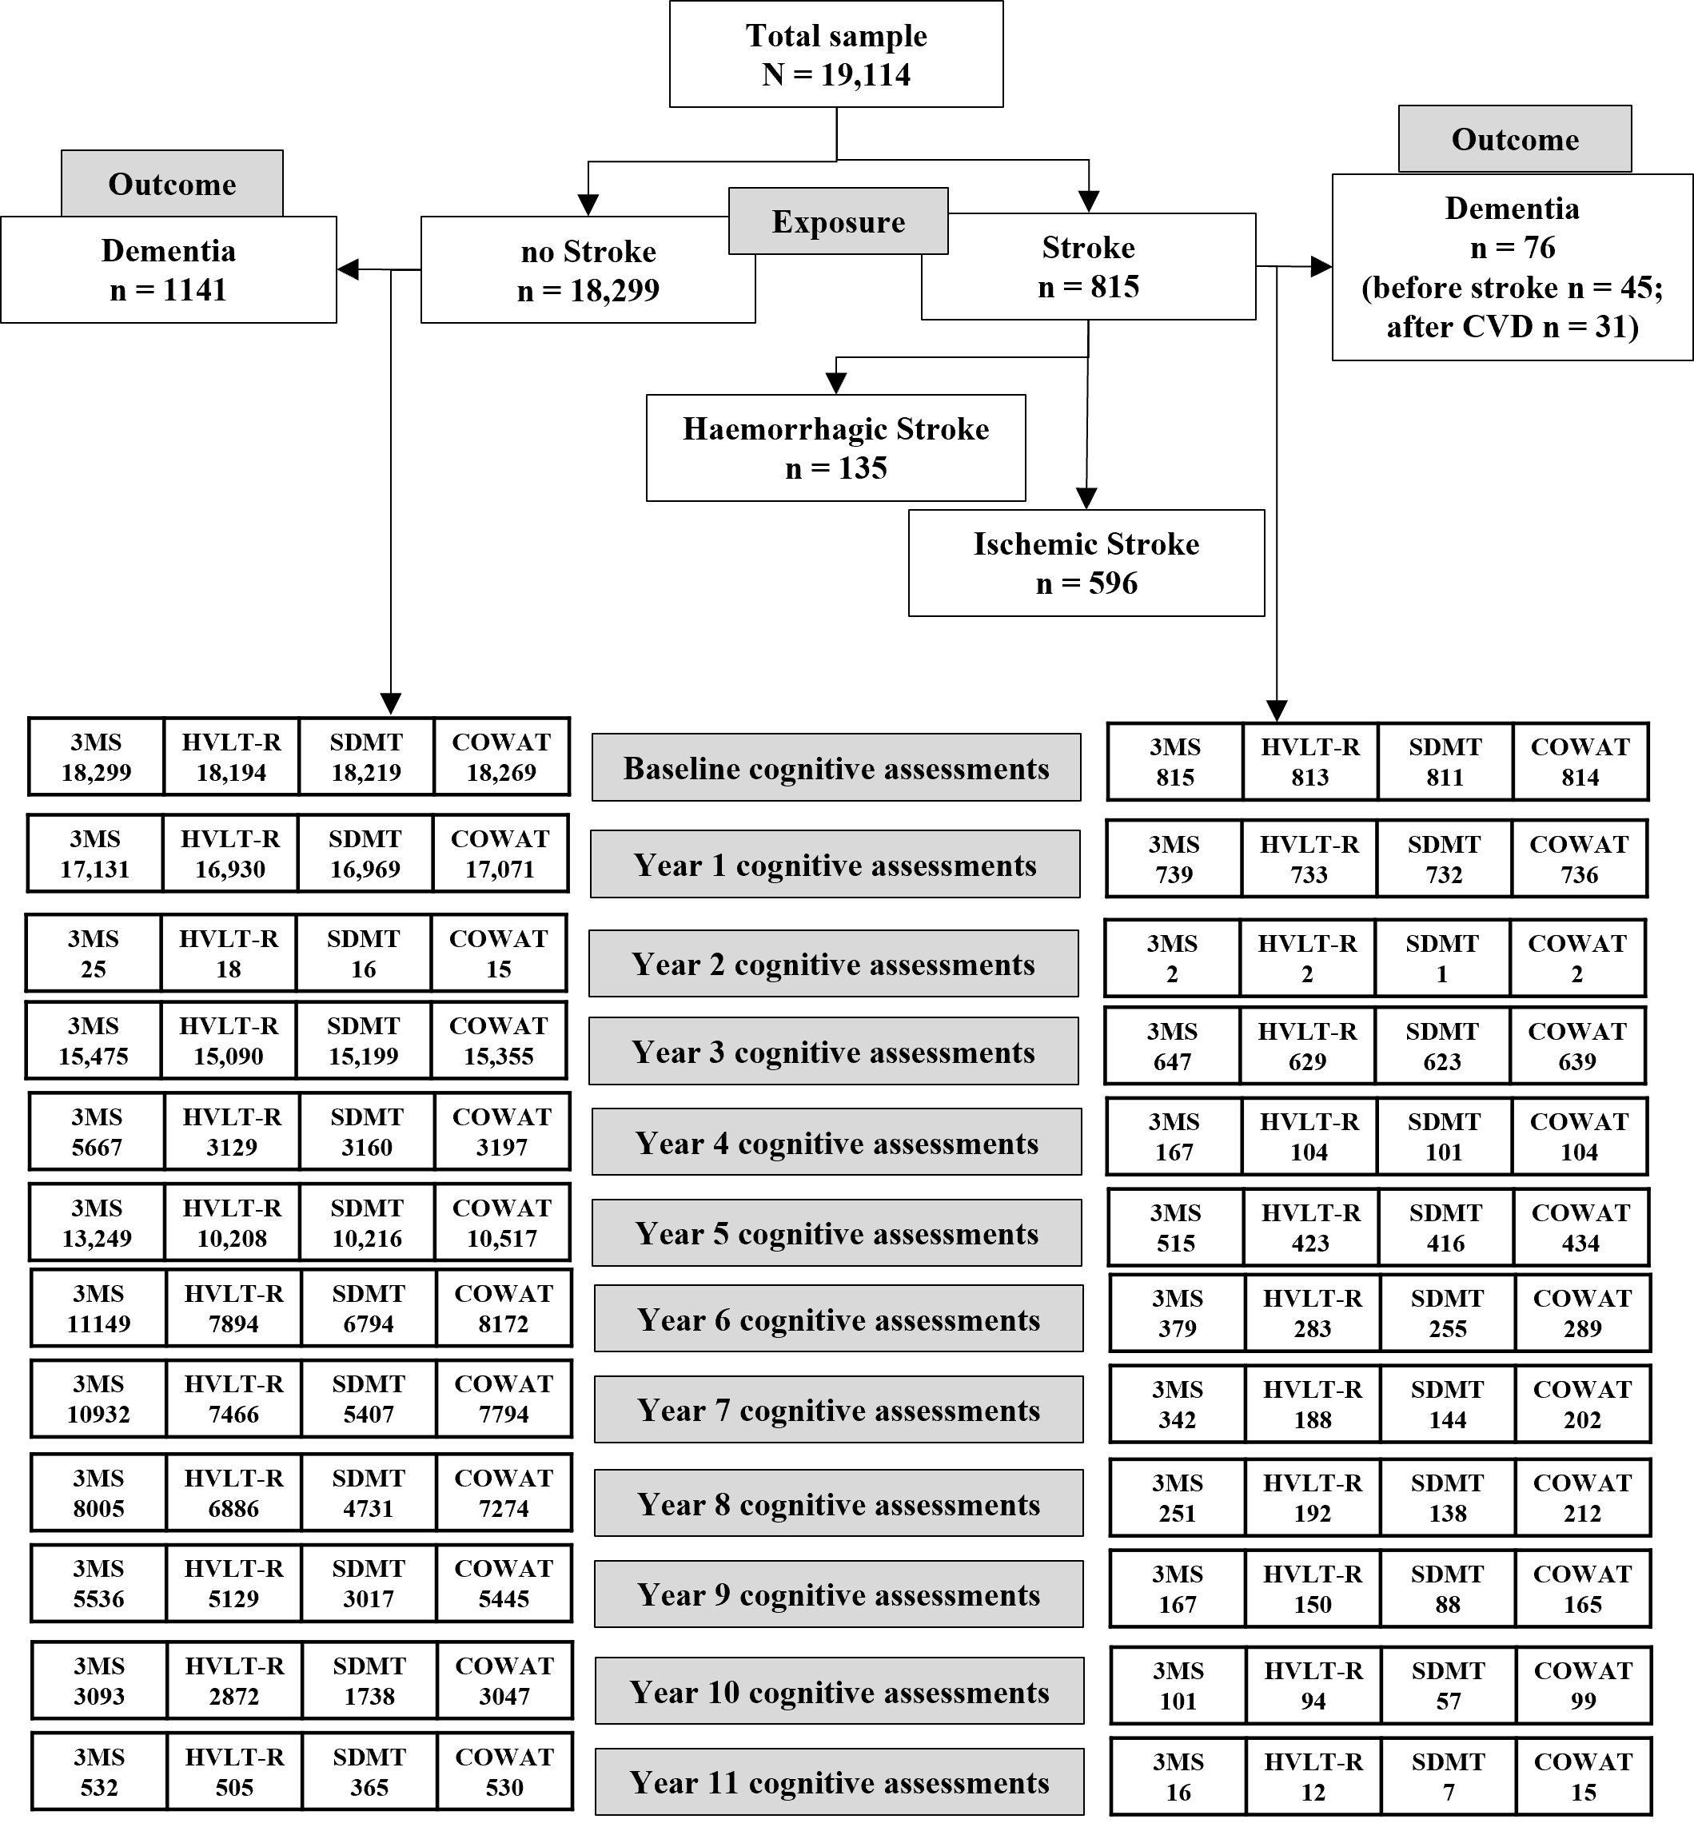
SF1. Participant flow diagram

