WB Bands
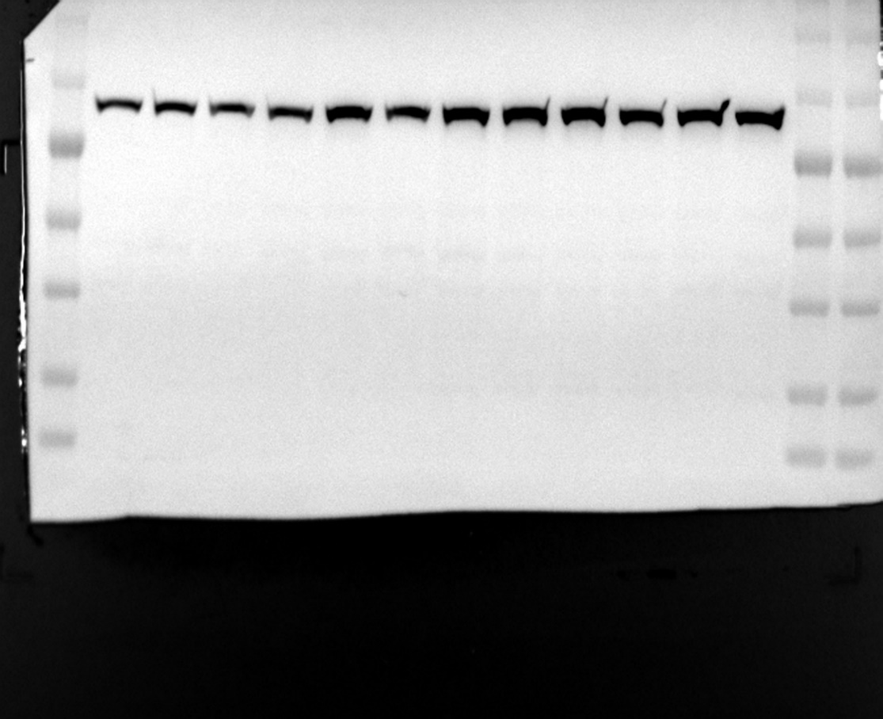
Figure 3A VPS35 90 kDa

VPS35 90 kDa
150 kDa
100 kDa
70 kDa
55 kDa
40 kDa
25 kDa
150 kDa
100 kDa
70 kDa
55 kDa
40 kDa
25 kDa
15 kDa
15 kDa

Nor-TG
IHT-TG

Figure 3A β-actin 42 kDa
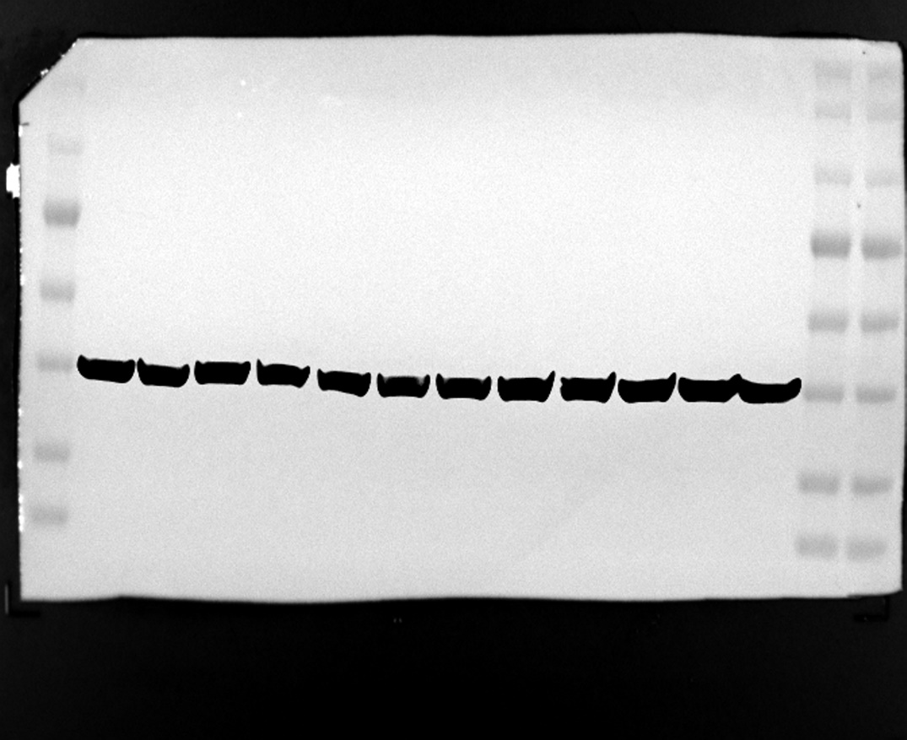
β-actin 42 kDa
150 kDa
100 kDa
70 kDa
55 kDa
40 kDa
25 kDa
150 kDa
100 kDa
70 kDa
55 kDa
40 kDa
25 kDa
15 kDa
15 kDa

Nor-TG
IHT-TG
180 kDa

Nor-TG
IHT-TG

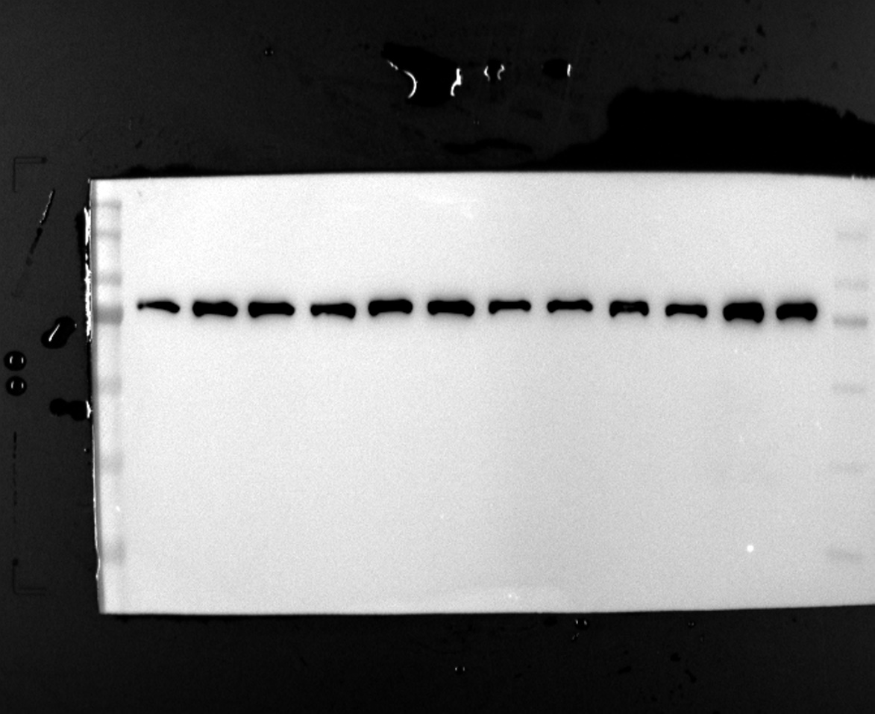
Figure 3H VPS35 90 kDa
150 kDa
180 kDa
100 kDa
150 kDa
100 kDa
70 kDa
70 kDa
55 kDa
55 kDa
40 kDa
40 kDa
25 kDa
25 kDa

VPS35 90 kDa
Nor oAβ IHT IHT+oAβ

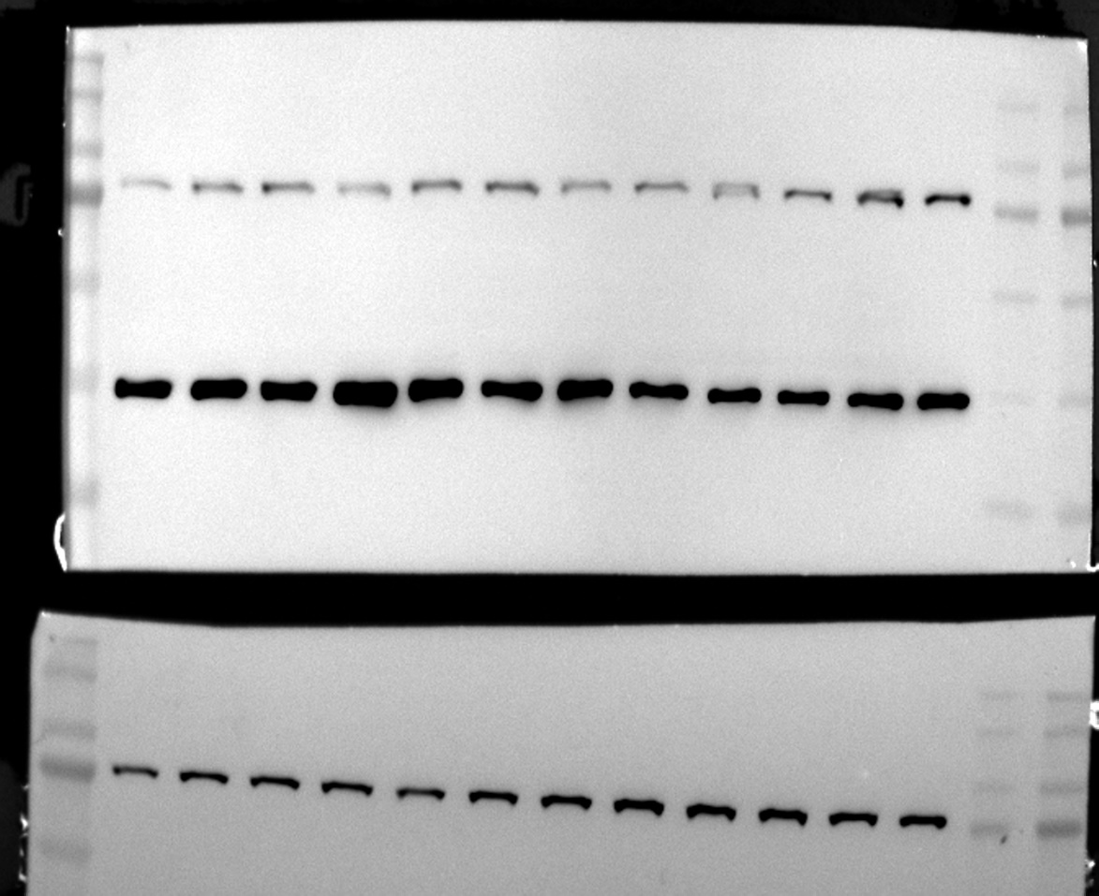
Figure 3H β-actin 42 kDa

β-actin 42 kDa
Nor oAβ IHT IHT+oAβ
150 kDa
100 kDa
70 kDa
55 kDa
40 kDa
25 kDa
180 kDa
150 kDa
100 kDa
70 kDa
55 kDa
40 kDa
25 kDa

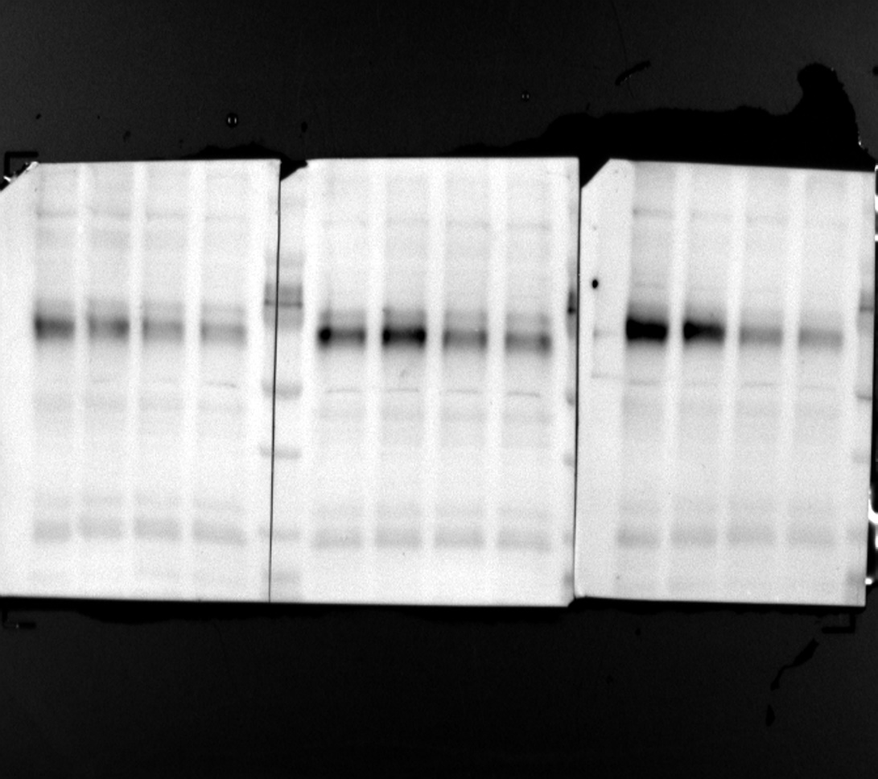
Figure 8E TFEB 65kDa

TFEB 65 kDa
Nor IHT sh IHT-sh
100 kDa
70 kDa
55 kDa
40 kDa
25 kDa
130 kDa
180 kDa
100 kDa
70 kDa
55 kDa
40 kDa
25 kDa
130 kDa
180 kDa

Figure 8E VPS35 90kDa
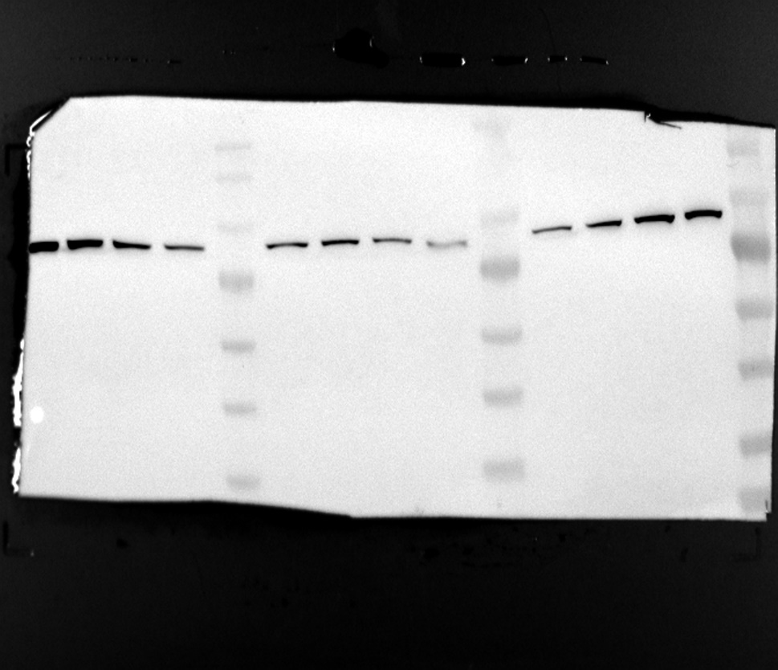
100 kDa
70 kDa
55 kDa
40 kDa

VPS35 90 kDa
Nor IHT sh IHT-sh
25 kDa
130 kDa
180 kDa
100 kDa
70 kDa
55 kDa
40 kDa
25 kDa
130 kDa
180 kDa

Figure 8E β-actin 42kDa
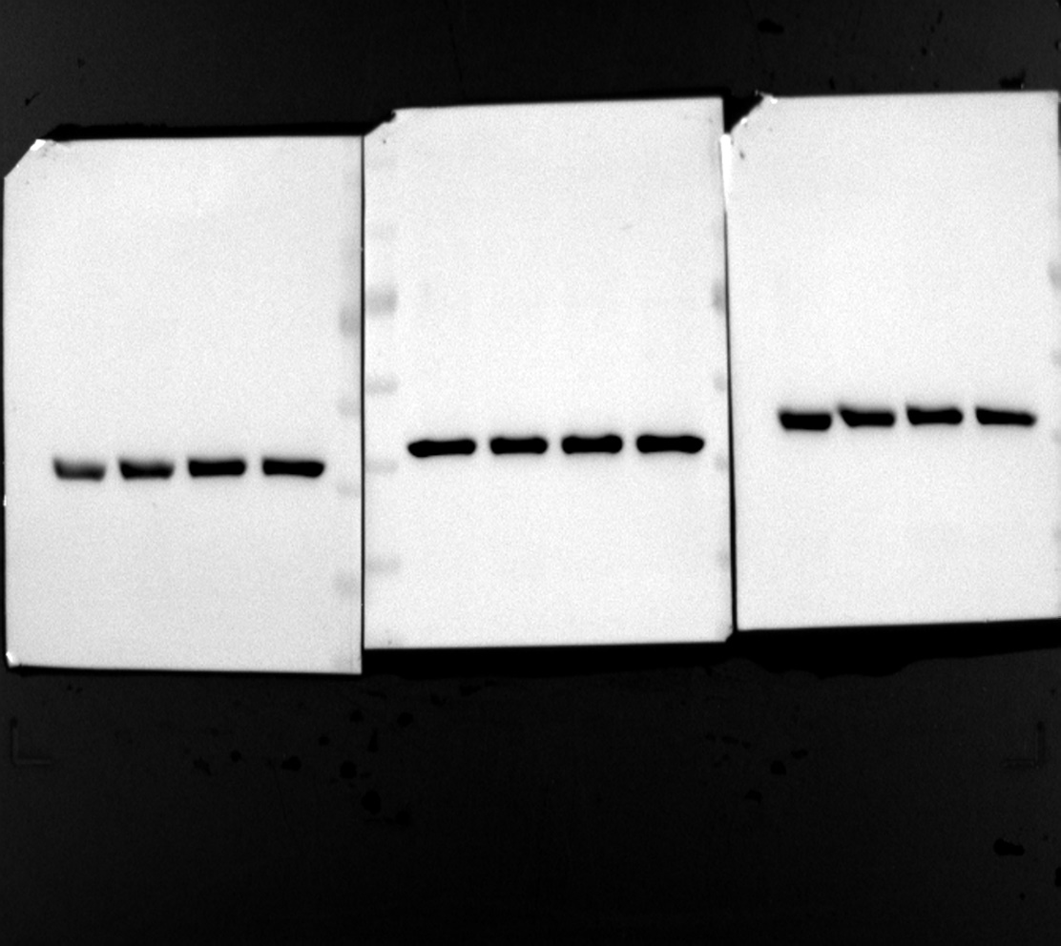
100 kDa
70 kDa
55 kDa
40 kDa
25 kDa
130 kDa
180 kDa
100 kDa
70 kDa
55 kDa
40 kDa
25 kDa
130 kDa
180 kDa

β-actin 42 kDa
Nor IHT sh IHT-sh

Agarose gel electropherogram
Figure 7B

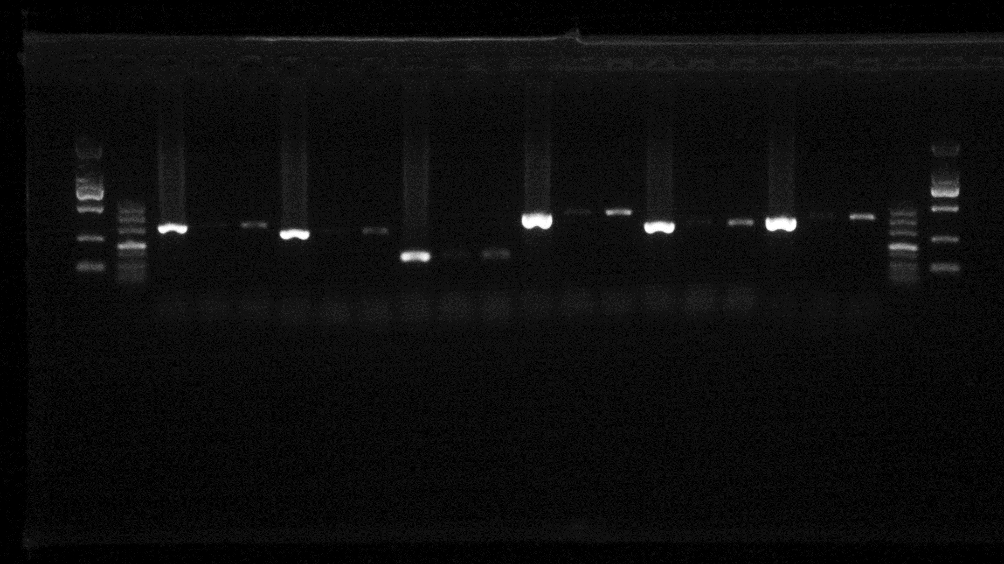
Marker
Marker
Marker
Marker
500 bp
200 bp
100 bp
500 bp
200 bp
100 bp
Input
IgG
TFEB
Input
IgG
TFEB
Input
IgG
TFEB
Input
IgG
TFEB
Input
IgG
TFEB
Input
IgG
TFEB
①
②
③
④
⑤
⑥
① mVps35(-146/165) 311 bp
② mVps35(-155/118) 273 bp
③ mVps35(148/278) 131 bp
④ mVps35(96/504) 409 bp
⑤ mVps35(341/660) 320 bp
⑥ mVps35(347/713) 367bp
TFEB potential binding site (-3/7)
TFEB potential binding site (204/213)
TFEB potential binding site (628/637)

