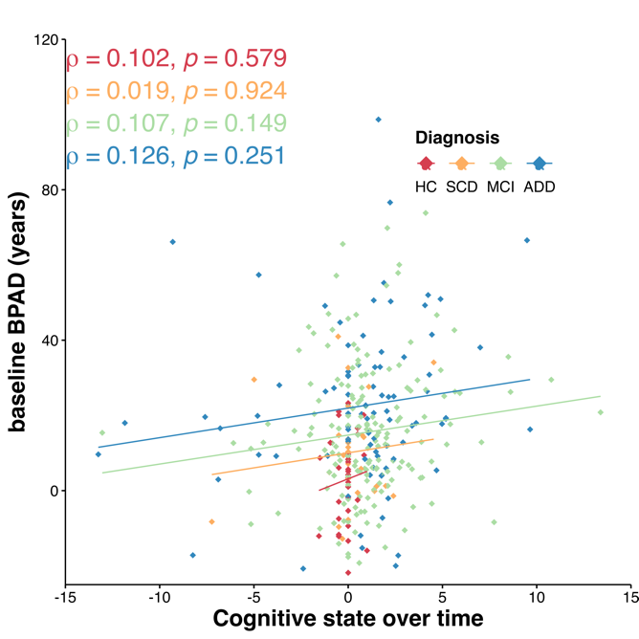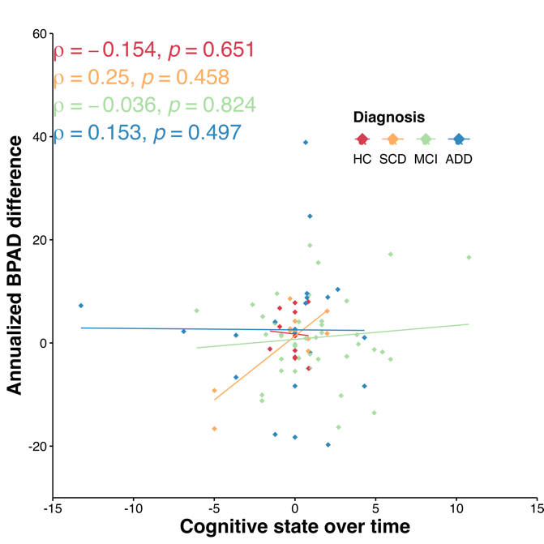
Supplementary Material 2: BPAD and cognitive state over time. left) baseline BPAD vs. cognitive state over time right) Annualized BPAD difference vs. cognitive state over time. Cognitively healthy controls, HC. Subjective cognitive decline subjects; SCD. Mild cognitive impairment patients; MCI. Alzheimer disease dementia patients; ADD. Brain predicted age difference; BPAD. The cognitive state over time (read. yearly difference in Mini Mental State Examination (MMSE)) was calculated by subtracting the follow-up (FU) MMSE score from the baseline (BL) MMSE and dividing it by the time between BL and FU in years. All diagnostic groups are visualized (HC in red, SCD in orange, MCI in green, and ADD in blue).

