Supplementary Material

Supplementary eTable 1. Non-significant predictors of future memory function.
Baseline Predictor | Univariate modelª | Basic model^{b}
 | β (95% CI) | β (95% CI)
Carotid stenosis | -0.14 (-0.21 – -0.08)*** | -0.04 (-0.11 – 0.03)
Hypertension (yes/no) | -0.14 (-0.25– -0.04)** | -0.10 (-0.20 – 0.01)
LDL-C | -0.06 (-0.09 – -0.02)** | -0.01 (-0.05 –0.03)
Physical activity (METh/week) | -0.02 (-0.13 – 0.09) | 0.01 (-0.02 – 0.04)
Prevalent or incident stroke | -0.25 (-0.39 – -0.12)*** | -0.13 (-0.26 – 0.00)
Smoking (never smoker as reference)  Smoker  Former smoker | 0.04 (-0.05 – 0.13)  -0.06 (-0.14 – 0.02) | 0.00 (-0.09 – 0.10)  -0.04 (-0.13 – 0.04)
ª Including only the predictor time between baseline and follow-up.
^{b} Including the predictor adjusted for age, sex, education, time between baseline and follow-up and prevalent or incident stroke.
* p<0.05, ** p<0.01, *** p<0.001

Supplementary eTable 2. Non-significant predictors of future attention/executive function.
Baseline Predictor | Univariate model ª | Basic model ^{b}
 | β (95% CI) | β (95% CI)
APOE-genotype  ɛ3/ɛ3  ɛ2/ɛ2 or ɛ2/ ɛ3  ɛ2/ɛ4  ɛ3/ɛ4 or ɛ4/ɛ4 | Reference  -0.00 (-0.11 – 0.11)  -0.18 (-0.41 – 0.04)  -0.02 (-0.10 – 0.07) | Reference  0.02 (-0.09 – 0.13)  -0.11 (-0.34 – 0.12)  0.01 (-0.08 – 0.10)
Carotid stenosis | -0.10 (-0.16 – -0.03)** | -0.01 (-0.08 – 0.06)
LDL-C | -0.03 (-0.07 – 0.00) | 0.03 (-0.01 – 0.07)
Number of pack years (smoking) | -0.00 (-0.00 – 0.00) | 0.00 (-0.00 – 0.01)
Physical activity (METh/week) | -0.00 (-0.03 – 0.03) | -0.01 (-0.04 – 0.03)
Smoking  Never smoker  Smoker  Former smoker | Reference  -0.09 (-0.18 – 0.00)  -0.03 (-0.11 – 0.00) | Reference  -0.04 (-0.14 – -0.05)  -0.01 (-0.09 – 0.08)
Systolic blood pressure (z-scores) | 0.12 (0.08 – 0.15)*** | 0.03 (-0.01 – 0.07)
Triglycerides (z-scores) | 0.08 (0.03 – 0.12)*** | 0.02 (-0.02 – 0.06)
ª Including only the predictor time between baseline and follow-up.
^{b} Including the predictor adjusted for age, sex, education, time between baseline and follow-up and prevalent or incident stroke.
* p<0.05, ** p<0.01, *** p<0.001

Supplementary eTable 3. Interaction effects with APOE-genotype.

Baseline Predictor | Memory function | Attention/Executive function
 | β (95% CI) ª | β (95% CI) ª
Alcohol consumption ^{b}  Q1 (0-0.23 standard drinks/day)  Q2 (0.24-0.56 standard drinks/day)  ɛ2/ɛ2 or ɛ2/ ɛ3  ɛ2/ɛ4  ɛ3/ɛ4 or ɛ4/ɛ4  Q3 (0.57-1.01 standard drinks/day)  ɛ2/ɛ2 or ɛ2/ ɛ3  ɛ2/ɛ4  ɛ3/ɛ4 or ɛ4/ɛ4  Q4 (1.02-7.5 standard drinks/day)  ɛ2/ɛ2 or ɛ2/ ɛ3  ɛ2/ɛ4  ɛ3/ɛ4 or ɛ4/ɛ4 | Reference  0.28 (-0.05 – 0.61)  0.76 (0.08 – 1.43)  0.21 (-0.05 – 0.46)  0.39 (0.07 – 0.71)  0.37 (-0.23 – 0.98)  0.24 (-0.02 – 0.49)  0.28 (-0.04 – 0.61)  0.59 (-0.10 – 1.28)  0.18 (-0.06 – 0.43) | Reference  0.41 (0.09 – 0.74)*  0.33 (-0.34 – 0.99)  0.32 (0.07 – 0.58)*  0.38 (0.06 – 0.70)*  0.38 (-0.22 – 0.98)  0.35 (0.10 – 0.60)**  0.30 (-0.02 – 0.62)  0.06 (-0.22 – 0.98)  0.24 (0.00 – 0.49)*
BMI (z-scores)  ɛ2/ɛ2 or ɛ2/ ɛ3  ɛ2/ɛ4  ɛ3/ɛ4 or ɛ4/ɛ4 | 0.02 (-0.09 – 0.13)  0.01 (-0.20 – 0.22)  0.06 (-0.03 – 0.15) | 0.00 (-0.11 – 0.11)  0.01 (-0.20 – 0.22)  -0.09 (-0.18 – -0.01)*
Education  ≤8 years  9-12 years  ɛ2/ɛ2 or ɛ2/ ɛ3  ɛ2/ɛ4  ɛ3/ɛ4 or ɛ4/ɛ4  >12 years  ɛ2/ɛ2 or ɛ2/ ɛ3  ɛ2/ɛ4  ɛ3/ɛ4 or ɛ4/ɛ4 | Reference  -0.10 (-0.35 – 0.15)  0.39 (-0.15 – 0.24)  -0.06 (-0.26 – 0.14)  -0.07 (-0.37 – 0.24)  0.10 (-0.56 – 0.76)  -0.26 (-0.48 – -0.03)* | Reference  0.17 (-0.01 – 0.60)  0.17 (-0.36 – 0.70)  0.09 (-0.10 – 0.29)  0.30 (-0.01 – 0.60)  -0.06 (-0.72 – 0.59)  -0.10 (-0.33 – 0.13)
HbA_{1c} (z-scores)  ɛ2/ɛ2 or ɛ2/ ɛ3  ɛ2/ɛ4  ɛ3/ɛ4 or ɛ4/ɛ4 | -0.02 (-0.14 – 0.11)  0.26 (-0.03 – 0.55)  -0.05 (-0.13 – 0.04) | -0.29 (-0.51 – -0.08)**  -0.62 (-1.18 –-0.06)*  -0.01 (-0.15 – 0.13)
HDL-C (z-scores)  ɛ2/ɛ2 or ɛ2/ ɛ3  ɛ2/ɛ4  ɛ3/ɛ4 or ɛ4/ɛ4 | 0.05 (-0.07 – 0.17)  0.25 (0.01 – 0.48)*  0.04 (-0.05 – 0.13) | 0.05 (-0.06 – 0.17)  -0.09 (-0.32 – 0.15)  -0.02 (-0.11 – 0.07)
Sex (0=male)  ɛ2/ɛ2 or ɛ2/ ɛ3  ɛ2/ɛ4  ɛ3/ɛ4 or ɛ4/ɛ4 | 0.11 (-0.12 – 0.34)  0.42 (-0.06 – 0.91)  -0.03 (-0.21 – 0.14) | -0.07 (-0.30 – 0.15)  -0.26 (-0.74 – 0.22)  -0.05 (-0.22 – 0.13)
Stroke (prevalent & incident)  ɛ2/ɛ2 or ɛ2/ ɛ3  ɛ2/ɛ4  ɛ3/ɛ4 or ɛ4/ɛ4 | -0.05 (-0.43 – 0.34)  -0.79 (-1.61 – 0.04)  -0.37 (-0.69 – -0.05)* | -0.20 (-0.58 – 0.19)  -0.32 (-1.14 – 0.51)  -0.40 (-0.72 – -0.08)*
See Supplementary Fig. 1-2 for visualization of interaction effects.
ª Model including the predictor, APOE-genotype and the interaction effect between the two, adjusted for age, sex, education, time between baseline and follow-up and prevalent or incident stroke.
^{b} Alcohol consumption in quartiles with lowest quartile as reference: Q1 = 0-0.23 standard drinks/day (0-3.37g/day); Q2 = 0.24-0.56 standard drinks/day (3.38- 7.83g/day); Q3: 0.57-1.01 standard drinks/day (7.84-15.2g/day); Q4 = 1.02-7.5 standard drinks/day, (15.3-105g/day).
* p<0.05, ** p<0.01, *** p<0.001
Supplementary eFigure 1. Significant interaction effects between predictors and APOE-genotype on memory function.
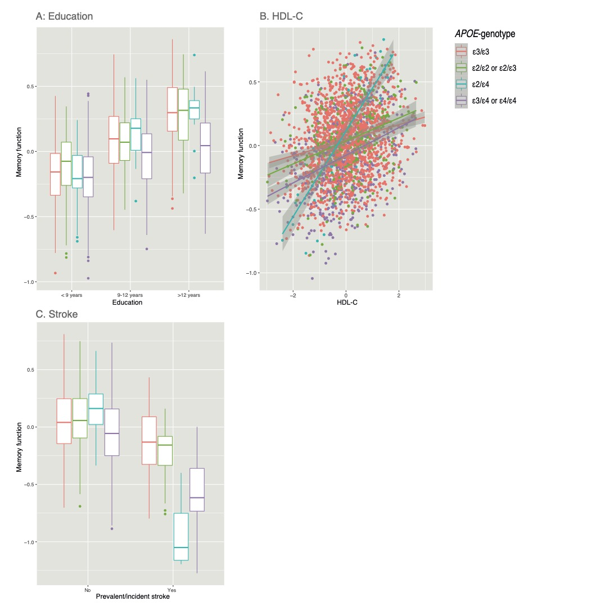
Supplementary eFigure 2. Significant interaction effects between predictors and APOE-genotype on attention/executive function.

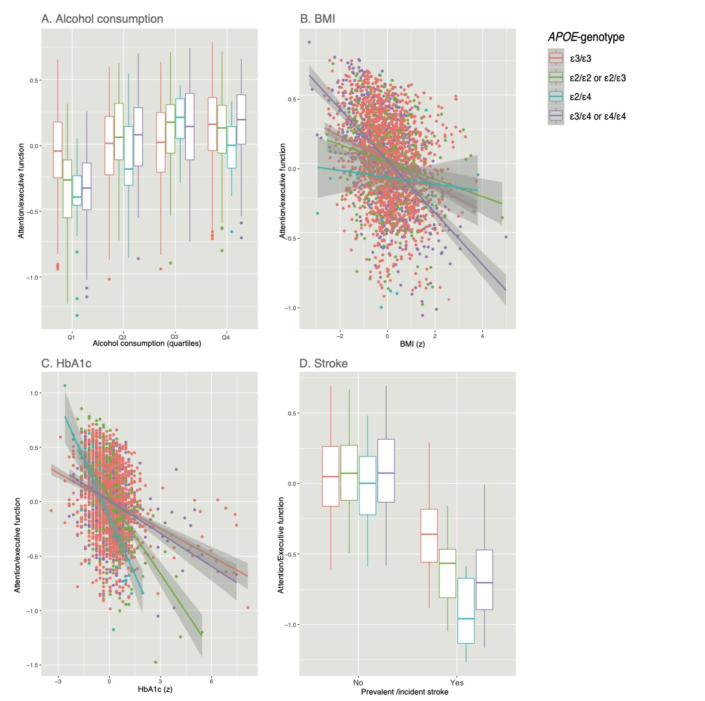

Supplementary eTable 4. Alcohol consumption sensitivity analyses.
Baseline Predictor | Basic model ª (Memory, MMSE) | Multivariable model ^{b} (Memory, MMSE) | Basic model ª (Executive function, AQT) | Multivariable model ^{c} (Executive, AQT)
 | β (95% CI) | β (95% CI) | β (95% CI) | β (95% CI)
Excluding participants with zero alcohol comsumption
Alcohol consumption ^{d}  Q1 (≤0.23 standard drinks/day)  Q2 (0.24-0.56 standard drinks/day)  Q3 (0.57-1.01 standard drinks/day)  Q4 (≥1.02 standard drinks/day) | Reference  0.05 (-0.07 – 0.18)  0.10 (-0.03 – 0,22)  0.09 (-0.04 – 0.22) | Reference  0.07 (-0.06 – 0.20)  0.09 (-0.04 – 0.22)  0.10 (-0.04 –0.23) | Reference  0.15 (0.03 – 0.27)*  0.17 (0.05 – 0.30)**  0.25 (0.13 – 0.38)*** | Reference  0.13 (0.00 – 0.26)*  0.15 (0.02 – 0.28)*  0.22 (0.08 – 0.35)**
Lancet Commission(5) cutoff for suggested increased risk of dementia
Alcohol >1.7 standard drinks/day | -0.06 (-0.18 – 0.06) | -0.01 (-0.14 – 0.12) | 0.13 (0.01 – 0.25)* | 0.11 (-0.01 – 0.24)
Alcohol >1.7 standard drinks/day (excluding zero consumers) | -0.07 (-0.19 – 0.05) | -0.03 (-0.16 – 0.10) | 0.11 (-0.01 – 0.23) | 0.09 (-0.03 – 0.22)

ª Model including the predictor adjusted for age, sex, education, time between baseline and follow-up and prevalent or incident stroke.
^{b} One model combining all significant predictors from the basic models (Table 2), adjusted for age, sex, education, time between baseline and follow-up, prevalent or incident stroke and blood lipid lowering medication.
^{c} One model combining all significant predictors from the basic models (Table 3), adjusted for age, sex, education, time between baseline and follow-up and blood lipid lowering medication.
^{d} Alcohol consumption in quartiles with lowest quartile as reference: Q1 ≤0.23 standard drinks/day (0-3.37g/day); Q2 = 0.24-0.56 standard drinks/day (3.38- 7.83g/day); Q3: 0.57-1.01 standard drinks/day (7.84-15.2g/day); Q4 ≥1.02 standard drinks/day, (≥15.3g/day).
* p<0.05, ** p<0.01, *** p<0.001
Predictors ª | Odds Ratios | 95 % CI | p
Age | 0.63 | 0.58 – 0.68 | <0.001
Alcohol consumption ^{b}  Q1 0-0.23 standard drinks/day  Q2 (0.24-0.56 standard drinks /day)  Q3 (0.57-1.01 standard drinks/day)  Q4 (1.02-7.5 standard drinks/day) | Reference  1.74  1.92  1.82 | Reference  1.42 – 2.14  1.55 – 2.38  1.46 – 2.27 | Reference  <0.001  <0.001  <0.001
APOE genotype  ɛ3/ɛ3  ɛ2/ɛ2 or ɛ2/ ɛ3  ɛ2/ɛ4  ɛ3/ɛ4 or ɛ4/ɛ4 | Reference  1.13  0.66  0.88 | Reference  0.90 – 1.41  0.44 – 1.01  0.74 – 1.03 | Reference  0.298  0.052  0.118
BMI | 0.97 | 0.90 – 1.04 | 0.372
Cholesterol | 1.05 | 0.98 – 1.13 | 0.192
Education  ≤8 years  9-12 years  >12 years | Reference  1.20  1.23 | Reference  1.02 – 1.41  1.01 – 1.50 | Reference  0.027  0.039
HbA_{1c} | 0.81 | 0.75 – 0.87 | <0.001
Hypertension | 0.74 | 0.64 – 0.86 | <0.001
Sex (0=male, 1=female) | 1.18 | 1.01 – 1.38 | 0.036
Stroke | 0.62 | 0.51 – 0.77 | <0.001
Supplementary eTable 5. Predictors of attending the follow-up visit.

This analysis was performed on n=6,103 participants including both the sample used in the present study (n=3,229) and those that did not attend the follow-up visit, but had data from the baseline visit (n=2,369).
ª All continuous variables as z-scores (i.e, not alcohol, APOE, education, hypertension, sex and stroke). One model combining all predictors.
^{b} Alcohol consumption in quartiles with lowest quartile as reference: Q1 = 0-0.23 standard drinks/day (0-3.37g/day); Q2 = 0.24-0.56 standard drinks/day (3.38- 7.83g/day); Q3: 0.57-1.01 standard drinks/day (7.84-15.2g/day); Q4 = 1.02-7.5 standard drinks/day, (15.3-105g/day).

REFERENCES

1. Livingston G, Huntley J, Sommerlad A, et al. Dementia prevention, intervention, and care: 2020 report of the Lancet Commission. Lancet 2020;396:413-446.

