SUPPLEMENTARY MATERIAL
Supplementary Text 1: Cognitively unimpaired participants in the SPIN cohort.
Asymptomatic volunteers are an extremely relevant group in the SPIN cohort. Volunteers are usually spouses or children of patients that are informed about our studies at the outpatient clinics of the Sant Pau Memory Unit. Volunteers can also learn about our projects through talks, our website (https://santpaumemoryunit.com) or social media (@SantPauMemory). All volunteers receive an initial consultation with a neurologist in which the SPIN protocol is explained in detail, inclusion/exclusion criteria are reviewed and informed consent is signed. More information about the evaluation protocol in cognitively normal participants of the SPIN cohort can be found in Alcolea et al. Alzheimer’s Dement (NY) 2019. Five out of the 66 cognitively unimpaired participants included in this study had subjective cognitive decline but full neuropsychological tests within normal range.

Supplementary Table 1: Demographics according to clinical diagnosis
Unless otherwise specified, quantitative measures are presented as mean (SD).
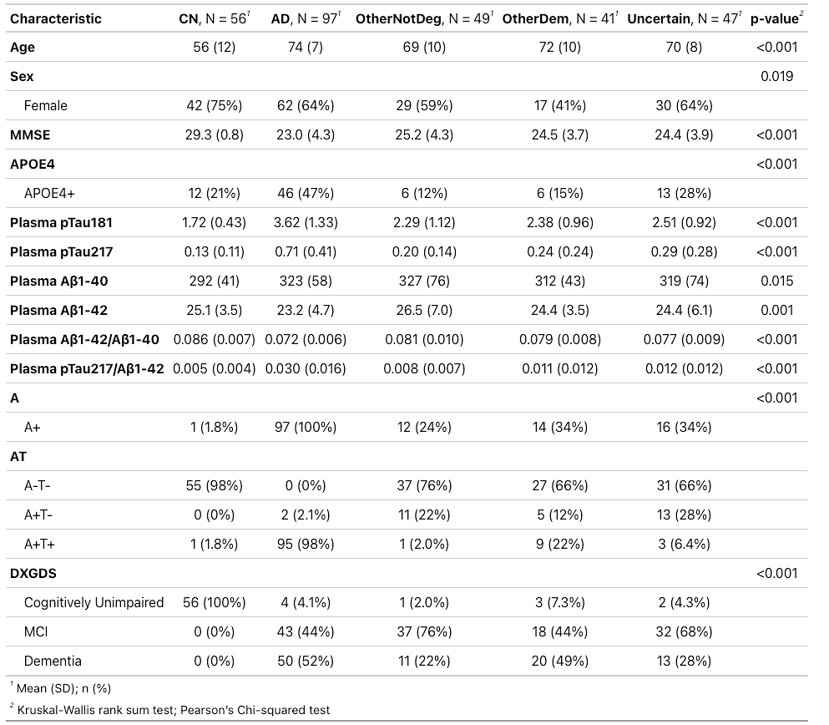
pTau₂₁₇, phosphorylated tau 217, pTau₁₈₁, phosphorylated tau 181. Aβ_{1–42}, Amyloid β_{1–42}. Aβ_{1–40}, Amyloid β_{1–40}. CU, cognitively unimpaired. OtherDem, other dementias. OtherNotDeg, not degenerative dementias.
Kruskal-Wallis rank sum test was used to compare continuous variables that were not normally distributed; Pearson’s Chi-squared test was used to compare categorical variables.
*Cognitively unimpaired etiologies: cognitively normal/healthy controls (n=56), other not neurodegenerative (n=1), preclinical AD stage 1 (n=2), preclinical AD stage 2 (n=2), Uncertain etiology (n=2), Vascular (n=3).

Supplementary Table 2: Demographics according to A status
Unless otherwise specified, quantitative measures are presented as mean (SD).
pTau₂₁₇, phosphorylated tau 217, pTau₁₈₁, phosphorylated tau 181. Aβ_{1–42}, Amyloid β_{1–42}. Aβ_{1–40}, Amyloid β_{1–40}. CU, cognitively unimpaired. OtherDem, other dementias. OtherNotDeg, not degenerative dementias.
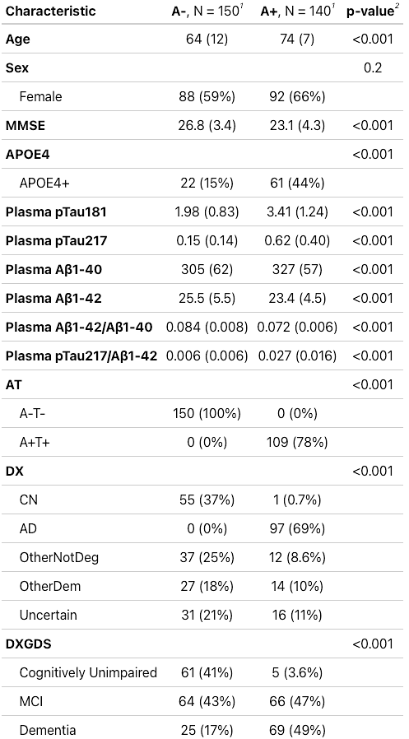


Wilcoxon rank sum test was used to compare continuous variables that were not normally distributed; Pearson’s Chi-squared test was used to compare categorical variables.

Supplementary Table 3: Inter-assay coefficients of variations of plasma biomarkers measured with the LUMIPULSE platform.
Analyte | Low Concentration CV (%) | Low Concentration (pg/mL) | High Concentration CV (%) | High Concentration (pg/mL)
pTau₂₁₇ | 4.5 | 0.58 | 5.7 | 4.59
pTau₁₈₁ | 4.6 | 5 | 4.1 | 45
Aβ_{1–42} | 5.7 | 21 | 6.6 | 209
Aβ_{1–40} | 5.5 | 214 | 6.7 | 2243
pTau₂₁₇, phosphorylated tau 217, pTau₁₈₁, phosphorylated tau 181. Aβ_{1–42}, Amyloid β_{1–42}. Aβ_{1–40}, Amyloid β_{1–40}. CV, coefficient of variation.

Supplementary Table 4: Comparison of plasma biomarkers’ accuracy using DeLong test adjusted by multiple comparisons
Contrast | Biomarker 1 | AUC1 | Biomarker 2 | AUC2 | P value (unadjusted) | P value (Bonferroni-adjusted)
A- vs. A+ | pTau₂₁₇ | 0.94 | pTau₁₈₁ | 0.88 | 4.5111E-05 | <0.05 (comp.mult)
A- vs. A+ | pTau₂₁₇ | 0.94 | pTau₂₁₇/Aβ_{1–42} | 0.95 | 0.0434699 | ns
A- vs. A+ | pTau₂₁₇ | 0.94 | Aβ_{1–42}/Aβ_{1–40} | 0.88 | 0.008582 | ns
A- vs. A+ | pTau₂₁₇ | 0.94 | Age+Sex+ APOEε4 | 0.84 | 5.9871E-05 | <0.05 (comp.mult)
A- vs. A+ | pTau₂₁₇ | 0.94 | Age+Sex+ APOEε4+pTau₂₁₇ | 0.96 | 0.00468322 | ns
A- vs. A+ | pTau₁₈₁ | 0.88 | pTau₂₁₇/Aβ_{1–42} | 0.95 | 9.3803E-06 | <0.05 (comp.mult)
A- vs. A+ | pTau₁₈₁ | 0.88 | Aβ_{1–42}/Aβ_{1–40} | 0.88 | 0.99792624 | ns
A- vs. A+ | pTau₁₈₁ | 0.88 | Age+Sex+ APOEε4 | 0.84 | 0.16609191 | ns
A- vs. A+ | pTau₁₈₁ | 0.88 | Age+Sex+ APOEε4+pTau₂₁₇ | 0.96 | 1.3124E-06 | <0.05 (comp.mult)
A- vs. A+ | pTau₂₁₇/Aβ_{1–42} | 0.95 | Aβ_{1–42}/Aβ_{1–40} | 0.88 | 0.00197812 | <0.05 (comp.mult)
A- vs. A+ | pTau₂₁₇/Aβ_{1–42} | 0.95 | Age+Sex+ APOEε4 | 0.84 | 1.0157E-05 | <0.05 (comp.mult)
A- vs. A+ | pTau₂₁₇/Aβ_{1–42} | 0.95 | Age+Sex+ APOEε4+pTau₂₁₇ | 0.96 | 0.09589594 | ns
A- vs. A+ | Aβ_{1–42}/Aβ_{1–40} | 0.88 | Age+Sex+ APOEε4 | 0.84 | 0.14280983 | ns
A- vs. A+ | Aβ_{1–42}/Aβ_{1–40} | 0.88 | Age+Sex+ APOEε4+pTau₂₁₇ | 0.96 | 0.00023526 | <0.05 (comp.mult)
A- vs. A+ | Age+Sex+APOEε4 | 0.84 | Age+Sex+ APOEε4+pTau₂₁₇ | 0.96 | 2.3492E-08 | <0.05 (comp.mult)
AD plasma biomarkers and their combinations that better discriminate A+ from A-. We included those with AUC >0.80 and p<0.05. pTau₂₁₇, phosphorylated tau 217, pTau₁₈₁, phosphorylated tau 181. Aβ_{1–42}, Amyloid β_{1–42}. Aβ_{1–40}, Amyloid β_{1–40}.

Supplementary Table 5: Plasma pTau217 accuracy to detect A positivity stratifying by cognitive status and age using the cutoff with a fixed sensititivy of 95%
MCI, mild cognitive impairment. S, sensitivity; Sp, specificity; NPV, negative predictive value; PPV, positive predictive value. pTau₂₁₇, phosphorylated tau 217.
The small number of participants with age under 60 and above 80 might alter accuracy performance for these age ranges due to potential overfitting of cutoffs in these subgroups.
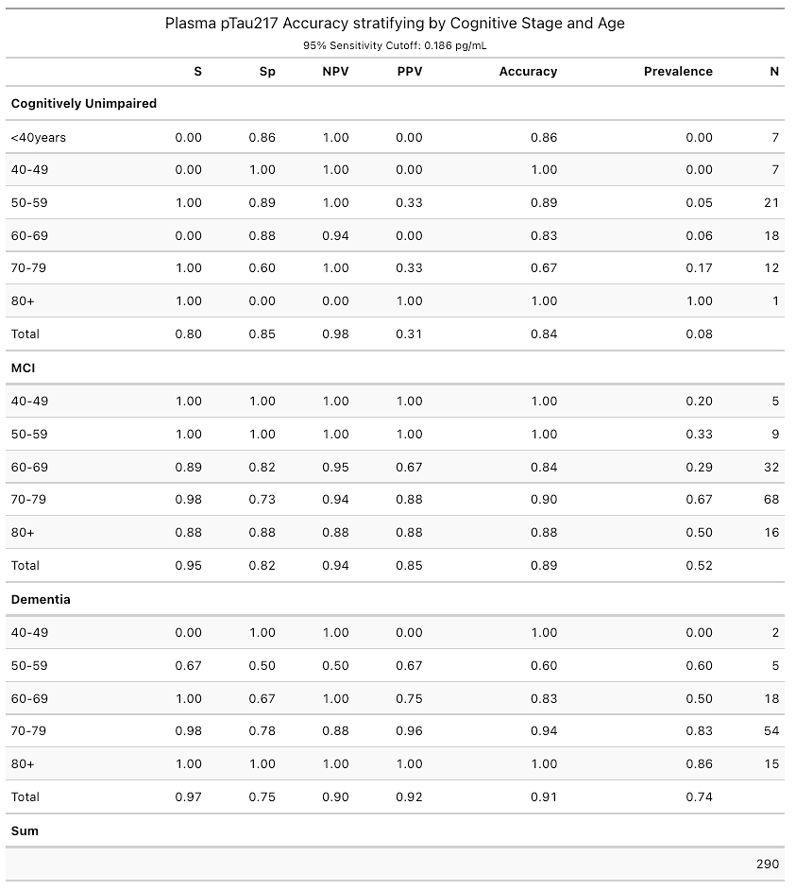
Supplementary Table 6: Plasma pTau217 accuracy to detect A positivity stratifying by cognitive status and age using a cutoff with a fixed specificity of 95%
MCI, mild cognitive impairment. S, sensitivity; Sp, specificity; NPV, negative predictive value; PPV, positive predictive value. pTau₂₁₇, phosphorylated tau 217.
The small number of participants with age under 60 and above 80 might alter accuracy performance for these age ranges due to potential overfitting of cutoffs in these subgroups.
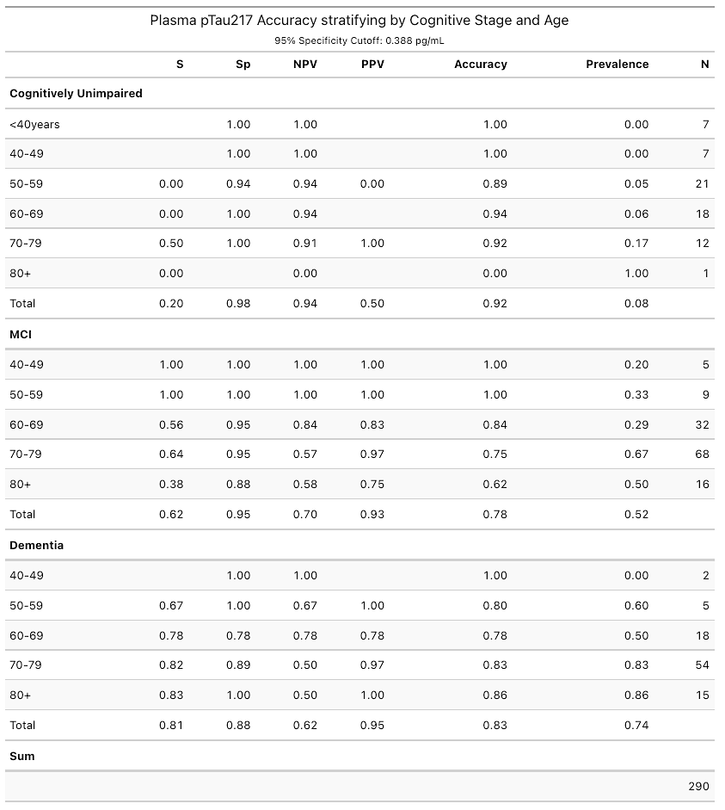

Supplementary Table 7: Plasma pTau₂₁₇ accuracy to detect A positivity stratifying by clinical diagnosis and age using a cutoff with a fixed sensitivity of 95%.
CN, cognitively unimpaired; MCI, mild cognitive impairment; AD, Alzheimer disease; OtherNotDeg, other not neurodegenerative; OtherDem, other dementias. S, sensitivity; Sp, specificity; NPV, negative predictive value; PPV, positive predictive value. pTau₂₁₇, phosphorylated tau 217.
The small number of participants with age under 60 and above 80 might alter accuracy performance for these age ranges due to potential overfitting of cutoffs in these subgroups.
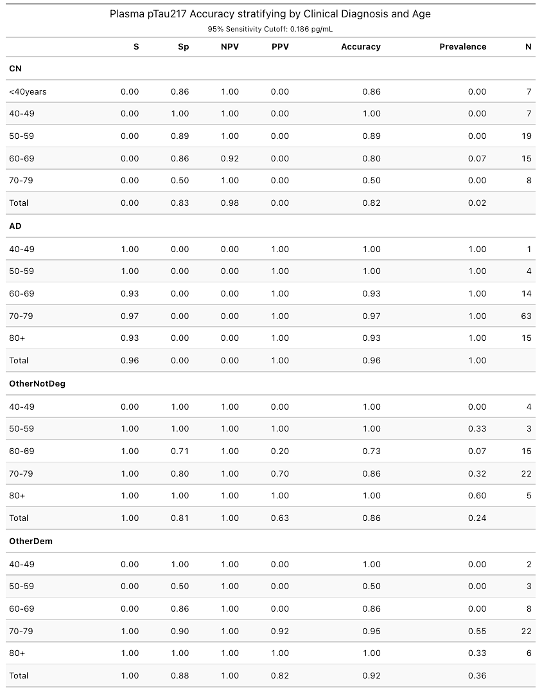
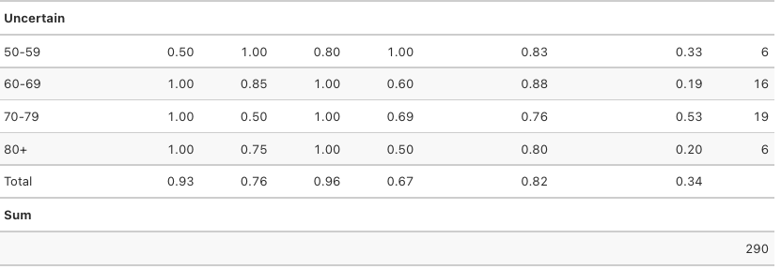

Supplementary Table 8: Plasma pTau217 accuracy to detect A positivity stratifying by clinical diagnosis and age using a cutoff with a fixed specificity of 95%
CN, cognitively unimpaired; MCI, mild cognitive impairment; AD, Alzheimer disease; OtherNotDeg, other not neurodegenerative; OtherDem, other dementias. S, sensitivity; Sp, specificity; NPV, negative predictive value; PPV, positive predictive value. pTau₂₁₇, phosphorylated tau 217.
The small number of participants with age under 60 and above 80 might alter accuracy performance for these age ranges due to potential overfitting of cutoffs in these subgroups
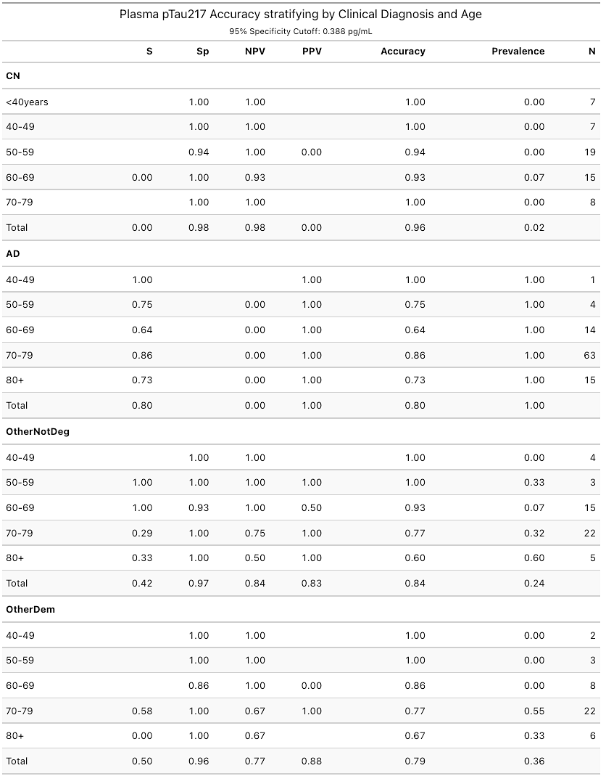
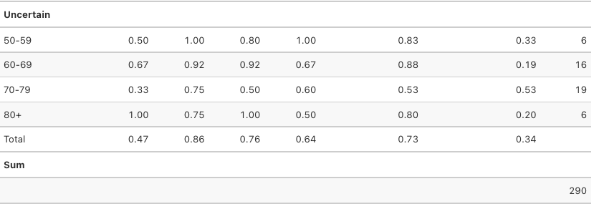

Supplementary Figure 1: Flowchart of study participants inclusion and exclusion criteria and sensitivity analysis
LP, lumbar puncture; AD, Alzheimer disease; GDS, global deterioration scale; CSF, cerebrospinal fluid; CU, cognitively unimpaired; MCI, mild cognitive impairment; MMSE, minimental state examination.
Supplementary Figure 2: Sensitivity analysis. Plasma Biomarker concentrations’ according the CSF amyloid status.

pTau₂₁₇, phosphorylated tau 217, pTau₁₈₁, phosphorylated tau 181. Aβ_{1–42}, Amyloid β_{1–42}. Aβ_{1–40}, Amyloid β_{1–40}. CU, cognitively unimpaired. MCI, mild cognitive impairment.
Plasma biomarkers Cohen’s d and Fold Change calculated in log-transformed data.

Supplementary Figure 3: Sensitivity analysis excluding participants close to the CSF Aβ_{1–42}/Aβ_{1–40} cutoff. Plasma Biomarkers Accuracy, ROC curves.

In this sensitivity analysis, participants with a CSF Aβ_{1–42}/Aβ_{1–40} value between 0.056 and 0.068 (0.062+/- 10%) were excluded.
pTau₂₁₇, phosphorylated tau 217, pTau₁₈₁, phosphorylated tau 181. Aβ_{1–42}, Amyloid β_{1–42}. Aβ_{1–40}, Amyloid β_{1–40}. CU, cognitively unimpaired. MCI, mild cognitive impairment.
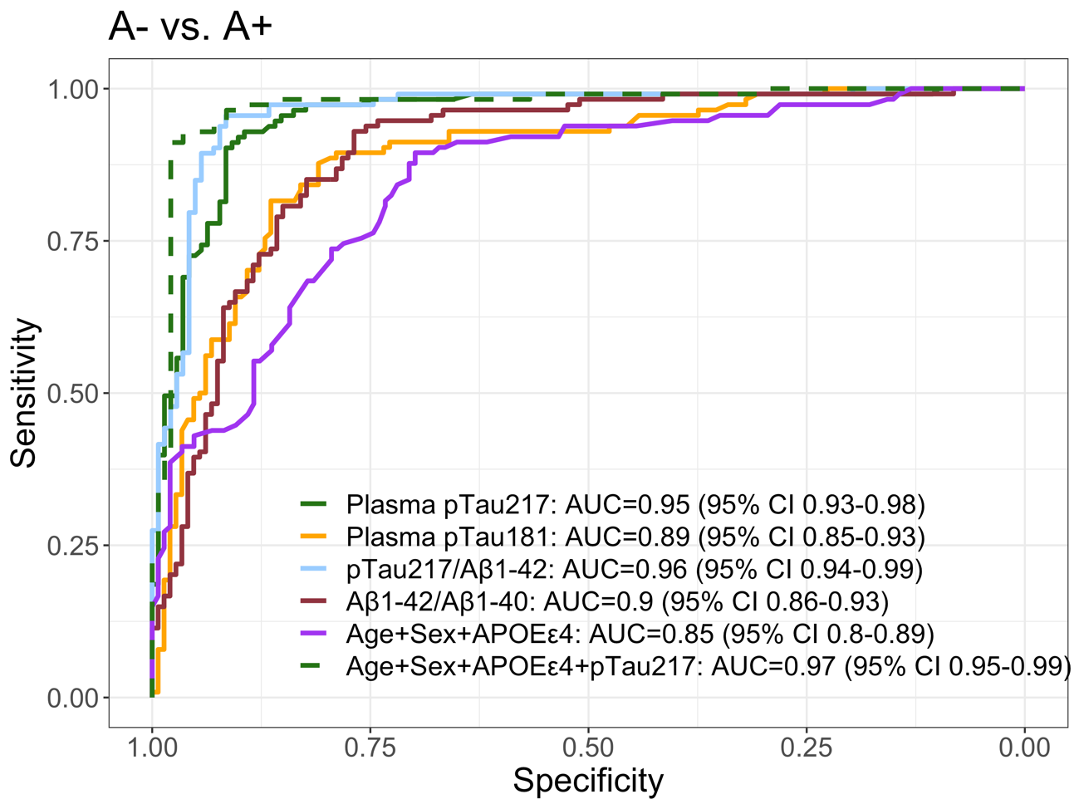

Supplementary Figure 4: Correlation maps by cognitive status

pTau₂₁₇, phosphorylated tau 217, pTau₁₈₁, phosphorylated tau 181. Aβ_{1–42}, Amyloid β_{1–42}. Aβ_{1–40}, Amyloid β_{1–40}. CU, cognitively unimpaired. MCI, mild cognitive impairment. Significance of the correlations was adjusted by multiple correlations (p-value adjusted by length of comparisons).
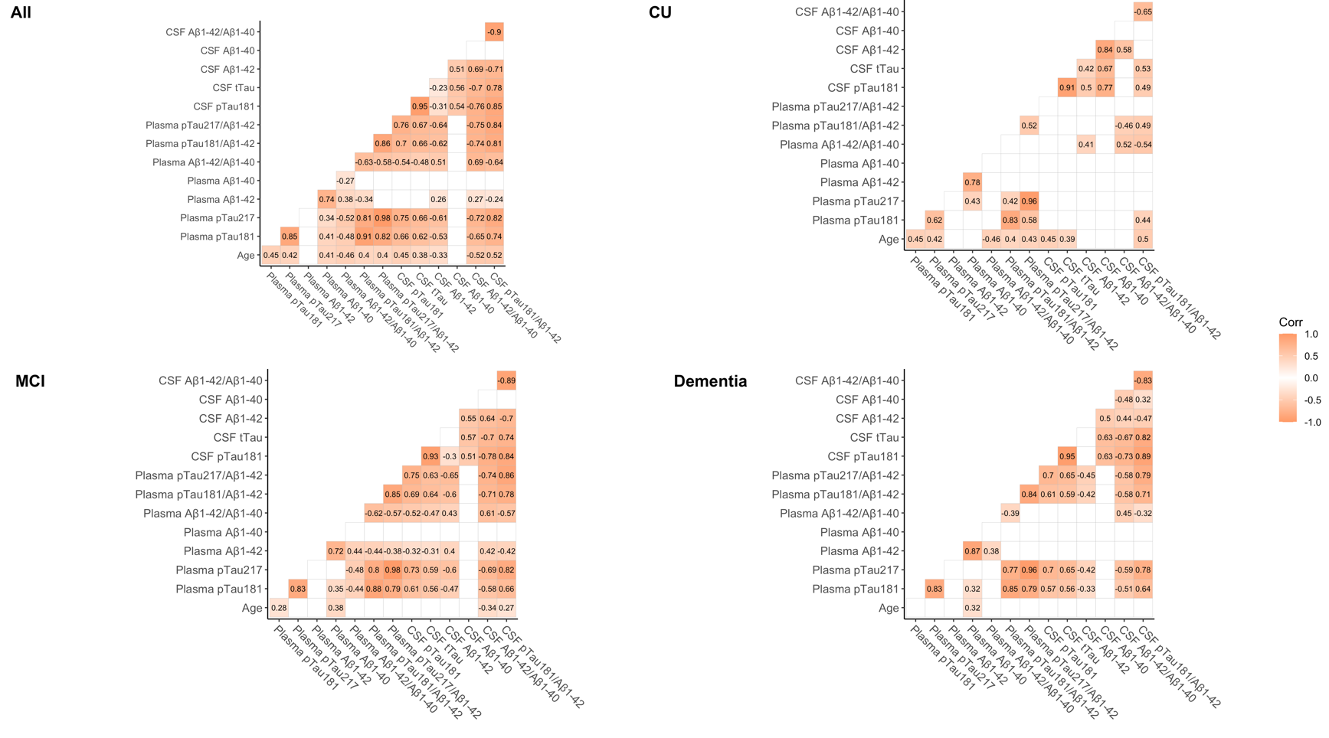

Supplementary Figure 5: Global and partial correlations of plasma biomarkers with CSF biomarkers
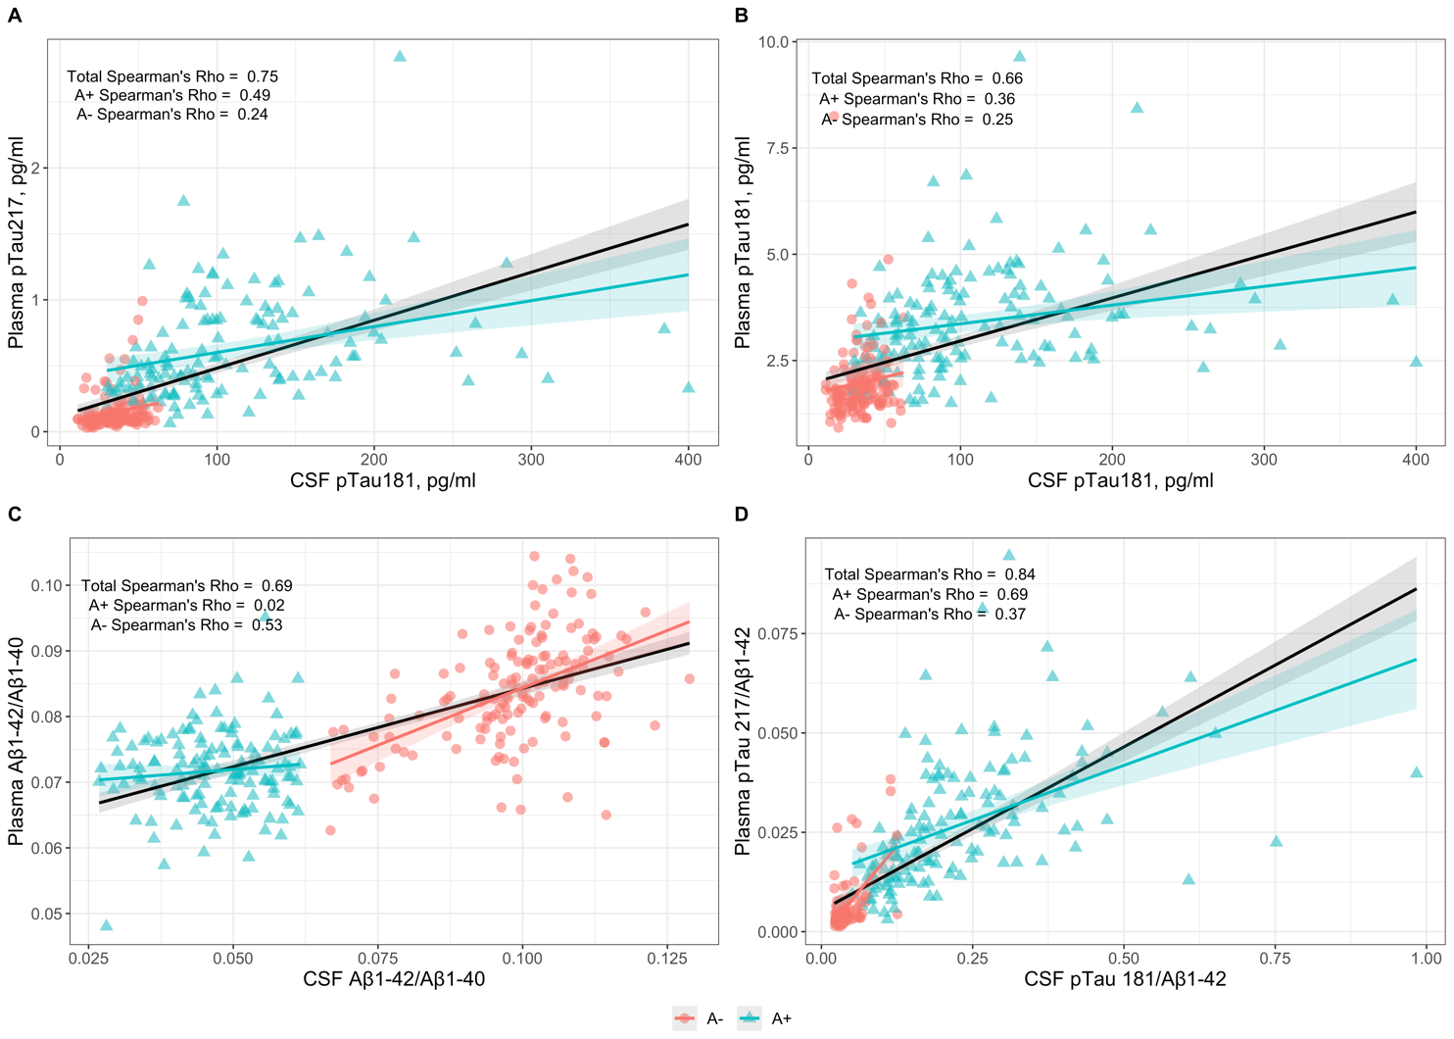
pTau₂₁₇, phosphorylated tau 217, pTau₁₈₁, phosphorylated tau 181. Aβ_{1–42}, Amyloid β_{1–42}. Aβ_{1–40}, Amyloid β_{1–40}.

Supplementary Figure 6: Complete Forest Plot of the influence of different variables in plasma biomarker concentrations.
Dots and bars represent the standardized beta coefficients of each variable in a multivariate regression model. Lines represent the 95% confidence interval for each standardized beta coefficient. Red vertical dashed lines indicate a null effect. We can see the effect size of A positivity adjusted by other variables.
pTau₂₁₇: phosphorylated tau 217. pTau₁₈₁: phosphorylated tau 181. Aβ_{1–42}: Amyloid β_{1–42}. Aβ_{1–40}: Amyloid β_{1–40}. eGFR: estimated glomerular filtration rate. VRF: vascular risk factors. HBP: high blood pressure. DLP: Dyslipidemia. DM, Diabetes mellitus. OSA, obstructive sleep apnea. MCI: mild cognitive impairment.

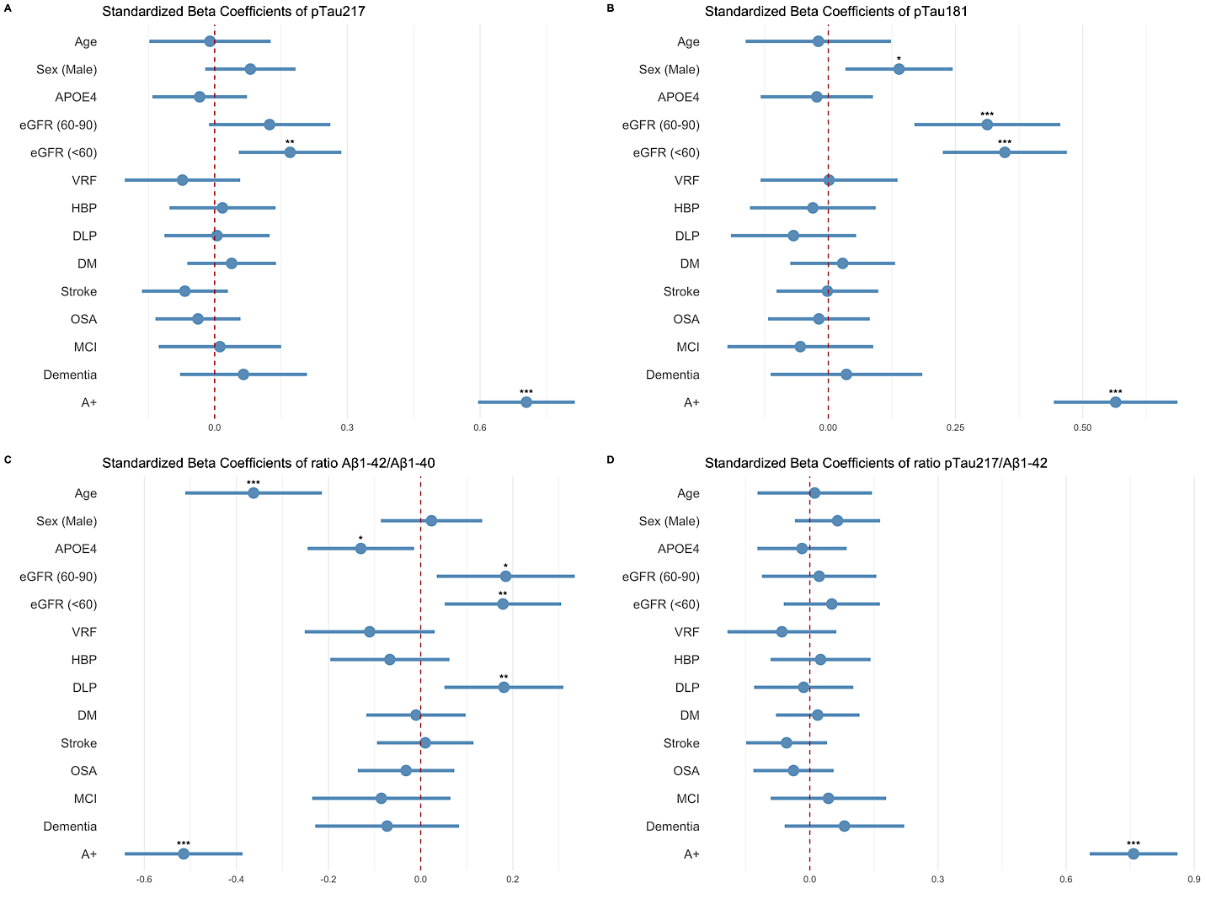
Supplementary Figure 7: Diagnostic accuracy of plasma markers to detect amyloid positivity in CSF
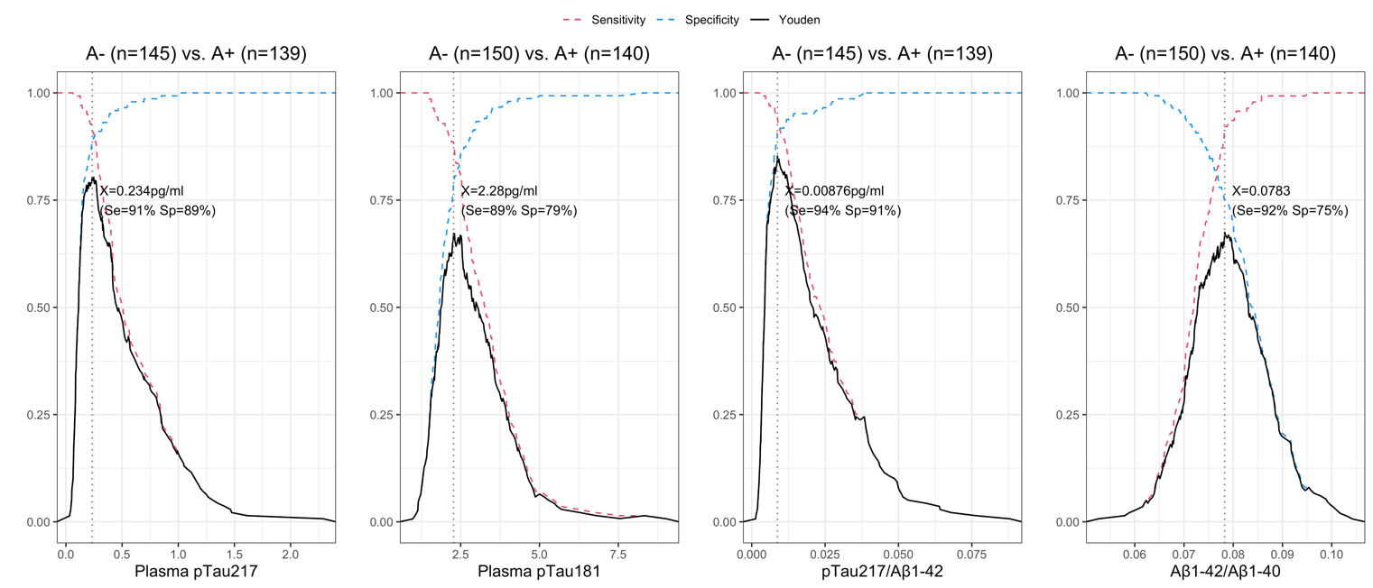
pTau₂₁₇, phosphorylated tau 217, pTau₁₈₁, phosphorylated tau 181. Aβ_{1–42}, Amyloid β_{1–42}. Aβ_{1–40}, Amyloid β_{1–40.}

Supplementary Figure 8: Areas Under the ROC curve of plasma markers to detect A positivity in distinct clinical subgroups
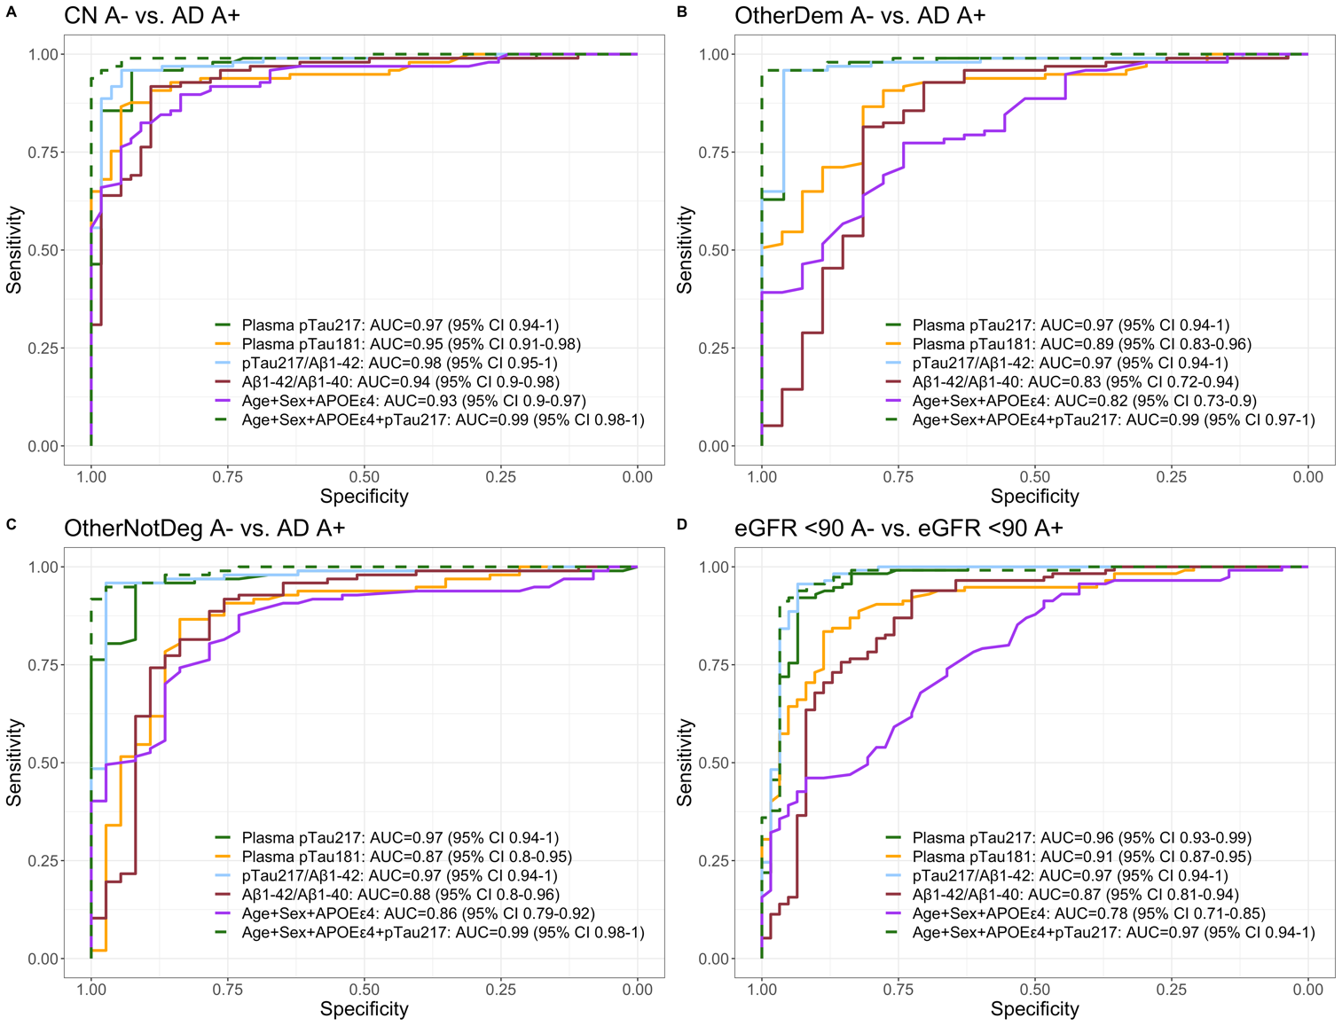
CU, cognitively unimpaired; AD, Alzheimer Disease; OtherDem, Other dementias; OtherNotDeg, Other not neurodegenerative. pTau₂₁₇, phosphorylated tau 217. pTau₁₈₁, phosphorylated tau 181. Aβ_{1–42}, Amyloid β_{1–42}. Aβ_{1–40}, Amyloid β_{1–40}.

Supplementary Figure 9: Areas Under the ROC curve of plasma markers to detect the CSF A+T+ profile
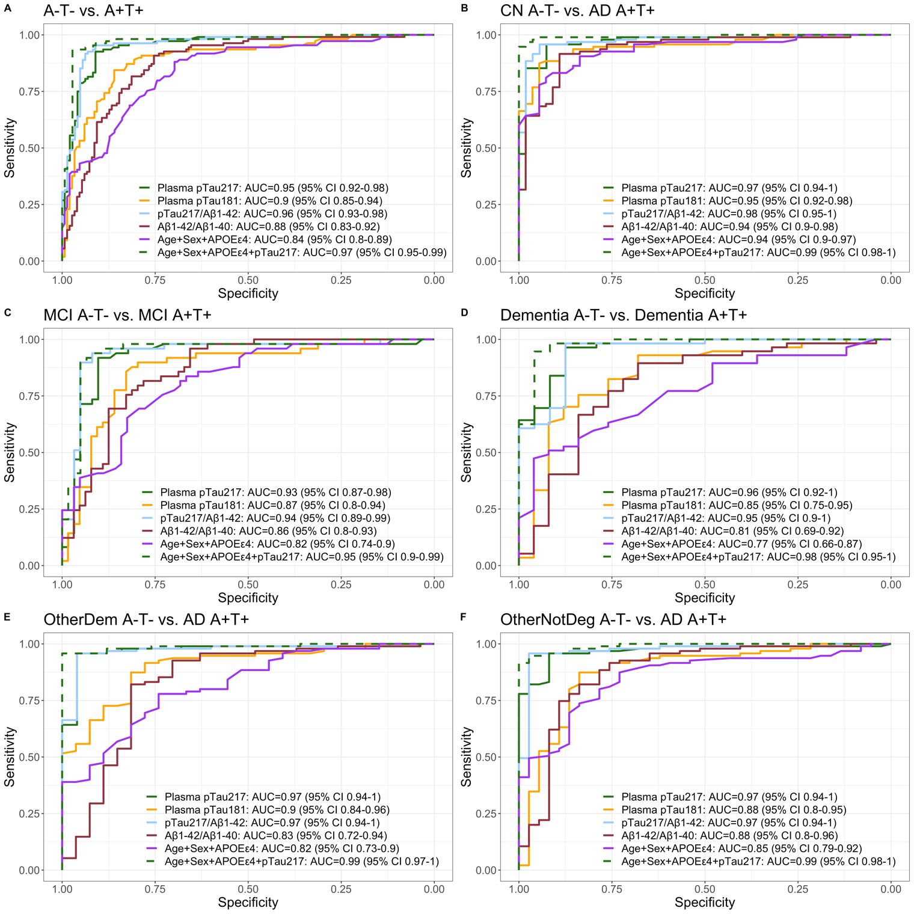
CU, cognitively unimpaired; AD, Alzheimer Disease; OtherDem, Other dementias; OtherNotDeg, Other not neurodegenerative. pTau₂₁₇, phosphorylated tau 217. pTau₁₈₁, phosphorylated tau 181. Aβ_{1–42}, Amyloid β_{1–42}. Aβ_{1–40}, Amyloid β_{1–40}.

Supplementary Figure 10: Data-driven supervised decision tree of plasma markers and demographic factors to detect amyloid positivity
We performed a decision tree analysis, a supervised, data-driven predictive model that identified the most informative variables for predicting CSF amyloidosis. We included pTau₂₁₇, pTau₁₈₁, ratio Aβ_{1–42}/ Aβ_{1–40}, Age, Sex and APOE ε4. The decision tree starts with a complexity parameter (CP) of 0.80, indicating it will not make additional splits unless they can significantly reduce the relative error rate, which is a good indication of controlling overfitting. Initially, the tree splits into two child nodes, where pTau₂₁₇ emerges as the most important variable for the first division (highest Youden cutoff 0.23 pg/mL). Subsequently, a second division is made in the right node with a CP of 0.05, using Aβ_{1–42/1-40} as the main variable for the partition (highest sensitivity cutoff 0.086). The variables pTau₂₁₇, pTau₁₈₁, and Aβ_{1–42/1-40} stand out as the most determinative in the model. In terms of error, the initial cross-validation error (xerror) after the first division is 0.27, compared to a relative error of 0.20, reflecting a good fit of the model to the initial data. However, the increase in cross-validation error after the first division indicates a potential onset of overfitting in subsequent divisions. The standard deviation of the cross-validation error (xstd) initially is 0.04, providing confidence in the stability of these error estimates. The misclassification rate for this algorithm was 7.4% (Sensitivity = 91%, Specificity = 94%, Accuracy = 93%, PPV = 94%, and NPV = 91%, with FNR = 9.4% and FPR=5.6%). Created with BioRender® (BioRender.com).
pTau_{217p}, phosphorylated tau 217. pTau₁₈₁, phosphorylated tau 181. Aβ_{1–42/1-40}, Amyloid β_{1–42}/Aβ_{1–40} ratio

