Fig.7A BNIP3L Fig.7A BNIP3L marker
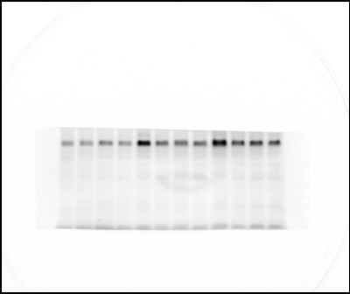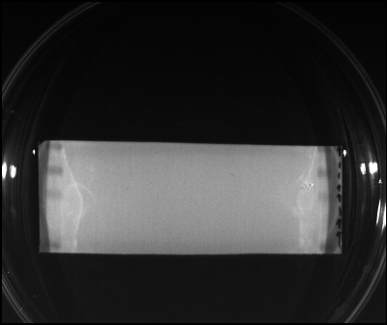

Fig.7A ADAM10 Fig.7A ADAM10 marker
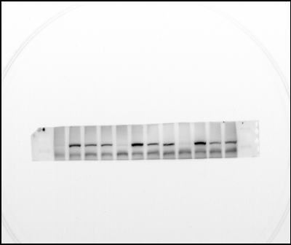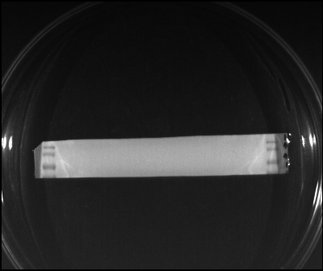

Fig.7A TUBLIN Fig.7A TUBLIN marker (2024.3.17)
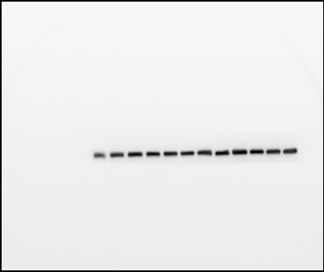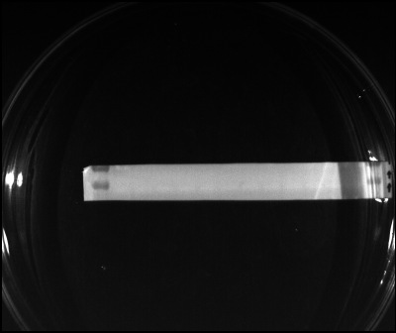

Fig.7D BNIP3L Fig.7D GAPDH
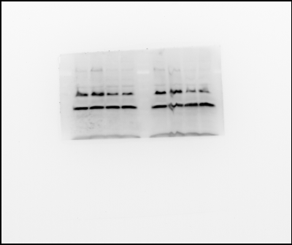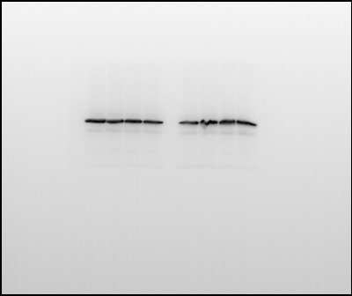
Fig.7D BNIP3L marker Fig.7D GAPDH marker (2023.6.29-30)
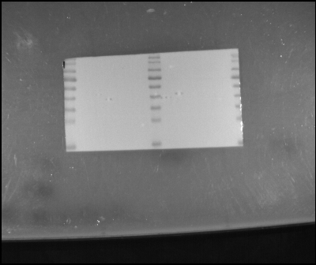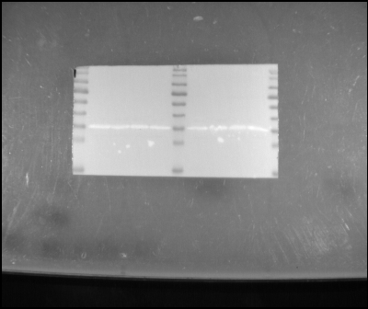

Fig.7D BNIP3L Fig.7D GAPDH
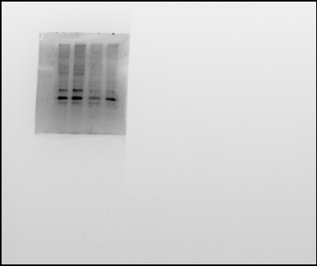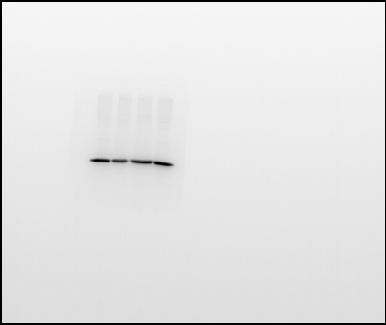
Fig.7D BNIP3L marker Fig.7D GAPDH marker (2023.6.29-30)
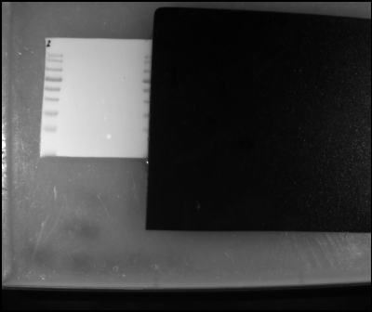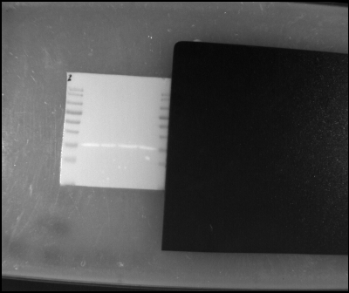

Fig.7D BNIP3L Fig.7D GAPDH
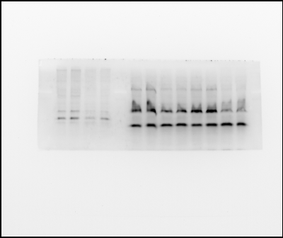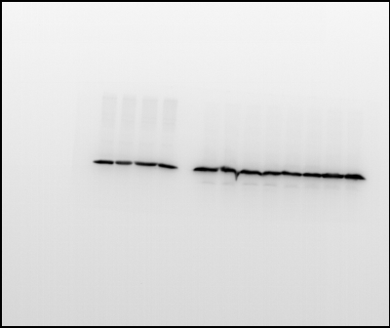
Fig.7D BNIP3L marker Fig.7D GAPDH marker (2023.6.29-30)
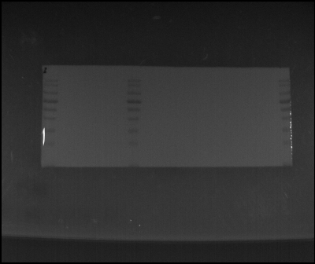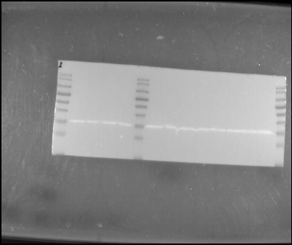

Fig.7E ADAM10 Fig.7E GAPDH
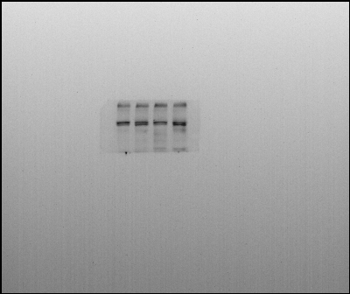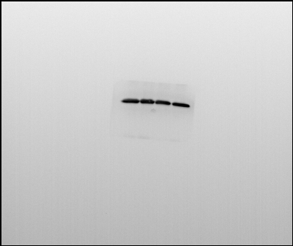
Fig.7E ADAM10 marker Fig.7E GAPDH marker (2023.5.17)
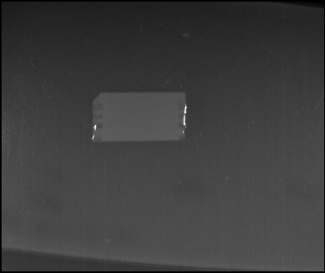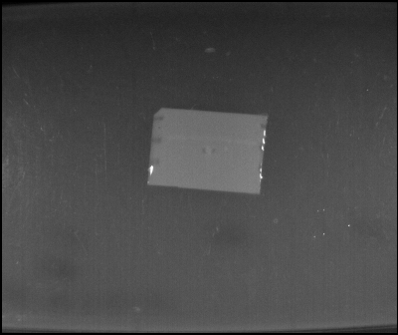
Fig.7E ADAM10 Fig.7E GAPDH
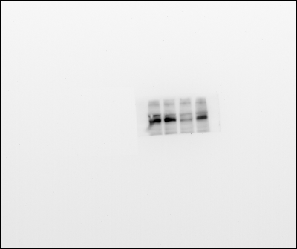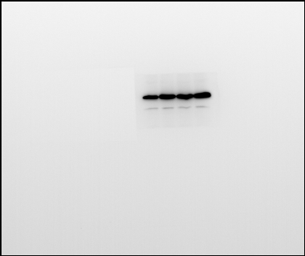
Fig.7E ADAM10 marker Fig.7E GAPDH marker (2023.5.24)
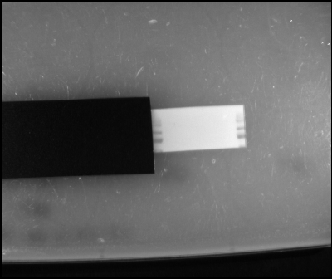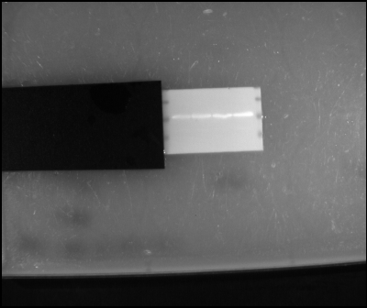
Fig.7E ADAM10 Fig.7E GAPDH
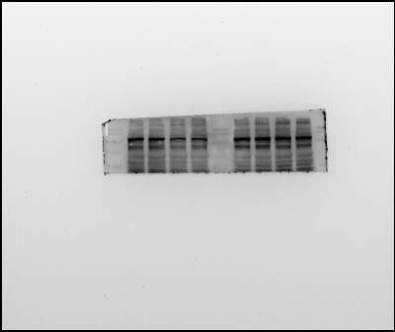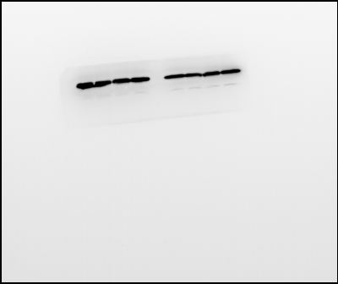
Fig.7E ADAM10 marker Fig.7E GAPDH marker (2023.5.25)
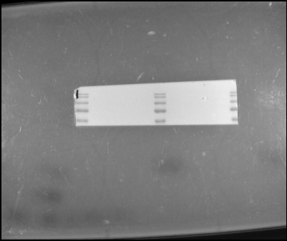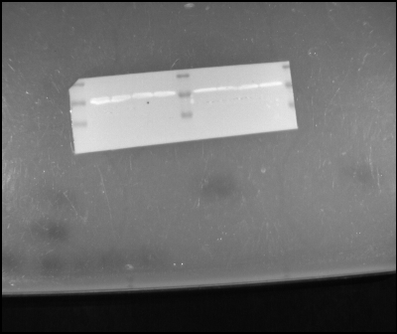

Fig.7F C83 Fig.7F GAPDH
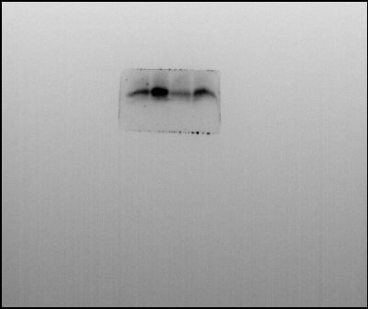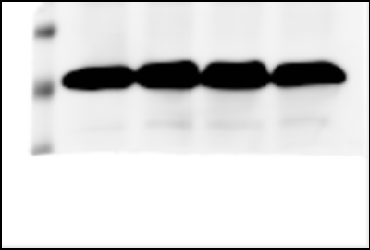
Fig.7F C83 marker (2023.5.19)

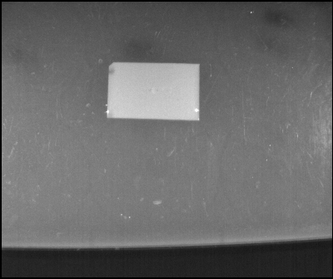

Fig.7F C83 Fig.7F GAPDH
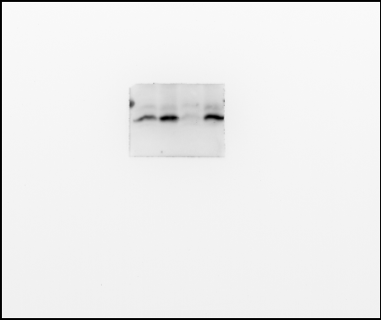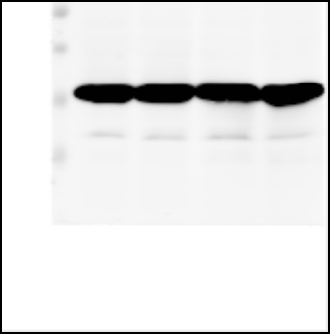
Fig.7F C83 marker (2023.5.24)
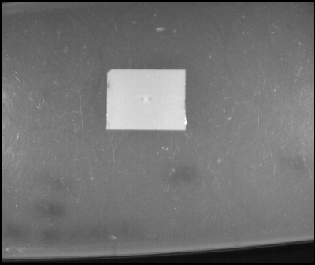

Fig.7F C83 Fig.7F GAPDH
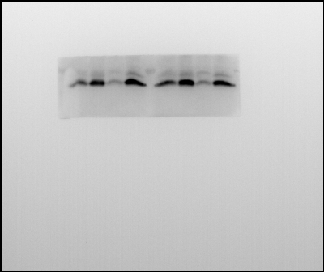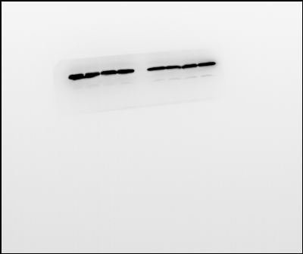

Fig.7F C83 marker Fig.7F GAPDH marker (2023.5.25)
