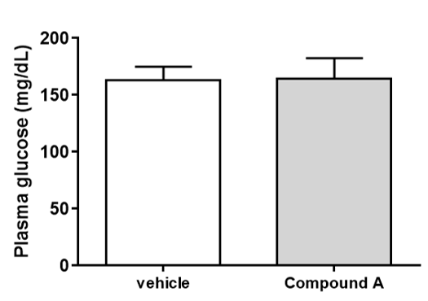
Figure S1 Effect of Compound A on plasma glucose levels in rats in the 2-DG uptake experiment. Data are shown as the mean ± S.D.
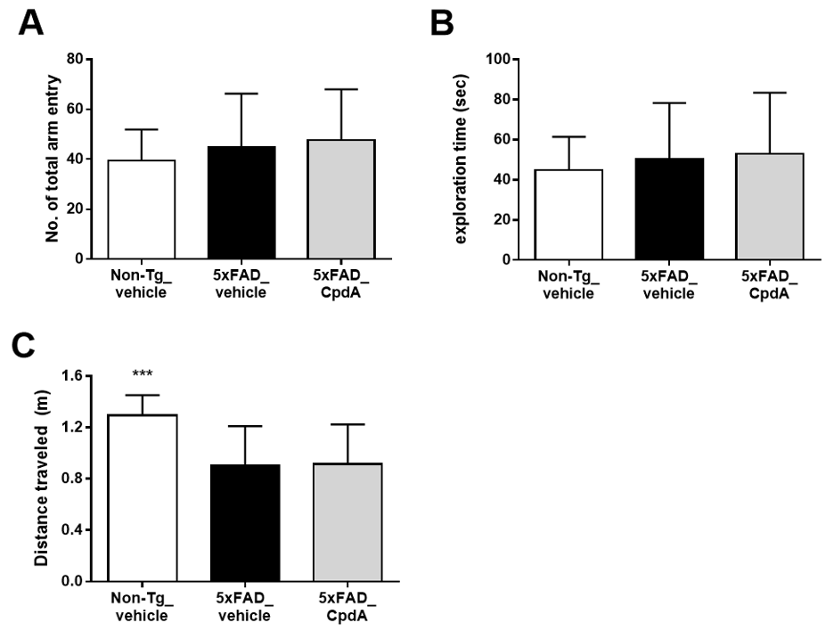
Figure S2 Effect of Compound A on the total arm entry in Y-maze test (A), exploration time in NORT (B), and the distance traveled during the probe test in MWM (C). Data were analyzed by one-way ANOVA followed by Dunnett-test. ***p<0.001 vs 5xFAD-vehicle. Data are shown as the mean ± S.D.

