Supplementary Materials – Skull segmentation
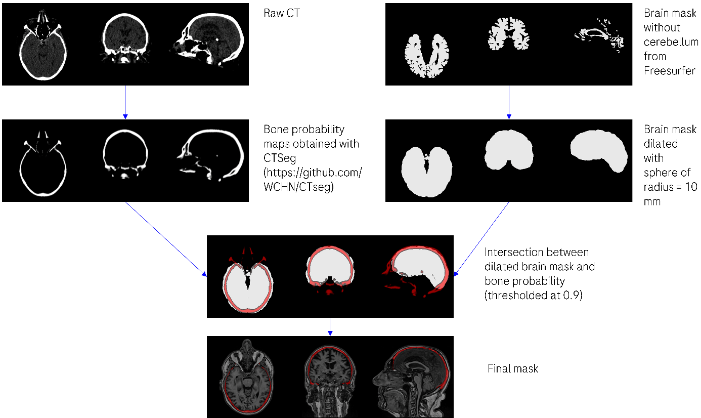
Figure shows the steps that were followed to obtain the skull/meninges ROI from the low-dose CT images: first, skull probability maps were obtained with CTseg (https://github.com/WCHN/CTseg) and aligned to the 3D T1-weighted image using the Advanced Normalization Tools (ANTs v2.4.3, https://github.com/ANTsX/ANTs). Since two CT images were available for each subject, the skull probability maps in T1 space were multiplied with each other and thresholded at 0.9. To get rid of bone structures far from the brain (teeth, vertebras, …), all voxels in the skull masks located at a distance greater than 10 mm from the FastSurfer brain mask were removed.

