Supplementary material

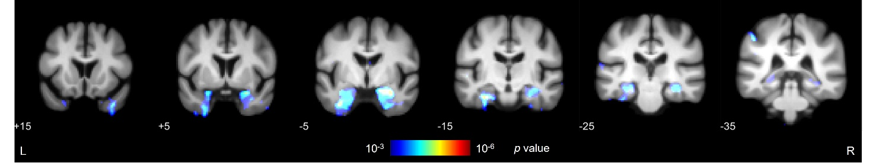
Supplementary Fig. 1. VBM results as a function of LATE stage after removing HS from the combined pathology model. Significant results at an uncorrected level (p<0.001) were found in left and right amygdala, hippocampi, inferior temporal gyri and left parahippocampal and postcentral gyri (predicted using the AAL3 atlas). HS = hippocampal sclerosis of aging; L = left; LATE = Limbic Predominant Age-Related TDP-43 Encephalopathy; R = right.

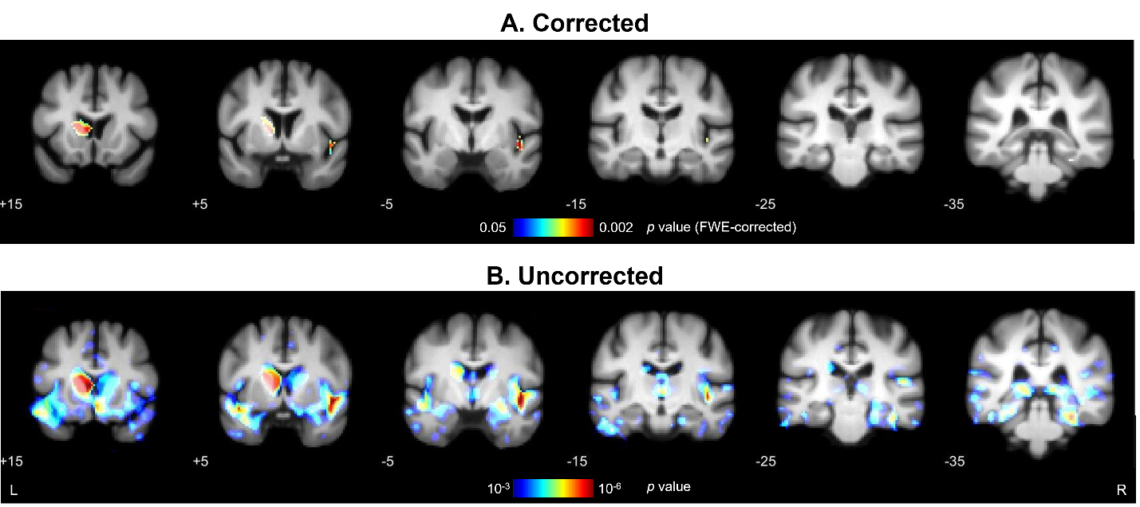
Supplementary Fig. 2. Differences in grey matter density as a function of cognitive performance. This VBM model evaluates regions with a positive correlation between sMMSE scores and grey matter density, while correcting for intracranial volume, age, sex and time to MRI. (A) Results after applying whole-brain FWE correction (p<0.05). (B) Uncorrected results (p<0.001). At an FWE-corrected level, significant results were found in the right insula, left caudate nucleus, right fusiform gyrus and left temporal superior gyrus (using the AAL3 atlas). FWE = family-wise error; L = left; R = right; sMMSE = severe Mini-Mental State Examination.

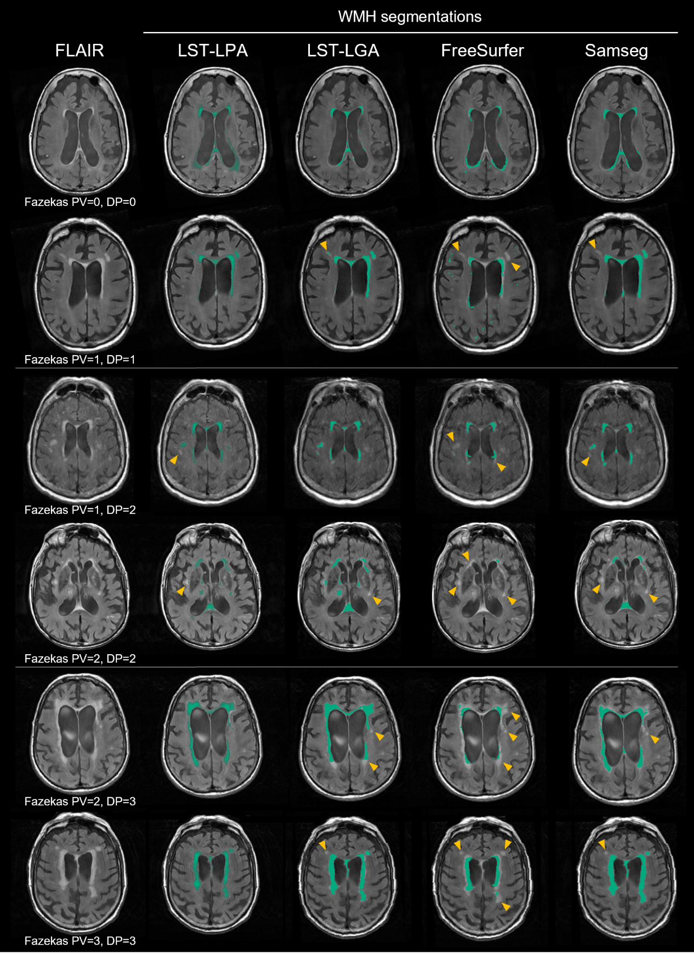
Supplementary Fig. 3. Examples of WMH segmentation results from each automated method. The left-most column shows an axial view of the FLAIR image, which on the right is overlayed with WMH maps (in green) obtained from each method. Examples include subjects with low, intermediate, and high WMH burden (2 of each level), with deep and periventricular Fazekas scores being specified. Orange arrows show examples of undersegmented lesions. DP = deep; PV = periventricular; WMH = white matter hyperintensity.

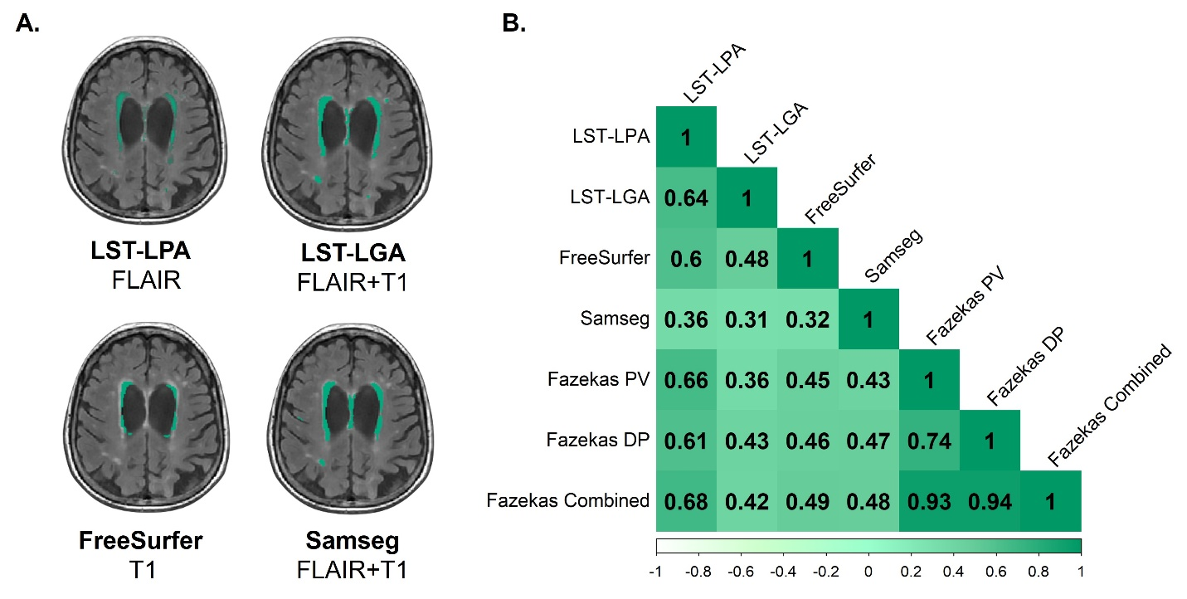
Supplementary Fig. 4. Correlation between WMH volumes from different segmentation methods and Fazekas scores. (A) Summary of tested methods with one example segmentation and input MRI sequences specified below the method name. (B) Matrix showing Pearson’s correlation coefficients between WMH volumes obtained with each method and Fazekas periventricular, deep, and combined (periventricular + deep) scores. All correlations were significant, (p<0.01). DP = deep; FLAIR = fluid-attenuated inversion recovery images; LST-LGA = Lesion Segmentation Toolbox-Lesion Growth Algorithm; LST-LPA = Lesion Segmentation Toolbox-Lesion Prediction Algorithm; PV = periventricular; T1 = T1-weighted images.

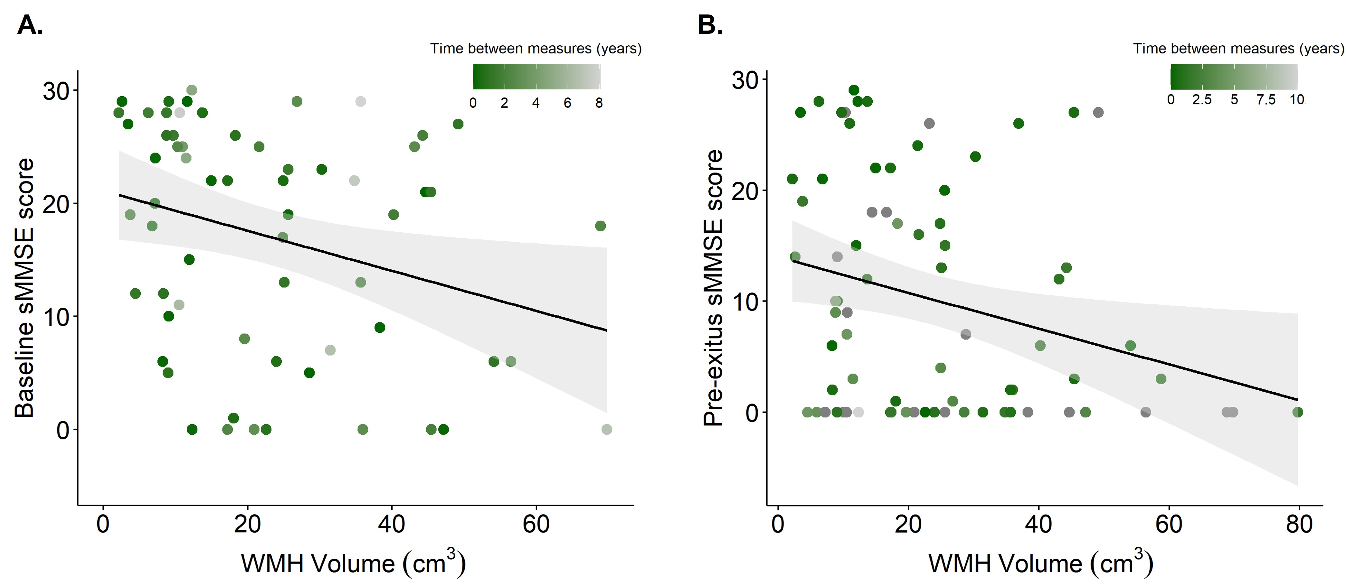 Supplementary Fig. 5. Baseline and pre-exitus sMMSE cognitive scores as a function of WMH burden. In generalized linear models correcting for demographic differences, these scores were both significantly associated with WMH volumes (p<0.01). Points of the scatterplot are color-coded according to the time between MRI and cognitive evaluation. Linear fit and 95% confidence interval (in grey) are shown. sMMSE = severe Mini-Mental State Examination; WMH = white matter hyperintensity.

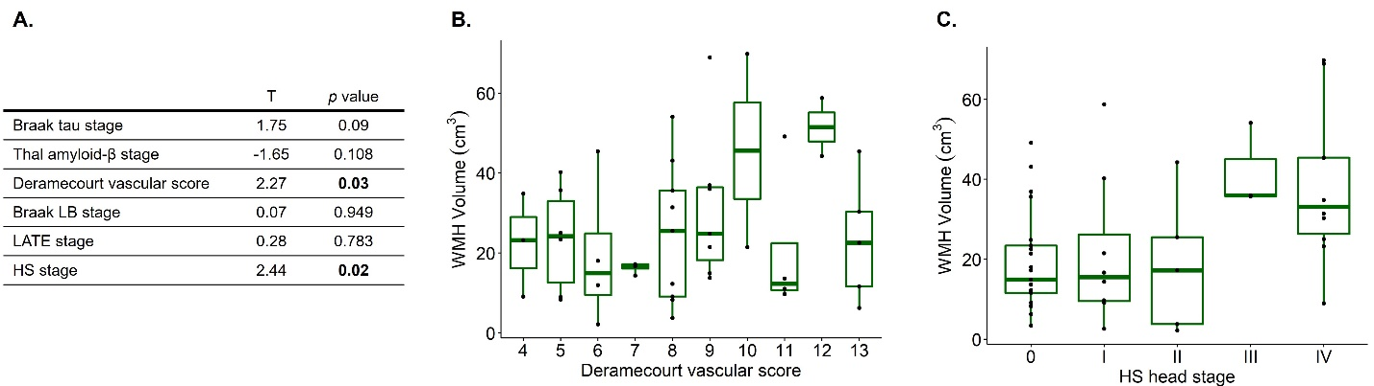
Supplementary Fig. 6. WMH volume modelled as a function of combined pathology, using scans with AMI below 3 years. (A) T and p values (those below 0.05 highlighted in bold) obtained from the model for each variable of interest. (B) WMH volumes as a function of Deramecourt vascular scores. (C) WMH volumes as a function of HS staging (evaluated in the hippocampal head), which shows a significant contribution in this subset of the cohort. HS = hippocampal sclerosis of aging; LATE = Limbic Predominant Age-Related TDP-43 Encephalopathy; LB = Lewy body pathology; WMH = white matter hyperintensity.

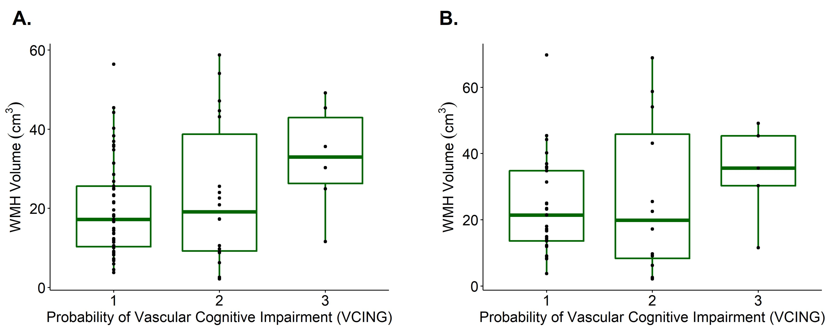
Supplementary Fig. 7. WMH volumes as a function of VCING vascular scores. (A) Using data from the whole cohort (n=79). (B) Using data from scans with an antemortem interval lower than 3 years (n=49). When replacing Deramecourt by VCING scores in the combined model showed in Fig. 4, the contribution of this variable was not significant. Nevertheless, greater WMH volumes were found in individuals with a high VCING score (value of 3) relative to those with low or intermediate scores (1-2) of this assessment. VCING = Vascular Cognitive Impairment Neuropathology Guidelines; WMH = white matter hyperintensity.

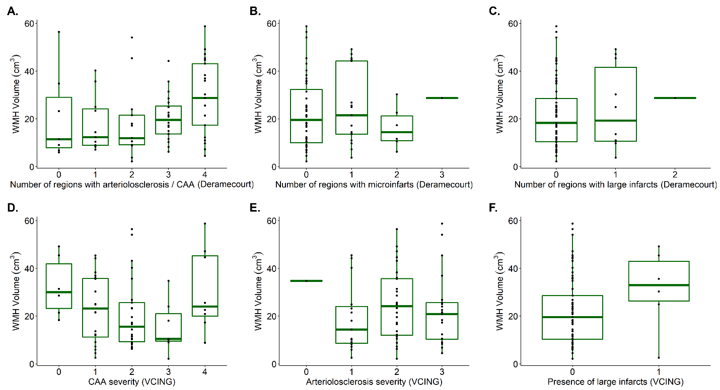
Supplementary Fig. 8. WMH volumes as a function of sub-scores of the Deramecourt and VCING evaluations. Using data from the whole cohort, WMH volumes were analyzed in separate models as a function of the three sub-scores from each framework. (A) Deramecourt sub-score: number of regions (frontal and temporal lobes, hippocampus and basal ganglia) affected by arteriolosclerosis or CAA (regional scores of 2 or higher as defined by Deramecourt et al. [35]). (B) Deramecourt sub-score: number of regions with microinfarcts (scores of 3 or more in hippocampus and basal ganglia, 5 or more in frontal and temporal lobes). (C) Deramecourt sub-score: number of regions with large infarcts (maximum regional scores). (D) VCING sub-score: severity of occipital leptomeningeal CAA. (E) VCING sub-score: severity of occipital arteriolosclerosis. (F) VCING sub-score: presence of one or more large subcortical infarcts. The regional prevalence of arteriolosclerosis or CAA (shown in A) was the only variable showing a significant association with WMH volumes in these models (T=2.11, p=0.039). CAA = cerebral amyloid angiopathy; VCING = Vascular Cognitive Impairment Neuropathology Guidelines; WMH = white matter hyperintensity.

Model type | Software | Dependent variable | Independent variables (pathologies) | Covariates | Results
Voxel-wise general linear model | SPM12 | Grey matter density maps | ADNC  Deramecourt vascular score  Braak α-synuclein stage  LATE stage  HS stage | sex  age at scan  AMI  T1 acquisition protocol  TIV | Figs. 2 and 3
Generalized linear model | RStudio | LST-LPA WMH volumes | Thal Aβ stage  Braak tau stage  Deramecourt vascular score  Braak α-synuclein stage  LATE stage  HS stage | sex  age at scan  AMI  TIV | Fig. 4
Voxel-wise general linear model | SPM12 | LST-LPA WMH maps | Thal Aβ stage  Braak tau stage  Deramecourt vascular score  Braak α-synuclein stage  LATE stage  HS stage | sex  age at scan  AMI  TIV | Fig. 5

Supplementary Table 1. Methodological summary of combined pathology models implemented in this study. For all MRI-pathology results shown in the main manuscript, model details and included variables are described for a clearer comparison. Results shown in Figs. 2 and 3 are derived from the same model, using different tests (combined F-contrast and individual T-contrast, respectively) to evaluate joint and independent effects. References to the evaluations from which pathology variables were derived are included in the manuscript methods. Aβ = amyloid-β; ADNC = Alzheimer’s Disease Neuropathological Change; AMI: antemortem interval; HS = hippocampal sclerosis of aging; LATE = Limbic Predominant Age-Related TDP-43 Encephalopathy; LST-LPA = Lesion Segmentation Toolbox-Lesion Prediction Algorithm; TIV = total intracranial volume; WMH = white matter hyperintensity.

 | Mean ± SD or %
Sex (%Females) | 83.51
Estimated age at onset | 75.82 ± 7.31
Age at death | 87.87 ± 6.67
Disease duration (years) | 11.95 ± 4.5
Time in nursing home (years) | 4.45 ± 3.12
Final sMMSE score | 9.13 ± 10.65
APOE genotype (%ε4 carriers) | 57.95
Ante-mortem interval to last MRI (years) | 3.04 ± 3
Post-mortem interval (hours) | 4.35 ± 1.78
High ADNC | 71.43
Lewy Bodies beyond brainstem | 42.86
Moderate-high vascular pathology | 60.44
TDP-43 inclusions beyond the amygdala | 56.04
Early or advanced HS | 64.84

Supplementary Table 2. Demographic and pathological distribution of the subjects included in this study. The right column shows mean and standard deviation (SD) for numeric variables, and percentage for categoric variables. First section of the table shows demographic and data collection details, and below section shows pathological distributions following high-burden thresholds specified in the Methods (Neuropathological Evaluation section). Data are shown for the 91 subjects included within T1-derived analyses (first two result sections), 86% of which are also included within WMH analyses (last two result sections). Therefore, the variability in these variables between both cohort groups is negligible. Post-mortem interval refers to the time elapsed between death and brain extraction. Abbreviations: ADNC = Alzheimer’s Disease Neuropathological Change; APOE = apolipoprotein E; HS = hippocampal sclerosis; SD = standard deviation; sMMSE = severe Mini-Mental State Examination.

Coordinates |  |  | Statistic
x | y | z | T | Label
Hippocampal sclerosis of aging (FWE-corrected, p<0.05)
16 | -14 | -22 | 6.1 | Right parahippocampal gyrus
-16 | -14 | -24 | 6.05 | Left parahippocampal gyrus
28 | 5 | -24 | 5.89 | Right superior temporal gyrus
-16 | -39 | 28 | 5.73 | Left middle cingulate gyrus
14 | -1 | -20 | 5.58 | Right parahippocampal gyrus
24 | 17 | 20 | 5.41 | Right caudate nucleus
24 | 25 | 12 | 5.25 | Right caudate nucleus
-30 | -18 | -24 | 5.22 | Left parahippocampal gyrus
ADNC (uncorrected, p<0.001)
50 | -59 | -2 | 5.47 | Right temporal middle gyrus
52 | -59 | -18 | 4.06 | Right temporal inferior gyrus
-22 | 19 | 14 | 4.82 | Left insula
10 | -42 | -40 | 4.47 | Right cerebellum
-60 | -21 | 12 | 4.46 | Left temporal superior gyrus
22 | -1 | 30 | 4.39 | Right caudate nucleus
24 | -31 | -6 | 4.34 | Right hippocampus
46 | -22 | -32 | 4.32 | Right temporal inferior gyrus
50 | 3 | -6 | 4.32 | Right insula
54 | -5 | -4 | 3.9 | Right temporal superior gyrus
-14 | -1 | 34 | 4.29 | Left middle cingulate gyrus
-22 | -1 | 28 | 3.79 | Left caudate nucleus
28 | -5 | -16 | 4.14 | Right amygdala
26 | -8 | -24 | 3.57 | Right hippocampus
-36 | -67 | 16 | 4.07 | Left middle occipital gyrus
Vascular pathology (uncorrected, p<0.001)
-14 | -41 | 22 | 4.03 | Left posterior cingulate gyrus
-12 | -33 | -10 | 3.89 | Left lingual gyrus
22 | -3 | 20 | 3.62 | Right caudate nucleus
-4 | -33 | 18 | 3.58 | Left posterior cingulate gyrus
-22 | -24 | -20 | 3.57 | Left parahippocampal gyrus
44 | -15 | 40 | 3.43 | Right precentral gyrus
16 | -3 | 32 | 3.41 | Right middle cingulate gyrus
24 | 21 | 10 | 3.4 | Right caudate nucleus
20 | -38 | -50 | 3.37 | Right cerebellum
Lewy body pathology (uncorrected, p<0.001)
8 | -42 | -26 | 4.92 | Right cerebellum
30 | -63 | -18 | 3.67 | Right fusiform gyrus
-12 | -27 | 0 | 4.88 | Left thalamus
-12 | 26 | -26 | 4.83 | Left medial orbital gyrus
6 | 59 | 5 | 4.6 | Right superior frontal gyrus
26 | 17 | -16 | 4.71 | Right insula
22 | 31 | -14 | 4.58 | Right anterior orbital gyrus
-36 | 10 | -22 | 4.6 | Left superior temporal gyrus
-22 | 4 | -34 | 3.74 | Left parahippocampal gyrus
-44 | -37 | 14 | 4.53 | Left superior temporal gyrus
46 | -9 | 4 | 4.47 | Right insula
42 | 15 | 56 | 4.39 | Right middle frontal gyrus
-10 | -40 | -26 | 4.28 | Left cerebellum
LATE (uncorrected, p<0.001)
-48 | -35 | 48 | 3.7 | Left postcentral gyrus
14 | -45 | 28 | 3.38 | Right posterior cingulate gyrus
30 | 17 | 18 | 3.35 | Right insula
40 | -19 | 28 | 3.22 | Right rolandic operculum
Hippocampal sclerosis of aging (uncorrected, p<0.001)
16 | -14 | -22 | 6.1 | Right parahippocampal gyrus
28 | 5 | -24 | 5.89 | Right superior temporal gyrus
-16 | -14 | -24 | 6.05 | Left parahippocampal gyrus
-16 | -39 | 28 | 5.73 | Left middle cingulate gyrus
-18 | -47 | 20 | 3.58 | Left precuneus
46 | 1 | 4 | 4.6 | Right insula
-12 | 12 | -24 | 4.59 | Left medial orbital gyrus
6 | 45 | 33 | 4.17 | Right superior frontal gyrus
-60 | -21 | 14 | 4.04 | Left postcentral gyrus
-12 | 31 | 2 | 4.02 | Left caudate nucleus
30 | 51 | -5 | 4.01 | Right superior frontal gyrus
-34 | 26 | -34 | 3.94 | Left middle temporal gyrus
16 | -33 | 30 | 3.89 | Right middle cingulate gyrus
18 | -43 | 22 | 3.72 | Right posterior cingulate gyrus
4 | -9 | 14 | 3.82 | Right thalamus

Supplementary Table 3. Result details from grey matter VBM as a function of individual pathologies. FWE-corrected (only surviving as a function of HS) and uncorrected results are shown, corresponding to results displayed in Figure 3. MNI coordinates, T-statistics and labels are shown for each cluster-level maximum (in bold), as well as for peak-level local maxima with differing labels to cluster-level ones. These labels are illustrative, as the AAL3 atlas is not specific to individuals with a high degree of atrophy. For each contrast, effects are organized in from higher to smaller of effect size of cluster-level maxima. Abbreviations: ADNC = Alzheimer’s Disease Neuropathological Change; FWE = family-wise error; LATE = Limbic Predominant Age-Related TDP-43 Encephalopathy.

