Figure 4. Model of reference change values, RCV % - Based on the lowest intermediate CV_{A}
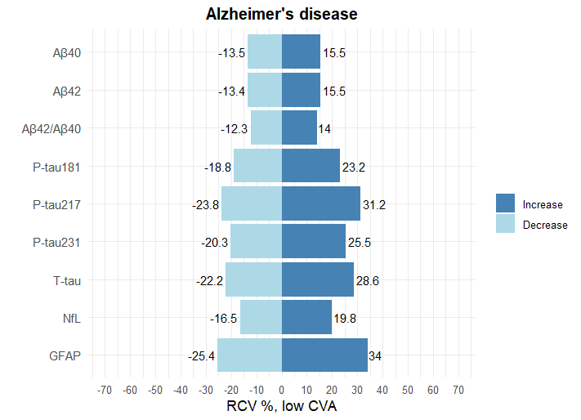
 | Aβ40 | Aβ42 | Aβ42/ Aβ40 | P-tau181 | P-tau217 | P-tau231 | T-tau | NfL | GFAP
NNHS | 0.5 | 0.5 | 0.4 | 1.0 | 1.7 | 1.2 | 1.4 | 0.7 | 1.9

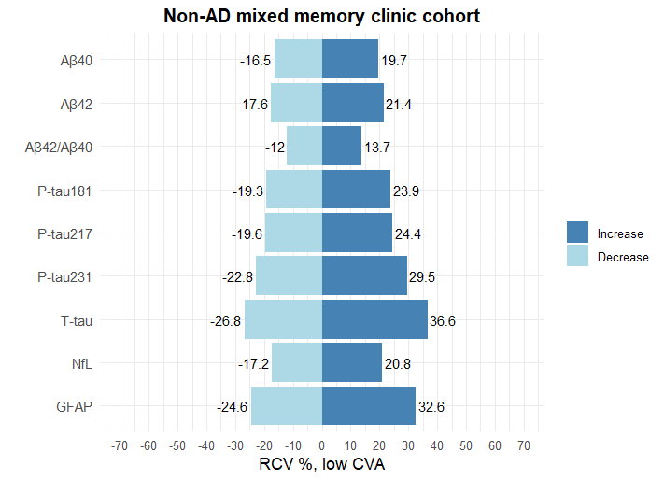
 | Aβ40 | Aβ42 | Aβ42/ Aβ40 | P-tau181 | P-tau217 | P-tau231 | T-tau | NfL | GFAP
NNHS | 0.7 | 0.8 | 0.4 | 1.0 | 1.1 | 1.5 | 2.2 | 0.4 | 1.8

Figures showing the amount of change for each biomarker to overcome that of intra-individual variability and assay variation. named Reference Change Value (RCV). The tables show the RCVs for each biomarker in patients with A) Alzheimer’s disease and B) non-AD consisting of a mixed memory clinic cohort. Calculations are based on the lowest intermediate CV_{A.} NNHS; number of samples needed to obtain homeostatic setpoint with 15% proximity to true value.

