Figure 7. Correlations in BBMs between visits
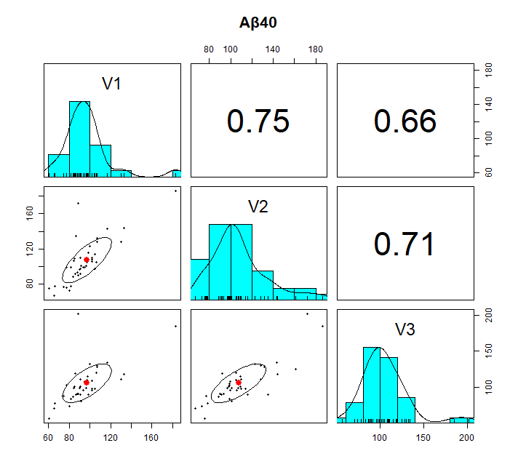 | 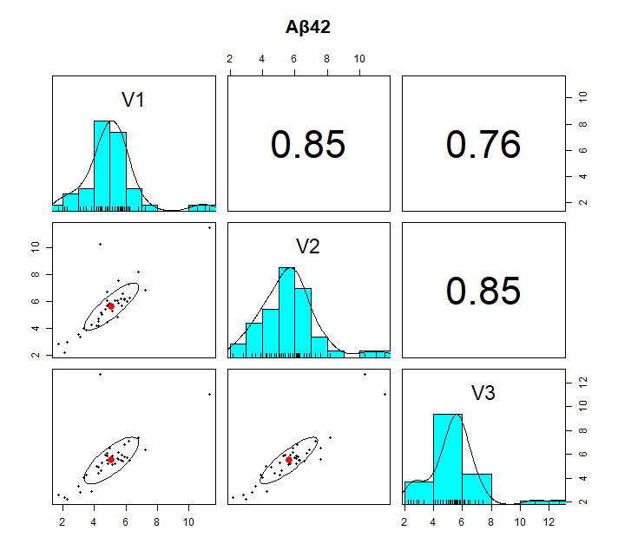
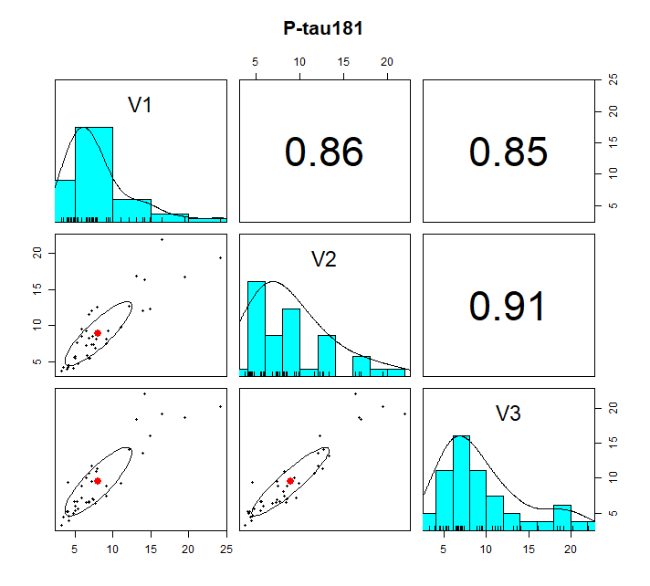 | 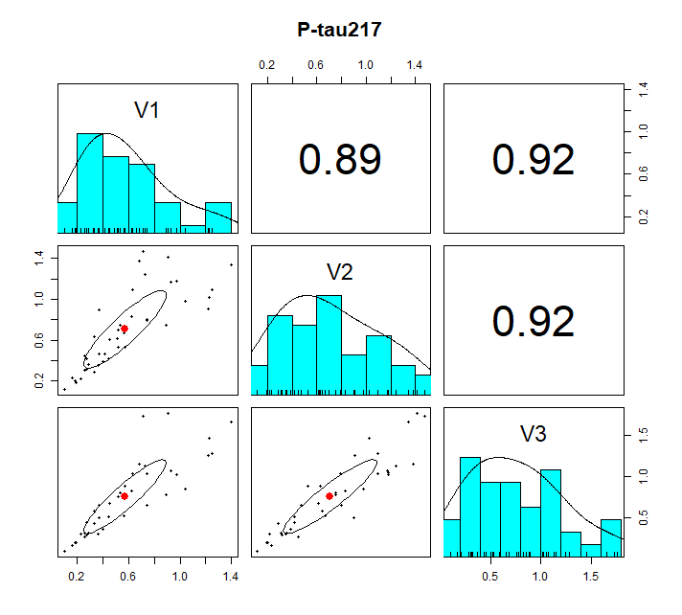 | 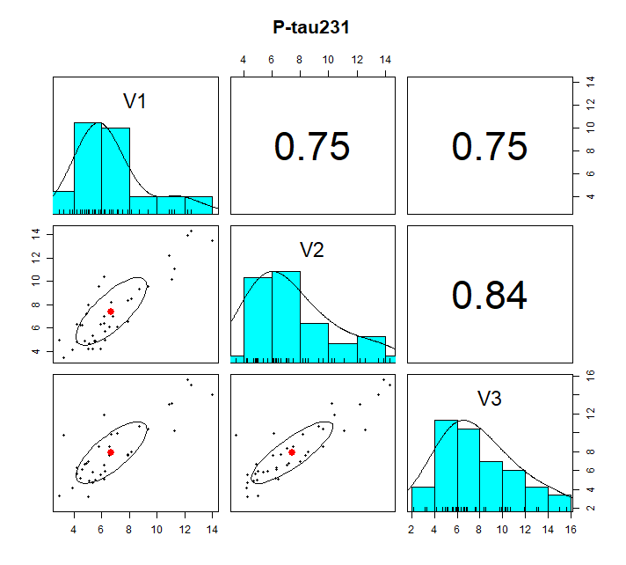
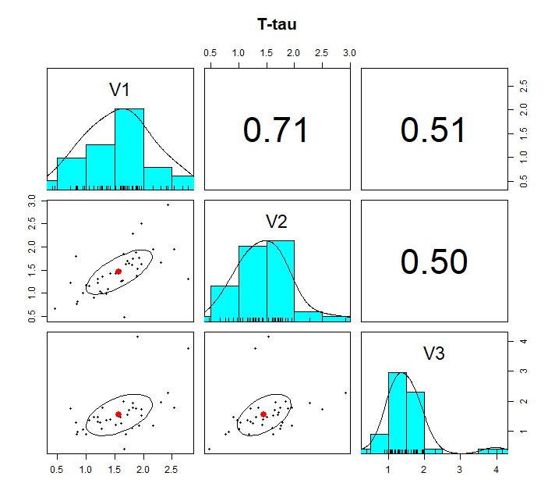 | 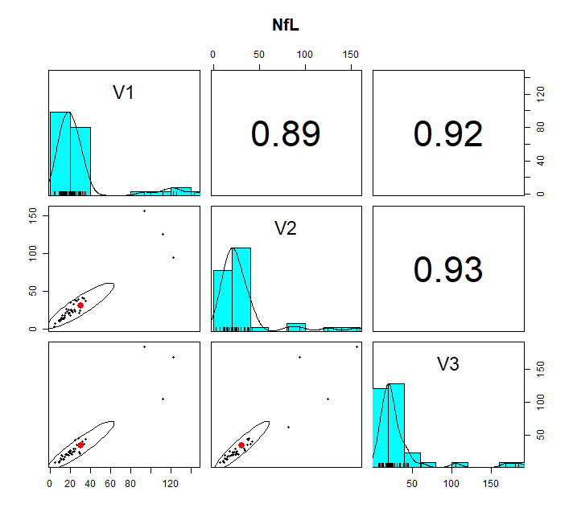 | 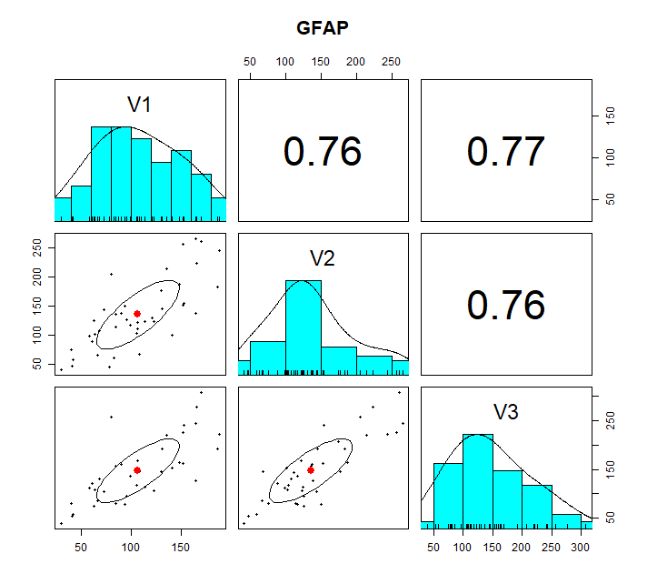
Histograms and scatterplot matrices based on Spearman’s correlations coefficient for each biomarker between visits.
V1, visit 1; V2, visit 2; V3, visit 3; Aβ40, amyloid beta 40; Aβ 20, amyloid beta 42; P-tau, phoshorylated tau; T-tau, total-tau; NfL, neurofilament light; GFAP, glial fibrillary acidic protein.

