Supplementary Online Content
eMethods. Detailed Methods
eTable 1. Characteristics of macular retinal sublayer thickness using ETDRS grid in CN, MCI, and ADD.
eTable 2. Repeatability results of full-layer retinal OCT-ISCF parameters.
eTable 3. Comparison of retinal OCT-ISCF among three groups.
eFigure 1. Changes of OCT-ISCF before and after cataract surgery. (A-E) stands for CON, ASM, COR, HOM and DIS, respectively (Pre: Preoperative; Post: postoperative).
eFigure 2. OCT-ISCF parameter change pattern of speckle noise signal in 5 normal subjects. (A-E) The results of CON, ASM, COR, HOM and DIS, respectively (CG: control group; TG: test group).
eReferences
This supplementary material has been provided by the authors to give readers additional information about their work.
eMethods.
Neurological examinations
Cognitive function of all participants was assessed by experienced professionals using neuropsychological batteries, such as Montreal Cognitive Assessment (MoCA) and Clinical Dementia Rating (CDR). MoCA is a widely used and rapid assessment method of cognitive function, but it often neglects to assess a patient's daily executive function.¹ In contrast, CDR integrates patients' cognitive and daily executive function, and not just based on the patient's psychological performance, including six dimensions of memory, orientation, judgment and ability to solve problems, social affairs, family life and hobbies, and personal care.² Therefore, it is reliable to use CDR score to classify different stages of AD, including MCI, while MoCA is suitable as a tool to quickly evaluate the impairment degree of cognitive function. All patients underwent magnetic resonance imaging (MRI) and Aβ-PET for differential diagnosis with other neurodegeneration diseases. The brain Aβ plaque burden was quantified by the standardised uptake value ratio (SUVr), which is the region of interest (ROI) of standardised uptake value normalised by the average uptake in the reference areas.³ In Aβ-PET, cerebellar gray matter, whole cerebellum, pons, and white matter are commonly used as reference areas.^{4,5} In this study, PET images of all subjects were processed using the AIBL (The Australian Imaging, Biomarker and Lifestyle) PET Computational Analysis (CapAIBL) platform. We chose cerebellum as the reference area, while different cerebral cortex regions and hippocampus were chosen as the ROI. In general, the cutoff value of SUVr in ROI sets 1.43 to distinguish negative and positive results.⁶
Routine ophthalmologic examinations
Two eyes of all participants underwent routine ophthalmic examinations by an experienced performer, including best-corrected visual acuity (BCVA) measurement, slit lamp microscopy, intraocular pressure (IOP) measurement, and fundus photography. Firstly, autorefraction (RM-800, Topcon Inc., Tokyo, Japan) was used to obtain the primary refractive condition, and then BCVA and spherical equivalent (SE) were obtained by subjective refraction using standard logarithmic visual acuity chart (GB11533, wenzhou xingkang medical tec. Co., Ltd, Wenzhou, China). Secondly, IOP was averaged over three measurements using a non-contact tonometer (TX-20, Canon Inc., Tokyo, Japan). Next, the ocular anterior segment was examined using the slit lamp microscopy (SLM-8E, ChongQingKangHuaRuiMing S&T Co., Ltd, Chongqing, China). Finally, fundus color images were taken using a retinal digital camera (CR-2AF, Canon Inc., Tokyo, Japan). Ocular conditions met the inclusion criteria to be included in the study.
Retinal OCT imaging and analysis
This study adopted 200 KHz sweep source OCT device (VG 200S, SVision Imaging Inc., Henan, China) to acquire retinal OCT images. The device has a light source wavelength of 1050nm with scan speed of 200,000 A-scans/second. The device is equipped with an eye tracking utility based on an integrated confocal scanning laser ophthalmoscope to eliminate eye movement artifacts. The axial resolution of the device is 5 μm, and the scan depth is 3 mm. We used a radial scan protocol centered on the macular fovea with scan width of 12 mm, scan lines of 18 lines, and repeat number of 32. After retinal OCT imaging for two eyes, OCT images from the right eye were prioritised for inclusion in subsequent image analysis. If the image quality of the right eye is poor (image quality index less than 7 or image discontinuity), the left eye will be included for subsequent image analysis.
Analysis of retinal OCT-ISCF
Suppose the image size is N×M, grey scale level sets k, and the spatial coordinate position of two points are (x, y) and (x+a, y+b) in the image. These two points form a pair whose grey scale association condition can be expressed as (g1, g2). If the point (x, y) moves across the whole image, grey scale association condition of the pair will vary (Figure 1-). Thus, the frequency of grey scale association condition (g1, g2) was calculated as f (g1, g2), and then was normalized into the occurrence probability P (g1, g2). P (g1, g2) is so called the gray level co-occurrence matrix (GLCM), and satisfies the following formula:
$P\left(g1,g2\right)=\frac{f(g1,g2)}{R}, R=\left\{\begin{aligned}N\left(M-1\right), θ=0 \\ \left(N-1\right)M, θ=90 \\ \left(N-1\right)\left(M-1\right), θ=45 or 135\end{aligned}\right.$ （1）
where θ indicates the movement direction, 0 and 90 indicate horizontal and vertical movement, respectively, and 45 and 135 degrees indicate oblique scanning.
There are several eigenvalues used to characterize the GLCM, which is called ISCF. The ISCF contain angular second order moment (ASM), contrast (CON), correlation (COR), homogeneity (HOM) and dissimilarity (DIS).⁷ ASM reflects the uniformity of image gray distribution and texture coarseness, which can be represented by the following formula:
$ASM=\sum_{i=1}^{k}{\sum_{j=1}^{k}{(P\left(i,j\right))^{2}}}$ （2）
CON reflects the sharpness of the image and the depth of the texture furrows, which meets the following formula:
$CON=\sum_{n=0}^{k-1}{n^{2}\left\{\sum_{\left|i-j\right|=n}{P(i,j)}\right\}}$ （3）
COR reflects the consistency of the texture and satisfies the following formula:
$COR=\sum_{i=1}^{k}{\sum_{j=1}^{k}{\frac{\left(ij\right)P\left(i,j\right)-u_{i}u_{j}}{S_{i}S_{j}}}}$ （4）
$u_{i}=\sum_{i=1}^{k}{\sum_{j=1}^{k}{iP(i,j)}}$ （5）
$u_{j}=\sum_{i=1}^{k}{\sum_{j=1}^{k}{jP(i,j)}}$ （6）
$S_{i}^{2}=\sum_{i=1}^{k}{\sum_{j=1}^{k}{P(i,j)(i-u_{i}}})^{2}$ （7）
$S_{j}^{2}=\sum_{i=1}^{k}{\sum_{j=1}^{k}{P(i,j)(j-u_{j}}})^{2}$ （8）
HOM reflects the local gray level uniformity of the image and satisfies the following formula:
$HOM=\sum_{i=1}^{k}{\sum_{j=1}^{k}{\frac{P(i,j)}{1+\left|i-j\right|}}}$ （9）
DIS has a strong positive linear relationship with COR, and meets the following formula:
$DIS=\sum_{i=1}^{k}{\sum_{j=1}^{k}{P(i,j)}}\left|i-j\right|$ （10）
Using the retinal sublayers segmentation algorithm, we can obtain the ISCF of each retinal sublayers. Then, we averaged the ISCF of all 18 retinal OCT images of each retinal sublayers from different scan angles for each eye.
eTable 1. Characteristics of macular retinal sublayer thickness using ETDRS grid in CN, MCI, and ADD.
ETDRS quadrant | CN | MCI | ADD | P Value
RNFL thickness, µm
Central 0-1mm | 8.09 (2.57) | 8.05 (3.49) | 8.09 (3.16) | 0.999
Inner superior | 30.27 (2.67) | 30.48 (1.87) | 29.71 (2.33) | 0.413
Inner nasal | 25.43 (3.12) | 25.97 (2.03) | 25.64 (2.86) | 0.815
Inner inferior | 31.01 (2.77) | 31.46 (2.01) ^{c} | 29.66 (2.73) ^{b} | 0.022*
Inner temporal | 25.17 (2.16) | 25.12 (2.27) | 25.09 (2.10) | 0.993
Outer superior | 39.67 (3.72) | 40.04 (3.18) | 38.94 (4.24) | 0.534
Outer nasal | 47.99 (6.39) | 49.72 (6.06) | 47.08 (5.01) | 0.219
Outer inferior | 41.63 (4.83) ^{c} | 41.49 (3.75) ^{c} | 39.14 (3.93) ^{a, b} | 0.034*
Outer temporal | 20.78 (1.88) | 20.75 (1.82) | 21.01 (1.62) | 0.822
GCIPL thickness, µm
Central 0-1mm | 13.80 (3.59) | 15.89 (6.10) | 16.97 (7.86) | 0.221
Inner superior | 77.77 (7.74) | 76.52 (5.72) | 77.82 (7.31) | 0.766
Inner nasal | 76.71 (8.75) | 75.76 (6.22) | 76.07 (9.01) | 0.931
Inner inferior | 77.71 (7.96) | 75.88 (4.42) | 76.38 (7.24) | 0.665
Inner temporal | 72.75 (7.80) | 70.74 (3.89) | 71.00 (6.42) | 0.514
Outer superior | 59.12 (4.45) | 57.90 (4.55) | 59.57 (5.68) | 0.470
Outer nasal | 66.45 (5.48) | 64.21 (4.06) | 66.52 (5.83) | 0.232
Outer inferior | 56.40 (5.07) | 55.31 (3.71) | 57.55 (5.66) | 0.248
Outer temporal | 62.01 (6.35) | 61.49 (3.64) | 62.03 (5.95) | 0.927
INL thickness, µm
Central 0-1mm | 23.21 (2.91) | 24.68 (3.13) | 25.09 (3.20) | 0.092
Inner superior | 45.43 (3.09) | 46.26 (2.99) | 45.35 (2.99) | 0.499
Inner nasal | 44.48 (4.15) | 45.94 (3.67) | 45.4 (3.94) | 0.481
Inner inferior | 45.27 (3.33) | 46.15 (2.80) | 45.15 (2.67) | 0.408
Inner temporal | 43.27 (3.08) | 44.04 (3.30) | 43.49 (3.37) | 0.727
Outer superior | 40.34 (3.37) | 40.43 (3.50) | 40.93 (3.18) | 0.759
Outer nasal | 44.39 (2.67) | 44.44 (2.93) | 44.51 (2.74) | 0.986
Outer inferior | 38.7 (3.55) | 38.93 (3.35) | 39.14 (3.26) | 0.890
Outer temporal | 40.08 (3.53) | 41.00 (2.52) | 40.78 (3.26) | 0.613
OPL thickness, µm
Central 0-1mm | 15.45 (2.66) | 16.17 (3.07) | 15.64 (3.23) | 0.717
Inner superior | 23.85 (2.79) | 23.62 (2.21) | 22.86 (2.67) | 0.305
Inner nasal | 24.50 (4.42) | 24.91 (3.84) | 25.71 (4.54) | 0.556
Inner inferior | 23.90 (2.72) | 24.00 (2.45) | 24.19 (3.15) | 0.925
Inner temporal | 22.96 (2.47) | 22.28 (2.17) | 22.13 (1.90) | 0.356
Outer superior | 24.87 (1.80) | 25.40 (1.52) ^{c} | 24.09 (1.55) ^{b} | 0.009*
Outer nasal | 24.77 (2.77) | 25.76 (2.99) | 26.22 (3.50) | 0.262
Outer inferior | 25.14 (1.79) | 25.69 (1.61) | 25.33 (1.83) | 0.582
Outer temporal | 25.14 (2.09) | 25.88 (1.45) ^{c} | 24.72 (1.51) ^{b} | 0.035*
ETDRS quadrant | CN | MCI | ADD | P Value
ONL thickness, µm
Central 0-1mm | 99.41 (8.97) | 99.32 (8.92) | 99.84 (9.97) | 0.974
Inner superior | 79.10 (7.29) | 78.62 (5.51) | 79.22 (6.79) | 0.943
Inner nasal | 81.19 (7.47) | 79.73 (6.53) | 79.20 (10.58) | 0.720
Inner inferior | 76.16 (8.56) | 76.10 (5.28) | 76.66 (8.02) | 0.949
Inner temporal | 80.58 (7.47) | 81.25 (5.51) | 81.98 (6.21) | 0.718
Outer superior | 60.91 (6.05) | 59.13 (5.32) | 60.49 (5.57) | 0.547
Outer temporal | 57.97 (7.02) | 57.63 (4.95) | 59.11 (5.60) | 0.582
Outer inferior | 52.43 (6.84) | 51.91 (4.16) | 53.18 (5.10) | 0.659
Outer nasal | 59.44 (6.93) | 56.53 (5.94) | 57.42 (7.24) | 0.371
MEZ thickness, µm
Central 0-1mm | 23.81 (1.53) | 23.16 (1.45) | 23.10 (1.61) | 0.229
Inner superior | 22.73 (2.09) | 21.95 (0.97) | 21.78 (1.19) | 0.051
Inner nasal | 22.84 (2.05) | 22.55 (1.05) | 22.29 (1.57) | 0.451
Inner inferior | 22.41 (1.44) | 21.86 (0.95) | 21.77 (0.99) | 0.108
Inner temporal | 22.85 (1.96) ^{c} | 22.22 (1.63) | 21.69 (1.29) ª | 0.029*
Outer superior | 20.95 (1.58) | 20.43 (0.96) | 20.55 (1.09) | 0.330
Outer nasal | 21.50 (1.29) | 20.81 (1.03) | 20.94 (1.31) | 0.158
Outer inferior | 21.18 (0.96) ^{c} | 20.6 (1.10) | 20.52 (1.03) ª | 0.048*
Outer temporal | 21.27 (1.40) | 20.67 (1.25) | 20.60 (1.05) | 0.116
OS thickness, µm
Central 0-1mm | 44.08 (4.33) | 42.80 (3.61) | 43.01 (4.38) | 0.558
Inner superior | 37.06 (3.47) | 37.65 (3.26) | 37.45 (2.97) | 0.827
Inner nasal | 37.90 (3.61) | 38.30 (2.81) | 38.31 (3.28) | 0.889
Inner inferior | 37.37 (3.36) | 37.57 (2.56) | 37.22 (2.81) | 0.900
Inner temporal | 36.82 (3.76) | 37.15 (2.45) | 36.86 (2.78) | 0.921
Outer superior | 36.53 (3.06) | 36.21 (2.90) | 36.06 (2.98) | 0.844
Outer nasal | 35.69 (3.23) | 35.04 (2.88) | 35.12 (3.04) | 0.741
Outer inferior | 35.78 (2.62) | 34.94 (2.63) | 35.28 (2.66) | 0.590
Outer temporal | 36.41 (2.61) | 35.66 (2.65) | 36.38 (2.43) | 0.511
RPE thickness, µm
Central 0-1mm | 23.55 (1.41) | 22.99 (1.93) | 23.32 (1.30) | 0.480
Inner superior | 21.99 (1.97) | 21.03 (1.77) | 21.20 (1.36) | 0.129
Inner nasal | 22.16 (1.72) | 21.58 (1.14) | 21.71 (1.51) | 0.415
Inner inferior | 20.39 (1.99) | 20.05 (1.25) | 20.50 (1.24) | 0.499
Inner temporal | 21.87 (2.18) | 21.38 (2.17) | 21.78 (1.64) | 0.444#
Outer superior | 21.65 (2.82) | 21.23 (2.87) | 20.76 (1.70) | 0.376
Outer nasal | 21.21 (2.07) | 20.68 (1.64) | 20.62 (1.50) | 0.432
Outer inferior | 20.56 (1.81) | 20.27 (2.16) | 19.87 (1.43) | 0.338
Outer temporal | 21.45 (2.58) | 21.30 (2.65) | 20.86 (1.59) | 0.549
Abbreviations: ADD, Alzheimer's disease-derived dementia; CN, cognitively normal; ETDRS, Early Treatment Diabetic Retinopathy Study; GCIPL, ganglion cells and inner plexiform layer, INL, inner nuclear layer; MCI, mild cognitive impairment; MEZ, myoid and ellipsoid zone; ONL, outer nuclear layer; OPL, outer plexiform layer; OS, outer segment of photoreceptor; RNFL, retinal nerve fiber layer; RPE, retinal pigment epithelium; a, Statistical difference with CN group; b, Statistical difference with MCI group; c, Statistical difference with ADD group; #, Kruskal-Wallis non-parametric test; *, P＜0.05.
eTable 2. Repeatability results of full-layer retinal OCT-ISCF parameters.
Parameters | First time | Second time | ICC
CON | 711.57 (55.56) | 708.45 (53.83) | 0.819
ASM | 1.8e⁻⁴ (9.0e⁻⁶) | 1.8e⁻⁴ (1.3e⁻⁵) | 0.866
COR | 7586.49 (472.44) | 7582.89 (568.88) | 0.935
HOM | 9.0e⁻² (4.0e⁻³) | 9.0e⁻² (5.0e⁻³) | 0.878
DIS | 14.32 (0.56) | 14.33 (0.67) | 0.871
Abbreviations: ASM, angular second moment; CON, contrast; COR, correlation; DIS, dissimilarity; HOM, homogeneity; ICC, intraclass correlation efficient.
eTable 3. Comparison of retinal OCT-ISCF among three groups.
Retinal sublayers | OCT-ISCF | CN | MCI | ADD | P Value
RNFL | CON | 5067.55 (685.91) | 4847.33 (957.99) | 4951.13 (853.70) | 0.710
RNFL | ASM | 1.7e⁻³ (1.2e⁻⁴) | 1.8e⁻³ (2.2e⁻⁴) | 1.8e⁻³ (2.1e⁻⁴) | 0.125
RNFL | COR | 9569.87 (690.92) | 9235.14 (1034.07) | 9132.28 (1040.18) | 0.272
RNFL | HOM | 0.45 (0.03) | 0.47 (0.03) | 0.48 (0.04) | 0.071
RNFL | DIS | 61.49 (4.13) | 60.00 (5.35) | 60.04 (5.49) | 0.561
GCIPL | CON | 3284.16 (570.23) | 3164.06 (520.6) | 3155.59 (568.69) | 0.691
GCIPL | ASM | 2.5e⁻³ (2.9e⁻⁴) ^{c} | 2.6e⁻³ (3.2e⁻⁴) | 2.7e⁻³ (3.3e⁻⁴) ª | 0.023*
GCIPL | COR | 7077.51 (805.9) ^{c} | 6746.76 (925.08) | 6447.67 (785.60) ª | 0.026*
GCIPL | HOM | 0.52 (0.04) | 0.54 (0.04) | 0.55 (0.04) | 0.064
GCIPL | DIS | 48.89 (4.22) | 47.78 (3.58) | 47.09 (4.45) | 0.305
INL | CON | 3809.06 (639.97) | 3528.43 (639.62) | 3628.08 (644.98) | 0.374
INL | ASM | 2.6e⁻³ (2.6e⁻⁴) ^{c} | 2.8e⁻³ (3.1e⁻⁴) | 2.9e⁻³ (3.2e⁻⁴) ª | 0.048*
INL | COR | 6478.65 (652.98) | 6176.07 (666.47) | 6078.76 (665.39) | 0.101
INL | HOM | 0.52 (0.04) | 0.54 (0.04) | 0.54 (0.04) | 0.080
INL | DIS | 55.11 (4.71) | 52.78 (4.55) | 52.97 (4.87) | 0.210
OPL | CON | 5274.05 (868.41) | 4891.76 (843.98) | 5130.30 (868.22) | 0.353
OPL | ASM | 2.7e⁻³ (1.8e⁻⁴) ^{c} | 2.9e⁻³ (3.1e⁻⁴) | 2.9e⁻³ (3.4e⁻⁴) ª | 0.006*
OPL | COR | 5847.10 (415.79) ^{c} | 5490.84 (571.87) | 5386.75 (619.24) ª | 0.017*
OPL | HOM | 0.48 (0.04) ^{c} | 0.50 (0.04) | 0.51 (0.04) ª | 0.048*
OPL | DIS | 68.58 (5.83) | 65.74 (5.52) | 66.60 (5.99) | 0.287
ONL | CON | 1636.38 (351.9) | 1575.52 (280.63) | 1588.85 (328.55) | 0.816
ONL | ASM | 3.4e⁻³ (5.2e⁻⁴) | 3.7e⁻³ (6.9e⁻⁴) | 3.7e⁻³ (5.2e⁻⁴) | 0.166
ONL | COR | 5496.87 (764.5) | 5183.97 (821.34) | 5122.4 (683.19) | 0.191
Retinal sublayers | OCT-ISCF | CN | MCI | ADD | P Value
ONL | HOM | 0.62 (0.06) | 0.65 (0.06) | 0.65 (0.06) | 0.210
ONL | DIS | 36.82 (4.07) | 35.84 (3.40) | 35.63 (3.59) | 0.498
MEZ | CON | 10962.42 (1219.25) | 10487.98 (1570.33) | 10886.81 (1600.8) | 0.528
MEZ | ASM | 1.9e⁻³ (1.9 ⁻⁴) | 2.1e⁻³ (2.8e⁻⁴) | 2.1e⁻³ (2.6e⁻⁴) | 0.086
MEZ | COR | 8744.21 (833.52) | 8148.7 (986.25) | 8115.09 (927.08) | 0.053
MEZ | HOM | 0.35 (0.03) | 0.36 (0.03) | 0.36 (0.02) | 0.324
MEZ | DIS | 105.83 (5.68) | 104.09 (7.38) | 105.55 (6.97) | 0.656
OS | CON | 8997.68 (1315.42) | 8806.33 (1091.21) | 8852.48 (1039.7) | 0.850
OS | ASM | 1.2e⁻³ (1.0e⁻⁴) ^{b, c} | 1.3e⁻³ (1.8e⁻⁴) ª | 1.3e⁻³ (1.6e⁻⁴) ª | 0.003*
OS | COR | 13302.27 (1211.54) ^{b, c} | 11991.38 (1476.05) ª | 11880.40 (1313.21) ª | 0.001*
OS | HOM | 0.36 (0.02) ^{c} | 0.37 (0.03) | 0.38 (0.03) ª | 0.037*
OS | DIS | 82.73 (6.19) | 81.00 (5.65) | 80.34 (5.65) | 0.336
RPE | CON | 15095.05 (1437.88) | 15087.07 (1544.06) | 15413.08 (1454.78) | 0.619
RPE | ASM | 2.2e⁻³ (2.0e⁻⁴) ^{c} | 2.3e⁻³ (2.1e⁻⁴) | 2.4e⁻³ (2.2e⁻⁴) ª | 0.006*
RPE | COR | 7049.06 (707.24) ^{c} | 6718.35 (613.91) | 6473.98 (606.02) ª | 0.006*
RPE | HOM | 0.40 (0.02) ^{c} | 0.41 (0.02) | 0.42 (0.02) ª | 0.096
RPE | DIS | 107.8 (5.69) | 107.79 (5.88) | 108.16 (5.57) | 0.960
Abbreviations: ASM, angular second moment; CON, contrast; COR, correlation; DIS, dissimilarity; GCIPL, ganglion cells and inner plexiform layer; HOM, homogeneity; INL, inner nuclear layer; MEZ, myoid and ellipsoid zone; OCT-ISCF, optical coherence tomography intensity spatial correlation features; ONL, outer nuclear layer; OPL, outer plexiform layer; OS, outer segment of photoreceptor; RNFL, retinal nerve fiber layer; RPE, retinal pigment epithelium; a, Statistical difference with CN group; b, Statistical difference with MCI group; c, Statistical difference with ADD group; *, P＜0.05.

eFigure 1. Changes of OCT-ISCF before and after cataract surgery. (A-E) stands for CON, ASM, COR, HOM and DIS, respectively. (Pre, Preoperative; Post, postoperative).
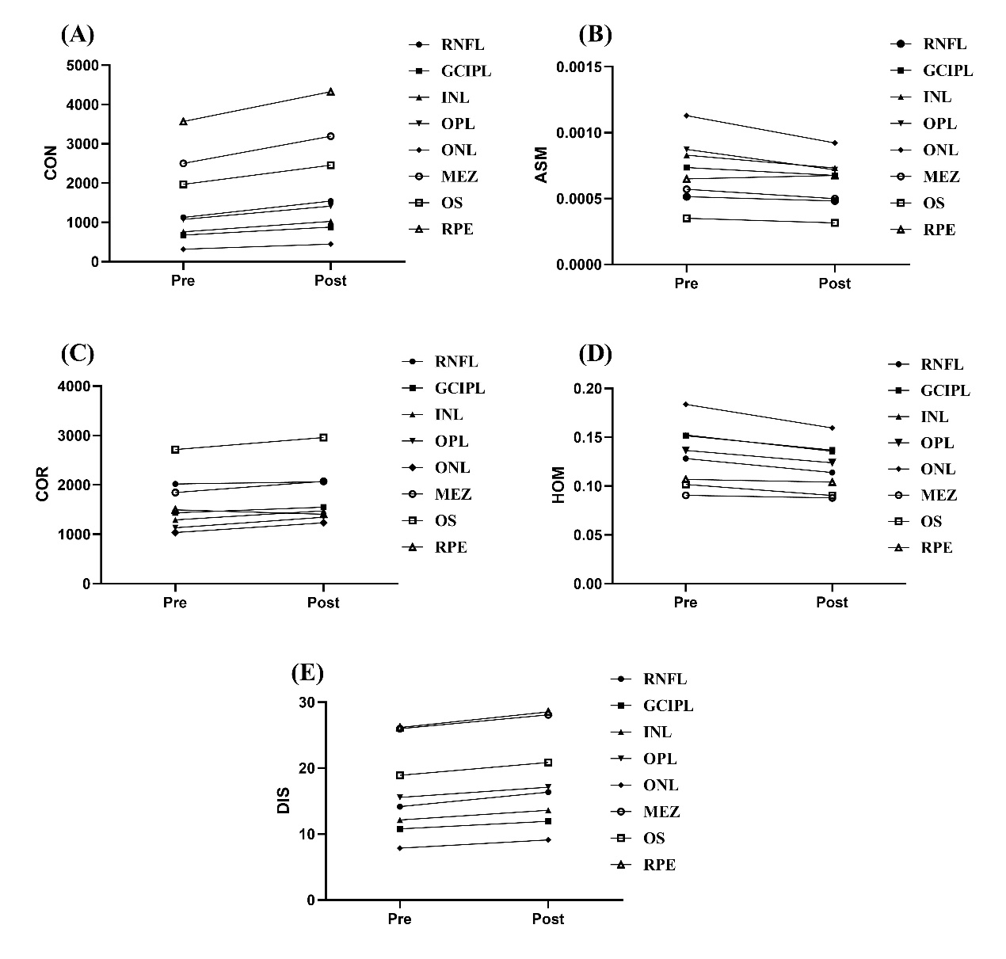
Abbreviations: ASM, angular second moment; CON, contrast; COR, correlation; DIS, dissimilarity; GCIPL, ganglion cells and inner plexiform layer; HOM, homogeneity; INL, inner nuclear layer; MEZ, myoid and ellipsoid zone; ONL, outer nuclear layer; OPL, outer plexiform layer; OS, outer segment of photoreceptor; RNFL, retinal nerve fiber layer; RPE, retinal pigment epithelium.
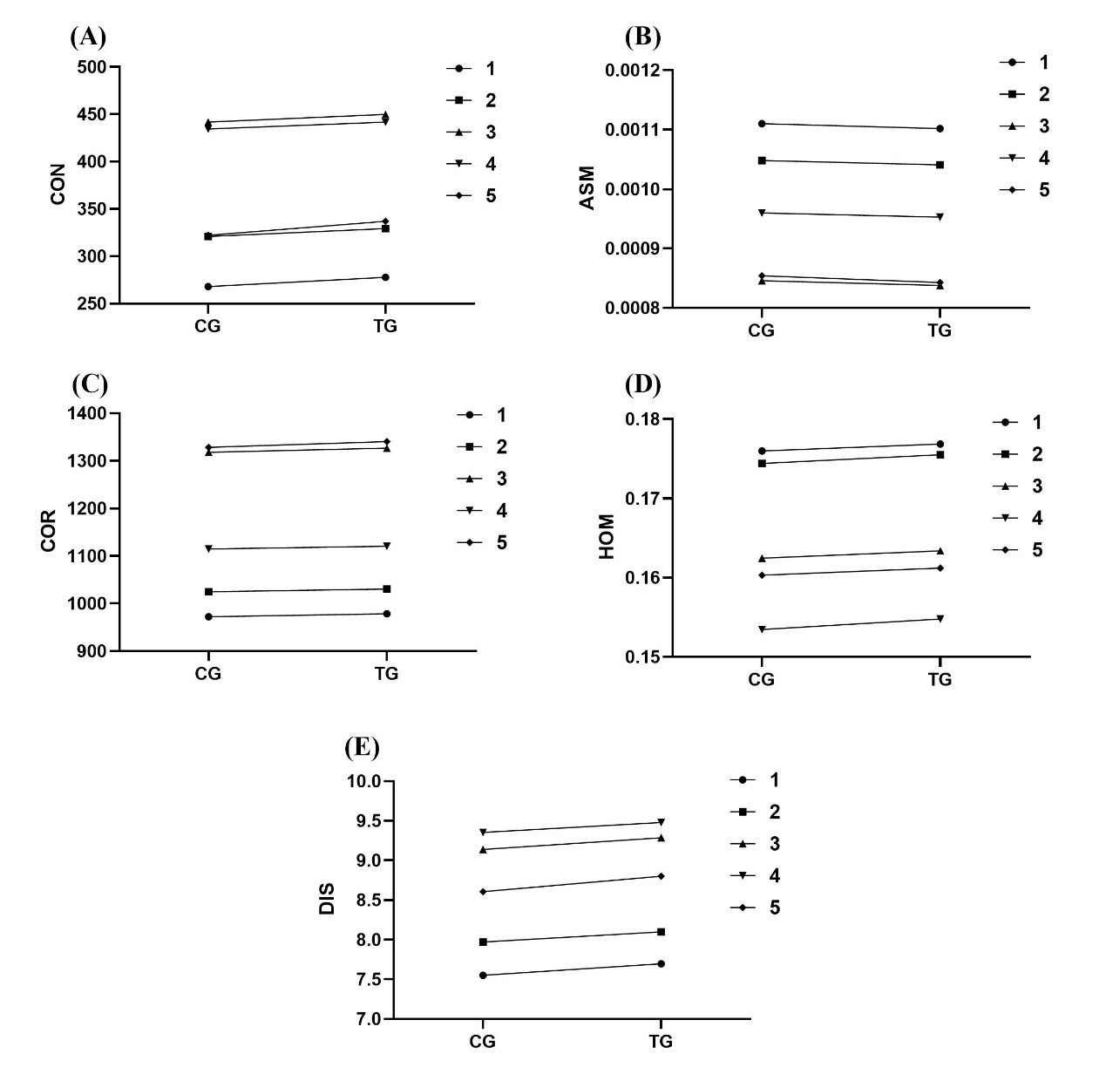
eFigure 2. OCT-ISCF parameters change pattern of speckle noise signal in 5 normal subjects. (A-E) The results of CON, ASM, COR, HOM and DIS, respectively. (CG: control group; TG: test group)
Abbreviations: ASM, angular second moment; CON, contrast; COR, correlation; DIS, dissimilarity; HOM, homogeneity.
eReferences
1. Nasreddine ZS, Phillips NA, Bédirian V, et al. The Montreal Cognitive Assessment, MoCA: a brief screening tool for mild cognitive impairment. J Am Geriatr Soc. 2005;53(4):695-699. https://doi.org/10.1111/j.1532-5415.2005.53221.x
2. Morris JC. The Clinical Dementia Rating (CDR): current version and scoring rules. Neurology. 1993;43(11):2412-2414. https://doi.org/10.1212/wnl.43.11.2412-a
3. Landau SM, Ward TJ, Murphy A, et al. Quantification of amyloid beta and tau PET without a structural MRI. Alzheimers Dement. 2023;19(2):444-455. https://doi.org/10.1002/alz.12668
4. Landau SM, Fero A, Baker SL, et al. Measurement of longitudinal β-amyloid change with 18F-florbetapir PET and standardized uptake value ratios. J Nucl Med. 2015;56(4):567-574. https://doi.org/10.2967/jnumed.114.148981
5. Iulita MF, Bejanin A, Vilaplana E, et al. Association of biological sex with clinical outcomes and biomarkers of Alzheimer's disease in adults with Down syndrome. Brain Commun. 2023;5(2):fcad074. https://doi.org/10.1093/braincomms/fcad074
6. Bullich S, Seibyl J, Catafau AM, et al. Optimized classification of (18)F-Florbetaben PET scans as positive and negative using an SUVR quantitative approach and comparison to visual assessment. Neuroimage Clin. 2017;15:325-332. https://doi.org/10.1016/j.nicl.2017.04.025
7. Kobayashi T, Sundaram D, Nakata K, Tsurui H. Gray-level co-occurrence matrix analysis of several cell types in mouse brain using resolution-enhanced photothermal microscopy. J Biomed Opt. 2017;22(3):36011. https://doi.org/10.1117/1.Jbo.22.3.036011

