Supplementary Materials
Table S1. Demographic, clinical, and biomarker features of the subsample with available GFAP measurement
 | Females | Males | p-value
 | N=67 | N=68
Clinical features
Age (years) | 69.1 (10.2) | 71.3 (8.68) | 0.196
Education (years) | 13.5 (4.33) | 14.8 (3.98) | 0.066
Caucasian ethnicity | 82% | 90% | 0.487
Clinical stage (CU/MCI/DEM) | 24/35/8 | 17/43/8 | 0.345
MMSE | 25.3 (3.46) | 26.2 (4.35) | 0.268
APOE ε4 carriership (%) | 44.6% | 30.8% | 0.148
Amyloid positivity (%) | 54% | 52.4% | 1
Biomarkers
Hippocampal volume (relative) | 0.0025 (± 0.00040) | 0.0025 (± 0.00038) | 0.252
AD cortical thickness (mm) | 2.74 (0.15) | 2.66 (0.27) | 0.040
Early-phase Tau SUVR | 1.31 (0.10) | 1.29 (0.12) | 0.285
Centiloid | 39.8 (44.3) | 38.3 (44.3) | 0.844
Global Tau SUVR | 1.43 (0.39) | 1.23 (0.20) | <0.001
Braak I-III Tau SUVR | 1.39 (0.36) | 1.29 (0.29) | 0.079
Braak IV Tau SUVR | 1.38 (0.26) | 1.28 (0.21) | 0.017
Braak V Tau SUVR | 1.38 (0.33) | 1.24 (0.22) | 0.006
Braak VI Tau SUVR | 1.25 (0.30) | 1.13 (0.19) | 0.006
GFAP (pg/ml) | 200 (110) | 170 (110) | 0.044
ARWMC | 7.73 (5.62) | 7.31 (5.23) | 0.713
TLV (mm3) | 4.74 (7.77) | 7.22 (12.8) | 0.190
Note: Continuous variables are reported as mean and standard deviation, categorical variables as number and percentage. All p-values are obtained by
Mann-Whitney U tests for continuous variables and proportion test for frequencies.
Abbreviations: AD, Alzheimer’s disease; ARWMC, age-related white matter change scale; CU, cognitively unimpaired; DEM, dementia; MCI, mild cognitive impairment; MMSE, mini-mental state examination; GFAP, Glial Fibrillary Acidic Protein; SUVR, standardized uptake value ratios; TLV, total lesion volume.

Table S2. Demographic, clinical, and biomarker features of the subsample with available clinical follow-up
 | Females | Males | p-value
 | N=68 | N=69
Clinical features
Age (years) | 71.4 (7.48) | 71.2 (6.97) | 0.931
Education (years) | 13.3 (3.99) | 14.8 (4.23) | 0.046
Caucasian ethnicity | 86% | 93% | 0.624
Clinical stage (CU/MCI/DEM) | 27/30/11 | 19/43/7 | 0.101
MMSE | 25.7 (3.18) | 25.6 (4.96) | 0.861
APOE ε4 carriership (%) | 46.2% | 32.7% | 0.148
Amyloid positivity (%) | 52.3% | 51.5% | 1
Biomarkers
Hippocampal volume (relative) | 0.0025 (± 0.00040) | 0.0025 (± 0.00038) | 0.229
AD cortical thickness (mm) | 2.70 (0.18) | 2.67 (0.23) | 0.438
Early-phase Tau SUVR | 1.31 (0.10) | 1.30 (0.13) | 0.688
Centiloid | 39.6 (50.0) | 38.9 (50.2) | 0.941
Global Tau SUVR | 1.43 (0.39) | 1.30 (0.28) | 0.026
Braak I-III Tau SUVR | 1.42 (0.34) | 1.35 (0.35) | 0.233
Braak IV Tau SUVR | 1.37 (0.24) | 1.30 (0.22) | 0.070
Braak V Tau SUVR | 1.38 (0.32) | 1.31 (0.30) | 0.205
Braak VI Tau SUVR | 1.24 (0.25) | 1.17 (0.25) | 0.146
GFAP (pg/ml) | 203 (119) | 170 (124) | 0.204
ARWMC | 8.16 (5.80) | 7.32 (5.08) | 0.472
TLV (mm3) | 5.30 (7.62) | 6.60 (9.44) | 0.407
Note: Continuous variables are reported as mean and standard deviation, categorical variables as number and percentage. All p-values are obtained by
Mann-Whitney U tests for continuous variables and proportion test for frequencies.
Abbreviations: AD, Alzheimer’s disease; ARWMC, age-related white matter change scale; CU, cognitively unimpaired; DEM, dementia; MCI, mild cognitive impairment; MMSE, mini-mental state examination; GFAP, Glial Fibrillary Acidic Protein; SUVR, standardized uptake value ratios; TLV, total lesion volume.

Figure S1. Meta ROI for early-phase perfusion images. A voxel-wise linear regression model including intensity-normalized early-phase tau images and the MMSE scores was used to identify a relevant meta-ROI for early-phase perfusion. The statistical threshold was set at p<0.005, FWE-corrected at the cluster level. The obtained ROI resembled the Alzheimer’s disease-typical hypometabolic pattern including temporoparietal and frontal regions and has been used to extract the SUVR for early-phase perfusion images.
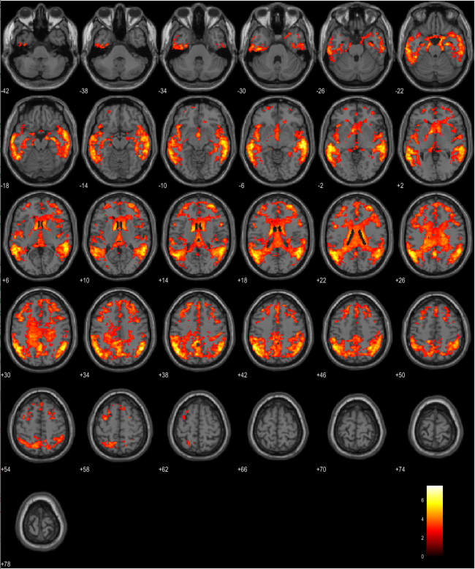

Figure S2. Associations between white matter lesions and cognitive outcomes in females (pink) and males (blue). Linear regressions show the different associations between ARWMC and TLV and cognitive performance (MMSE at baseline) and decline (MMSE rate of changes). The shaded areas around each regression line in the plots represent the confidence intervals for the regression lines.

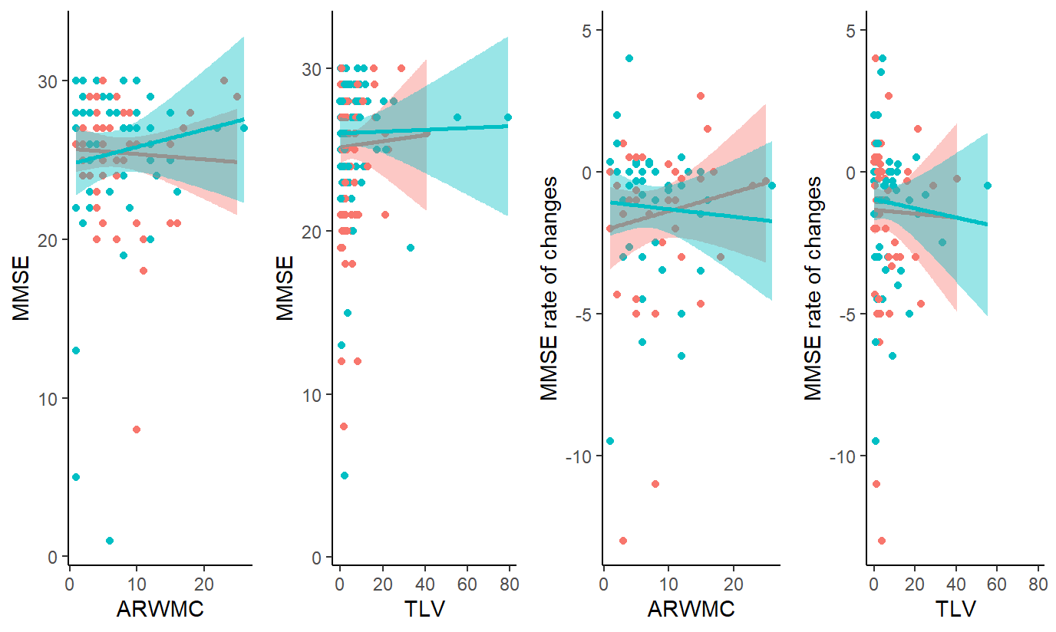

Figure S3. Longitudinal results show different cognitive trajectories of MMSE scores over time in females and males at different levels of AD cortical thickness. Results obtained with the longitudinal linear mixed-effect model showed a significant three-way interaction effect showing that females with high atrophy (lower tertile) exhibited faster cognitive decline than men with high atrophy, and males with low atrophy (upper tertile) exhibited faster cognitive decline then females with low atrophy.
