Supplementary Materials
Supplementary Methods
1. Inclusion and exclusion criteria of study participants 2
1.1 Inclusion criteria 2
1.2. Exclusion criteria 2
2. Aβ PET acquisition and quantification 2
2.1 Aβ PET acquisition 2
2.2. Aβ PET quantification using rdcCL methods 3
3. Plasma collection and processing 4

Supplementary Tables
Table S1. Diagnostic performances at Samsung Medical Center 6
Table S2. Subgroup analysis of p-tau217 and Aβ42/40 8

Supplementary Figures
Figure S1. Flow diagram of participant selection 12
Supplementary References 13

Supplementary methods
1. Inclusion and exclusion criteria of study participants
1.1. Inclusion criteria
Diagnostic criteria for cognitively unimpaired were as follows: absence of objective
cognitive impairment as determined by comprehensive neuropsychological assessment
(performance above -1.0 standard deviation (SD) of age- and education-matched norms in
memory and above -1.5 SD in other cognitive domains). Mild cognitive impairment (MCI)
was diagnosed using the following criteria¹⁻³: (1) self-reported cognitive complaints by the
individual or their caregiver; (2) objective cognitive impairment in any cognitive domain
(below -1.0 SD of age- and education-matched norms in memory or below -1.5 SD in other
cognitive domains); (3) absence of significant impairment in activities of daily living; and (4)
absence of dementia. Diagnosis of dementia of the Alzheimer type (DAT) followed the
National Institute on Aging and Alzheimer's Association (NIA-AA) diagnostic criteria⁴
.
1.2. Exclusion criteria
Participants with territorial infarctions, cortical stroke, brain tumor, vascular
malformation on MRI, White matter hyperintensity due to radiation injury, multiple
sclerosis, vasculitis, or leukodystrophy were excluded.

2. Aβ PET acquisition and quantification
2.1. Aβ PET acquisition
Participants underwent ¹⁸F-Florbetaben PET and ¹⁸F-Flutemetamol positron emission tomography(PET) scans at Samsung Medical Center using a Discovery STe PET/computed tomography (CT) scanner (GE Medical Systems, Milwaukee, WI, USA) in three-dimensional scanning mode, covering 47 slices with a thickness of 3.3 mm across the entire brain. The scans were performed on separate days, with no significant differences in the mean interval times (4.0 ± 2.5 months across all groups, p = 0.89). The median longitudinal follow-up interval was 2.98 years for FBB and 2.87 years for FMM. CT images were obtained using a 16-slice helical CT (140 KeV, 80 mA; 3.75-mm section width) for attenuation correction. The PET scans were conducted 90 minutes after injection of mean doses of 311.5 MBq FBB and 185 MBq FMM, respectively, following protocols recommended by the tracer manufacturers. The emission PET scans lasted 20 minutes in dynamic mode (consisting of 4 × 5 min frames). Three-dimensional PET images were reconstructed using the ordered-subsets expectation maximization algorithm in a 128 × 128 × 48 matrix with a voxel size of 2 mm × 2 mm × 3.27 mm (FBB iterations = 4 and subset = 20; FMM iterations = 4 and subset = 20).

2.2. Aβ PET quantification using rdcCL methods
We used a methodology to direct comparison Centiloid (dcCL) units for FBB and FMM PET scans without the need to convert to the Pittsburgh Compound B Standardized Uptake Value Ratio(SUVR) ⁵, and data were processed using Statistical Parametric Mapping version 8 (SPM8) for normalization. Global and regional Centiloid volumes of interest (VOIs) were created using the whole cerebellum mask from The Global Alzheimer's Association Interactive Network as the reference region. The common area of Aβ accumulation in FMM and FBB PET images was determined using images from 25 Aβ-positive and 18 Aβ-negative patients in a comparative cohort. For each participant, four average images were generated for both positive and negative groups using each tracer. Positive-dominant FBB and FMM cortical (CTX) VOIs were defined by subtracting negative from positive images for each tracer. The FBB-FMM CTX VOI comprised the top 20% of voxels with the strongest intensity among the overlapping regions of these VOIs⁵.
The process of calculating MRI-based regional CL values involved obtaining SUVR from normalized PET images using VOIs derived from the whole cerebellum mask and specific VOIs for five subregions (Frontal, Parietal, Posterior Cingulate, Temporal, and Striatum) based on the Automated Anatomical Labeling atlas. Intensity of each subregion was divided by the intensity from the whole cerebellum VOI, acting as the reference region, to determine regional SUVR values. The sum of these five subregion VOIs constituted the VOI for the whole cortex. Similarly, SUVR values for the entire cortex were obtained using the same method. These SUVR values for the whole cortex were converted into CL values using the CL conversion formula.
$$CL = 100 *({SUVR}_{ind}-{SUVR}_{YC-0})/({SUVR}_{ADCI-100}-{SUVR}_{YC-0})$$
${SUVR}_{ind}$ refers to individual SUVR values, while ${SUVR}_{ADCI-100}$ and ${SUVR}_{YC-0}$ represent the average SUVR values of AD participants and young healthy controls, respectively, corresponding to CL values of 100 and 0 from our cohort in previous study²⁸. This process resulted in an equation to transform SUVR values from the entire cortex into CL values. The same approach was used to derive regional CL values by applying the steps to regional SUVR values.

3. Plasma collection and processing
We obtained 8 mL of blood from each participant, placed the sample into a 0.5 M ethylenediaminetetraacetic acid–containing tube, and mixed it for 5 minutes. Plasma was extracted from the blood sample after centrifugation (1300 × g, 4°C) for 10 minutes and dispensed into 5 or 10 vials at a volume of 0.3 mL each. All plasma samples were stored frozen at −75°C until analysis. This process complied with the manual for human resource collection and registration of the National Biobank of the Republic of Korea.
The frozen plasma samples were shipped to the Department of Psychiatry and Neurochemistry, University of Gothenburg, for analysis. These samples were thawed on wet ice and centrifuged at 500 × g for 5 minutes at 4°C. Plasma amyloid-β (Aβ)40, Aβ42, Glial fibrillary acidic protein, and Neurofilament light chain were quantified using the commercial Neurology 4‐Plex E kit (Quanterix). The p-tau217 concentration was measured using two different immunoassay platforms. First, measurements were performed using the ALZpath Simoa® p-tau217 v2 assay (Quanterix, PN 104371). For this analysis, plasma samples were thawed only once and diluted three- or four-fold, as required for use with the Simoa HD-X Analyzer. The ALZpath assay employs specific capture and detection antibodies targeting phosphorylated tau at threonine 217, providing high specificity. Assays were performed according to the manufacturer's instructions, and data were analyzed using the accompanying software. The lower limit of quantification (LLOQ) was approximately 0.06 pg/mL, with a dynamic range of 0.007 to 30 pg/mL. Quality control samples were included in each batch to ensure consistency, and both inter- and intra-assay variability were assessed to confirm analytical precision.
Second, additional p-tau217 measurements were obtained using an electrochemiluminescence (ECL)-based immunoassay on the Meso Scale Discovery (MSD) platform (Rockville, Maryland)⁶. This customized assay utilized biotinylated-IBA493 as the capture antibody and SULFO-TAG-Ru-4G10-E2, an anti-tau monoclonal antibody, as the detector. All assays were performed in technical duplicate using the same plasma aliquot, and plates were processed within the same batch on streptavidin-coated small spot plates to minimize inter-assay variability. Plasma samples were thawed on ice and centrifuged at 10,000 × g for 5 minutes at 4 °C to remove particulate matter. Aliquots were used immediately and were not re-frozen to avoid protein degradation. The LLOQ for this assay was 0.05 pg/mL, with intra-assay and inter-assay coefficients of variation (CVs) of <10% and <15%, respectively. The dynamic range of the assay was approximately 0.05 to 20 pg/mL.

Supplementary Table S1 Diagnostic performances for combining p-tau217 and other plasma biomarkers from the K-ROAD cohort at Samsung Medical Center.
CU
Model | AUC | 95% CI |  | *p value |  | AIC | BIC |  |  | **p value
ALZpath
p-tau217 | 0.905 | 0.869 | 0.940 |  | ref | 301.7 |  | 309.6 | ref
p-tau217, Aβ42/40 | 0.937 | 0.912 | 0.962 |  | 0.0013 | 262.7 |  | 274.6 | <0.0001
p-tau217, GFAP | 0.903 | 0.868 | 0.939 |  | 0.0569 | 303.6 |  | 315.5 | 0.7798
p-tau217, NfL | 0.916 | 0.884 | 0.948 |  | 0.0071 | 298.4 |  | 310.3 | 0.022
MSD
p-tau217 | 0.861 | 0.820 | 0.902 |  | ref | 356.1 |  | 364.0 | ref
p-tau217, Aβ42/40 | 0.901 | 0.869 | 0.933 |  | 0.0037 | 310.3 |  | 322.1 | <0.0001
p-tau217, GFAP | 0.862 | 0.821 | 0.902 |  | 0.8659 | 347.2 |  | 359.0 | 0.0010
p-tau217, NfL | 0.861 | 0.820 | 0.902 |  | 0.5903 | 358.1 |  | 369.9 | 0.9710

CI
Model | AUC | 95% CI |  | *p value |  | AIC | BIC |  |  | **p value
ALZpath
p-tau217 | 0.935 | 0.913 | 0.956 |  | ref | 795.3 |  | 805.4 | ref
p-tau217, Aβ42/40 | 0.936 | 0.915 | 0.957 |  | 0.3525 | 783.1 |  | 798.3 | <0.0001
p-tau217, GFAP | 0.935 | 0.913 | 0.956 |  | 0.3869 | 797.2 |  | 812.3 | 0.7498
p-tau217, NfL | 0.935 | 0.914 | 0.956 |  | 0.2570 | 794.6 |  | 809.8 | 0.1016
MSD
p-tau217 | 0.932 | 0.912 | 0.953 |  | ref | 825.8 |  | 835.9 | ref
p-tau217, Aβ42/40 | 0.934 | 0.913 | 0.954 |  | 0.5672 | 804.5 |  | 819.6 | <0.0001
p-tau217, GFAP | 0.932 | 0.911 | 0.953 |  | 0.7831 | 820.2 |  | 835.4 | 0.006
p-tau217, NfL | 0.933 | 0.912 | 0.953 |  | 0.0780 | 826.9 |  | 842.0 | 0.3405
*p values were calculated using the DeLong test to compare the areas under the curve between models. **p values were calculated based on the Likelihood Ratio Test to assess the overall model fit improvement. Abbreviations: CU, cognitively unimpaired; CI, cognitively impaired; AUC, areas under the curve; AIC, Akaike information criterion; BIC, Bayesian information criterion; MSD, Meso Scale Discovery; GFAP, Glial Fibrillary Acidic Protein; NfL, Neurofilament Light Chain.

Supplementary Table S2 Diagnostic performances for Plasma p-tau217 and Aβ42/40 combination across subgroups.
CU
Subgroup | Model | AUC | 95% CI |  | *p value |  | AIC  = BIC
ALZpath
< 65 | p-tau217 | 0.876 | 0.751 | 1.000 |  | ref | 81.0
 | p-tau217, Aβ42/40 | 0.928 | 0.860 | 0.995 |  | 0.1227 | 68.5
≥ 65 | p-tau217 | 0.908 | 0.878 | 0.938 |  | ref | 349.1
 | p-tau217, Aβ42/40 | 0.940 | 0.920 | 0.961 |  | 0.0011 | 295.4
Male | p-tau217 | 0.944 | 0.911 | 0.977 |  | ref | 117.9
 | p-tau217, Aβ42/40 | 0.959 | 0.934 | 0.983 |  | 0.1808 | 104.2
Female | p-tau217 | 0.897 | 0.857 | 0.937 |  | ref | 312.1
 | p-tau217, Aβ42/40 | 0.938 | 0.913 | 0.963 |  | 0.0006 | 259.7
Obese | p-tau217 | 0.894 | 0.833 | 0.955 |  | ref | 0.894
 | p-tau217, Aβ42/40 | 0.930 | 0.890 | 0.969 |  | 0.0328 | 0.930
Non-Obese | p-tau217 | 0.922 | 0.890 | 0.954 |  | ref | 0.922
 | p-tau217, Aβ42/40 | 0.948 | 0.926 | 0.970 |  | 0.0062 | 0.948
APOE ε4  carrier | p-tau217 | 0.899 | 0.847 | 0.950 |  | ref | 0.899
APOE ε4  carrier | p-tau217, Aβ42/40 | 0.912 | 0.866 | 0.958 |  | 0.2632 | 0.912
APOE ε4  non-carrier | p-tau217 | 0.919 | 0.883 | 0.955 |  | ref | 0.919
APOE ε4  non-carrier | p-tau217, Aβ42/40 | 0.949 | 0.926 | 0.972 |  | 0.0086 | 0.949
MSD
< 65 | p-tau217 | 0.895 | 0.814 | 0.976 |  | ref | 81.1
 | p-tau217, Aβ42/40 | 0.948 | 0.912 | 0.985 |  | 0.0878 | 61.7
≥ 65 | p-tau217 | 0.867 | 0.831 | 0.904 |  | ref | 407.5
 | p-tau217, Aβ42/40 | 0.908 | 0.879 | 0.936 |  | 0.0007 | 352.3
Male | p-tau217 | 0.910 | 0.858 | 0.962 |  | ref | 154.3
 | p-tau217, Aβ42/40 | 0.920 | 0.879 | 0.961 |  | 0.5926 | 138.3
Female | p-tau217 | 0.863 | 0.823 | 0.903 |  | ref | 334.3
 | p-tau217, Aβ42/40 | 0.921 | 0.893 | 0.949 |  | <.0001 | 275.6
Obese | p-tau217 | 0.868 | 0.809 | 0.927 |  | ref | 0.868
 | p-tau217, Aβ42/40 | 0.916 | 0.878 | 0.954 |  | 0.0433 | 0.916
Non-Obese | p-tau217 | 0.883 | 0.845 | 0.921 |  | ref | 0.883
 | p-tau217, Aβ42/40 | 0.922 | 0.894 | 0.951 |  | 0.0010 | 0.922
APOE ε4  carrier | p-tau217 | 0.852 | 0.788 | 0.916 |  | ref | 170.0
APOE ε4  carrier | p-tau217, Aβ42/40 | 0.862 | 0.802 | 0.923 |  | 0.5317 | 150.0
APOE ε4  non-carrier | p-tau217 | 0.882 | 0.841 | 0.922 |  | ref | 318.6
APOE ε4  non-carrier | p-tau217, Aβ42/40 | 0.930 | 0.904 | 0.957 |  | 0.0014 | 263.9

CU
Subgroup | Model | AUC | 95% CI |  | *p value |  | **AIC  = BIC
ALZpath
< 65 | p-tau217 | 0.970 | 0.948 | 0.992 |  | ref | 198.5
 | p-tau217, Aβ42/40 | 0.969 | 0.947 | 0.992 |  | 0.8402 | 191.5
≥ 65 | p-tau217 | 0.925 | 0.908 | 0.941 |  | ref | 1168.1
 | p-tau217, Aβ42/40 | 0.927 | 0.910 | 0.943 |  | 0.4487 | 1133.8
Male | p-tau217 | 0.925 | 0.901 | 0.948 |  | ref | 576.5
 | p-tau217, Aβ42/40 | 0.932 | 0.910 | 0.955 |  | 0.0021 | 538.0
Female | p-tau217 | 0.944 | 0.926 | 0.961 |  | ref | 790.2
 | p-tau217, Aβ42/40 | 0.942 | 0.924 | 0.959 |  | 0.5422 | 787.2
Obese | p-tau217 | 0.937 | 0.914 | 0.959 |  | ref | 352.4
 | p-tau217, Aβ42/40 | 0.941 | 0.919 | 0.963 |  | 0.4356 | 336.6
Non-Obese | p-tau217 | 0.931 | 0.913 | 0.949 |  | ref | 1012.9
 | p-tau217, Aβ42/40 | 0.931 | 0.913 | 0.950 |  | 0.8768 | 986.9
APOE ε4  carrier | p-tau217 | 0.941 | 0.908 | 0.973 |  | ref | 433.9
APOE ε4  carrier | p-tau217, Aβ42/40 | 0.939 | 0.907 | 0.971 |  | 0.5669 | 424.3
APOE ε4  non-carrier | p-tau217 | 0.929 | 0.912 | 0.946 |  | ref | 932.7
APOE ε4  non-carrier | p-tau217, Aβ42/40 | 0.931 | 0.914 | 0.948 |  | 0.7231 | 901.0
MSD
< 65 | p-tau217 | 0.960 | 0.937 | 0.984 |  | ref | 234.2
 | p-tau217, Aβ42/40 | 0.963 | 0.939 | 0.986 |  | 0.4140 | 223.3
≥ 65 | p-tau217 | 0.924 | 0.908 | 0.941 |  | ref | 1207.9
 | p-tau217, Aβ42/40 | 0.927 | 0.911 | 0.944 |  | 0.3354 | 1185.3
Male | p-tau217 | 0.935 | 0.913 | 0.956 |  | ref | 585.2
 | p-tau217, Aβ42/40 | 0.944 | 0.924 | 0.964 |  | 0.0021 | 563.3
Female | p-tau217 | 0.932 | 0.914 | 0.950 |  | ref | 856.9
 | p-tau217, Aβ42/40 | 0.932 | 0.914 | 0.950 |  | 0.9448 | 845.4
Obese | p-tau217 | 0.936 | 0.912 | 0.959 |  | ref | 428.6
 | p-tau217, Aβ42/40 | 0.938 | 0.914 | 0.962 |  | 0.7751 | 425.5
Non-Obese | p-tau217 | 0.930 | 0.912 | 0.947 |  | ref | 1010.0
 | p-tau217, Aβ42/40 | 0.933 | 0.916 | 0.950 |  | 0.2334 | 978.5
APOE ε4  carrier | p-tau217 | 0.933 | 0.899 | 0.966 |  | ref | 460.8
APOE ε4  carrier | p-tau217, Aβ42/40 | 0.933 | 0.900 | 0.966 |  | 0.9255 | 449.2
APOE ε4  non-carrier | p-tau217 | 0.927 | 0.910 | 0.944 |  | ref | 981.3
APOE ε4  non-carrier | p-tau217, Aβ42/40 | 0.930 | 0.913 | 0.947 |  | 0.4378 | 959.5
*p values were calculated using the DeLong test to compare the areas under the curve between models. **Since no new parameters were estimated when applying CI/CU estimated parameters to the subgroups, AIC = BIC, and LRT were not available. Abbreviations: CU, cognitively unimpaired; CI, cognitively impaired; SD, Standard deviation; n, Number of individuals; BMI, Body mass index; APOE, Apolipoprotein E; MCI, Mild cognitive impairment; DAT, Dementia of Alzheimer’s type; rdcCL, regional direct comparison Centiloid.

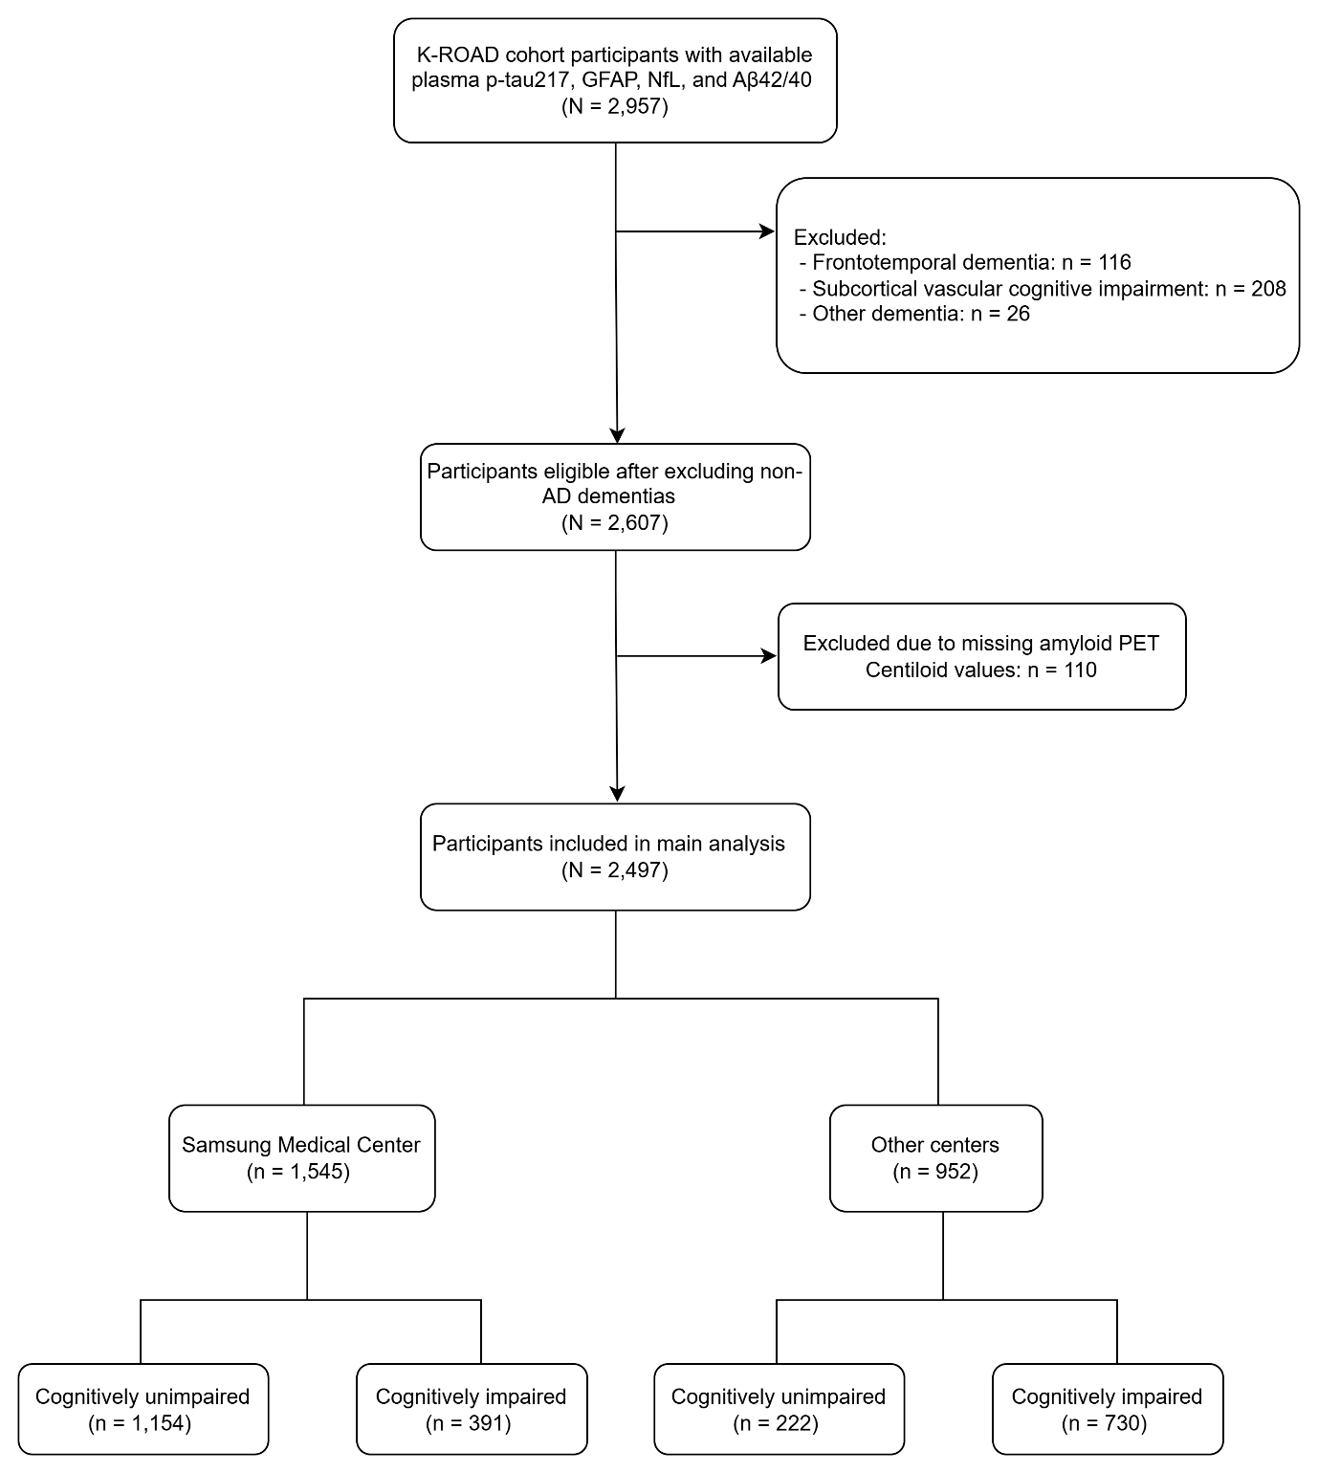
Supplementary Figure 1 Flow diagram of participant selection from the K-ROAD cohort for plasma biomarker and amyloid PET analysis.
Abbreviations: GFAP, Glial fibrillary acidic protein; NfL, Neurofilament light chain; AD, Alzheimer’s disease

Supplemental references
- Albert MS, DeKosky ST, Dickson D, et al. The diagnosis of mild cognitive impairment due to Alzheimer's disease: recommendations from the National Institute on Aging-Alzheimer's Association workgroups on diagnostic guidelines for Alzheimer's disease. Alzheimers Dement. 2011;7(3):270-279. doi:10.1016/j.jalz.2011.03.008.
- Kim J, Jahng S, Kim S, et al. A comparison of item characteristics and test information between the K-MMSE~2:SV and K-MMSE. Dement Neurocogn Disord. 2024;23(3):117-126. doi:10.12779/dnd.2024.23.3.117.
- Ryu HJ, Yang DW. The Seoul Neuropsychological Screening Battery (SNSB) for comprehensive neuropsychological assessment. Dement Neurocogn Disord. 2023;22(1):1-15. doi:10.12779/dnd.2023.22.1.1.
- McKhann GM, Knopman DS, Chertkow H, et al. The diagnosis of dementia due to Alzheimer's disease: recommendations from the National Institute on Aging-Alzheimer's Association workgroups on diagnostic guidelines for Alzheimer's disease. Alzheimers Dement. 2011;7(3):263-269. doi:10.1016/j.jalz.2011.03.005.
- Cho SH, Seo SW, Kim JH, et al. A new Centiloid method for (18)F-florbetaben and (18)F-flutemetamol PET without conversion to PiB. Eur J Nucl Med Mol Imaging. 2020;47:1938-1948. doi:10.1007/s00259-020-04761-w.
- Thijssen EH, La Joie R, Strom A, et al. Plasma phosphorylated tau 217 and phosphorylated tau 181 as biomarkers in Alzheimer’s disease and frontotemporal lobar degeneration: a retrospective diagnostic performance study. Lancet Neurol 2021;20:739–52. doi:10.1016/S1474-4422(21)00214-3.

